# FINANCIAL & ADMINISTRATIVE MANUAL

**August 2019**



## Table of Contents

FINANCIAL & ADMINISTRATIVE MANUAL 1

Table of Contents i

INTRODUCTION 1

WTCS Fiscal Management 1

FAM Contact 1

Uniform Financial Fund Accounting System (UFFAS) 2

Introduction 2

UFFAS Reporting 2

UFFAS Contact 2

UFFAS MIS Contact 2

The Uniform Financial Fund Accounting System 3

Account Structure 3

Fund Type/Account Group 4

Governmental Fund Category 4

Non-Governmental Funds 5

Proprietary Fund Category 5

Fiduciary Fund Category 5

Account Groups 5

Cost Center 7

Instructional Area 7

Non-Instructional Area 8

Technical Assistance 8

Academic Administration 8

Instructional Resources 9

Student Services 9

General Institutional 10

Physical Plant 10

Auxiliary Services 11

Public Service 11

Unassignable 11

Classification 12

Balance Sheet 13

Assets 13

Current Assets 13

Noncurrent Assets 14

Capital Assets 14

General Long-Term Debt Account Group Assets 14

Liabilities 15

Current Liabilities 15

Noncurrent Liabilities 15

General Long-Term Debt Account Group Liabilities 16

Fund Equity 16

Contributed Capital 3100-3199 16

Investment in General Capital Assets 3200-3299 16

Retained Earnings 3300-3399 16

Fund Balance 3400-3499 16

Revenues 18

41YY Local Government 18

42YY State Aids 18

43YY Statutory Program Fees 18

44YY Material Fees 19

45YY Other Student Fees/Charges 19

46YY - 48YY Institutional Revenue 20

49YY Federal Revenue 20

Expenditures 22

50YY - SALARIES/WAGES 22

Positions 22

51YY FRINGE BENEFITS – 25

52YY - 56YY CURRENT EXPENDITURES 25

57YY RESALE GOODS & SERVICES 27

58YY CAPITAL OUTLAY 27

59YY DEBT SERVICE 27

Other Resources 28

Interfund Transfers 28

Proceeds From Debt/Sales 28

Fund Equity 28

Fund Balance 28

Reserves 28

Designations 28

Other Uses 28

Interfund Transfers 29

Repayment of Debt 29

Fund Equity 29

Fund Balance 29

Reserves 29

Designations 29

Function 30

UFFAS Record Layout 32

Record Identifier 32

District Number 32

Fiscal Year 33

Fund 33

Cost Center 33

Classification 33

Account Amount 33

Debit-Credit Code 33

Function 34

Edits and Reasonableness Testing 35

Overview 35

Data Element Relationships 36

Edits 42

Overview 42

Edits 42

1 INVALID RECORD IDENTIFIER 42

2 INVALID FISCAL YEAR 43

4 INVALID FUND 43

5 INVALID COST CENTER 43

6 INVALID CLASSIFICATION 43

8 INVALID AMOUNT 43

9 INVALID DEBIT/CREDIT 43

10 DUPLICATE ACCOUNT 43

11 INCOMPATIBLE FUND AND CLASSIFICATION 44

14 INCOMPATIBLE FUNCTION AND CLASSIFICATION 44

15 INCOMPATIBLE COST CENTER AND CLASSIFICATION 44

17 CLASS 5434 MUST HAVE COST CENTER > 899 44

19 CLASS 5418/5419 FUND 1/2 Not COST CENTER 978 44

20 CLASS 5157 REPORTED WITH COST CENTER OTHER THAN 968 44

Reasonableness Testing 44

Overview 44

Reasonableness Tests Cross-References 45

Reasonableness Tests 45

76 WARNING: ($ amount) IN FUND 1, CLASS 3452 > 10% OF FUND 1 and 2, CLASSES 4200-4213 + 4215 + 4217-4299 ($ amount) 46

77 WARNING: FUND 1 CLASS 3491 > $0 AND ($ amount) IN FUND 1, 2 CLASS 3492 < 5% OF FUND 1,2 CLASSES 4200-4213 + 4215 + 4217-4299 ($ amount) 46

78 WARNING: ($ amount) IN FUND 1, CLASS 3491 > 15% OF FUND 1 and 2, CLASSES 4200-4213 + 4215 + 4217-4299 ($ amount) 46

79 WARNING: NON-POSTSECONDARY PROGRAM FEES ≠ $0 47

80 WARNING: DIVISION X EXPENDITURES = YYYYY.YY AND ADMIN EXPENDITURES = ZZZZ.ZZ 47

81 ERROR: COST CENTER XXX, FUND Y EXPENDITURES = ZZZZZ.ZZ 47

82 WARNING: SUM OF CLASS CODES WWWW-XXXX, FUND Y = ZZZZZ.ZZ 48

83 ERROR: SUM OF CLASS CODES XXXX-YYYY = ZZZZZ.ZZ 48

84 ERROR: SUM OF CLASS CODES XXXX-YYYY = ZZZZZ 49

86 ERROR: SUM OF CLASSES 4540-4541 = ZZZZ.ZZ 49

87 ERROR: SUM OF CLASSES 4600-4649 = ZZZZ.ZZ 49

88 WARNING: SUM OF CLASSES 4660-4669 (FUND 4) = ZZZZ.ZZ 49

89 ERROR: SUM OF CLASSES VVVV-WWWW, FUNDS X AND Y = ZZZZ.ZZ 50

90 ERROR: SUM OF CLASSES 4960-4969 LESS THAN $100,000 AND NOT EQUAL TO $0 50

92 WARNING: CLASS CODE 5434 RECORDS NOT IN COST CENTERS 931 OR 953 WERE FOUND 50

93 ERROR: CLASS 5119 USED WITH 5101-5107 51

94 ERROR: SUM OF CLASSES 1301-1307 ZZZZZ.ZZ NOT EQUAL TO SUM OF CLASSES 2301-2307 ZZZZZ.ZZ 51

95 ERROR: SUM OF CLASSES 1701-1707 ZZZZZ.ZZ NOT EQUAL TO SUM OF CLASSES 2501-2507 ZZZZZ.ZZ 51

96 ERROR: ZZZZZ.ZZ REPORTED IN CLASS 5157 OUTSIDE OF COST CENTER 968 51

97 WARNING: FUND 1 CLASS 3451 > 25% OF CLASSES 5000-5999 52

98 WARNING: FUND 2 CLASS 3451 > 25% OF CLASSES 5000-5999 52

Corrections 52

Accounting Principles 53

Legal Compliance and Financial Operations 53

Conflicts Between Accounting Principles and Legal Provisions 53

The Budget and Budgetary Accounting 53

The Accounting System 53

Accruals 53

Fund Accounting 54

Financial Reporting 54

Guidelines 55

Audio-Visual Aids - Capitalization 55

Capital Donations 55

Computer Software - Capitalization 55

Capitalization 55

Contracted Services 55

Curriculum Development 56

Debt Refinancing 56

Debt Service Funds Expenditures - Budget and Reporting 56

Debt Service Repayment Period 56

Deferred Student Fee Accounting 56

Excess/Deficit Fund Balances 56

Excess Property 57

Gifts and Donations 57

Interest Income Distribution 57

Investment and External Investment Pools Accounting 57

Grant Funded Student Fees 57

Inter-fund Borrowing 57

Long-Term Operational Borrowing 58

Maintenance Agreements 58

Municipal Mutual Insurance Reserves Capitalization 58

OPEB 58

GAAP Basis 58

Budgetary Basis 59

Property Tax Distribution 59

Property Tax Revenue Recognition 59

Real Property Tax Refunds 59

Software Purchases/Development (GASB 51) 60

Student Financial Assistance 61

Terminology 62

Accrual Basis 62

Accrued Expenses 62

Accrued Liabilities 62

Accrued Revenue 62

Amount Available in Debt Service Fund 62

Amount to be Provided for Retirement of General Long-Term Obligations 62

Budgetary Integration 62

Capital Outlay 62

Capital Program 63

Cost Allocation Report 63

Cost Center 63

Current Expenditures Per Student 63

Current Loans 63

Custodial Fund 63

Debt Limit 63

Equalized Valuation 63

Equipment 64

Equipment – Fixed 64

Equipment – Movable 64

Fees 64

Financial and Compliance Audits 64

Function 64

Gross Bonded Debt 64

Maintenance of Plant 64

Minor Equipment 65

Operational Budget 65

Operational Mill Rate 65

Overhead Cost 65

Overlapping Debt 65

Remodeling 65

Repairs 65

Replacement of Equipment 65

Reserve 66

Set 66

Short-Term Debt 66

Special Audit 66

State Aid 66

Student Activities 66

Student Fees 66

Supplies and Materials 66

Material Fees 67

Statutory Requirement 67

Expenditure Definition 67

FAM Definitions 67

Supplies and Materials 67

Minor Equipment 67

Equipment 67

Equipment - Fixed 67

Equipment - Movable 67

Administrative Code Definitions 68

Minor Equipment 68

Fixed Equipment 68

Movable Equipment 68

Methodology 68

Problem Areas 69

Academic Administration 69

Divisional Administration 69

Enterprise Expenditures 69

Grouping Instructional Areas 69

Non-instructional Expenditures 69

Printing 69

Technical Assistance 69

Miscellaneous 70

Non-Governmental Fund Accounting 71

Joint Enterprise/Instructional Operations 71

Definition 71

Examples 71

Accounting Treatment 71

Enterprise Operations 72

Definition 72

Examples 73

Accounting Treatment 73

Internal Service Operations 74

Definition 74

Examples 74

Accounting Treatment 74

Fiduciary Activities 75

Aidable/Nonaidable Activities 77

Aidable Activities 77

Nonaidable Activities 77

Annual Budget 79

Introduction 79

Organization of Document 79

Legal Requirements for District Budgets 79

Designated for Subsequent Year 81

Budget Contact 81

Budget Document Format 82

Budget Document Criteria 82

Policy Document Section 82

Required Items: 82

Supplemental Items: 83

Financial Plan Section 84

Required Items: 84

Supplemental Items: 85

Operations Guide Section 85

Supplemental Items: 85

Communications Device Section 86

Required Items: 86

Supplemental Items: 86

Description of Functional Units 87

Expenditures 87

Revenues 88

Basis of Accounting 89

Basis of Budgeting 89

Sample Statements and Schedules 90

Budgetary Statements of Resources, Uses and Changes in Fund Balance 92

General Fund 93

Special Revenue Fund 94

Capital Projects Fund 95

Debt Service Fund 96

Enterprise Fund 97

Internal Service Fund 98

Budgetary Expenditures by Object Level 100

Position Summary – FTE Basis 102

Combined Fund Summary 103

Equalized Valuations & Mill Rates 104

Legal Debt Limitations 105

Notice of Public Hearing p. 1 107

Notice of Public Hearing p. 2 108

General Requirements 109

Appropriations/Expenditures 109

Contingencies 109

Reservations / Designations 109

Tax Levy 109

Budget Modification 110

Budget Modification 110

System Office Reporting 110

Budget Modification (Sample) 111

The Financial and Single Audit 112

Financial Audits 112

Purpose and Description 112

Audit Contact 112

Major Accounting Policies 112

Procurement of Audit Services 113

The Audit 113

Engagement Letters 113

Representation Letters 114

Attorney Letters 114

Auditor's Report 114

Submission Requirements 115

Submission List 115

The Audited Financial Report (AFR) 117

Contents 117

Internal Control 124

The Management Letter/SAS 114 Communication 124

Working Papers 124

Retention of Working Papers 125

Sample Engagement Letter 126

Single Audits 128

Background 128

Overview 128

Schedules 132

Expenditures of Federal and State Awards 132

Findings and Questioned Costs 132

Prior Year(s) Findings and Questioned Costs 134

Sample Schedules 135

Findings and Questioned Costs 138

Prior Year(s) Findings and Questioned Costs 140

Management Decision 141

District Responsibilities as a Subrecipient Grantor 142

Primary Recipient Monitoring Responsibilities 142

Cost Allocation Report Reconciliation 143

Format 143

Revenue Reconciliation Example 144

Expenditure Reconciliation Example 144

Remuneration Standards for Federal and State Grants 145

Standards for Allowable Compensation 145

Required Support Documentation 145

Paper vs. Electronic Documentation 146

Cost Allocation Report 147

Introduction 147

List of Schedules 147

Submission Requirements 147

Cost Allocation Report Contact 148

Schedule Instructions 149

VE-CA-1 Expenditure Summary 149

VE-CA-2 Expenditure Re-Cap 150

VE-CA-3 Functional Cost Allocation 151

VE-CA-4 Divisional Cost Allocation 152

Division Schedule Instructions 152

Distribution Instructions 152

Instructions for Other Lines 153

VE-CA-5 Divisional Summary 154

VE-CA-6 Allocation Bases 155

VE-CA-7 Revenue Summary 156

VE-CA-8 Non-Resident Tuition (Deleted) 157

VE-CA-9 Cost Allocation Summary 158

VE-CA-9s Cost Allocation Summary Supplement 160

Schedule Examples 161

VE-CA-1 162

VE-CA-2 163

VE-CA-3 164

VE-CA-4 165

VE-CA-5 166

VE-CA-6A 167

VE-CA-6B/C 168

VE-CA-7 169

VE-CA-8 170

VE-CA-9 171

V-CA-9s 172

IPED’s Financial Reporting 173

Part A – Statement of Net Position 174

Part B – Revenue and Other Additions 176

Part C – Expenses and Other Deductions 179

19 Total Expenses & Deductions – Enter the sum of line 15 and all expense amounts reported in the Non-operating Revenues (Expenses) section of the REC.Part D – Summary of Changes in Net Assets 180

Part E – Scholarships and Fellowships 181

Part F – Component Units – FASB Standards 182

Part G – Component Units – GASB Standards 182

Part H – Details of Endowment Assets 184

Part I – Not Used 184

Part J – Revenue Data for Bureau of Census 184

Part K – Expenditure Data for Bureau of Census 185

Part L – Debt and Assets 187

Higher Learning Commission Reporting 188

IV EDUCATIONAL PROGRAMS 188

V FINANCIAL STRENGTH 189

Procurement 191

Scope 191

Procurement Contact 191

Procurement Review 191

General Requirements 191

Procurement Procedures 194

Less than $25,000 194

$25,000 to $50,000 195

Greater than $50,000 195

Public Construction 195

Formal Consortium Method of Procurement Thresholds 195

Exceptions 196

Competitive Procurement Procedures (>$50,000) 197

Competitive Sealed Bids 197

Competitive Selection (RFP) 198

Specific Brand Name 202

Documentation 202

Contract Provisions 203

Miscellaneous 203

Disposal of Property 204

Bid Notice/Opening Spreadsheet Samples 205

Bid Notice Sample 205

Bid Opening Spreadsheet Sample 206

Facilities 207

Scope 207

Facilities Contact 207

General Requirements 208

Project Concept Review 208

Project Approval 208

Requests 209

Project Concept Review Request 209

Land Acquisition 209

Additional or New Facilities 210

Leasing & Rentals 212

Remodeling 214

Three Year Facilities Plan 217

Single Campus Site Designation 223

SUMMARY OF CHANGES 225

Overall 225

UFFAS 225

Annual Budget 225

The Financial and Single Audit 225

Cost Allocation Report 226

Procurement 226

Facilities 226

# INTRODUCTION

### WTCS Fiscal Management

The Wisconsin Technical College System (WTCS) operates under a statutorily created shared governance system related to fiscal management policies, procedures and formats. Each Wisconsin Technical College System district, while retaining certain options in its financial accounting systems and budget procedures, is required to meet specific statewide minimum standards for budget format, accounting, fiscal reporting, and general financial management.

A committee of state and local representatives meets periodically to consider revisions, updates, and refinements to these standards. Its fundamental objective is the production of consistent, accurate, and timely financial data for the improvement of the overall administrative decision making process.

Fiscal management is a dynamic force. The process of improving fiscal management and adapting to changing circumstances is never-ending as is the balance between federal, state, and local influences. Wisconsin's technical college system, however, is actively engaged in the development and refinement of fiscal management techniques, procedures, and formats which should make it possible to assure the taxpaying public that we will continue to use fiscal resources to the best possible advantage.

Office of Finance and Management Services

Division of Administrative Services

### FAM Contact

Inquiries regarding this manual should be directed to:

Michelle Rudman

WI Technical College System

4622 University Avenue

P. O Box 7874

Madison, WI 53707-7874

608‑266‑1433

[michelle.rudman@wtcsystem.edu](mailto:michelle.rudman@wtcsystem.edu)

# Uniform Financial Fund Accounting System (UFFAS)

### Introduction

[Section 38.04(11)(bm)](http://docs.legis.wi.gov/statutes/statutes/38/04/11?view=section), Wis. Stats., states: "The board shall prescribe a detailed uniform financial fund accounting system, applicable to all district boards, which provides for the recording of all financial transactions inherent in the management of the districts and the administration of the district aid programs." The term "recording" has been interpreted by the System Office to mean that districts must record each transaction in the district’s financial records such that it can be identified with a specific account number listed in this manual. Districts may use an alternate coding system for entry of each transaction provided that coding system directly corresponds to the standard UFFAS account codes. Allocations, algorithms, and other indirect methods may be used at the time transactions are entered into the system but not in converting from an internal coding system to a standard UFFAS account code.

### UFFAS Reporting

At any time during the year districts must be able to generate a report based on total or selected UFFAS accounts. Annually, by the date in the annual WTCS [reporting calendar](http://mywtcs.wtcsystem.edu/resources-policies/state-law-and-policy/administrative-bulletins), districts shall submit to the System Office a year-end report of UFFAS accounts with a balance other than $0.00. No subtotal or grand total accounts are to be submitted. These reports shall be on a budgetary basis. Refer to the UFFAS Record Layout section for submission detail. All errors resulting from the edits and reasonableness testing must be corrected. The UFFAS contact below is to be notified by email when the district has finalized submitting data for the fiscal year.

If districts use an alternate internal coding system for data entry, the district shall also generate a crosswalk, identifying the specific account number or numbers that were used to input transactions for each standard UFFAS account used. These crosswalks shall be structured to allow reviewers to trace each UFFAS account through the district’s accounting records to specific source documentation for each entry and from each source document through the district’s accounting records to a specific UFFAS account or accounts.

#### UFFAS Contact

Questions regarding UFFAS, this section of the manual and data correction should be directed to:

Michelle Rudman

Wisconsin Technical College System

4622 University Avenue

P.O. Box 7874

Madison, Wisconsin 53707-7874

(608) 266‑1433

[michelle.rudman@wtcsystem.edu](mailto:michelle.rudman@wtcsystem.edu)

#### UFFAS MIS Contact

Questions regarding technical issues related to UFFAS data transmission and processing should be directed to:

Jason Ring

Wisconsin Technical College System

4622 University Avenue

P.O. Box 7874

Madison, Wisconsin 53707-7874

(608) 266‑9858

[jason.ring@wtcsystem.edu](mailto:jason.ring@wtcsystem.edu)

## The Uniform Financial Fund Accounting System

### Account Structure

|  |  |  |
| --- | --- | --- |
| X | XXX | XXXX |
| FUND TYPE OR ACCOUNT GROUP |  |  |
|  | COST CENTER**\*** |  |
|  |  | CLASSIFICATION |

**\*** Includes Function

## Fund Type/Account Group

x - xxx - xxxx

FUND: "A fund is defined as a fiscal and accounting entity with a self-balancing set of accounts recording cash and other financial resources, together with all related liabilities and residual equities or balances and changes therein, which are segregated for the purpose of carrying on specific activities or attaining certain objectives in accordance with specific regulations, restrictions, or limitations."[1]

The following fund types, funds within fund types, account groups and related code numbers are the only allowable funds, account groups and codes which may be reported. However, use of every fund type listed below is not required. GASB requires that there be enough fund types for full and fair disclosure. Districts may meet this requirement without using all the fund types listed below.

### Governmental Fund Category

1 General Fund Type: The general fund type is available for any legally authorized purpose and is therefore used to account for all revenues and expenditures for activities not provided for in other funds. This fund is used to record the current operations of the district.

2 Special Revenue Fund Type: A special revenue fund type is used to account for the proceeds and related financial activity of specific revenue sources that are legally restricted for a specific purpose except for major capital projects and expendable trusts. Such a fund requires budgetary accounting and is created either by statute, charter, or board resolution to provide certain activities with definite and continuing revenues. After the fund is created, it usually continues year after year until discontinued or revised by proper legal action.

Generally speaking, activities which are project in nature and not considered to be part of the regular program of the district should be budgeted and controlled through the Special Revenue Fund. Typical inclusions are: Vocational Education Act, Adult Education Act, and Job Training Partnership Act projects. Excluded would be construction or remodeling projects, and fiduciary activities, including student loans.

3 Capital Projects Fund Type: The capital projects fund type is used to account for all resources and related financial activity for all capital expenditure projects regarding the acquisition of sites, purchase or construction of buildings (including equipping), lease/purchase of buildings, or remodeling and improvement of buildings. Any acquisition, construction, equipping, remodeling or improvement financed through the proprietary or fiduciary funds must be budgeted and accounted for in the respective fund. All movable and fixed equipment not purchased through proprietary or non-expendable trust funds must also be budgeted and accounted for in the capital projects fund type. Minor equipment purchased for and within two years of the acquisition of a building shall be budgeted and accounted for in the appropriate capital projects fund.

4 Debt Service Fund Type: The debt service fund type is used to account for the accumulation of resources for, and the payment of general long term debt and long term lease purchase debt principal and interest.

### Non-Governmental Funds

#### Proprietary Fund Category

5 Enterprise Fund Type: The enterprise fund type is used to account for district operations where the cost of providing goods or services to students, district staff, faculty or the general public on a continuing basis is financed or recovered primarily through user charges or where the district board has decided that periodic determination of revenues, expenses or net income is appropriate.

6 Internal Service Fund Type: The internal service fund type is used to account for the financing and related financial activities of goods and services provided by one department of the district to other departments of the district, or to other governmental units on a cost reimbursement basis.

#### Fiduciary Fund Category

The fiduciary fund category is used to account for the activity controlled by the government, not derived from the government’s own-source revenues or non-exchange transactions, and is administered through a trust or held for the benefit of individuals. The fiduciary fund category is composed of four fund types:

7 Pension Trust Fund Type: The pension trust fund type is used to record resources and related financial activities for assets held in trust for pension plans, other post-employment benefit plans, and employee benefit plans.

7 Investment Trust Fund Type: The investment trust fund type is used to record resources and related financial activities for assets held in trust of the external portion of an investment pool.

7 Private-Purpose Trust Fund Type: The private-purpose trust fund type is used to record resources and related financial activity of trust arrangements where the individuals, private organizations, and other governments are the beneficiaries.

7 Custodial Fund Type: The custodial fund type is used to record resources and related financial activity held in a custodial capacity, where funds are received, temporarily invested, and remitted to other parties.

### Account Groups

8 General Capital Assets Account Group: The general capital assets account group is used to record assets of a physical nature having a long period of usefulness such as land, building and equipment. However, the general fixed asset account group does not include capital assets utilized in proprietary fund activities or in fiduciary funds. Minor equipment is not to be recorded in this account group.

9 General Long-Term Debt Account Group: The general long-term debt account group is used to record all outstanding general long-term liabilities except for the long-term liabilities of the proprietary and fiduciary funds, which are to be accounted for in the respective fund.

## Cost Center

x - xxx - xxxx

Cost Center is a three digit identifier which groups instructional and non-instructional accounts by type of activity. For instructional activities, the related Instructional Area is reported as the Cost Center. Any account which cannot be associated with a cost center shall be reported as blank ("    "). Actual cost centers must be reported in conjunction with expenditure classifications. Therefore, a blank cost center may not be reported with an expenditure account.

The Function of the account is derived from the reported Cost Center. Refer to the Function section for a crosswalk between Cost Center and Function.

### Instructional Area

The first cost center of each instructional division (X00) shall be used to record expenditures associated with that division's administrators, supervisors, coordinators and their support staff.

The remaining cost centers must correspond to the instructional areas listed in report [INS310](https://apps.wtcsystem.edu/wtcs-web/) Instructional Area by Division. For example, cost center 101 would contain costs corresponding to all instructional area 101 courses. This three digit code for recording instructional costs is mandatory. Approval of a new instructional area will automatically create an equivalent cost center, using the same three-digit number. Requests for the addition of a cost center prior to the approval of an instructional area to allow for recording of planning and start-up costs are to be submitted to the UFFAS contact.

Agriculture

000 Agriculture Administration

Business

100 Business Administration

Graphics and Applied Arts

200 Graphic and Applied Arts Administration

Family and Consumer Education

300 Family and Consumer Education Administration

Industrial

400 Industrial Administration

Service and Health Occupations

500 Service and Health Occupations Administration

Technical

600 Technical Administration

Television

700 Television Administration

General Education

800 General Education Administration

### Non-Instructional Area

The non-instructional organization areas have been grouped into functional areas, with the second digit of the Cost Center representing the associated Function. Only the following cost centers may be reported. If a district wishes to create an additional non-instructional Cost Center, a request for approval must be submitted to the UFFAS contact. This request should define the non-instructional organizational area, the proposed number and the reason for creation of the new cost center.

If 25% or more of a person's time is spent performing work directly related to a specific non-instructional cost center, that individual's remuneration, fringe benefits, and other related costs are to be allocated to that cost center. Allocation may be based on a percentage less than 25% at the district's option.

#### Technical Assistance

Technical assistance is non-instructional activity which help a service recipient accomplish an organizational purpose, goal or mission. For example, designing a production line for a manufacturer.

910 Technical Assistance - Agriculture

911 Technical Assistance - Business

912 Technical Assistance - Graphics and Applied Arts

913 Technical Assistance - Family and Consumer Education

914 Technical Assistance - Industrial

915 Technical Assistance - Service and Health Occupations

916 Technical Assistance - Technical

917 Technical Assistance - Television

918 Technical Assistance - General Education

#### Academic Administration

919 General Instruction/Administrators

Administrators, specialists, and support staff with no direct classroom duties and not identifiable with one or more specific divisions. The planning function may be reported here or under Cost Center 932. Positions with Staff Accounting Position Classification 98 Instructor may not be reported under the cost center. Includes retiree stipends and fringe benefits for staff originally reported in any function 1 cost center. Examples are:

Certified campus administration

Certification administration

Economic development administration (including 38.14 contract administration)

Program planning

Tech prep administration

Curriculum development administration coordination

Distance learning course administration

School-to-work administration

Correctional administration

Course and work load administration

Support services related to the above administrative activities

#### Instructional Resources

921 Library/Learning Resource Center

Includes all activities related to providing the library functions of reference/learning materials for student use.

922 Audio Visual Services

Includes all activities related to providing audio visual instructional materials for classroom use.

923 Instructional Data Processing - Multiple Cost Centers

Includes instructional data processing activities which support multiple instructional cost centers. Use is optional and charge-back to user units is not required.

924 Distance Learning Support

Includes all non-instructional activities related to support of distance education.

928 Other Instructional Resources

Includes all other Instructional Resources costs not identified with other cost centers.

929 Instructional Resources Administration

Includes administration and clerical support whose activities are general or non-specific in nature or who can be identified with more than one cost center in this function.

#### Student Services

931 Admissions/Registration

Includes all activities related to admission and registration, including enrollment management

932 Recruitment/Placement

Includes all activities related to recruitment and placement. The planning function may be reported here or under Cost Center 919. Printing/advertising costs for recruiting materials are to be recorded in Cost Center 963. Advertising specific to a program may be directly charged to that program.

933 Guidance/Counseling

Includes all activities related to guidance and counseling, including testing, career education, and AODA.

934 Student Support Activities

Includes student organizations, student center, child/parent center, health center, and varsity and intramural athletics.

935 Financial Aids/Veteran's Affairs

937 Technical Assistance - Student Services

Includes all s. 38.14(3) Wis. Stats., Technical Assistance contract activities that relate to Function 3 - Student Services: guidance, counseling, testing.

938 Other Student Services

Includes all Student Services costs not included in other cost centers, including tutors and interpreters providing instructional support.

939 Student Services Administration

Includes administration and clerical support whose activities are general or non-specific in nature or who can be identified with more than one cost center in this function.

#### General Institutional

951 District Board

Costs associated with the scope or duties of the district board as defined within s. 38.14, Wis. Stats.

952 President's/Director's Office

Costs associated with the operations of the President's/Director's office.

953 Administrative/Financial Services (Business Office)

Includes costs associated with the chief financial officer (CFO), including when the CFO supervises but does not directly manage functions under other cost centers. When 25% or more of the CFO's time is spent directly managing functions under another cost center, allocate the CFO's costs between the cost centers.

954 Campus administration

Only to be used when the campus administrator position does not require certification. If certification is required, use Cost Center 919.

961 Administrative Data Processing

962 Word Processing/Clerical

963 Public Relations

Includes publications, communications, governmental relations, and advertising/printing for recruiting and public awareness.

964 Human Resources

Includes affirmative action and quality activities.

965 Duplicating/Printing/Photocopying

966 Central Services

Includes purchasing, shipping and receiving, and mailroom.

968 General Institutional

Includes general institutional audit, general legal counsel fees, institutional insurance, and insurance consultants. Cost associated with long-term borrowing may be reported in the General Fund or a Debt Service Fund. These costs include bond counsel, bond rating agency, and long-term capital borrowing financial consultants. (See Cost Center 971 if recorded in a Debt Service Fund.)

969 General Institutional Administration

Includes administration and clerical support whose activities are general or non-specific in nature or who can be identified with more than one cost center in this function.

#### Physical Plant

971 Aidable Debt Service

Includes bond counsel, bond rating agency, and long-term capital borrowing financial consultants. (See cost center 968 if recorded in the General Fund.)

972 Non-Aidable Debt Service

978 Physical Plant

#### Auxiliary Services

981 Bookstore

982 Food Service

983 Resale

Includes vending.

984 Cosmetology

985 Child Care

986 Housing/Transportation

988 Other Auxiliary Services

Includes Internal Services.

989 Auxiliary Services Administration

Includes administration and clerical support whose activities are general or non-specific in nature or who can be identified with more than one cost center in this function.

#### Public Service

991 Radio Station

992 Public Television

998 Other Public Services

Includes cultural events.

#### Unassignable

Unassignable - Non-expenditure accounts that are not assignable to a specific Cost Center should be reported with a blank ("    ") Cost Center. Districts which prefer not to report blank should report Cost Center 968 General Institutional for accounts other than those reported with Function 8 Auxiliary Services (report Cost Center 988 Other Auxiliary Services) and Function 9 Public Service (report Cost Center 998 Other Public Services).

## Classification

x - xxx - xxxx

The first digit of the classification is the accounting category.

Code Object Group of Accounts

1 Assets

2 Liabilities

3 Fund Equity

4 Revenue

5 Expenditures

6 Other Resources

7 Other Uses

### Balance Sheet

These classifications must be used for recording assets, liabilities, and fund equities/balances and are established at the range and individual classification level.

#### Assets

##### Current Assets

1100-1199 Cash

The cash range includes demand deposits (checking accounts), currency, checks, money orders, bank drafts, petty cash, cash change, and stamp funds. Negative balances are to be reported under Liabilities.

1200-1299 Investments

The investment range includes certificates of deposit, savings accounts, treasury bills, treasury notes, repurchase agreements, and other governmental securities.

1300-1399 Receivables

The receivable range includes current receivables from the tax levy, tuition, state aid, federal, loans, fees, books, contracts, supplies, materials, interest and any other amounts owed to the district by persons, firms, corporations, or other governmental agencies. However, any amounts loaned to other district funds which are less than one year in duration must be recorded utilizing the following classification numbers:

1301 Due From General Fund

1302 Due From Special Revenue Funds

1303 Due From Capital Projects Funds

1304 Due From Debt Service Funds

1305 Due From Enterprise Funds

1306 Due From Internal Service Funds

1307 Due From Fiduciary Funds

Refer to Noncurrent Assets for inter-fund loans of one year or more. The all funds aggregate of Due From (classifications 1301 – 1307) must equal the all funds aggregate Due To (classifications 2301 – 2307). A UFFAS cross-reference edit has been added which results in an error message when the compared amounts are not equal.

1400-1499 Inventory

The inventory range includes books, food supplies, small tools, minor equipment and other non-capital items. It does not include fixed asset equipment.

1500-1599 Prepaid Expenses

The prepaid range includes any prepayment of expenditures which has not yet been expensed such as insurance, rent, interest, travel advances, salary advances. It does not include advances to other funds.

1530 Prepaid Debt Service Fund Expense

1600-1699 Other Current Assets

The other current assets range may be used to record transactions which cannot be classified in any of the above categories and only with prior approval from the UFFAS contact. Requests to use this range must be submitted in writing, specifying the type of transaction, the amount, and the reason why it should be reported in this category. Based on this request, a new account may be established for inclusion in the Uniform Financial Fund Accounting System.

##### Noncurrent Assets

1700-1799 Noncurrent Assets

This range is used to record loans of one year or more in duration. Any amounts loaned to other district funds must be recorded utilizing the following classification numbers:

1701 Advance to General Fund

1702 Advance to Special Revenue Funds

1703 Advance to Capital Projects Funds

1704 Advance to Debt Service Funds

1705 Advance to Enterprise Funds

1706 Advance to Internal Service Funds

1707 Advance to Fiduciary Funds

The all funds aggregate of Advance To (classifications 1701 – 1707) must equal the all funds aggregate of Advance From (classifications 2501 – 2507). A UFFAS cross-reference edit produces an error message if these aggregate amounts are not equal.

##### Capital Assets

1800-1879 Capital Assets

The following ranges must be used. Further detail may be recorded at the district's option provided the detail remains within the ten classifications provided for each major capital asset type.

1810-1819 Land

1820-1829 Site Improvement

1830-1839 Building

1840-1849 Building Improvement

1850-1859 Equipment

1860-1869 Leasehold Improvement

1870-1879 Construction in Progress

The capital assets classifications must include accumulated depreciation where applicable.

##### General Long-Term Debt Account Group Assets

1901 Amount Available in Debt Service Funds

1902 Amount to be Provided for Long-Term Obligations

The total of these accounts must equal the general long-term debt of the district.

#### Liabilities

##### Current Liabilities

2100-2199 Accounts Payable

The accounts payable range includes sales tax payable, insurance payable (other than employee fringe benefit insurance), contracts payable, vendors payable, and cash overdrafts. Cash overdrafts (negative cash balances) shall not be recorded in the Assets section of the balance sheet.

2200-2299 Employee Related Payables

The employee related payable range includes accrued wages and salaries payable, withholdings payable, related district fringe benefits payable, employee charitable contributions payable, union dues payable, savings deductions payable, tax sheltered annuities payable, and garnishments payable.

2300-2399 Other Current Liabilities

This range includes loans and notes payable within one year, interest payable, and loans to other funds payable within one year. Loans to other funds are recorded utilizing the following classification numbers:

2301 Due to General Fund

2302 Due to Special Revenue Funds

2305 Due to Enterprise Funds

2306 Due to Internal Service Funds

2307 Due to Fiduciary Funds

There are legal restrictions on borrowings from the Capital projects and Debt Service Funds; therefore, no "Due to" classifications have been established for these funds.

2400-2499 Deferred Revenues

This account includes deposits and student fees collected in advance.

##### Noncurrent Liabilities

2500-2599 Noncurrent Liabilities

The noncurrent liabilities range is used to recognize loans or payables which will not be repaid within the next twelve months. This range includes advances from other district funds as well as long-term notes payable, capital leases payable, land contracts payable, and vested employee benefits payable. Any loans to other district funds one year or more in duration must be recorded utilizing the following classifications:

2501 Advance from General Fund

2502 Advance from Special Revenue Funds

2505 Advance from Enterprise Funds

2506 Advance from Internal Service Funds

2507 Advance from Fiduciary Funds

Long-term loans from Capital projects Funds and Debt Service Funds are prohibited. Therefore, no "advance from" classifications have been established for these two fund types. In addition, the district must establish a repayment plan for all advances from other district funds, including the term of the loan and the funding source.

##### General Long-Term Debt Account Group Liabilities

2600-2620 General Long-Term Debt

2621-2640 Long-Term Post-Employment Benefits Payable

#### Fund Equity

##### Contributed Capital 3100-3199

This range is used in the Proprietary Fund Category and Fiduciary Fund Category to record Contributed Capital.

##### Investment in General Capital Assets 3200-3299

This range is used in the General Capital Assets Account Group to recognize the district's equity in general capital assets.

##### Retained Earnings 3300-3399

This range is used in the Proprietary Fund Category and Fiduciary Fund Category to record accumulated earnings.

##### Fund Balance 3400-3499

Only reservations and reservations and designations of fund balance specifically listed may be reported.

###### Reserves

3411 Reserve for Encumbrances

Equal to outstanding encumbrances of the fund.

3412 Reserve for Prepaid Expenditures

Equal to the prepaid expenditures of the fund.

3413 Reserve for Non-Current Assets

Equal to the noncurrent assets of the fund.

3414 Reserve for Self-Insurance

Amount set aside to fund self-insurance. This reserve may only be used in an Internal Service Fund.

3415 Reserve for Student Government and Organizations

Fund balance held in trust for student organizations.

3416 Reserve for Student Financial Assistance

Equal to the total fund equity resulting from student financial assistance programs. Please note that most state and federal programs do not allow districts to retain equity in surplus funds. This reservation may only be used in the Fiduciary Fund.

3417 Reserve for Post-Employment Sick Pay

Amount equal to computed obligation for vested post-employment sick pay benefits.

3418 Reserve for Post-Employment Benefits

Amount equal to computed obligation for vested post-employment insurance benefits.

3430-3439 Reserve for Capital Projects

Total fund balance net of the Reserve for Encumbrances in a Capital Projects Fund. This reserve may only be used in Capital Projects Funds.

3440-3449 Reserve for Debt Service

Equal to the total fund balance in the Debt Service Funds. This reservation may only be used in Debt Service Funds.

###### Designations

3451 Designated for Operations

The amount designated for operations may not exceed the documented cash flow deficit of the fund type. This designation may only be used in the General Fund and Special Revenue Funds. During editing, the amount reported in this classification is tested against 25% of the expenditures (classification range 5xxx) reported. This test is done separately for funds 1 and 2 (warnings 97 and 98). If the amount reported in either fund exceeds 25% of reported expenditures in that fund a warning is returned.

3452 Designated for State Aids Fluctuations

The amount designated for state aids fluctuations may not exceed 10% of the district's budgeted total state aids net of Property Tax Relief Aid (classification 4216, which is not subject to fluctuation). Therefore, the 10% limit is based on classification ranges 4200-4213 + 4215 + 4217-4299 in the district's current adopted budget. This designation may only be used in the General Fund.

3491 Designated for Subsequent Years

Fund balance set aside to fund operations subsequent to the forthcoming budget year. An amount equal to 5% of the state aids (classification range 4200-4213 + 4215 + 4217-4299) in the district's current adopted budget must be designated for subsequent year (classification 3492) before this classification may be used. The amount designated for subsequent years may not exceed 15% of the district's budgeted total state aids (classification range 4200-4213 + 4215 + 4217-4299) in the district's current adopted budget. This designation may only be used in the General Fund.

3492 Designated for Subsequent Year

All fund balance not reserved or designated in the above classifications. This designation may only be used in the General Fund and Special Revenue Funds.

Requests for other reserves or designations must be submitted via email to the UFFAS contact for approval. Include the proposed classification number, classification title, an explanation of what this classification would include and an example.

District financial documents and statements may only include fund equity/balance titles and classifications approved by the System Office and included in this section of the manual.

### Revenues

The following revenue categories (indicated by Y's) are mandatory. Districts have the option of recording further detail for those classifications where a range of numbers has been provided. Generally, revenues are reported with a blank cost Center. However, Cost Centers shall be reported for federal revenue associated with Auxiliary Services and Public Services if applicable.

#### 41YY Local Government

4110-4117 Tax Levy

4118 Real Tax Levy Refunds

4119 Personal Property Tax Levy Refunds

4120-4129 T.I.F.

4130-4139 Payments in Lieu of Taxes

Includes donations in lieu of property taxes by exempt entities.

4140-4149 Other Revenue from Local Governments

#### 42YY State Aids

4210-4213 General State Aids

4214 Aid in Lieu of Personal Property Tax (effective 2018-19)

(used to record aid received under [s. 79.096](https://docs.legis.wisconsin.gov/statutes/statutes/79/I/096), Wis. Stats.)

4215 Outcomes Based Aid (effective 2014-15)

(used to record aid received under [s. 38.28(2)(be)](http://docs.legis.wi.gov/statutes/statutes/38/28/2/be), Wis. Stats.)

4216 Property Tax Relief Aid (effective 2014-15)

(used to record aid received under [s. 38.16(4)](http://docs.legis.wisconsin.gov/statutes/statutes/38/16/4), Wis. Stats.)

4217 Aid in Lieu of Property Taxes on DNR Exempt Land

(Use to record aid received for land exempt under S. 70.114, Wis. Stats.)

4218 Aid in Lieu of Computer Taxes

4219 General State Aids Adjustments/Prior Year

4220-4229 Driver Education Aids

4230-4239 Chauffeur Training Aids

4240-4249 Incentive Grants

4250-4254 State Grants - System Office

4255-4259 State Grants - Other Sources

The 4250-4254 and 4255-4259 ranges include state-funded projects other than Incentive Grants as well as student financial assistance.

4260 Interdistrict Supplemental Aids

4261 WI GI Bill Remission Aid

#### 43YY Statutory Program Fees

4310-4319 Program Fees – Collegiate Transfer

4320-4329 Program Fees – Associate Degree

4330-4339 Program Fees – Technical Diploma

4340-4349 Program Fees – Vocational Adult

4360-4369 Program Fees – Non-Postsecondary

#### 44YY Material Fees

4410-4419 Material Fees – Collegiate Transfer

4420-4429 Material Fees – Associate Degree

4430-4439 Material Fees – Technical Diploma

4440-4449 Material Fees – Vocational Adult

4450-4459 Material Fees – Community Services

4460-4469 Material Fees – Non-Postsecondary

#### 45YY Other Student Fees/Charges

Although items in this range have historically been referred to as student fees, only certain of them are student fees, which require statutory authorization. The remaining items (indicated with an *) are charges, recovering costs which are not directly instructional.

4510 Collegiate Transfer Out-of-State Tuition

4511 Postsecondary/Vocational Adult/Non-Postsecondary Out-of-State Tuition

4520 Collegiate Transfer Distance Education Out-of-State Tuition

4521 Postsecondary/Voc Adult/Non-Postsecondary Distance Education Out-of-State Tuition

4522 Online Course Fees

4540 Outside Authority Fees

4541 Outside Authority Fee Refunds

4550-4559 Community Services Tuition

4570* Application Fees

4571 Student Activity and Incidental Fees

This classification is limited to Expendable Trust Funds - Fund 7

4572* Late Registration Fees

4573* Processing Fees

4574* Graduation Fees

4575* Transcript Fees

4580* Testing Fees

This account includes but is not limited to GED tests, proficiency tests, and advanced standing fees.

4581* Health Fees

4582* Parking Fees

4583* Locker Fees

4584 Student Project Fees

(Use of this classification is limited. Refer to of the Student Fees – Other Students Fees section of the [Client Reporting System Manual](http://mywtcs.wtcsystem.edu/data-systems-grp/data-system-manuals/client-reporting-system) for guidance.)

4585 Supplemental Vocational-Adult Seminar/Workshop Fees

4586 Alcohol and Other Drug Abuse (AODA) Fees

4587* Aviation Fees

4588 Professional Development Seminar/Workshop Fees

4589 Mandated Training Course Fees

4590-4599* Miscellaneous Student Fees

The total for this range shall not exceed 5% of the total of the 45XX accounts. If the total is expected to exceed 5%, the district must submit the composition of Miscellaneous Student Fees to the UFFAS contact for review. It may be necessary for system office to create additional student fee classifications based on our review.

#### 46YY - 48YY Institutional Revenue

4600-4609 38.14(3) Contracts - Customized Instruction

4610-4619 38.14(3) Contracts - Customized Instruction with other WTCS Districts

4620-4629 38.14(3) Contracts - Technical Assistance

4630-4639 38.14(3) Contracts - Technical Assistance with other WTCS Districts

4640-4649 38.14(3) Contracts - Fiscal and Management Services

4650 118.15(1) Class-size Contracts

4651 118.15(1) Slotter Contracts

4652 38.14(12) Class-size Contracts

4653 38.14(12) Slotter Contracts

4660-4669 Interest Income

4670-4679 Rental Income

4680-4689 Royalties

4690-4699 Gifts, Grants and Bequests

4720-4739 Student Organizations (including sales)

4740 S. 66.0301 Assessments

This classification is to be used by s. 66.0301 fiscal agents to record assessments to consortium partners. Formerly, the statutory cite was s. 66.30

4741 Rebates (includes P-Card and other rebates)

4742-4798 (Reserved for future needs)

4799 Motorcycle Training Capital Charge

4800-4849 Sales

These accounts include revenue from sales activities such as capital and equipment, resale, material and supply sales, parts, food, cafeteria, printing, vending, bookstore, cosmetology, dental fees, postage, and broadcasting income. However, it is the district's option to determine the degree of specificity needed.

4850-4899 Other Revenue

This range includes but is not limited to student over/under payments and fines. Each fund's Other Revenue shall not exceed 1% of the total Institutional Revenue for that fund. If Other Revenue is expected to exceed this limit, the composition of Other Revenue must be submitted for review to the UFFAS contact. It may be necessary for the System Office to create additional Institutional Revenue classifications based on our review.

#### 49YY Federal Revenue

4910-4919 Perkins Career & Technical Education Act

4920-4929 Adult Education & Family Literacy Act

4930-4939 Workforce Investment Act

4940-4949 Department of Vocational Rehabilitation

4950-4958 Student Financial Assistance

4959 Student Financial Assistance Administration

4960-4969 Any grants not classified above where the federal reimbursement per grant is equal to or greater than $100,000.

4970-4999 All other grants not classified above where the federal reimbursement per grant is less than $100,000.

### Expenditures

The following expenditure categories (indicated by Y's) are mandatory. With the exception of the Salaries/Wages classifications in the 50YY range, districts must use the specific classification and classification ranges listed. Districts have the option of recording further detail for those classifications where ranges are provided.

If a type of expenditure exceeding $10,000 cannot be recorded within the classifications provided, the district shall submit a request for an additional classification to the UFFAS contact. Include the nature of the expenditure, the amount, and proposed classification number and title.

#### 50YY - SALARIES/WAGES

The salaries/wages classification ranges listed below have been established as an optional guide, using the position classifications defined in the Affirmative Action Compliance Report. Districts are not required to record salaries/wages within these specific position type ranges. However, all salaries, wages, and non-cash remuneration (such as tax sheltered annuities) must be reported in the 50YY range.

##### Positions

5000 – 5006 Instructional Administration

Instructional Administrator. Include persons who are designated as administrators by the district who manage, supervise or evaluate instructional staff and exercise overall supervisory responsibility for the delivery, development or design of instruction. Included within this category would be those professional non-instructional staff who supervise personnel. The district director shall be reported under this category

Instructional Related Administrator. Include persons employed by a district who manage, supervise or evaluate instructional related supervisors or counselors and exercise overall supervisory responsibility for matters affecting student services and other areas, without the responsibility for the delivery, development, or design of instruction.

5007 – 5012 Instructional Supervision

Instructional Related Supervisor. Include persons employed by the district who, under the direction of an administrator, supervise student services staff, including counselors or other instructional related staff, act as liaison with business and industry and the secondary schools within the district, without the responsibility of delivery, development, or design of instruction.

Instructional Supervisor. Include persons employed by the district who, under the direction of an instructional administrator, manage one or more instructional programs and supervise staff who deliver, develop or design instruction. Under Cost Center 919, only the Economic Development Coordinator and associated costs may be reported in this range.

For an instructional supervisor allocated to three or less divisions, cost is to be recorded based on a direct allocation of actual expenditures for each division. When an instructional supervisor is allocated to four or more divisions, cost is to be recorded based on a reasonable distribution methodology as determined and developed by the district. Instructional supervisors should be reported in cost centers 000, 100, 200, 300, 400, 500, 600, 700, 800 and 911-918.

5013-5018 Counselor

Include Counselors and Alcohol and Other Drug Abuse (AODA) Facilitators. This includes persons designated as counselors by the district director by virtue of their responsibilities for counseling students on vocational/career and personal concerns through the use of interviews, tests and other techniques based on modern psychological principles and persons who are responsible for AODA activities and issues.

5019 – 5024 Librarian

Include persons who are responsible for the operation and management of a library and the library services program. This position requires WTCS certification.

5025 – 5030 Instructional Specialist

Include persons employed by the district who advise and assist the instructional staff in the development and use of various curriculum materials, instructional devices and presentation techniques including audio-visual equipment, television, computers and equipment used to provide distance learning.

5031 – 5036 Administrative & Managerial

Include persons whose assignments require major responsibility for management of the institution or a customarily recognized department or subdivision thereof. Assignments require the performance of work directly related to management policies or general business operations of the institution, department or subdivision, etc. It is assumed that assignments in this category customarily and regularly require the incumbent to exercise discretion and independent judgment and to direct the work of others. This category does not include individuals that supervise personnel.

5037 – 5042 Professional Non-Faculty

Include persons whose assignments would require either college graduation or experience of such kind and amount as to provide comparable background. Included would be all staff members with assignments requiring specialized professional training who should not be reported under Administrative and Managerial (91) and who should not be classified under any of the four "nonprofessional" categories of activities.

5043 – 5048 Clerical/Secretarial

Include persons whose assignments typically are associated with clerical activities or are specifically of a secretarial nature. Include personnel who are responsible for internal and external communications; recording and retrieval of data (other than computer programmers) and/or information and other paper work required in an office such as bookkeepers, stenographers, clerk typists, office-machine operators, statistical clerks and payroll clerks; sales clerks and library clerks who are not recognized as librarians; and area agents for adult and continuing education.

5049 – 5054 Non-Instructional Supervisor/Coordinator

Include persons who have responsibilities for supervising professional non-faculty, non-certified paraprofessional, technical, clerical, craft and service/maintenance staff.

5055 – 5060 Technical/Paraprofessionals

Include persons whose assignments require specialized knowledge or skills which may be acquired through experience or academic work such as is offered in many two-year technical institutes, junior colleges or through equivalent on-the-job training. Include computer programmers and operators, drafters, engineering aids, junior engineers, mathematical aids, licensed practical or vocational nurses, dietitians, photographers, radio operators, scientific assistants, technical illustrators, technicians (medical, dental, electronic, physical sciences), and similar occupations not properly classifiable in other occupational-activity categories but which are institutionally defined as technical assignments. Include persons who perform some of the duties of a professional or technician in a supportive role, which usually require less formal training and/or experience normally required for professional or technical status such as proctors, tutors and teacher aides.

5061 – 5066 Skilled Crafts

Include persons whose assignments typically require special manual skills and a thorough and comprehensive knowledge of the processes involved in the work, acquired through on-the-job training and experience or through apprenticeship or other formal training programs. Include mechanics and repairers, electricians, stationary engineers, skilled machinists, carpenters, compositors and typesetters.

5067 – 5072 Service/Maintenance

Include persons whose assignments require limited degrees of previously acquired skills and knowledge, and in which workers perform duties which result in or contribute to the comfort, convenience and hygiene of personnel and the student body or which contribute to the upkeep and care of buildings, facilities or grounds of the institutional property. Include laundry and dry cleaning operatives, cafeteria and restaurant workers, truck drivers, bus drivers, garage laborers, custodial personnel, gardeners and groundskeepers, refuse collectors, construction laborers and security personnel.

5073 – 5093 Instructor

Include persons and entities employed as instructors teaching courses and other activities assigned under their instructional contracts. Instruction related activities may only be reported under function 1 for this range. Staff under instructor contracts assigned to work duties reportable in other functions are to be reported in the appropriate UFFAS range associated with those work duties.

5094 – 5096 Student Employees

Include all students regardless of funding source.

5097 – 5099 Retirees

Includes all stipends and other remuneration attributable to early retirement and post retirement for all individuals previously employed by the district. Amounts for Function 1 staff must be reported under cost center 919, amounts for all other operational staff must be reported under cost center 968, and amounts for non-operational staff must be reported under the cost center(s) where they were employed.

#### 51YY FRINGE BENEFITS –

Fringe benefits are to be allocated to cost centers except for retiree fringe benefits. Retiree fringe benefits for Function 1 staff must be reported under cost center 919, retiree fringe benefits for all other operational staff must be reported under cost center 968, and retiree fringe benefits for non-operational staff must be reported under the cost center(s) where they were employed. Except for retiree fringe benefits, allocation to the following classifications is required.

5101 Health Insurance

5102 Dental Insurance

5103 Vision Insurance

5104 Life Insurance

5105 Retirement

5106 F.I.C.A.

5107 Long-Term Disability/Income Protection

5108 Long-Term Care

5118 Retiree Fringe Benefits

Retiree fringe benefits may be distributed to the above fringe benefit classifications or consolidated under this classification

5119 Undistributed Fringe Benefits

The actual cost of all fringe benefits for active employees may be recorded in this classification rather than classification 5101-5107. Use of this classification and any classification in the 5101-5107 range is prohibited. Distribution of actual costs among cost centers is required in conjunction with this classification. Also, districts will maintain the ability to identify actual total cost of each type of fringe benefits: e.g., health insurance and life insurance.

5157 OPEB Prior Service

OPEB prior service liability recognition/amortization, including current year disbursements and accruals. Expenditures reported in this classification are not aidable. This classification is only reportable in cost center 968.

Districts can reclassify a portion of the pay-as-you-go expenditure up to but not to exceed the annual Service Cost in certain situations. See OPEB - Budgetary Basis in the Accounting Guidelines section.

5158 WRS Prior Service

Amortization amounts are to be recorded based on the fund and cost center of the related remuneration. Expenditures reported in this classification are not aidable. Pay-downs related to the General and Special Revenue Funds are to be recorded under Cost Center 968 General Institutional.

5159 Miscellaneous Fringe Benefits

5199 Lump Sum Fringe Benefits

#### 52YY - 56YY CURRENT EXPENDITURES

5200 - 5209 Travel

5210 - 5229 Professional Development

Including employee tuition reimbursement, dues, memberships, and subscriptions.

5230 - 5259 Supplies, Minor Equipment and Postage

All Material Fee related supplies are to be recorded in the General Fund or a Special Revenue Fund under classification 5230, using cost centers which are the equivalent of instructional areas (excludes 000, 100, 200, 300, 400, 500, 600, 700, 800 and 900-999). Supplies not related to Material Fees are not to be recorded under this classification in cost centers equivalent to instructional areas. See the Material Fee section of this manual for more information.

5260 - 5269 Duplicating/Printing/Photocopying

All Material Fee related duplicating/printing/photocopying is to be recorded in the General Fund or a Special Revenue Fund under classification 5260, using cost centers which are the equivalent of instructional areas (excludes 000, 100, 200, 300, 400, 500, 600, 700, 800 and 900-999). Duplicating/printing/photocopying not related to Material Fees are not to be recorded under this classification in cost centers equivalent to instructional areas. See the Material Fees section of this manual for more information.

5270 - 5279 Advertising/Publications

5280 - 5289 Repairs

5290 Teacher Certification

This classification is not aidable. Only report the amount billed by the System Office. Report locally incurred cost such as certification classes in other classifications as appropriate.

5299 Unallocated Expenditures

Expenditures otherwise recorded in classification 5200-5299 and 5350-5399 may be consolidated in this classification. Classifications/expenditure types which may not be included are 5230 Supplies, 5260 Duplicating/Printing/Photocopying and 5290 Teacher Certification. 5230 and 5260 must be recorded separately for material fee computations and 5290 must be recorded separately for state aid computations. Use of this consolidated classification is optional.

5301 - 5349 Professional Academic Contracts

Include instruction, curriculum development, and technical assistance under Cost Centers 000 - 918. Includes honorariums.

5350 - 5399 Professional Non-Academic/Other Contracts

Includes honorariums.

5410 - 5419 Rentals

All facility rentals are to be recorded under classification 5418-5419. Non-facility rentals are to be recorded in classifications 5410-5417. All operational facility rentals are to be recorded in the General Fund or a Special Revenue Fund under Cost Center 978.

5431 Interest Expense

5432 Uncollectible Student Fees Expense

This classification is not aidable.

5434 Bank Service/Credit Card/Collection Agency Fees

General/Special Revenue Fund - Record fees related to student enrollments (course fees, activity fees, etc.) in Cost Center 931. Record all other operational fees in Cost Center 953.

Other Funds - Record non-operational fees in the appropriate cost center and fund, e.g., record credit card fees resulting from bookstore transactions in cost center 981, fund 5.

5435 WI GI Bill Supplemental Payments

Supplemental payments made under the WI GI Bill to students (based on required conversion to federal Post 911 Act benefits). Classification only reportable under cost center 935 Financial Aid/Veterans Affairs in fund 1, function 3.

5440 - 5449 Insurance

Includes worker's and unemployment compensation. Insurance recoveries are to be contra-expensed to the account(s) used to record the loss.

5450 - 5459 Utilities

5460 Depreciation

5500 - 5549 Student Activities/Clubs

5600 - 5649 Federal and State Grants, Loans, and Scholarships

5650 - 5699 Other Expenditures

The total for this range shall not exceed 5% of the total expenditures in the 52XX - 56XX range. If the total is expected to exceed 5%, the district must submit the composition of Other Expenditures (included types and amounts) to the UFFAS contact for review. It may be necessary for the System Office to create additional Current Expense classifications based on a review of these requests.

#### 57YY RESALE GOODS & SERVICES

Districts can use and report all numbers within the 5700 - 5799 range. Self-funded insurance and other appropriate charges are to be reported within this range in the Internal Service Fund Type. This range may not be used in Governmental Fund Types.

#### 58YY CAPITAL OUTLAY

5810 - 5819 Land

5820 - 5829 Buildings & Fixtures

5830 - 5839 Improvements/Remodeling

5840 - 5859 Equipment

5860 - 5869 Architect Fees

#### 59YY DEBT SERVICE

5900 - 5919 Long-Term Principal

5920 - 5939 Long-Term Interest

5970 - 5979 Agent, Legal and Other Fees

5980 - 5989 Lease-Purchase Principal

5990 - 5999 Lease-Purchase Interest

### Other Resources

The 60YY range is used to report other resources.

#### Interfund Transfers

6010 Interfund Transfers In

6019 Interfund Transfers In - Non-Aidable

#### Proceeds From Debt/Sales

6030 Proceeds from Debt

6040 Proceeds from Sale of Capital Assets

The following accounts must be used to record decreases in fund equities/balances. With the exception of changing the first digit to a 6, all classifications coincide with the 3YYY classifications in the Balance Sheet section.

#### Fund Equity

6100 - 6199 Contributed Capital

6200 - 6299 Investment in General Capital Assets

6300 - 6399 Retained Earnings

#### Fund Balance

##### Reserves

6411 Reserve for Encumbrances

6412 Reserve for Prepaid Expenditures

6413 Reserve for Non-Current Assets

6414 Reserve for Self-Insurance

6415 Reserve for Student Government and Organizations

6416 Reserve for Student Financial Assistance

6417 Reserve for Post-Employment Sick Pay

6418 Reserve for Post-Employment Benefits

6430 - 6439 Reserve for Capital Projects

6440 - 6449 Reserve for Debt Service

##### Designations

6451 Designated for Operations

6452 Designated for State Aids Fluctuations

6491 Designated for Subsequent Years

6492 Designated for Subsequent Year

### Other Uses

The 70YY range is used to report other uses.

#### Interfund Transfers

7010 Interfund Transfers Out

#### Repayment of Debt

7030 Repayment of Debt –

Used to record the liquidation of long-term debt principal with debt proceeds, i.e., refinancing.

The following accounts must be used to record increases in fund equities/balances. With the exception of changing the first digit to a 7, all classifications coincide with the 3YYY classifications in the Balance Sheet section.

#### Fund Equity

7100 - 7199 Contributed Capital

7200 - 7299 Investment in General Capital Assets

7300 - 7399 Retained Earnings

#### Fund Balance

##### Reserves

7411 Reserve for Encumbrances

7412 Reserve for Prepaid Expenditures

7413 Reserve for Non-Current Assets

7414 Reserve for Self-Insurance

7415 Reserve for Student Government and Organizations

7416 Reserve for Student Financial Assistance

7417 Reserve for Post-Employment Sick Pay

7418 Reserve for Post-Employment Benefits

7430 - 7439 Reserve for Capital Projects

7440 - 7449 Reserve for Debt Service

##### Designations

7451 Designated for Operations

7452 Designated for State Aid Fluctuations

7491 Designated for Subsequent Years

7492 Designated for Subsequent Year

## Function

Function is used to aggregate related Cost Centers. Function is not reported in the UFFAS submission. While processing UFFAS submissions, the System Office’s programming assigns a Function code to each account based on the reported Cost Center. Any Cost Center beginning with "0‑8" is assigned to function 1. Cost Centers beginning with "9" are assigned to functions based on the second digit of the Cost Center.

Blank 0 - No assigned function: UFFAS programming automatically assigns Function 0 to all records submitted with a blank Cost Center. Since a valid Cost Center must be reported in conjunction with expenditure classifications, no expenditure classification will be assigned Function 0. Functions 8 and 9 shall be reported for federal revenue as appropriate.

0XX - 8XX 1 - Instruction: This function includes teaching, academic administration, including clerical support, and other activities related directly to the teaching of students, guiding the students in the educational program and coordination and improvement of teaching.

910 – 918 1 – Non-Instructional Area – Technical Assistance: This function includes non-instructional activities which help a service recipient accomplish an organizational purpose, goal or mission.

919 1 – Non-Instructional Area – Academic Administration: This function includes administration (and related support costs) with no direct classroom duties and not identifiable with one or more specific academic divisions.

92X 2 - Instructional Resources: This function includes all learning resource activities such as library and audio-visual aids center, learning resources center, instructional media center, instructional resources administration and clerical support.

93X 3 - Student Services: This function includes those non-instructional services provided for the student body such as student recruitment; student services administration and clerical support; admissions; registration; counseling, including testing and evaluation; non-instructional alcohol and other drug abuse services; health services; financial aids; placement; and follow-up. Non-instructional athletics such as varsity and intramural athletics are also included but such costs are not aidable.

N/A 4 - Not Used

N/A 5 - Not Used

95X - 96X 6 - General Institutional Expense: This function includes all services benefiting the entire district except for those identifiable to other specific functional categories. Examples of this type of expenditure are general administrative functions including the district board, the office of the district director, the district business office, and general supporting administrative offices. Also, legal fees, external audit fees, general liability insurance, interest on operational borrowing, and public information are included. Administrative data processing may be included in this function but, where possible, should be allocated to other more specialized functions. General personnel, employment relations, and affirmative action programs should be included in this function.

97X 7 - Physical Plant: This function includes all services required for the operation and maintenance of the district's physical facilities. Principal and interest on long-term obligations is included under this function as are general utilities such as heat, light and power.

98X 8 - Auxiliary Services: This function includes commercial type activities. Examples are bookstore, cafeteria, and vending machines.

99X 9 - Public Service: This function includes items of general public benefit such as public television and cultural events.

## UFFAS Record Layout

Position Date Element

1-2 Record Identifier

3-4 District Number

5-8 Fiscal Year

9 Fund

10-12 Blank

13-15 Cost Center

16-19 Classification

20 Blank

21-31 Account Amount

32 Debit-Credit Code

33-80 Blank

### Record Identifier

The Record Identifier specifies the type of record submitted. The Record Identifier for all UFFAS records is “W3”.

### District Number

The Wisconsin Technical College System (WTCS) has 16 districts, each of which is assigned a unique number.

01 Chippewa Valley

02 Western

03 Southwest

04 Madison

05 Blackhawk

06 Gateway

08 Waukesha

09 Milwaukee

10 Moraine Park

11 Lakeshore

12 Fox Valley

13 Northeast

14 Mid-State

15 Northcentral

16 Nicolet

17 Indianhead

Report the number for your district. Submissions with an incorrect District Number will be returned. There is no error message associated with District Number. District Number problems are identified in a pre-processing step.

### Fiscal Year

WTCS district fiscal years run from July 1 to June 30. Report the 4-digit calendar year that ends the fiscal year being reported. Since UFFAS data is always submitted after the June 30 end of a fiscal year but prior to the following December 31, report the calendar year of the submission. For Fiscal Year 2019‑2020 the reported value would be 2020.

### Fund

A fund is defined as a fiscal and accounting entity with a self-balancing set of accounts recording cash and other financial resources, together with all related liabilities and residual equities or balances and changes therein, which are segregated for the purpose of carrying on specific activities or attaining certain objectives in accordance with specific regulations, restrictions, or limitations."[2]

### Cost Center

Cost Center is a three digit identifier which groups instructional and non-instructional accounts by type of activity. For instructional activities, the related Instructional Area is reported as the Cost Center. The Cost Center shall be reported as blank ("    ") on any non-expenditure record which cannot be associated with a Cost Center. A valid Cost Center must be reported in conjunction with expenditure classifications. Therefore, a blank cost center may not be reported with an expenditure account.

### Classification

Classification is a systematic arrangement of items into classes or related groups. The most basic element in an accounting system, it identifies the type of transaction in a general ledger or type of balance on a balance sheet.

### Account Amount

The Account Amount is the dollar amount reported for this account.

This data element must be numeric and greater than zero. A decimal point will be assumed for a dollars and cents format. The maximum reportable value is 99999999999, which indicates $999,999,999.99.

### Debit-Credit Code

This field indicates whether the balance of the account is a debit or credit:

D = Debit

C = Credit

1 Assets D = + C = -

2 Liabilities D = - C = +

3 Fund Equity D = - C = +

4 Revenue D = - C = +

5 Expenditures D = + C = -

6 Other Resources D = - C = +

7 Other Uses D = + C = -

### Function

The account’s Function is derived from the reported Cost Center. Function 1 is assigned to any Cost Center beginning with "0‑8". The second digit of the Cost Center is assigned to any Cost Center beginning with “9”. Function 0 is assigned if Cost Center is blank. Note: No function 4 Cost Centers exist and Function 5 is combined with Function 6. Therefore, any Cost Center reported with 5 as the second digit is assigned to Function 6.

## Edits and Reasonableness Testing

### Overview

System Office programming reviews district data submissions to ensure validity of the data. The reviews are detailed in the Data Element Relationships, Edits and Reasonableness Testing sections, which follow this section. Records determined to be in error by the edits are rejected and must be corrected. The reasonable tests can return either an “ERROR” or “WARNING” message, but these messages do not result in the record being rejected. Records associated with reasonable testing that result in an error message must be corrected. Records associated with reasonable testing that result in a warning message should be reviewed to determine if the data is accurate or if correction(s) need to be submitted.

Each UFFAS data submission results in the generation of the following processing and edit reports, which can be accessed on a System Office server by authorized district staff. The following list details the report number/identifier, the report title and the reports content.

errprint.txt

This report contains four sections:

VE620200A UNIFORM ACCOUNTING EDIT RUN STATISTICS

This section details:

the number of records submitted, rejected and accepted

balance sheet totals

nominal account totals

transfer totals

* notifications if debits/credits or accounts are out of balance. If any are out of balance, the report indicates ” * DEBITS AND CREDITS DO NOT BALANCE - DISTRICT DATA RESUBMISSION REQUIRED *” and corrections must be submitted.

VE620200B UNIFORM ACCOUNTING EDIT RESULTS

This section lists any edit errors. If there are no errors the report indicates “**** CONGRATULATIONS - NO ERRORS DETECTED ****”.

VE620200C UNIFORM ACCOUNTING EDIT RUN SUMMARY

This section summarizes the edit findings listed in report VE620200B. If there are no errors the report indicates “**** CONGRATULATIONS - NO ERRORS DETECTED ****”.

VE620200D DATA REASONABLENESS ERRORS AND WARNINGS

This section lists any reasonableness testing warnings and errors. If there are no warnings or errors the report indicates “**** CONGRATULATIONS - NO ERRORS DETECTED ****”.

fcstctr.txt

This report is not titled. This report details the titles associated with reported Instructional Areas and Cost Centers.

UFAXXFULLYYYYPRODA.txt

This report is not titled. Each line of the report is a position-by-position reproduction of the data on a record submitted by the district. The records are listed in Fund and Classification order. In the report title, XX is the reported District Number and YYYY is the reported Fiscal Year.

ve620300.txt

VE620300 BALANCE SHEET: POST-CLOSING MODE

### Data Element Relationships

The following table details the Funds and Functions reportable in conjunction with each valid classification or classification range. If a classification is not listed it is not reportable in UFFAS. Function 0 is not reportable. This function is automatically assigned by System Office programming to all records submitted with a blank Cost Center. This table is used in edits 11, 12 and 14 to verify that only allowable Fund/Classification, Function/Fund and Function/Classification combinations have been reported.

Classification Function(s) Fund(s)

1100-1199 0123__6789 1234567__

1200-1299 0123__6789 1234567__

1300 0123__6789 1234567__

1301 0123__6789 _2__567__

1302 0123__6789 1___567__

1303 0123__6789 12__567__

1304 0123__6789 12__567__

1305 0123__6789 12___67__

1306 0123__6789 12__5_7__

1307 0123__6789 12__56___

1308-1399 0123__6789 1234567__

1400-1499 0123__6789 12­_567__

1500-1529 0123__6789 123_567__

1530 0123__6789 1234567__

1531-1599 0123__6789 123_567__

1600-1699 0123__6789 123_567__

1700 0123__6789 1234567__

1701 0123__6789 _2__567__

1702 0123__6789 1___567__

1703 0123__6789 12__567__

1704 0123__6789 12__567__

1705 0123__6789 12___67__

1706 0123__6789 12__5_7__

1707 0123__6789 12__56___

1708-1799 0123__6789 1234567__

1810-1819 0123__6789 ____5678_

1820-1829 0123__6789 ____5678_

1830-1839 0123__6789 ____5678_

1840-1849 0123__6789 ____5678_

1850-1859 0123__6789 ____5678_

1860-1869 0123__6789 ____5678_

1870-1879 0123__6789 ____5678_

1901 0123__6789 ________9

1902 0123__6789 ________9

2100-2199 0123__6789 1234567__

2200-2299 0123__6789 123_567__

2300 0123__6789 123_567__

2301 0123__6789 _23_567__

Classification Function(s) Fund(s)

2302 0123__6789 1_3_567__

2305 0123__6789 123__67__

2306 0123__6789 123_5_7__

2307 0123__6789 123_56___

2308-2399 0123__6789 1234567__

2400-2499 0123__6789 1234567__

2500 0123__6789 1234567__

2501 0123__6789 _23_567__

2502 0123__6789 1_3_567__

2505 0123__6789 123__67__

2506 0123__6789 123_5_7__

2507 0123__6789 123_56___

2508-2599 0123__6789 1234567__

2600-2620 0123__6789 ________9

2621-2640 0123__6789 ________9

3100-3199 0123__6789 ____567__

3200-3299 0123__6789 _______8_

3300-3399 0123__6789 ____567__

3411 0123__6789 123___7__

3412 0123__6789 12__567__

3413 0123__6789 12__567__

3414 0123__6789 _____6___

3415 0123__6789 ______7__

3416 0123__6789 ______7__

3417 0123__6789 123_567__

3418 0123__6789 123_567__

3430-3439 0123__6789 __3______

3440-3449 0123__6789 ___4_____

3451 0123__6789 12_______

3452 0123__6789 1________

3491 0123__6789 12_______

3492 0123__6789 12_______

4110-4117 0123__6789 1234567__

4118 0123__6789 1234567__

4119 0123__6789 1234567__

4120-4129 0123__6789 1234567__

4130-4139 0123__6789 1234567__

4140-4149 0123__6789 1234567__

4210-4216 0123__6789 12_4_____

4217 0123__6789 12_4_____

4218 0123__6789 12_4_____

4219 0123__6789 12_______

4220-4229 0123__6789 12_______

4230-4239 0123__6789 123______

4240-4249 0123__6789 123___7__

4250-4254 0123__6789 123_567__

4255-4259 0123__6789 123_567__

4260 01_3______ 12_______

Classification Function(s) Fund(s)

4261 01________ 1________

4310-4319 01________ 12_______

4320-4329 01________ 12_______

4330-4339 01________ 12_______

4340-4349 01________ 12_______

4360-4369 01________ 12_______

4410-4419 01________ 12_______

4420-4429 01________ 12_______

4430-4439 01________ 12_______

4440-4449 01________ 12_______

4450-4459 01________ 12_______

4460-4469 01________ 12_______

4510 01________ 12_______

4511 01________ 12_______

4520 01________ 12_______

4521 01________ 12_______

4522 01________ 12_______

4540 01________ 12_______

4541 01________ 12_______

4550-4559 01________ 12_______

4570 01_3______ 12_______

4571 01_3_______ _2____7__

4572 01_3______ 12_______

4573 01_3______ 12_______

4574 01_3______ 12_______

4575 01_3______ 12_______

4580 01_3______ 12_______

4581 01_3______ 12_______

4582 01_3______ 123______

4583 01_3______ 12____7__

4584 01________ 12_______

4585 01________ 12_______

4586 01________ 12_______

4587 01________ 12_______

4588 01________ 12_______

4589 01________ 12_______

4590-4599 0123______ 12____7__

4600-4609 01________ 12_______

4610-4619 01________ 12_______

4620-4629 0123__67__ 12_______

4630-4639 0123__67__ 12_______

4640-4649 01______8_ ____5____

4650 01______8_ 12__5____

4651 01______8_ 12__5____

4652 0_______8_ 12__5____

4653 0_______8_ 12__5____

4660-4669 0123__6789 1234567__

4670-4679 0123__6789 123_567__

Classification Function(s) Fund(s)

4680-4689 0123__6789 123_567__

4690-4699 0123__6789 1234567__

4720-4739 0123__6789 123___7__

4740 0123__6789 ______7__

4741 0123__6789 123_567__

4799 0123__6789 123______

4800-4849 0123__6789 __3_567__

4850-4899 0123__6789 123_567__

4910-4919 0123__6789 123_567__

4920-4929 0123__6789 123_567__

4930-4939 0123__6789 123_567__

4940-4949 0123__6789 123_567__

4950-4958 0123_____ ____567__

4959 0123__6789 123_567__

4960-4969 0123__6789 1234567__

4970-4999 0123__6789 1234567__

5000-5099 _123__6789 123_567__

5101 _123__6789 123_567__

5102 _123__6789 123_567__

5103 _123__6789 123_567__

5104 _123__6789 123_567__

5105 _123__6789 123_567__

5106 _123__6789 123_567__

5107 _123__6789 123_567__

5108 _123__6789 123_567__

5118 _123__6789 123_567__

5119 _123__6789 123_567__

5157 ______6___ 123_567__

5158 _123__6789 123_567__

5159 _123__6789 123_567__

5199 _123__6789 123_567__

5200-5209 _123__6789 123_567__

5210-5229 _123__6789 123_567__

5230-5259 _123__6789 123_567__

5260-5269 _123__6789 123_567__

5270-5279 _123__6789 123_567__

5280-5289 _123__6789 123_567__

5290 _123__6789 123_567__

5299 _123__6789 123_567__

5301-5349 _1________ 12_______

5350-5399 _123__6789 123_567__

5410-5419 _123__6789 123_567__

5431 _123__6789 123_567__

5432 __3____ 12____7__

5434 _123__6789 12__567__

5435 __3______ 1________

5440-5449 _123__6789 12__567__

5450-5459 _123__6789 12__567__

Classification Function(s) Fund(s)

5460 _1____6_8_ ____567__

5500-5549 _1__3__6789 ______7__

5600-5649 _123__6789 ______7__

5650-5699 _123__6789 123_567__

5700-5799 ________8_ ____56___

5810-5819 _123__6789 __3_567__

5820-5829 _123__6789 __3_567__

5830-5839 _123__6789 __3_567__

5840-5859 _123__6789 __3_567__

5860-5869 _123__6789 __3_567__

5900-5919 _______789 ___4567__

5920-5939 ______789 ___4567__

5970-5979 ______789 ___4567__

5980-5989 ______789 ___4567__

5990-5999 ______789 ___4567__

6010 01234_6789 1234567__

6019 0123__6789 12_______

6020 0123__6789 1234567__

6030 0123__6789 1234567__

6040 0_23__6789 ____567__

6100-6199 0123__6789 ____567__

6200-6299 0123__6789 _______8_

6300-6399 0123__6789 ____567__

6411 0123__6789 123___7__

6412 0123__6789 12__567__

6413 0123__6789 12__567__

6414 0123__6789 _____6___

6415 0123__6789 ______7__

6416 0123__6789 ______7__

6417 0123__6789 123_567__

6418 0123__6789 123_567__

6430-6439 0123__6789 __3______

6440-6449 0123__6789 ___4_____

6451 0123__6789 12_______

6452 0123__6789 1________

6491 0123__6789 1________

6492 0123__6789 12_______

7010 0123__6789 1234567__

7020 0123__6789 1234567__

7030 0123__6789 1234567__

7100-7199 0123__6789 ____567__

7200-7299 0123__6789 _______8_

7300-7399 0123__6789 ____567__

7411 0123__6789 123___7__

7412 0123__6789 12__567__

7413 0123__6789 12__567__

7414 0123__6789 _____6___

7415 0123__6789 ______7__

Classification Function(s) Fund(s)

7416 0123__6789 ______7__

7417 0123__6789 123_567__

7418 0123__6789 123_567__

7430-7439 0123__6789 __3______

7440-7449 0123__6789 ___4_____

7451 0123__6789 12_______

7452 0123__6789 1________

7491 0123__6789 1________

7492 0123__6789 12_______

### Edits

#### Overview

Edit errors are detailed in report VE620200B Uniform Accounting Edit Results and summarized in report VE620200C Uniform Accounting Run Summary. If there are no errors, these reports indicate “**** CONGRATULATIONS - NO ERRORS DETECTED ****”. If there are errors, the left side of the VE620200 B report is headed by a data element position grid which identifies the record position of the data detailed below the grid and the right side of the report is headed “ERROR MESSAGES. “ The following is an example of the data element position grid:

0 0 1 1 2 2 3 3 4 4 5 5 6 6 7 7 8

1...5....0....5....0....5....0....5....0....5....0....5....0....5....0....5....0

Each error is identified on a line below these headers. For each edit error, the data reported on the associated W3 record is reproduced below the data element position grid. Each data element used in the edit is identified by ticky marks (||) below the data reported for that data element. In the following example Fund (2), Cost Center (400) and Classification (5418) were used in the edit.

W3XX20102 4005418 00000150000D

| |||||||

On the same line the edit error number and edit title are displayed on the right side under the “ERROR MESSAGES” heading. For the example produced above, the error message would be:

19 CLASS 5418 FUND 1/2 MUST BE COST CENTER 978

This indicates that for Funds 1 and 2 classification 5418 must be reported in Cost Center 978.

______________________________________________________________________________

The following information is detailed for each edit:

The error number and message listed on the output reports

The record layout position and name of data element(s) used in the edit (indicated by ticky marks “||” on report VE620200B)

The valid codes (where applicable)

A description of what the edit verifies

The corrective action to take(where applicable)

#### Edits

##### 1 INVALID RECORD IDENTIFIER

1-2 Record Identifier

Must be “W3”.

##### 2 INVALID FISCAL YEAR

5-8 Fiscal Year

Must be the calendar year of the submission. For Fiscal Year 2019‑2020 the reported value would be 2020.

The same value must be reported all records in a submission.

##### 4 INVALID FUND

9 Fund

Must be a valid fund.

##### 5 INVALID COST CENTER

13-15 Cost Center

Must be numeric or blank. Blank implies there is no Cost Center. Numbers in the range 000-899 must be valid Instructional Area Numbers. Numbers in the range 900-999 must be valid non-instructional cost centers.

##### 6 INVALID CLASSIFICATION

16-19 Classification

The classification must be numeric and must be a valid Classification listed in the Data Element Relationships table.

##### 8 INVALID AMOUNT

21-31 Account Amount

Must be numeric and greater than zero. A decimal point will be assumed for a dollars and cents format. The maximum reportable value is 99999999999, which indicates $999,999,999.99.

##### 9 INVALID DEBIT/CREDIT

32 Debit-Credit Code

Indicates whether the balance of the account is a debit or credit:

D = Debit

C = Credit

##### 10 DUPLICATE ACCOUNT

9 Fund

13-15 Cost Center

16-19 Classification

The same Fund, Cost Center and Classification can only be reported on one record in a submission.

##### 11 INCOMPATIBLE FUND AND CLASSIFICATION

9 Fund

16-19 Classification

The Fund and Classification reported on each record must be an allowable combination listed in the Data Element Relationships table.

##### 14 INCOMPATIBLE FUNCTION AND CLASSIFICATION

13-15 Cost Center

16-19 Classification

Function is derived from the reported Cost Center. The derived Function and reported on each record must be an allowable combination listed in the Data Element Relationships table.

##### 15 INCOMPATIBLE COST CENTER AND CLASSIFICATION

13-15 Cost Center

16-19 Classification

A blank Cost Center may not be reported with any expenditure Classification (5XXX)

##### 17 CLASS 5434 MUST HAVE COST CENTER > 899

13-15 Cost Center

16-19 Classification

If Classification is 5434 then the Cost Center must be greater than 899.

##### 19 CLASS 5418/5419 FUND 1/2 Not COST CENTER 978

9 Fund

13-15 Cost Center

16-19 Classification

If Classification is 5418 or 5419 (facility rentals) and Fund is 1 or 2, the Cost Center must be 978 (Physical Plant).

##### 20 CLASS 5157 REPORTED WITH COST CENTER OTHER THAN 968

13-15 Cost Center

16-19 Classification

If Classification is 5157 the Cost Center must be 968.

### Reasonableness Testing

#### Overview

These tests aggregate the amounts reported for certain classifications or classification ranges and test the sums for reasonableness. If a reasonable test determines that the sum is outside the allowable amount/range either an “ERROR” or “WARNING” message is generated depending on the severity of the edit (i.e. ERRORS are a definite problem while WARNINGS may be a problem). These messages do not result in the record being rejected.

Error and warning messages are detailed in report VE620200D Data Reasonableness Errors and Warnings. If there are no errors or warnings, the report indicates “**** CONGRATULATIONS - NO ERRORS DETECTED ****”. If there are errors and/or warnings messages, for each message the report details the reasonableness test number and message and the sum(s) of the classifications used in the reasonableness test. Unlike edits, for reasonableness tests the involved records are not reproduced on this report since the test applies to multiple records and the message applies to the classification(s) sum rather than individual records. Instead, the calculated sum(s) are included with each message.

Records associated with reasonable testing that result in an error message must be corrected. Records associated with reasonable testing that result in a warning message should be reviewed to determine if the data is accurate or if correction(s) need to be submitted.

#### Reasonableness Tests Cross-References

The following list of reasonableness tests identifies the test number, the messages that is returned for sums out of the allowable range and the classification(s) used in the test.

76 Warning 3452, 4200-4215, 4217-4299

79 Warning 4360-4369

80 Warning 5000-5999

81 Error 5000-5999

82 Warning 1200-1399, 2100-2640, 3300-3399

83 Error 4310-4349, 4410-4449

84 Error 4110-4119, 4210-4219, 4240-4259

86 Error 4540-4541

87 Error 4600-4649

88 Warning 4660-4669

89 Error 4910-4919, 4920-4929, 4950-4958

90 Error 4960-4969

91 Error 4970-4999

92 Warning 5434

93 Error 5119, 5101-5107

94 Error 1301-1307, 2301-2307

95 Error 1701-1707, 2501-2507

96 Error 5157

97 Warning 3451, 5000-5999

98 Warning 3451, 5000-5999

#### Reasonableness Tests

The following information is detailed for each reasonableness test:

The test number and message listed on the output report. The calculated sums in the test messages in the following list are indicated by “ZZZZZ.ZZ”.

The record layout position and name of data element(s) used in the test.

* The rationale of the test.

##### 76 WARNING: ($ amount) IN FUND 1, CLASS 3452 > 10% OF FUND 1 and 2, CLASSES 4200-4213 + 4215 + 4217-4299 ($ amount)

9 Fund Code

16-19 Classification

21-31 Account Amount

32 Debit-Credit Code

Rationale: Classification 3452 Designated for State Aids Fluctuations (Fund 1 only) may not exceed 10% of the district’s Funds 1 and 2 state aids net of aid in lieu of personal property tax and property tax relief aid (classifications 4200-4213 + 4215 + 4217‑4299) in the district’s current adopted budget. The amount reported in classification 3452 exceeds this 10% limitation in the reported year. Ensure that the amount reported in classification 3452 does not exceed the 10% limitation in the most current adopted budget. If the reported amount does not exceed the 10% limitation in the most current adopted budget no correction is required.

##### 77 WARNING: FUND 1 CLASS 3491 > $0 AND ($ amount) IN FUND 1, 2 CLASS 3492 < 5% OF FUND 1,2 CLASSES 4200-4213 + 4215 + 4217-4299 ($ amount)

9 Fund Code

16-19 Classification

21-31 Account Amount

32 Debit-Credit Code

Rationale: Classification 3491 Designated for Subsequent Years (Fund 1 only) may not exceed $0 if the total of Funds 1 and 2 classification 3492 Designated for Subsequent Year is not at least 5% of the Fund 1 state aids net of aid in lieu of personal property tax and property tax relief aid (classifications 4200-4213 + 4215 + 4217‑4299) in the district’s current adopted budget. The amount reported in class 3491 exceeds $0 and the amount Designated for Subsequent Year does not equal at least the 5% state aids requirement in the reported year. Ensure that the amount reported in classification 3492 meets the 5% requirement in the most current adopted budget. If the 5% requirement is met in the most current adopted budget no correction is required. If not, Fund 1 classification 3491 must be $0.

##### 78 WARNING: ($ amount) IN FUND 1, CLASS 3491 > 15% OF FUND 1 and 2, CLASSES 4200-4213 + 4215 + 4217-4299 ($ amount)

9 Fund Code

16-19 Classification

21-31 Account Amount

32 Debit-Credit Code

Rationale: Classification 3491 Designated for Subsequent Years (Fund 1 only) may not exceed 15% of the district’s Funds 1 and 2 state aids net of aid in lieu of personal property tax and property tax relief aid (classifications 4200-4213 + 4215 + 4217‑4299) in the district’s current adopted budget. The amount reported exceeds this 15% limitation in the reported year. Ensure that the amount reported in classification 3491 does not exceed the 15% limitation in the most current adopted budget. If the reported amount does not exceed the 15% limitation in the most current adopted budget no correction is required.

##### 

##### 79 WARNING: NON-POSTSECONDARY PROGRAM FEES ≠ $0

16-19 Classification

21-31 Account Amount

32 Debit-Credit Code

Rationale: The sum of classifications 4360-4369 Program Fees – Non-Postsecondary must be $0 unless the district offered Hearing Impaired Program (HIP) or Visually Impaired Program (VIP) courses. All other courses in the aid category are statutorily exempt from program fees.

##### 80 WARNING: DIVISION X EXPENDITURES = YYYYY.YY AND ADMIN EXPENDITURES = ZZZZ.ZZ

13-15 Cost Center (Division is 1st character)

16-19 Classification

21-31 Account Amount

32 Debit-Credit Code

If the sum of Cost Warning if sum of

Classifications Division Centers’ expenditures Division Admin Cost Center

5000‑5999 0 001‑099 is > 750,000.00 000 is less than 25,000.01

5000‑5999 1 101‑199 is > 750,000.00 100 is less than 25,000.01

5000‑5999 2 201‑299 is > 750,000.00 200 is less than 25,000.01

5000‑5999 3 301‑399 is > 750,000.00 300 is less than 25,000.01

5000‑5999 4 401‑499 is > 750,000.00 400 is less than 25,000.01

5000‑5999 5 501‑599 is > 750,000.00 500 is less than 25,000.01

5000‑5999 6 601‑699 is > 750,000.00 600 is less than 25,000.01

5000‑5999 7 701‑799 is > 750,000.00 700 is less than 25,000.01

5000‑5999 8 801‑899 is > 750,000.00 800 is less than 25,000.01

Rationale: For each instructional division, this test reports any divisional administrative cost center reported with total expenditures less than $25,000.01 if the instructional cost centers within that division have expenditures totaling greater than $750,000.

##### 81 ERROR: COST CENTER XXX, FUND Y EXPENDITURES = ZZZZZ.ZZ

9 Fund Code

13-15 Cost Center (Division is 1st character)

16-19 Classification

21-31 Account Amount

32 Debit-Credit Code

Error if

Classifications Cost Center Fund sum of expenditures is_

5000‑5999 921 1 Less than or equal to 0

5000‑5999 931 1 Less than or equal to 0

5000‑5999 932 1 Less than or equal to 0

5000‑5999 933 1 Less than or equal to 0

5000‑5999 934 1 Less than or equal to 0

5000‑5999 935 1 Less than or equal to 0

5000‑5999 951 1 Less than or equal to 0

5000‑5999 952 1 Less than or equal to 0

5000‑5999 953 1 Less than or equal to 0

5000‑5999 961 1 Less than or equal to 0

5000‑5999 964 1 Less than or equal to 0

5000‑5999 966 1 Less than or equal to 0

5000‑5999 978 1 Less than or equal to 0

Rational: This test verifies that total expenditures greater $0.00 are reported for each listed cost center.

##### 82 WARNING: SUM OF CLASS CODES WWWW-XXXX, FUND Y = ZZZZZ.ZZ

9 Fund Code

16-19 Classification

21-31 Account Amount

32 Debit-Credit Code

For Warning if sum

Classifications Fund(s) of values is

1200‑1299 1 Less than 0

1300‑1399 any Less than 0

2100‑2640 any Less than 0

3300‑3399 any Less than 0

Rationale: This test verifies that Investments (1200-1299), Receivables (1300-1399), Liabilities (2100-2640) and Retained Earnings (3300-3399) are not reported for a negative amount.

##### 83 ERROR: SUM OF CLASS CODES XXXX-YYYY = ZZZZZ.ZZ

16-19 Classification

21-31 Account Amount

32 Debit-Credit Code

For

Classifications Error if sum of values is_

4310‑4319* Less than or equal to 0 (collegiate transfer districts only)

4320‑4329 Less than or equal to 0

4330‑4339 Less than or equal to 0

4340‑4349 Less than or equal to 0

4410‑4419* Less than or equal to 0 (collegiate transfer districts only)

4420‑4429 Less than or equal to 0

4430‑4439 Less than or equal to 0

4440‑4449 Less than or equal to 0

Rationale: This test verifies that the total program fee revenue and the total material fee revenue by aid category is greater than $0.00. Classifications 4360-4369 Program Fees – Non-Postsecondary or 4460-4469 Material Fees – Non-Postsecondary are not tested since in many districts all non-postsecondary offerings are fee exempt due to grant funding. Also, 4450-59 Material Fees – Community Service is not tested since many districts do not offer Community Service courses.

* Ranges 4310‑4319 and 4410‑4419 are only tested for districts which offer collegiate transfer courses

##### 84 ERROR: SUM OF CLASS CODES XXXX-YYYY = ZZZZZ

16-19 Classification

21-31 Account Amount

32 Debit-Credit Code

For

Classifications Error if sum of values is_

4110-4119 Less than or equal to 0

4210-4219 Less than or equal to 0

4240-4259 Less than or equal to 0

Rationale: This test verifies that classification ranges 4110-4119 Tax Levy, 4210-4219 State Aids and 4240-4259 Incentive Grants/State Grants are each reported for an amount greater than $0.00

##### 86 ERROR: SUM OF CLASSES 4540-4541 = ZZZZ.ZZ

16-19 Classification

21-31 Account Amount

32 Debit-Credit Code

For

Classification Error if sum of values is

4540-4541 less than or equal to 0

Rationale: This test verifies that total revenues greater than $0.00 are reported for Outside Authority Fees net of refunds (classifications 4540-4541).

##### 87 ERROR: SUM OF CLASSES 4600-4649 = ZZZZ.ZZ

16-19 Classification

21-31 Account Amount

32 Debit-Credit Code

For Error

Classification if sum for classification is

4600‑4649 less than or equal to 0

Rationale: This test verifies that total revenues greater than $0.00 are reported for 38.14(3) Contracts (classification range 4600-4649).

##### 88 WARNING: SUM OF CLASSES 4660-4669 (FUND 4) = ZZZZ.ZZ

9 Fund Code

16-19 Classification

21-31 Account Amount

32 Debit-Credit Code

For and Warning if

Classification Fund sum for classification is

4660‑4669 4 less than or equal to 0

Rationale: This test verifies that total Interest Income revenue (classification range 4660-4669) reported in the Debt Service Fund (Fund 4) is greater than $0.00.

##### 89 ERROR: SUM OF CLASSES VVVV-WWWW, FUNDS X AND Y = ZZZZ.ZZ

9 Fund Code

16-19 Classification

21-31 Account Amount

32 Debit-Credit Code

For and Error if

Classification Fund sum for classification is

4910-4919 1 & 2 less than or equal to 0

4920-4929 1 & 2 less than or equal to 0

4950-4958 7 less than or equal to 0

Rationale: This test totals the Perkins Career & Technical Education Act (classification range 4910-4919) and the Adult Education & Family Literacy Act (classification range 4920-4929) revenue reported in the General Fund and Special Revenue Funds (Funds 1 and 2) and verifies that each total is greater than $0.00. It also totals the Student Financial Assistance (classification range 4950-4958) revenue reported in the Fiduciary Funds (Fund 7) and verifies that the total is greater than $0.00.

##### 90 ERROR: SUM OF CLASSES 4960-4969 LESS THAN $100,000 AND NOT EQUAL TO $0

16-19 Classification

21-31 Account Amount

32 Debit-Credit Code

For

Classification Error if sum for classification is

4960‑4969 less than zero or

greater than 0 but less than $100,000.00

Rationale: This test totals classification range 4960-4969 (grants with federal reimbursement per grant equal to or greater than $100,000) and verifies that the total is equal to $0.00 or equal to or greater than $100,000.00.

##### 92 WARNING: CLASS CODE 5434 RECORDS NOT IN COST CENTERS 931 OR 953 WERE FOUND

9 Fund Code

13-15 Cost Center

16-19 Classification

For

Classifications Warning records for this classifications are

5434 found in cost centers other than 931 or 953 in funds 1 or 2

Rationale: This test verifies that Bank Service/Credit Card/Collection Agency Fees expenditures (classification 5434) are not reported in the General Fund or Special Revenue Funds (Funds 1 and 2) in any cost centers other than 931 and 953.

##### 93 ERROR: CLASS 5119 USED WITH 5101-5107

16-19 Classification

32 Debit-Credit Code

For this message will be flagged

Classifications if the sum for the classifications is

5119 greater than zero

and

5101-5107 greater than zero

Rationale: Classification 5119 (Undistributed Fringe Benefits) may not be reported in conjunction with classification 5101 thru 5107 (distributed fringe benefits).

##### 94 ERROR: SUM OF CLASSES 1301-1307 ZZZZZ.ZZ NOT EQUAL TO SUM OF CLASSES 2301-2307 ZZZZZ.ZZ

16-19 Classification

32 Debit-Credit Code

The sum of classifications 1301-1307 must equal the sum of classes 2301-2307.

Rationale: All funds aggregate of Due From (classifications 1301 – 1307) must equal the all funds aggregate Due To (classifications 2301 – 2307).

##### 95 ERROR: SUM OF CLASSES 1701-1707 ZZZZZ.ZZ NOT EQUAL TO SUM OF CLASSES 2501-2507 ZZZZZ.ZZ

16-19 Classification

32 Debit-Credit Code

The sum of classifications 1701-1707 must equal the sum of classes 2501-2507.

Rationale: All funds aggregate of Advance To (classifications 1701 – 1707) must equal the all funds aggregate of Advance From (classifications 2501 – 2507).

##### 96 ERROR: ZZZZZ.ZZ REPORTED IN CLASS 5157 OUTSIDE OF COST CENTER 968

13-15 Cost Center

16-19 Classification

All amounts in class 5157 must be reported in Cost Center 968.

Rationale: OPEB Prior Service expenditures reported in classification 5157 are not aidable. 5157 is only reportable in cost center 968. This classification is not to include actuarially computed liabilities resulting from current year employment (the normal component of the ARC), which are aidable.

##### 97 WARNING: FUND 1 CLASS 3451 > 25% OF CLASSES 5000-5999

9 Fund Code

16-19 Classification

21-31 Account Amount

32 Debit-Credit Code

Rationale: Classification 3451 Designated for Operations may not exceed the Fund 1 documented cash flow deficit. The amount reported in Fund 1 exceeds 25% of the total reported expenditures (classifications 5000 – 5999) in Fund 1. If this warning is received it must be addressed in one of three ways:

* Email to the FAM Contact a cash flow analysis for the reported year that documents the need for the amount in fund 1.
* Email to the FAM Contact a computation documenting that the amount reported does not exceed 25% of the expenditures in the most current adopted budget for fund 1
* Reduce the amount classified as Designated for Operations for the reported year so that it does not exceed 25% of the expenditures reported in fund 1.

##### 98 WARNING: FUND 2 CLASS 3451 > 25% OF CLASSES 5000-5999

9 Fund Code

16-19 Classification

21-31 Account Amount

32 Debit-Credit Code

Rationale: Classification 3451 Designated for Operations may not exceed the Fund 2 documented cash flow deficit. The amount reported in Fund 2 exceeds 25% of the total reported expenditures (classifications 5000 – 5999) Fund 2. If this warning is received it must be addressed in one of three ways:

* Email to the FAM Contact a cash flow analysis for the reported year that documents the need for the amount in fund 2.
* Email to the FAM Contact a computation documenting that the amount reported does not exceed 25% of the expenditures in the most current adopted budget for fund 2
* Reduce the amount classified as Designated for Operations for the reported year so that it does not exceed 25% of the expenditures reported in fund 2.

### Corrections

Corrections must be submitted for all errors identified by the edits and reasonableness tests. Reasonable testing warnings indicate that there may be a problem with the data. Review the data to determine if corrected data needs to be submitted.

Corrections of errors identified by these edits are made by a complete resubmission of the entire UFFAS data file.

## Accounting Principles

GASB pronouncements and standards apply to the technical college system. There may be conflicts between GASB governance and state statutes, administrative code, and the Financial & Administrative Manual, as noted below in Conflicts Between Accounting Principles and Legal Provisions.

### Legal Compliance and Financial Operations

A district's accounting system must make it possible: (a) to show that all applicable legal provisions have been complied with and (b) to determine fairly and with full disclosure the financial position and results of financial operations of the constituent funds and self-balancing account groups of the district.

### Conflicts Between Accounting Principles and Legal Provisions

Occasionally, legal provisions and generally accepted accounting principles will conflict. In such a case, the basic financial statements should be prepared in conformance with generally accepted accounting principles (GAAP), and additional schedules should be prepared in compliance with legal provisions and responsibilities. The accounting system may be maintained on a legal basis, but should include sufficient records to convert to GAAP-based reporting.

### The Budget and Budgetary Accounting

An annual budget must be adopted by every district and the accounting system should provide budgetary control over revenues and expenditures. The Annual Budget section of this manual details the annual budget document format. The annual budget document is due in the System Office by July 1 of each year (see [s. 38.04, Wis. Stats.](https://docs.legis.wisconsin.gov/statutes/statutes/38/04)).

The Cost Allocation Report section of this manual provides the instructions for completion, in conjunction with the budget and fiscal reporting, of the cost allocation report.

### The Accounting System

District accounting systems provide for double entry bookkeeping. Financial transactions are recorded in terms of debits and credits in a general ledger from subsidiary books and records. The system also provides for budgetary control of revenues and expenditures which establishes a direct relationship between the financial budget and accounting reports. The Uniform Financial Fund Accounting System section of this manual defines the uniform financial fund accounting system.

### Accruals

For management control, obligations should be recorded on an encumbrance basis as commitments are made. This includes all contracts (for employment as well as for purchases of services), purchase orders, agreements, and any other evidences which constitute an obligation for a fixed, approximate, or "not to exceed" amount. Incoming and outgoing out of district tuition (revenue and expense) are to be reported on a strict accrual basis. Inventories of fuel oil, coal, etc., are to be expended as utilized. Program fees and materials fees must be recorded on the accrual basis. Special care must be exercised in the treatment of summer session revenues in order that compliance with [s. 20.902, Wis. Stats.](https://docs.legis.wisconsin.gov/statutes/statutes/20/X/902), is maintained.

Encumbrances reduce the balance available in the budget of the year of the encumbrance, NOT the year in which the payment (or final payment) is made. At the cutoff point separating two fiscal years, encumbrances should be reported as a reserve in the equity section of the balance sheet.

Not only are expenditures and revenues to be recorded at the time the payable or receivable occurs, as opposed to when cash actually changes hands, but other adjustments are vital to a true accrual system. Purchases of, and additions to, inventories should be recorded at asset value and periodically adjusted as sales or direct consumption occurs. Inventory purchases, including those of oil, coal, and gas may be expensed only if their values are determined at the close of the fiscal year and appropriate adjusting/reversing entries made.

### Fund Accounting

The district's accounting system must be organized and operated on a fund basis. A fund is defined as an independent fiscal and accounting entity with a self-balancing set of accounts recording cash and/or other resources together with all related liabilities, obligations, reserves and equities which are segregated for the purpose of carrying on specific activities or attaining objectives in accordance with special regulations, restrictions, or limitations.

### Financial Reporting

Financial statements and reports showing the current condition of budgetary and proprietary accounts should be prepared periodically to control financial operations. At the close of each fiscal year, an audited financial report covering all funds, account groups, and financial operations of the districts should be prepared and published.

## Guidelines

### Audio-Visual Aids - Capitalization

Units or sets of audio-visual aids, including interactive computer disks and video cassettes which contain structured instructional programming, which cost more than $5,000 and have a life of two or more years are to be recorded as movable equipment in a Capital Projects Fund, Enterprise Fund, or Internal Service Fund, as appropriate. Audio-visual aids purchased with equipment to utilize them are to be considered separate purchases. When licensing agreements are procured in conjunction with the purchase of audio-visual aids, the agreement and the aids are to be considered a single procurement and accounted for as such.

### Capital Donations

Proper accounting treatment for capital donations depends on whether the district intends to retain or sell the capital asset. If the district does not intend to sell the asset, the donation is to be recorded as a direct addition to the General Capital Assets Account Group. If the district does intend to sell the donated capital asset, it is to be recorded as revenue in the appropriate governmental fund. Further information on this subject can be found in GASB Statement Number 11.

### Computer Software - Capitalization

Computer software which costs more than $5,000 ($100,000 for internally developed software) and has a life of two or more years is to be recorded as equipment in a Capital Projects Fund, Enterprise Fund, Internal Service Fund, or Fiduciary Fund, as appropriate. When software is procured in conjunction with the hardware on which it will operate, the software and the hardware are to be considered a single procurement and accounted for as such. When licensing agreements are procured in conjunction with the purchase of software, the agreement and the software are to be considered a single procurement and accounted for as such. Additional information is available under Software Purchases/Development later in this section.

### Capitalization

The capitalization threshold is $5,000 for equipment/software and $15,000 for remodeling.

### Contracted Services

All contracts entered into under s. 38.14(3), Wis. Stats., shall be accounted for in the General Fund and Special Revenue Funds with the following exception. Contracts to provide fiscal or management services entered into under s. 38.14(3)(bm), Wis. Stats., shall be accounted for in the Enterprise Funds. All contract revenue must be recorded in classification 4600-4649 with the exception of bookstore and other enterprise activities resulting from these contracts which are to be recorded as Sales revenue (4800 - 4839) in the Enterprise Funds. For definitions, refer to the [Contract Reporting System Manual](http://mywtcs.wtcsystem.edu/data-systems-grp/data-system-manuals/contract-reporting-system). Revenue from contracts with other Wisconsin Technical College System Districts must be classified as Customized Instruction or Technical Assistance and a special revenue range has been established for these contracts to facilitate preparation of consolidated WTCS system data. However, when a WTCS district contracts to "sell" part of an instructor's contract to another WTCS district, the total salary and fringes for the employee are to be recorded in the appropriate Cost Center for the instructional area the instructor normally is employed in.

### Curriculum Development

Curriculum development is to be coded to the appropriate cost center based on the instructional area of the curriculum being developed. Standard expenditure classifications are to be used.

### Debt Refinancing

When long-term debt is refinanced, GAAP requires that Repayment of Debt is debited and Proceeds from Debt is credited. Therefore, this activity is recorded and reported as Other Resources (not revenue) and Other Uses (not expenditures) for financial purposes. Debt refinancing is not an aidable cost. Refinanced debt will be aided when liquidated.

### Debt Service Funds Expenditures - Budget and Reporting

Expenditures in the Debt Service Funds expenditures are to be budgeted and reported based on principal and interest due dates (in the debt issues) during the period July 1 - June 30 for GAAP and budget based statements and for state reporting purposes. Payments made after June 30 are not to be reported as current year expenditures; however, the associated tax levy is to be reported as revenue in the year levied.

### Debt Service Repayment Period

The repayment period for long-term capital borrowing should approximate the estimated useful life of the acquired assets whenever possible. This will result in recognition of the cost of the assets over the useful life.

### Deferred Student Fee Accounting

When a student's fees are deferred, the statutorily required Program Fee and Material Fee amounts are to be recorded in full as revenues and receivables. Subsequent write-off of deferred fees is to be recorded in account 5432, a non-aidable expenditure account. Fees paid to collection agencies for recovery of deferred student fees are to be recorded in classification 5434 Collection Agency Fees on Deferred Student Fees under Cost Center 931 in the General Fund and Special Revenue Funds. This classification is aidable.

### Excess/Deficit Fund Balances

Districts should develop written plans regarding excess fund balances and material deficits. Deficit fund balance plans should specifically address elimination of the deficit and funding at a break-even point, as a minimum, in future years. Such plans may include equity transfers from the General Fund and/or assignment of tax levy revenues to the activity. Plans for excess fund balances may include transfers to the General Fund or elimination through future revenue reductions. Excess fund balance transfers to the General Fund may be subsequently redistributed to other funds.

Capital Project Fund equities resulting from borrowed funds which will not be expended on the activities authorized in the borrowing must be reverted to the Debt Service Fund, up to the total principal and interest outstanding on the originating debt, with any excess amount transferred to the General Fund.

Refer to the Non-Governmental Funds section for specific requirements regarding Proprietary Fund balances.

### Excess Property

Participation Fees in the excess property program are to be recorded as Capital project Fund(s) expenditures. The purpose of the statewide excess property program is primarily to acquire equipment at marginal cost for districts. Participation fees paid relative to this program can most closely be compared to the example of architect fees related to construction projects, which are capitalized.

### Gifts and Donations

While [s. 38.14(4), Wis. Stats.](https://docs.legis.wisconsin.gov/statutes/statutes/38/14), specifically authorizes district boards to accept gifts, grants and bequests there is no comparable statutory authority for district boards to gift or donate districts cash and/or property to any individual or entity. This includes governmental units, educational institutions and charitable organizations.

### Interest Income Distribution

Interest income must be allocated to the various funds using a reasonable methodology. Such methodology is to be based on the amount of equity invested. Due to legal restrictions on Capital projects and Debt Service Funds' equity, it is extremely important that an equitable distribution of interest income be accomplished. This allocation may be waived for any fund where annual interest income is less than $5,000.

### Investment and External Investment Pools Accounting

District investments, including the Local Government Investment Pool (LGIP), are subject to GASB Statement 31. Districts are to consider the mark to market value established by the LGIP, which may result in a decrease in interest income based upon the June 30 pool statement.

### Grant Funded Student Fees

A variety of accounting methodologies are used for state and/or federal grant funded student fees. The System Office has agreed not to establish a required standard methodology. It is recommended that districts consider recording the state/federal revenue in a Fiduciary Fund. Appropriate program and material fees would be recognized in the General Fund through accounting entries which debit cash and credit fee revenue accounts in the General Fund and debit expenditure and credit cash in the Fiduciary Fund. Funding for other fees, bookstore charges, and other funded student costs would be handled in a similar manner.

Alternatively, the state/federal revenue could be recorded in a Special Revenue. To recognize the appropriate program and material fees, a contra-revenue (debit) and a credit to cash would be recognized in the Special Revenue Fund and cash would be debited and the appropriate program and material fee accounts would be credited in the General Fund. Funding for other fees, bookstore charges, and other funded student costs would be handled in a similar manner. Recording expenditures rather than contra-revenues in the Special Revenue Fund results in double operational revenues and expenditures.

### Inter-fund Borrowing

While the appropriateness of short-term interfund borrowing is recognized, legal restrictions on the use of Capital Projects and Debt Service Funds' equity prohibit the interfund borrowing of these equities.

Generally, the following equities are not available for interfund borrowing:

Debt service tax levy

Proceeds from long-term borrowing

Reserved fund balances

### Long-Term Operational Borrowing

Districts are authorized by [s. 67.12(12), Wis. Stats.](https://docs.legis.wisconsin.gov/statutes/statutes/67/12/12), to issue promissory notes to fund "general and current" cash flow requirements. However, the debt service on such borrowings is not aidable. Therefore, all principal, interest, and related expenditures for operational borrowing under [s. 67.12(12), Wis. Stats.](https://docs.legis.wisconsin.gov/statutes/statutes/67/12/12), shall be deducted in computing a district's state aids.

### Maintenance Agreements

Maintenance agreements are current expenditures and are not capitalizable. This includes maintenance agreements purchased in conjunction with the equipment purchase. Contracts which cover multiple fiscal years are to be amortized over the life of the contract, with the unutilized portion recorded as a prepaid expenses (classification range 1500-1599).

### Municipal Mutual Insurance Reserves Capitalization

Districts shall capitalize amounts assessed to establish and maintain the Municipal Mutual reserve required by the Office of the Commissioner of Insurance. Such amounts shall not be reported as aidable expenditures in UFFAS.

### OPEB

#### GAAP Basis

GASB Statements 74 and 75 have been implemented to replace GASB Statements 43 and 45 as the accounting/reporting requirements for OPEBs. Implementation of the regulation requires recording the associated asset/liability and expense but does not require districts to fund the liability. The OPEB components required to be recognized in your GAAP-basis financial statements are:

The Net OPEB Liability/Asset is the actuarially calculated present value for benefits that were earned in prior fiscal years but not yet paid to the retiree (aka Total OPEB Liability/Asset), less any amounts funded (aka Fiduciary Net Position).

The OPEB Expense includes changes in the Net OPEB Liability/Asset that must be recognized each year. The OPEB Expense includes the Service Cost which is the actuarially calculated amount of benefits received in the current year for those employees employed in the current year who may receive the benefit once they retire that must be recognized in full each year.

Payments made on a pay-as-you-go basis reduce the amount of Actuarially Determined Contribution recognized in a fiscal year. The OPEB Expense less the pay-as-you-go payments less the Fiduciary Net Position of an OPEB trust equals the amount to be accrued.

#### Budgetary Basis

With the implementation of these standards, the pay-as-you-go amount is no longer aidable since it represents expenditures for prior fiscal periods. Report pay-as-you-go expenditures and any expenditures resulting from funding of the Unfunded Prior Service Liability in classification 5157 OPEB Prior Service and cost center 968 General Institutional. On the cost allocation report, the net amount reported in classification 5157 is deducted on the VE‑CA‑1 schedule (Reductions column) with any applicable WRS prior service liability expenditures. If funded with debt, pay-as-you-go expenditures are deducted on line G.2 of the VE-CA-9 schedule. These deductions eliminate OPEB prior service expenditures from current year aidable cost and FTE calculations.

Under the budgetary basis, the Service Cost is reported as an aidable expenditure up to the amount of the funded Actuarially Determined Contribution (net of the pay-as-you-go amount). An unfunded Actuarially Determined Contribution (net of the pay-as-you-go amount) is not reportable as aidable. Districts which only fund the pay-as-you-go expenditures would never have an aidable expenditure on this basis since the amount accrued for the Actuarially Determined Contribution would not be reported as aidable.

However, in this situation an amount up to the Service Cost will be aided. Districts can reclassify a portion of the pay-as-you-go expenditure up to but not to exceed the unfunded annual Service Cost. This is to be done by debiting the appropriate fringe benefit expenditure classifications related to the OPEBs and crediting classification 5157. The debits are to be the same classifications and cost centers used to report the Service Cost for GAAP purposes. Aidable cost cannot exceed the Service Cost associated with the General Fund and the Special Revenue Fund – Operational.

### Property Tax Distribution

Each district may select the distribution methodology used to record tax levy. However, as a minimum, tax levy must be recorded in the Debt Service Fund in time to make debt payments as they come due. Districts shall not record tax levy in a fund in excess of the amount budgeted in that fund.

### Property Tax Revenue Recognition

For all GAAP purposes, property tax revenue is to be accounted for and reported as revenue in the year for which it was levied.

For all budgetary purposes, including budget based reporting, districts may record the entire levy amount as revenue in the year of the levy.

### Real Property Tax Refunds

Subsequent levies to recover real property tax refunds are to be spread over all taxing authorities in the district, not just the taxing authority where the refund occurred. These levies result in a redetermination of the district’s equalization valuation. However, districts are to include the full amount levied for the current year plus the refund amount to be recovered in a single levy. The combined amount is to be disclosed in the budget and financial statements.

If the district is aware of the refund prior to closing its books for the year of the original levy, Tax Levy is to be reduced by the amount of the refund. If the refund is re-levied in the subsequent year, it is to be recognized as Tax Levy revenue.

If the district has recognized a revenue and becomes aware of the refund subsequent to closing its books for the year of the original levy but before certifying the levy for the subsequent budget year, the levy may be increased for the refund amount. In this subsequent budget year, the refund is to be recorded as a tax levy contra-revenue under classification 4118 (Real Tax Levy Refunds) since the amount has been recognized as a Tax Levy revenue in the original year of levy and again in the subsequent year.

If the district has recognized a revenue and becomes aware of the refund subsequent to closing its books for the year of the original levy and after certifying the levy for the subsequent budget year, the refund is to be recorded as a tax levy contra-revenue under classification 4118 (Real Tax Levy Refunds). The district may budget and levy an amount to recover the refund in the next subsequent year.

### Software Purchases/Development (GASB 51)

These standards related to accounting for purchases and development of software are based on GASB 51, Accounting and Financial Reporting for Intangible Assets.

The cost of purchasing and/or developing software intended for internal use which meets the capitalization standards in the Computer Software – Capitalization topic is to be capitalized. Internally developed software (new as well as upgrades and enhancements) is subject to these standards. However, where the total project cost is less than $100,000 the project is not to be capitalized. This threshold is based on materiality and functionality – projects costing less than $100,000 are not considered to be material nor do they add significant functionality to district software systems. Costs related to internally developed software where the total project cost is less than $100,000 are to be expensed in the General Fund. Purchased ‘off the shelf’ software that is more than minimally modified is considered internally developed software. However, the $100,000 threshold does not apply to costs associated with purchased software, even if it has been minimally modified to fit the needs of the intended user. Purchased software should be capitalized when the cost is $5,000 or more.

Software development costs (such as software configuration, coding and testing) are to be capitalized up until the point where software is substantially complete, including substantial user testing, and ready to be operated for its intended use. In most cases, this will be the point in time when the software is put into operation and actually capturing live data which is used for management and reporting purposes. Any post-implementation costs (such as data conversion, user training and maintenance) are to be expensed.

The cost of staff (IT and non-IT) who participate in the development of purchased software is to be capitalized until the software is in production and expensed thereafter. Non-IT staff includes end users who participate in the development of software (such as testing and data conversion prior to implementation). Capitalizable costs are limited to remuneration, fringe benefits, and travel. This standard also applies to internally developed software, subject to the $100,000 minimum threshold. Data conversion after the software is put into operation, all end user training, and all maintenance costs are to be expensed.

Where the software is composed of separate modules (such as Human Resources, General Ledger, Student), capitalization standards are to be applied to each module individually. Also, significant upgrades and improvements which extend the useful life or increase functionality of the software are to be capitalized. Increased functionality involves the ability of the software to have increased capacity or efficiency. It should be noted that upgrades and improvements that extend the useful life without adding capacity or efficiency are rare.

Software licenses generally meet the criteria for capitalization and should be accounted for similar to purchased or internally generated software, depending on the degree of modification necessary to fit the needs of the intended user. License agreement renewals of a capitalized license are subject to the same capitalization criteria as the original license agreement. If a license agreement or renewal is under $5,000 or has a life of less than 2 years, it should be expensed.

Cloud computing (also known as hosting) arrangements should be broken down into their various components and each component accounted for individually. Software license components should be accounted for the same as other software licenses which are discussed above. Service contract and/or maintenance agreement components should be expensed.

All capitalization standards contained in this document are subject to the normal materiality consideration – compliance is not required for immaterial items. The WTCS has established the useful life of major administrative software systems to be at least five years in the absence of conclusive evidence of a shorter period. As with other capital acquisitions, we recommend that long-term debt associated with software acquisition have a repayment schedule equal to the useful life of the software. Software jointly developed by an [s. 66.0301, Wis. Stats.](https://docs.legis.wisconsin.gov/statutes/statutes/66/III/0301), consortia of which a WTCS district is a member is to be treated as though it was purchased rather than internally developed by the district. Documentation and reporting of capitalized costs is to include in-kind contributions (e.g., staff time) as well as cash.

### Student Financial Assistance

Federal revenue for Student Financial Assistance (classifications 4951-4958) must be recorded in the Fiduciary Fund Category (Fund 7). The administrative allowance (classification 4959) must be recorded in the General Fund or a Special Revenue Fund. This will ensure that the administrative revenue is recorded in the same fund as the associated expenditures.

## Terminology

### Accrual Basis

The basis of accounting under which revenues are recorded when earned or when levies are due, and expenditures are recorded as soon as they result in liabilities, regardless of when the revenue is actually received or the payment is actually made.

### Accrued Expenses

Expenses incurred during the current accounting period, but which are not payable until a subsequent accounting period.

### Accrued Liabilities

Amounts owed but not yet due or paid.

### Accrued Revenue

Revenue earned during the current accounting period, but which is not collected until a subsequent accounting period.

### Amount Available in Debt Service Fund

An account in the General Long-Term Debt Group of Accounts which designates the amount available in Debt Service Funds for the retirement of general long-term debt. This amount shall be equal to the total assets and deferred revenue which has been accumulated to pay debt principal.

### Amount to be Provided for Retirement of General Long-Term Obligations

An account in the General Long-Term Debt Group of Accounts which represents the amount to be provided from taxes or other general revenue to retire outstanding general obligation indebtedness.

### Budgetary Integration

The management control technique through which the annual operating budget is recorded in the general ledger through the use of budgetary accounts. It is intended to facilitate control over revenues and expenditures during the year. Budgetary accounts are not included in the Uniform Financial Fund Accounting System (UFFAS).

### Capital Outlay

An expenditure which results in the acquisition of capital assets or additions to capital assets which are presumed to have benefits for more than two years. Capital outlay includes expenditures for land or existing buildings, improvements or grounds, construction of buildings, additions to buildings, remodeling of buildings, and equipment costing more than $5,000 per unit or set.

### Capital Program

A plan for capital expenditures to be incurred each year over a fixed period of years to meet the capital needs of the district. It sets forth each project or other contemplated expenditures in which the district is to have a part and specifies the full resources estimated to be available to finance the projected expenditures.

### Cost Allocation Report

This report is used to calculate the distribution of state aids to districts and prepare financial reports including state statistical summaries and reports on the financing of vocational education in Wisconsin. The data is also used to answer requests for information from the governor, the legislature and the public.

### Cost Center

The smallest segment of a program that is separately recognized in the district's records, accounts, and reports. Program-oriented budgeting, accounting, and reporting aspects of an information system are built upon the identification and use of cost centers.

### Current Expenditures Per Student

Current expenditures for a particular period of time divided by an FTE (full-time equivalent) unit of measure.

### Current Loans

Short-term interest bearing debt issued in anticipation of collection of tax levy pursuant to [s. 67.12(8m), Wis. Stats.](https://docs.legis.wisconsin.gov/statutes/statutes/67/12/8m) Debt must be retired by November 1 of the following fiscal year.

### Custodial Fund

A fund used to record resources received, held and disbursed as custodian or fiscal agent for others, rather than as an owner. Resources and utilizations of custodial funds are not institutional revenues and expendituresand should be reported appropriately. A custodial fund is formerly known as an **A**gency **F**und**.**

### Debt Limit

The maximum amount of gross or net debt legally permitted. For the Wisconsin Technical College System, the limits are 5% of equalized valuation for the aggregate amount of indebtedness [Section [67.03(1)](http://docs.legis.wi.gov/statutes/statutes/67/03/1) of Wis. Stats.] and 2% for bonded indebtedness [Section [67.03(9)](http://docs.legis.wi.gov/statutes/statutes/67/03/9) of Wis. Stats.]. The computation shall be based on equalized valuation with TIF's in.

### Equalized Valuation

The full value of the taxable property in a district as determined by the Wisconsin Department of Revenue. Full value less the equalized value of tax incremented financing (TIF) properties is used for allocation of tax levy by a district to municipalities within the district.

### Equipment

Any item, unit or set which cost $5,000 or more and has a useful life expectancy of two years or more.

### Equipment – Fixed

Equipment is fixed if actual annexation to real property occurs; it is applied or adopted to a use or purpose for which the real property is devoted; and there is an intention of making the actual annexation to real property to make a permanent accession.

### Equipment – Movable

Equipment is movable if it retains its original shape, appearance and use; is non-expendable, is not fixed equipment, costs $5,000 or more per item, unit or set; and has a life of two years or more. This includes audiovisual aids, computer software, interactive computer disks and video cassettes. The medium is not a determining factor so software and information obtained via the internet are capitalizable if they meet the other requirements (life and cost).

### Fees

Student fees are authorized under [s. 38.24, Wis. Stats.](https://docs.legis.wisconsin.gov/statutes/statutes/38/24) See the Fees section of the [Client Reporting System Manual](http://mywtcs.wtcsystem.edu/data-systems-grp/data-system-manuals/client-reporting-system) for further information about student and non-student fees.

### Financial and Compliance Audits

An examination leading to the expression of an opinion on: (1) the fairness of presentation of the audited entities basic financial statements in conformance with GAAP, and (2) the audited entities compliance with the various finance-related legal and contractual provisions used to ensure acceptable governmental organizational performance and effective management stewardship. Public sector oversight bodies typically require independent auditors to include responses to standard legal compliance audit questionnaires in financial and compliance audit reports.

### Function

A group of related activities aimed at accomplishing a major service or activity for which a governmental unit is responsible. For example, Student Services is a function.

### Gross Bonded Debt

The total amount of direct debt of a government represented by outstanding bonds before deduction of any assets available and earmarked for their retirement.

### Maintenance of Plant

Repairs of plant and equipment. Those activities which are concerned with keeping the grounds, buildings, and equipment at their original condition of completeness or efficiency during the asset's normal life cycle. These are expenses, not capital asset additions to the fixed asset group of accounts. This does not include remodeling.

### Minor Equipment

Any non-consumable item, unit or set which is not equipment or a supply, regardless of life.

### Operational Budget

The budget for the General Fund and Special Revenue Fund(s).

### Operational Mill Rate

The total mill rate for all funds other than the Debt Service Fund.

### Overhead Cost

Those elements of cost necessary in the production of a unit or the performance of a service which are of such a nature that the amount applicable to the product or service cannot be determined accurately or readily. Overhead cost usually relates to those expenditures which do not become an integral part of the finished product or service, such as rent, heat, light, supplies, management, supervision, and other similar items.

### Overlapping Debt

The proportionate share of the debts of local governments located wholly or in part within the limits of the reporting government which must be borne by property within each government. Except for special assessment debt, the amount of debt of each unit applicable to the reporting unit is arrived at by (1) determining what percentage of the total assessed value of the overlapping jurisdiction lies within the limits of the reporting unit, and (2) applying this percentage to the total debt of the overlapping jurisdiction. Special assessment debt is allocated on the basis of the ratio of assessments receivable in each jurisdiction which will be used wholly or in part to pay off the debt to total assessments receivable which will be used wholly or in part for this purpose.

### Remodeling

Any major permanent structural improvement to a building. It includes changes of partitions, roof structure, or walls, as well as the restoration of an asset to original condition of completeness or efficiency after its normal life cycle. Repairs are not included here but are included under maintenance. For capitalization purposes, a $15,000 threshold will apply.

### Repairs

The restoration of an asset to its original condition of completeness or efficiency from a worn, damage, or deteriorated condition during its normal life cycle. (See MAINTENANCE OF PLANT)

### Replacement of Equipment

A complete unit of equipment purchased to take the place of another complete unit of equipment which is to be sold, scrapped, or written off the record, and serving the same purpose as the replaced unit in essentially the same way.

### Reserve

An account used to earmark net fund resources subject to externally enforceable legal restrictions.

### Set

A set is a group of items that are interrelated and whose usefulness would be significantly impaired if any one or more of the items were removed from the set. (e.g., Classroom chairs are not considered sets and would be considered as an individual item for each chair. Learning carrels would be considered as a set as would a set of tools that are procured along with a portable tool cabinet.) A basic supplemental criteria that should be used in determining a set is how the industry markets their products. If they market them as a package then there is an agreement for the items to be considered a set.

### Short-Term Debt

Debt with a maturity of one year or less after the date of issuance. Short-term debt usually includes floating debt, bond anticipation notes, tax anticipation notes, and interim warrants.

### Special Audit

An examination, the scope of which is limited to some particular phase of activities or to a period of time different from the usual examination.

### State Aid

Funds made available by the legislature for distribution to each district based on a prescribed formula of distribution.

### Student Activities

Direct and personal services for WTCS students such as varsity and intramural athletics, entertainment, publications, clubs, band and orchestra that are generally managed or operated by the student body under the guidance and direction of a staff member, and which are not part of the regular instructional program. Refer to GASB 84 for appropriate financial reporting.

### Student Fees

See Fees.

### Supplies and Materials

A tangible item of an expendable nature that is consumed, worn out or deteriorated in use or any item which loses its identity through fabrication or incorporation into a different or more complex unit or substance.

## Material Fees

### Statutory Requirement

Material Fees are established under [s. 38.24(1m)(s)](https://docs.legis.wisconsin.gov/statutes/statutes/38/24), Wis. Stats., which requires that the state board "Establish uniform fees against all students, including tuition exempted students under par. (b), to cover the cost of consumable materials in addition to program fees."

### Expenditure Definition

Supplies associated with material fees are those consumable, tangible items which are used by students and instructors in the instructional process, including class and office. Consumable means that the items are used up, expended, or diminished in function through use. Tangible means that the items have physical being, that they are palpable. Instructional process means the interaction which occurs between the instructor and the students during scheduled class periods and related office time. Printing is limited to nominal amounts of handouts which are intended to supplement rather than supplant textbooks and workbooks.

Examples of included items are welding rod, chemicals, tongue depressors, and chalk. Examples of excluded items are instructor reference books, audio-visual aids, and computer software.

### FAM Definitions

#### Supplies and Materials

A tangible item of an expendable nature that is consumed, worn out or deteriorated in use or any item which loses its identity through fabrication or incorporation into a different or more complex unit or substance.

#### Minor Equipment

Any non-consumable item, unit or set which is not equipment or a supply, regardless of life.

#### Equipment

Any item, unit or set which costs $5,000 or more and has a useful life expectancy of two years or more.

#### Equipment - Fixed

Equipment is fixed if actual annexation to real property occurs; it is applied or adopted to a use or purpose for which the real property is devoted; and there is an intention of making the actual annexation to real property to make a permanent accession.

#### Equipment - Movable

Equipment is movable if it retains its original shape, appearance and use; is non-expendable, is not fixed equipment; costs $5,000 or more per item, unit or set; and has a life of two years or more. This includes audiovisual aids, computer software, interactive computer disks and video cassettes.

### Administrative Code Definitions

#### Minor Equipment

If it is neither movable nor fixed equipment and is not a disposable supply item. [[7.06(5)3](http://docs.legis.wisconsin.gov/code/admin_code/tcs/7/06)]

#### Fixed Equipment

If actual annexation to real property occurs; it is applied or adopted to the use or purpose for which the real property is devoted; and there is an intention by the district making the actual annexation to real property to make a permanent accession. [[7.06(5)2](http://docs.legis.wisconsin.gov/code/admin_code/tcs/7/06)]

#### Movable Equipment

If it retains its original shape, appearance and use; is non-expendable; is not fixed equipment; has a value exceeding $5,000 per set or item, and has a life of 2 years or more. [[7.06(5)1](http://docs.legis.wisconsin.gov/code/admin_code/tcs/7/06)]

### Methodology

The methodology used by the System Office to establish material fees uses enrollment and FTE data from the Client Reporting System and expenditure data from the Uniform Financial Fund Accounting System (UFFAS). The first step is to determine the enrollments, FTEs and expenditures by instructional cost center, which are the equivalent of instructional areas, e.g., 101 is Accounting. The expenditures are taken from Funds 1 and 2, classifications 5230 for supplies and 5260 for Duplicating/Printing/Photocopying (hereafter referred to as printing). The following steps are all done by cost center on a statewide basis.

The next step is to determine the number of enrollments in each instructional cost center under material fee classification 00 - the only classification that has a flat fee per enrollment rather than a fee per credit. Currently, the rate for material fee category 00 is $4.50 per enrollment. This enrollment number is then multiplied times $4.50. The methodology assumes an average expenditure of $4.50 per enrollment for courses under material fee category 00, so this amount becomes the expenditures associated with these enrollments. For instructional areas which have material fee category 00 assigned to them for all courses, this is the end of the process.

For other instructional areas, the amount computed above (by instructional cost center) is subtracted from the total expenditures, which results in the expenditures associated with the material fee category assigned to the instructional cost center. This amount is divided by the instructional area credits (FTEs x 30) generated by enrollments in courses under the assigned material fee category, which results in the average expenditure per credit. To allow for inflation, this amount is then increased by the Consumer price Index for the two years following the year of the data base. This adjusted expenditure amount becomes the basis for the material fee category in the forthcoming year. In the case of instructional areas which are assigned to material fee category 00, the actual expenditures are compared to the computed amount. If there is a substantial variance between these amounts, the instructional area is considered for assignment to another material fee category.

### Problem Areas

#### Academic Administration

Same as division administration. Supplies and printing which meet the material fee definition are never to be recorded under the academic administration cost center.

#### Divisional Administration

Supplies and printing which meet the material fee definition are never to be recorded under division administration cost centers. This includes situations where the items relate to a number of instructional areas within the division or between divisions, even if the intention is to distribute them to appropriate instructional cost centers at the end of the year.

Enterprise Expenditures - Enterprise related expenditures are not to be recorded under the instructional cost centers. Examples include printing, supplies used for individual student projects where the student selects the project and produces an item which the student is allowed to keep (this can include meals in cooking classes), and supplies used by students during non-class practice which is not required of all students enrolled in the class.

#### Grouping Instructional Areas

Same as divisional administration. This has been especially prevalent in the Basic Skills Education instructional areas (851-890), but has also been seen in other areas for specific types of expenditures such as welding rod.

#### Non-instructional Expenditures

Some districts have recorded non-instructional expenditures under the instructional cost centers. Examples include advisory committee meals, classroom treats such as coffee and donuts, audio-visual training materials, computer software, class photos, and student pins/badges.

#### Printing

Historically, some districts have not charged user cost centers for the cost of printing. Therefore, these expenditures were not detailed in the UFFAS data base by instructional cost center. Effective with FY 1994‑95, all districts must charge user units for printing costs. There is no waiver of this requirement for aggregate expenditures under a minimum threshold. Also, a number of districts have allowed instructors to produce substantial portions of instructional materials through printing. This not only results in misclassification of the expenditures and under-collection of enterprise revenues (textbook, workbooks, and their equivalents are to be sold through the bookstore), it also puts the district at risk of violating copyright laws.

#### Technical Assistance

Technical assistance, by definition, is not instruction and should never be used to record expenditures for instructional supplies and/or printing.

### Miscellaneous

All other classifications in the supply (5231-5258) and printing (5261-5269) ranges are available to the Funds 1 and 2 instructional cost centers for items which do not meet the definition for material fees.

Classifications 5230 and 5260 may be used in non-instructional cost centers to record non-instructional supplies and printing, respectively.

## Non-Governmental Fund Accounting

### Joint Enterprise/Instructional Operations

#### Definition

Activities that are comprised of an instructional component based on an approved specific instructional program and an enterprise component which meets the definition of enterprise operations. There must be a material relationship between the two components for a joint operations to exist (e.g., students involved in enterprise component as a course requirement or the components share facilities, equipment, staff, and/or supplies).

#### Examples

Culinary Program/Enterprise Resale

Child Care Program/Enterprise Service

Automotive Program Parts Store

Residential Construction

Classroom Resale - Parts, Supplies, etc.

Cosmetology-Barbering Program/Enterprise Service & Resale

Marketing Program/Enterprise Stores

Dental Program/Enterprise Service

TV & Radio Program/TV & Radio Service & Resale

Media Software

#### Accounting Treatment

If a material relationship does not exist between the instructional and enterprise components, do not use the following recommended accounting treatment. The general accounting procedures used for instructional offerings apply to the instructional component. Refer to the Enterprise Operations section for the accounting treatment that applies to the enterprise component.

1. The direct costs of the instructional component are to be charged to the respective cost center in the General Fund under Function 1 with the exception of equipment which is to be recorded in a Capital Projects Fund.

The direct costs of the enterprise component, including equipment and facilities, are to be charged to the respective cost center in the Enterprise Fund/Auxiliary Services Function.

Shared costs including but not limited to salaries and wages, fringe benefits, supplies, equipment, utilities, and insurance are to be allocated between the instructional component and the enterprise component based on a methodology to be developed by the district. A separate methodology is to be developed for each joint operation and, while it is not required, it may be appropriate to develop multiple methodologies for a single type of joint operation based on site of the operation or type of the operation (e.g., a food service line vs. gourmet dining). These allocation methodologies and any subsequent modifications are to be retained by the district and are subject to review by the System Office.

1. Revenue directly attributable to the instructional component or the enterprise component is to be recorded in the fund related to the respective component. For example, program and material fees must be recorded in the General Fund, whereas, sales revenue from a food service sub-component totally unrelated to the instructional component must be recorded in the Enterprise Fund.

All other revenue (joint revenue) shall be recorded in the Enterprise Fund.

1. For each enterprise operation or reporting segment, the district shall develop a business plan. This plan shall include the amount of retained earnings needed for inventory, capital acquisition, future growth and cash flow. These business plans and any subsequent modifications are to be retained by the district and are subject to System Office review.

Annually, any retained earnings in excess of the amount identified in that operation's or reporting segment's business plan shall be transferred to the General Fund. These transfers will be deducted from aidable cost.

Equity from one enterprise operation or segment level may not be transferred directly to other enterprise operations or segment levels to cover losses or provide operating funds. Enterprise equity which is transferred to the General Fund becomes part of the General Fund equity, which is available for any legal purpose of general district equity, including transfer to other enterprise operations.

1. Districts may annually budget property tax levy in Enterprise Funds. Also, enterprise funds may borrow funds from other unrestricted funds.
2. All short-term borrowing directly associated with the instructional component is to be recorded in the General Fund. Long-term borrowing directly associated with the instructional component is to be recorded in the General Long-Term Debt Account Group.

All short- and long-term borrowing associated with the enterprise component is to be recorded in the respective cost center in the Enterprise Fund of the associated enterprise operation.

Any short-term borrowing for both the instructional and enterprise components is to be allocated between the General Fund and the Enterprise Fund based on the shared cost allocation methodology developed under number 1 above. Any long-term borrowing for both the instructional and enterprise components is to be allocated between the General Long-Term Debt Group of Accounts and the Enterprise Fund based on the shared cost allocation methodology developed under number 1 above.

### Enterprise Operations

#### Definition

Operations where the cost of providing goods or services to students, district staff, faculty or the general public on a continuing basis is financed or recovered primarily through user charges or where the district board has decided that periodic determination of revenues, expenses or net income is appropriate. Sometimes referred to as income determination or commercial-type funds, these funds are used to account for a government's ongoing organizations and activities that are similar to those often found in the private sector. These operations may be district operated or operated by contracted vendors.

#### Examples

Bookstore

Food Service

Vending

Parts Store

Classroom Resale - Parts, Supplies, etc.

Parking

Residential Housing

Wellness Center

Child Care

Media Software

#### Accounting Treatment

All assets, liabilities, equities, revenues, expenses and transfers relating to these activities shall be accounted for in enterprise funds. This includes equipment purchased for and long-term debt incurred for these operations.

1. The direct costs of the enterprise operation are to be charged to the respective cost center in a separate Enterprise Fund under Function 8. Direct costs include but are not limited to salaries, wages, fringe benefits, travel, supplies, depreciation, equipment and facilities. Also included are material amounts of expenses normally recorded in the General Fund such as utilities and insurance. If these items cannot be allocated at the time of payment, a subsequent expense is to be recorded in the Enterprise Fund and a contra-expenditure is to be recorded in the General Fund. Non-material items recorded in the General Fund need not be charged to the Enterprise Fund. All short-term and long-term debt related to the enterprise operation is to be recorded in the Enterprise Fund associated with the operation.
2. For each enterprise operation or reporting segment, the district shall develop a business plan. This plan shall include the amount of retained earnings needed for inventory, capital acquisition, future growth and cash flow. These business plans and any subsequent modifications are to be retained by the district and are subject to System Office review.

Annually, any retained earnings in excess of the amount identified in that operation's or reporting segment's business plan may be transferred to any other enterprise operation up to the maximum allowable retained earnings of that operation. Such transfers must be specifically approved by the district board if they were not approved in the original approved district budget for the year. Any excess retained earnings which are not transferred to another enterprise operation must be transferred to the General Fund. Such transfers to the General Fund will be deducted from aidable cost. Internal service type activity excess earning may only be transferred to the General Fund.

1. Districts may annually budget property tax levy in Enterprise Funds. Also, enterprise funds may borrow funds from other unrestricted funds.

### Internal Service Operations

#### Definition

Activities whereby goods or services are provided by one department or unit to other departments or units on a cost-reimbursement basis.

#### Examples

self-insurance

instructional data processing

administrative data processing

printing/reproduction

advertising

postage/mail

telephone

fleet/motor pool

#### Accounting Treatment

Self-insurance must be accounted for through an Internal Service Fund, with charge-backs to user units. There is no minimum threshold for this requirement.

Instructional data processing serving multiple instructional areas may be accounted for in cost center 107 (Business Data Processing) or in cost center 923 (Instructional Data Processing - Multiple Cost Centers). Charge-backs to users units are optional. If data processing activities supporting multiple instructional cost centers are charged to cost center 107, charge-backs to user units should be considered for material amounts. Retaining material amounts of instructional data processing expenditures related to other cost centers in cost center 107 will overstate cost per FTE computations in cost center 107.

Administrative data processing is to be recorded in cost center 961 (Data Processing). Charge-backs are not required, regardless of the amount.

Printing/Reproduction is to be recorded in cost center 965 (Duplicating/Printing/Photocopying). Charge-backs to user units are required, regardless of the amount. There is no minimum threshold.

Advertising for recruiting and public awareness is to be recorded in cost center 963 (Public Relations), with no charge-backs. Advertising for a specific instructional program is to be charged to the instructional cost center under which the program is offered. Administrative advertising, such as legal notices, is to be charged to the appropriate cost center under function 5 (General Institutional) in the General Fund.

Postage/mail, including freight and express service such as Federal Express, is to be recorded in the General Fund under cost center 966 (Central Services) or in an Internal Service Fund. If recorded in the General Fund, charge-back to user units in the General and Special Revenue Funds is optional. However, material amounts recorded in the General Fund which are related to user units in funds other than the General and Special Revenue Funds must be charged back. Charge-back to user units is required if postage is recorded in an Internal Service Fund.

Telephone is to be recorded in the General Fund under cost center 966 (Central Services) or in an Internal Service Fund. If recorded in the General Fund, charge-back to user units in the General and Special Revenue Funds is optional. However, material amounts recorded in the General Fund which are related to user units in funds other than the General and Special Revenue Funds must be charged back. Charge-back to user units is required if telephone is recorded in an Internal Service Fund.

Fleet/motor pool is to be recorded in the General Fund under cost center 966 (Central Services) or in an Internal Service Fund. If recorded in the General Fund, charge-back to user units in the General and Special Revenue Funds is optional. However, material amounts recorded in the General Fund which are related to user units in funds other than the General and Special Revenue Funds must be charged back. Charge-back to user units is required if fleet is recorded in an Internal Service Fund.

For each internal service operation, the district shall develop a business plan. This plan shall include the amount of retained earnings needed for inventory, capital acquisition, future growth and cash flow. These business plans and any subsequent modifications are to be retained by the district and are subject to System Office review.

Annually, any retained earnings in excess of the amount identified in that operation's or reporting segment's business plan shall be transferred to the General Fund. These transfers will be deducted from aidable cost.

Equity from one internal service operation may not be transferred directly to other internal service operations to cover losses or provide operating funds. Equity which is transferred to the General Fund becomes part of the General Fund equity, which is available for any legal purpose of general district equity, including transfer to other internal service operations.

### Fiduciary Activities

GAAP requirements shall be met for fiduciary activities. All fiduciary activities should be assigned to one of the four fiduciary activity types – Pension (and other employee benefit) Trust Funds, Investment Trust Funds, Private-Purpose Trust Funds, and Custodial Funds.

See Fiduciary Activities Flowchart to determine how the fiduciary activity should be reported.

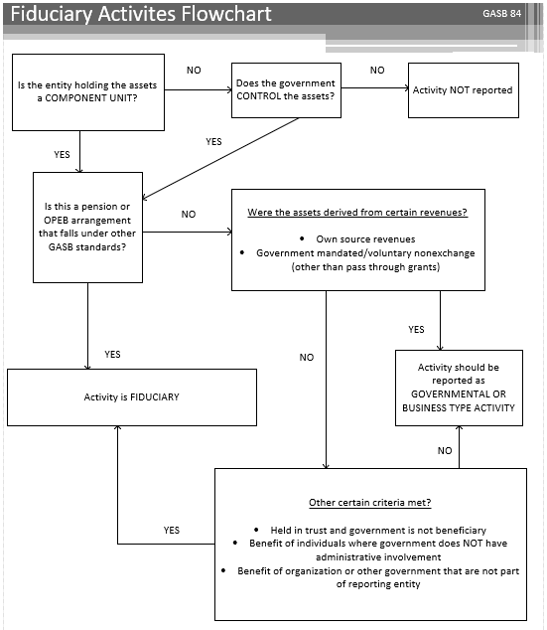

## Aidable/Nonaidable Activities

### Aidable Activities

The instructional process and the learning experience involve more than providing an instructor and a classroom or laboratory. The educational environment includes certain other components to be effective. The following instructional related services are integral components of the educational activities of the Wisconsin Technical College System and, as such, the cost of providing them is aidable with general purpose revenue (state aids):

Career Counseling, Assessment, and Testing which assists students in making career/ educational decisions.

Registration, Financial Aids Administration, Admissions/Outreach, Graduation and Placement Services which assist student entry into and exit from the educational process.

Library and Media Services which support the educational process.

Tutorial Services and Skills Development Centers which increase the student success rate and the effectiveness of the educational process.

Student Life Coordination which provides administrative due process for students, works with and regulates all phases of student life on campus, and regulates student activity expenditures in conformity with state and district policies.

* Health Services which include minimal emergency health and minor nursing services to provide continuity in the educational process and protect the districts against insurance liability.

These instructional related services shall be accounted for in the districts' operational funds to ensure their aidability with state general purpose revenue. Also, a specific user fee may be charged for these services per [s. 38.14(9), Wis. Stats.](https://docs.legis.wisconsin.gov/statutes/statutes/38/14/9)

### Nonaidable Activities

The following student activities and similar student activities are not aidable and may be funded by specific user charges, student activities fees, gate receipts, fund raising, contributions, local tax contributions, and other such sources of income:

Varsity and intramural athletics

Student government

Cultural student activities (non-instructional)

Student newspaper (non-instructional)

Student club activities (non-instructional)

Bookstore

Barber/cosmetology (non-instructional)

Child care (non-instructional)

Food services (non-instructional)

Student housing facilities

Student stores (non-instructional)

Transportation (non-instructional)

* TV, ITFS, and radio (non-instructional)

The debt service, capital, operational expenditures, and revenues related to these non‑aidable activities shall be accounted for in the districts' Enterprise Funds and/or Fiduciary Funds.

# Annual Budget

## Introduction

Each district shall annually prepare a budget document and budget summary in accordance with [s. 65.90, Wis. Stats](http://nxt.legis.state.wi.us/nxt/gateway.dll?f=templates&fn=default.htm&d=stats&jd=65.90)., (municipal budgets) and the rules contained in Administrative Code [TCS 7](http://www.legis.state.wi.us/rsb/code/tcs/tcs007.pdf) as established by the state board under s. 38.04(11)(a), Wis. Stats. Each WTCS district is encouraged to solicit input from the public and concerned groups throughout the budgetary process. By July 1 of each year, districts shall submit the budget document via e‑mail as an attached Word, Excel, or Adobe Acrobat file to the System Office contact.

Prior to adoption of the budget, districts shall hold a public hearing to solicit public input on the proposed budget. This meeting shall be advertised through a Class 1 Legal Notice.

Subsequent to adoption of the budget, all modifications must be approved by at least two-thirds of the full membership of the district board. Any approved modifications must be published as a Class 1 Legal Notice within 10 days of the board action and reported to the System Office as specified in the Budget Modification section. Budget modifications do not require re-issuance of the budget document.

### Organization of Document

The budget document will need to fulfill four basic purposes:

a policy document

a financial plan

an operations guide

* a communications device.

Districts have the flexibility to organize the budget document to meet their needs as long as the required criteria in the Budget Document Format section are met. Districts can use section titles such as Introduction, Financial Data, and Supplemental Data or some other headings if they so desire. For example, the organizational chart might be placed in an Introduction section, a Policy Section, or some other section.

### Legal Requirements for District Budgets

[S. 65.90 stats.](http://nxt.legis.state.wi.us/nxt/gateway.dll?f=templates&fn=default.htm&d=stats&jd=65.90), states "Every municipality shall annually…formulate a budget and hold public hearings thereon…list all existing indebtedness and all anticipated revenue from all sources during the ensuing year and shall likewise list all proposed appropriations for each department, activity and reserve account during the said ensuing year…shall show actual revenues and expenditures for the preceding year, actual revenues and expenditures for not less than the first 6 months of the current year and estimated revenues and expenditures for the balance of the current year…show for informational purposes by fund all anticipated unexpended or unappropriated balances, and surpluses…summary of the budget required under sub. (1) and notice of the place where the budget in detail is available for public inspection and notice of the time and place for holding the public hearing thereon shall be published as a Class 1 notice, under [s. 985 stats](http://legis.wisconsin.gov/statutes/Stat0985.pdf)., in the municipality at least 15 days prior to the time of the public hearing…shall include all of the following for the proposed budget and the budget in effect, and shall also include the percentage change between the budget of the current year and the proposed budget:…general fund, all expenditures…general government, capital outlay, debt service, other financing uses…general fund, all revenues…taxes, intergovernmental revenues, public charges for services, intergovernmental charges, miscellaneous revenue, other financing sources…All beginning and year-end governmental and proprietary fund balances…The contribution of the property tax to each governmental fund and to each proprietary fund that receives property tax revenue and the totals for all funds…Revenue and expenditure totals, by fund, for each governmental fund, and for each proprietary fund and the revenue and expenditure totals for all funds combined…Any budget summary…shall include an itemization of proposed increases and decreases to the current year budget due to new or discontinued activities and functions…the technical college system board under [s. 38.04 stats](http://nxt.legis.state.wi.us/nxt/gateway.dll?f=templates&fn=default.htm&d=stats&jd=38.04)., shall encourage and consult with interested public and private organizations regarding the budget summary information required under pars. (a) and (b)…shall specify the revenue and expenditure detail that is required under par. (b) 1. and 2. for…technical college districts…may publish any additional budget summary information that its governing body considers necessary…shall be reported separately…not less than 15 days…after the publication of the proposed budget and the notice of hearing thereon a public hearing shall be held at the time and place stipulated…amount of tax to be levied or certified, the amounts of the various appropriations and the purposes for such appropriated stated in a budget required under sub. (1) may not be changed unless authorized by a vote of two-thirds of the entire membership of the governing body…shall publish a Class 1 notice thereof, under [s. 985 stats](http://legis.wisconsin.gov/statutes/Stat0985.pdf)., within 10 days after any change is made. Failure to give notice shall preclude any changes in the proposed budget and alterations thereto made."

[S. 38.04(11) stats](http://nxt.legis.state.wi.us/nxt/gateway.dll?f=templates&fn=default.htm&d=stats&jd=38.04(11))., states "The board shall establish uniform reporting methods for fiscal…information which shall be provided by the district boards as the board deems necessary and shall require common use of the fiscal year for operations and data reporting…shall establish, by rule, uniform formats and reporting standards for…budgets approved by district boards under [s. 38.12(5m)](http://nxt.legis.state.wi.us/nxt/gateway.dll?f=templates&fn=default.htm&d=stats&jd=38.12(5m))…promulgate rules governing the financing of capital expenditure under [s. 38.15](http://nxt.legis.state.wi.us/nxt/gateway.dll?f=templates&fn=default.htm&d=stats&jd=38.15) , and the management of reserve funds…prescribe a detailed uniform financial fund accounting system, applicable to all district boards, which provides for the recording of all financial transactions inherent in the management of the districts and the administration of the district aid program."

[S. 38.12(5m) stats](http://nxt.legis.state.wi.us/nxt/gateway.dll?f=templates&fn=default.htm&d=stats&jd=38.12(5m))., states "The district board shall prepare its annual budget in compliance with rules promulgated by the board under [s. 38.04(11)(a)](http://nxt.legis.state.wi.us/nxt/gateway.dll?f=templates&fn=default.htm&d=stats&jd=38.04(11)). The district board shall submit an approved copy of its budget to the board by July 1 of each year and shall report any subsequent budget modification to the board within 30 days of approval of the modification by the district board."

[S. 38.16 stats](http://nxt.legis.state.wi.us/nxt/gateway.dll?f=templates&fn=default.htm&d=stats&jd=38.16)., District tax levy (1) states "Annually by October 31, or within 10 days after receipt of the equalized valuations from the department of revenue, whichever is later, the district board may levy a tax on the full value of the taxable property of the district for the purpose of making capital improvements, acquiring equipment, operating and maintaining the schools of the district, and paying principal and interest on valid bonds or notes now or hereafter outstanding as provided in [s. 67.035](http://nxt.legis.state.wi.us/nxt/gateway.dll?f=templates&fn=default.htm&d=stats&jd=67.035). The district board secretary shall file with the clerk of each city, village and town, any part of which is located in the district, a certified statement showing the amount of the levy and the proportionate amount of the tax to be spread upon the tax rolls for collection in each city, village and town. Such proportion shall be ascertained on the basis of the ratio of full value of the taxable property of that part of the city, village or town located in the district to the full value of all taxable property in the district, as certified to the district board secretary by the department of revenue…(2) The district board may borrow money and levy taxes to be used for the purchase or construction of buildings and for additions, enlargements and improvements to buildings and for the acquisition of sites and equipment…may issue its bonds or promissory notes under [ch 67](http://legis.wisconsin.gov/statutes/Stat0067.pdf) to pay the cost thereof."

### Designated for Subsequent Year

When developing the budget for the forthcoming year, the anticipated year-end balance of the Designated for Subsequent Year classification shall be utilized as a funding source for the budget year. For example, when developing the 2020-21 budget the total anticipated 2019-20 year-end Designated for Subsequent Year balance must be budgeted to fund 2020-21 operations.

### Budget Contact

Questions regarding the budget document, budget summary and budget modifications should be directed to:

Michelle Rudman

Wisconsin Technical College System

4622 University Avenue

P.O. Box 7874

Madison, Wisconsin 53707-7874

(608) 266‑1433

[michelle.rudman@wtcsystem.edu](mailto:michelle.rudman@wtcsystem.edu)

## Budget Document Format

### Budget Document Criteria

There are four basic purposes that need to be considered when preparing the budget document. They are:

Policy Document: As a policy document, the budget tells the story behind the numbers by articulating budget priorities and goals, links past and future budget activities to the present budget, and discloses the assumptions upon which budgetary decisions and estimates have been made.

Financial Plan: As a financial plan, the budget presents a consolidated budget summary, cross-classifies financial data, and presents information on revenues, expenditures, indebtedness, capital spending, and other sources and uses.

Operations Guide: As an operations guide, the budget allocates resources amongst departments and programs, establishes performance objectives and measures, and reports prior year operating results and accomplishments.

* Communications Device: As a communications device, the budget describes a district's organizational structure and staffing, explains a district's financial structure and budget process, and highlights the demographics, economic, and cultural features of the community served by the district.

### Policy Document Section

The policy document section of the budget document includes the following items:

#### Required Items:

###### Table of Contents

###### Transmittal Letter

Must be signed by a district board member. If the president's message is part of the transmittal letter, the president must also sign the transmittal letter.

###### Management Discussion and Analysis

This statement can take many forms. It may be part of the transmittal letter. Included under this criteria are the following:

Vision Statement

Mission Statement

If the district has a statutory mission statement that is different from the mission statement, the district has the option of including the statutory mission statement in the budget document also (being sure to properly label the statement).

Goals and Objectives

Districtwide long-term and short-term goals and objectives

Budget Process

A description of the district's budgetary process needs to be included. Consider the following items to include in the description: budget timetable, budget process steps, planning guidelines, planning assumptions, and budget modification process.

Current Environment

A description of issues, challenges, priorities, major changes, trends, etc., that have an impact on the current year and the new budget year.

Accomplishments for the Current Year

Position Summary – FTE Basis

A districtwide staff position summary schedule is required. The position summary is to include, at a minimum, the number of staff FTE positions detailed by category and by year.

* Categories – FTE numbers for the following categories. Additional breakdowns within these categories are optional.
* Administrators/Supervisors
* Faculty
* Other Staff
* FTEs - position counts are to be on an FTE (full-time equivalency) basis, not a headcount basis.
* Prior year totals by category on an actual basis.
* Current year totals by category on an actual year-to-date basis.
* Budget year totals by category and detailed by fund and category.
* Footnote: Footnote should include what positions are or are not included in the position counts shown on this summary. For example, districts may or may not choose to include part-time instructors, temporary staff or students. Data should be presented on a consistent basis for all years.

#### Supplemental Items:

Cover Page: Included in the cover page are:

List of Board Members

College Administration

Identification of who prepared the budget

Footnote: The footnote would include who to contact (including phone number) to get additional information regarding the budget document.

President's Message

This may be included as part of the transmittal letter or in place of the transmittal letter. This is to be signed by the district president.

WTCS State Map

District Map

Organizational Chart

Financial Policies

Include a brief description of some of the district's financial policies. These may include, but not be limited to, cash management, investment management, risk management, debt structure, capital / capital assets, fund balance targets, audit, and internal control.

Programmatic Policies

Include a brief description of some of the district's programmatic policies. These may include, but not be limited to, criteria for starting and ending programs and monitoring of programs.

District Profile

This includes identification of your campus locations and any other pertinent information you deem necessary to provide. This may be placed elsewhere.

Position Summary

Budget Year Total broken down by fund

Prior Year(s) Actual Totals. Number of years actual shown are up to the district.

Other Information

### Financial Plan Section

The financial plan section of the budget document includes the following:

#### Required Items:

###### Pro Forma Balance Sheet

Make sure document is entitled "Pro Forma Balance Sheet." Note: Reserve for encumbrances are not to be included on these balance sheets.

Beginning of the budget year: This is required. It is recommended that districts add a prior year memo total to the balance sheet.

* End of the budget year: This is recommended. It is recommended that districts add a prior year memo total to the balance sheet.

###### Budgetary Statements of Resources, Uses and Changes in Fund Balance

###### Budgetary Expenditures by Object Level

This schedule details budgeted expenditure amounts for each fund at the object level:

Personal Services

Salaries and Wages

Fringe Benefits

Current Expenditures

Capital Outlay

Debt Service

Total Budgeted Expenditures

On the schedule, the object levels are the line titles and the fund types are the column headings.

###### Long-Term Obligation Schedules

Schedule of Long-Term Obligations –

This schedule shall be ordered by issue date with the oldest first. The required detail for each indebtedness is as follows:

* Type of indebtedness.
* Original amount of indebtedness.
* Date of issuance (month and year).
* Holder of indebtedness with the exception of bond holders. If the holder has changed, the original holder must also be identified.
* Purpose for which the indebtedness was issued.

The outstanding total principal for the issuance. Districts may also include detail by year.

Combined Schedule of Long-Term Obligations - A combined repayment schedule by year for the first 5 years and in 5 year blocks after the first 5 years detailing principal, interest, and total amount still to be paid.

###### Combined Fund Summary

###### Description of Funds

###### Revenue sources and description

This is a narrative description of what is included in the major categories of revenues.

###### Expenditure Sources and Description

This is a narrative description of what is included in the major categories of expenditures.

###### Legal Debt Limitations

Include a description of the legal debt limit as well as showing the calculation for the district's compliance with the limit. Refer to the sample schedule for the specific language to be used and the types of debt subject to each limitation.

###### Capital Equipment / Projects Summary

Include a summary of the district's capital projects and equipment summary. For construction or remodeling projects where additional square footage or major efficiencies are projected to occur, an estimate of the impact to the operating budget is recommended to be included. For example, if you are adding a new wing, you will have additional utility bills, cleaning services / staff, possibly additional staffing levels. These will have an impact on the operating budget. These costs need to be quantified.

###### Combining Fund Summary

This fund summary shows the budgeted year fund summaries side by side.

###### Basis of Budgeting

This is a narrative description identifying the accounting basis used to prepare the budget.

#### Supplemental Items:

Other information: Districts may include additional information as desired, i.e., historical trend / comparison information.

### Operations Guide Section

The operations guide section of the budget document includes the following:

#### Supplemental Items:

###### Organizational unit activities / functions

Briefly describe the functions or activities performed by the various organizational units within your district. The district would determine what an organizational unit would be based upon their organizational structure.

###### Organizational Unit Organizational Charts

###### Organizational Unit Short-Term and Long-Term Goals and Objectives

###### Organizational Unit Staff Position Summary

###### Organizational Unit Budget Summaries

###### Performance Measurements / Outcomes / Indicators of Success

This should be shown in tabular form showing prior year(s) actual, current year estimate, and next year's projection. Suggested information to be shown would include, but not be limited to: cost per FTE, placement rates, starting salary, number of programs reviewed, NCA accreditation, number of 38.14 contracts, number of repeat contracts, number of students graduating, percent of enrollment, percent of enrollment vs. percent of general population, EEOC data, number of invoices paid on time, number of students completing programs, minority purchases.

### Communications Device Section

Many of these criteria pertain to the document as a whole rather than to a particular section of the document. Some of these global criteria include:

User-friendly formatting and layout of pages

Use of white spaces on pages

Consistency of layout

Use of tables, graphs, and charts

#### Required Items:

###### Statistical Section

Equalized Valuation

Five years of information are required, additional years are optional.

###### Enrollment headcount and FTE

###### Five years of information are required, additional years are optional.

###### Mill rates (operational and debt)

###### Five years of information are required, additional years are recommended.

###### List of programs

###### District profile (list of campuses)

This may be included in a different section of the document.

#### Supplemental Items:

###### Glossary

Common terms or acronyms should be identified here.

###### Other planning process

This would include strategic planning, capital improvement, etc. Some of this is already included under the policy section criteria with the inclusion of the mission and vision statements as well as long and short-term goals and objectives.

###### Statistical Information

Property valuation by jurisdiction

Largest taxpayers

Tax levy and rates

District population

Number of high school graduates

Tuition rates

Overlapping Debt

Overlapping Mill Rate

Other statistical / demographic information

### Description of Functional Units

#### Expenditures

The Wisconsin Technical College System Board requires each technical college to classify expenditures by function to provide activity detail of our primary activity--instruction. The following is a listing and description of the expenditure functions used by Dairyland.

###### Instruction

This function includes teaching, academic administration, including clerical support, and other activities related directly to the teaching of students, guiding the students in the educational program, and coordination and improvement of teaching.

###### Instructional Resources

This function includes all learning resource activities such as the library and audio-visual aids center, learning resource center, instructional media center, instructional resources administration, and clerical support.

###### Student Services

This function includes those non-instructional services provided for the student body such as student recruitment; student services administration and clerical support; admissions; registration; counseling, including testing and evaluation; health services; financial aids; placement; and follow up. Non-instructional athletics such as varsity and intramural athletics are also included.

###### General Institution

This function also includes all services benefiting the entire college, exclusive of those chargeable directly to other functional categories. Examples of this type of expenditure are legal fees, external audit fees, general liability insurance, non-resident tuition, interest on operational borrowing, and public information. General personnel, employment relations, and affirmative action programs are included in this function.

###### Physical Plant

This function includes all services required for the operation and maintenance of the physical facilities. Principal and interest on long-term obligations are included under this function as are the general utilities such as heat, light, and power.

###### Auxiliary Services

This function includes commercial-type activities such as the bookstore and child-parent center.

#### Revenues

Dairyland Technical College has a diversified funding base composed of property taxes, state aid, student fees, federal grants, and institutionally-generated revenues. Dairyland believes that this diversity, the strength of the local economy, and its fiscal management will continue to provide the resources required to fulfill its mission now and in the future without significant changes in the level of services provided.

###### Property Taxes

Dairyland's major revenue source is local property taxes. Annually, in October, the property tax levy is billed based upon the equalized value of taxable property, excluding tax incremental financing districts, to the local municipalities who act as assessors and collection agencies. All delinquencies are assumed by the respective counties, thus Dairyland will receive the full amount of its levy. All Wisconsin technical colleges must set an operating property mill rate that does not increase the revenue for the district by a percentage that exceeds the district’s valuation factor. The debt service mill rate is added to the operational mill rate to get a total mill rate amount.

###### State Aids

State aids are provided by the Wisconsin Technical College System (WTCS). State aid is calculated based upon an expenditure-driven formula equalized for tax-leveling ability. The basic formula is as follows:

[(Total general and special revenue fund expenditures - all non-property tax or interest income revenue) + debt service expenditures] * (state average of taxable property per full-time equivalent student / Dairyland taxable property per full-time equivalent student)]

###### Student Fees

Statutory and other fees are collected from students. Program fee, material fee and out-of-state tuition rates are set annually by the WTCS based upon estimated total operating expenditures of all districts. Examples of other fees include, community service course fees, group dynamics course fees, testing fees, application fees, and graduation fees.

###### Institutional Revenue

These revenues are generated by business and industry contracts (38.14 contracts) for customized instruction and technical assistance, technical preparation contracts (tech prep, 118.15 slotter contracts), interest or investment earnings, and enterprise activities.

###### Federal Grants

Dairyland receives federal grants for specific projects and student financial assistance such as Adult Basic Education, Pell, Federal Work Study, Federal Family Evaluation Loan Program, and Division of Vocational Rehabilitation.

###### State Grants

Dairyland receives various state grants for specific projects such as Displaced Homemakers, Youth Apprenticeship, and Incentive Grants.

### Basis of Accounting

Basis of accounting refers to when revenues and expenditures or expenses are recognized in the accounts and reported in the financial statements. Basis of accounting relates to the timing of the measurement made, regardless of the measurement focus applied.

The governmental and fiduciary funds are accounted for on a modified accrual basis. Under the modified accrual basis of accounting, transactions are recorded in the following manner:

1. Revenues are recognized when they become both measurable and available (susceptible to accrual). All revenues are considered susceptible to accrual. Summer session tuition and fees are prorated between the fiscal years covered by the summer session, based on the number of days of the session that fall in each fiscal year. For debt service, property taxes levied to make principal and interest payments with due dates within the fiscal year are revenue. Any debt service property taxes levied to make principal and interest payments with due dates outside the fiscal year are deferred revenue.
2. Expenditures are recognized when the liability is incurred, except for interest and principal on general long-term obligation debt, which are recognized as expenditures when due. Expenditures for claims and judgments are recognized when it becomes probable that an asset has been impaired or a liability has been incurred.
3. Expenditures for compensated absences, including vacation and sick leave, are recognized when the liability is incurred for past services of an employee that vest and accumulate.
4. Capital assets are recorded as capital outlays at the time of purchase.
5. Proceeds of long-term obligations are treated as a financing source when received.

The proprietary funds are accounted for on an accrual basis, whereby revenues are recognized when measurable and earned and expenses are recorded as liabilities when incurred and, where applicable, depreciation expense is also included.

The Governmental Accounting Standards Board (GASB) Statement No. 20 "Accounting and Financial Reporting for Proprietary Funds and Other Governmental Entities that Use Proprietary Fund Accounting" provides that proprietary funds may apply all GASB pronouncements as well as the following pronouncements issued on or before November 30, 1989, unless those pronouncements conflict with or contradict GASB pronouncements: Statements and interpretations of the Financial Accounting Standards Board (FASB), Accounting Principles Board (APB) opinions, and Accounting Research Bulletins (ARBs) on the Committee on Accounting Procedure. Dairyland has elected to apply only FASB, APB, and ARB materials issued on or before November 30, 1989.

### Basis of Budgeting

Dairyland adopts an annual operating budget which is prepared on substantially the same basis as the financial statements, which are prepared in accordance with GAAP, except budgetary expenditures include encumbrances and budgetary revenues include all summer session tuition and fees for the summer session ending in the fiscal year and property taxes levied for the fiscal year.

## Sample Statements and Schedules

The following sample statements and schedules illustrate the formatting requirements previously presented in this section. The amounts presented are not necessarily consistent between schedules nor are they intended to portray any actual district's operations.

Pro-Forma Balance Sheet

### Budgetary Statements of Resources, Uses and Changes in Fund Balance

The following seven pages contain examples of the Budgetary Statement of Resources, Uses and Changes in Fund Balance. There is a separate example for each fund.

#### General Fund

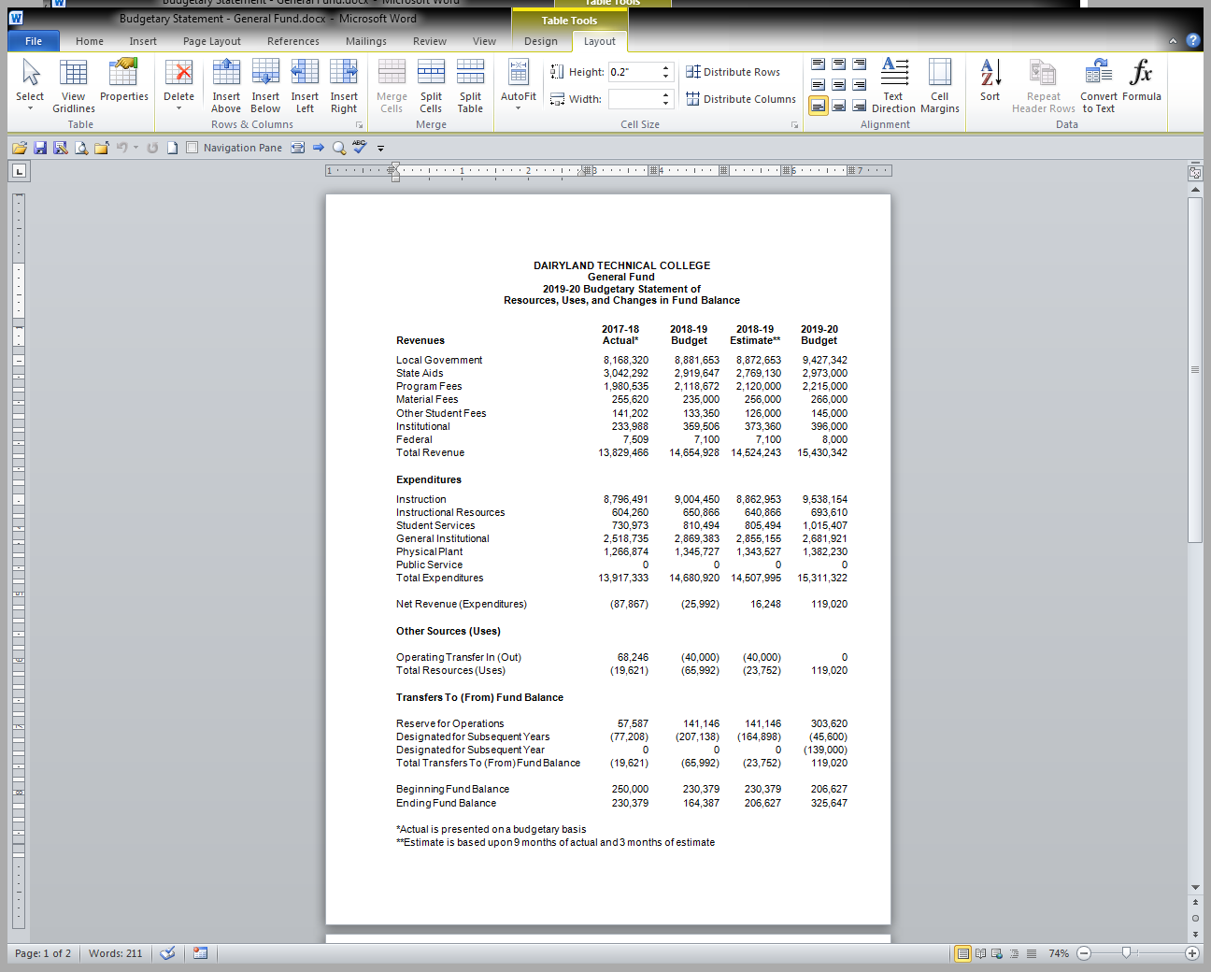

#### Special Revenue Fund

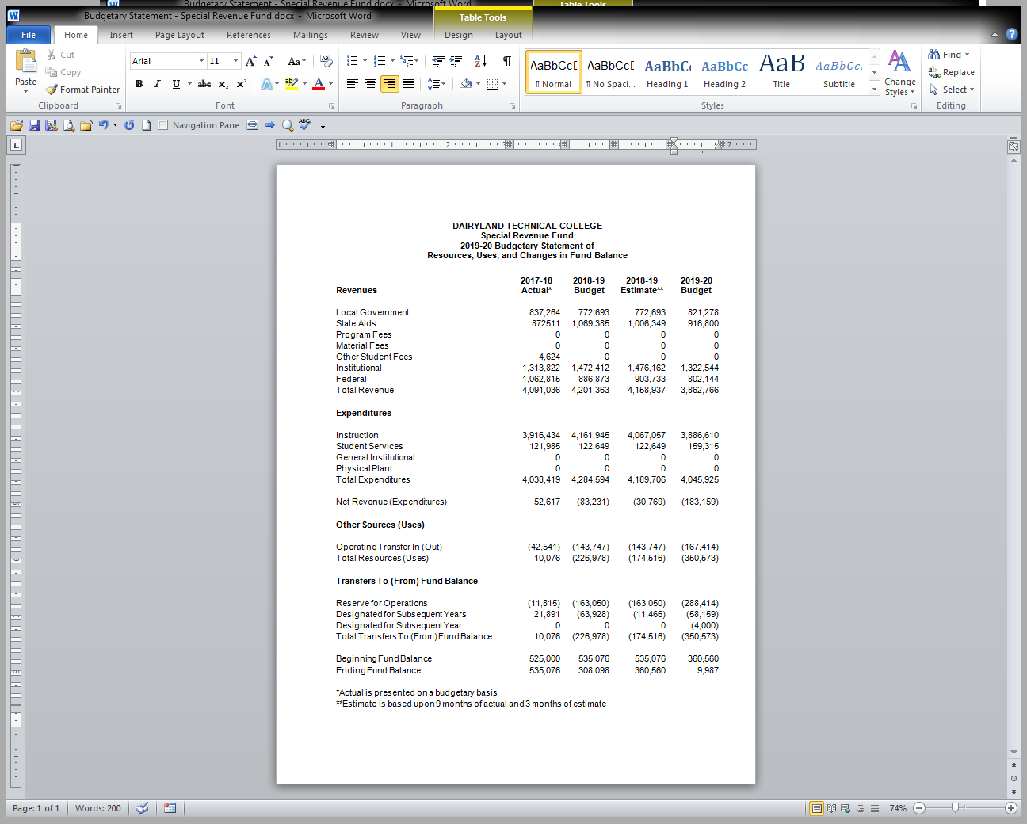

#### Capital Projects Fund

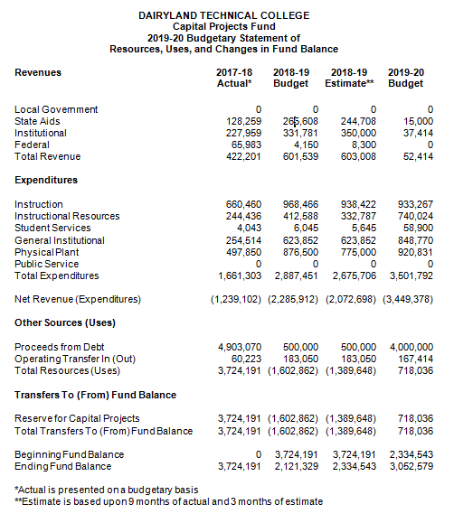

#### Debt Service Fund

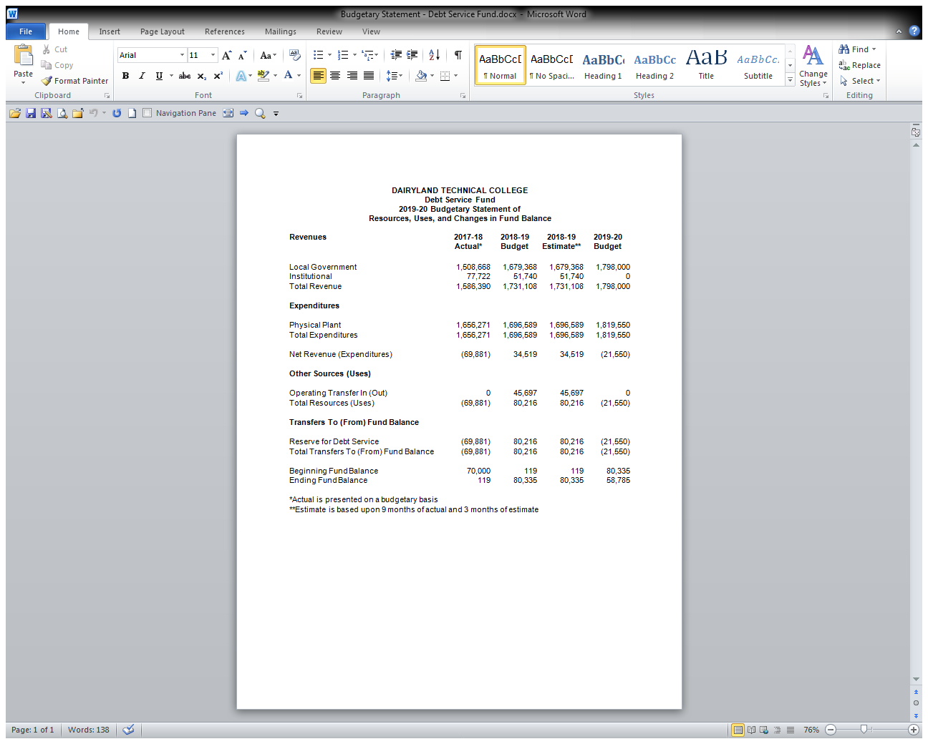

#### Enterprise Fund

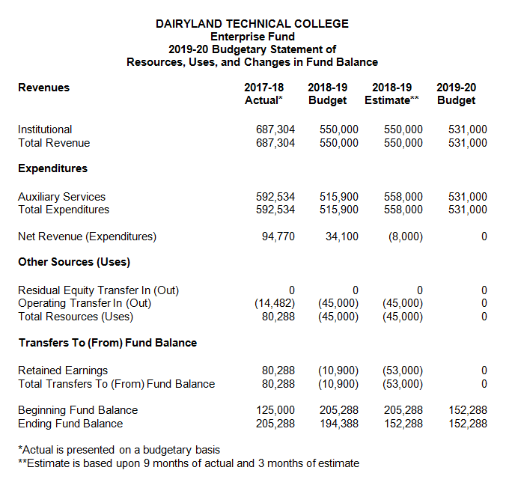

#### Internal Service Fund

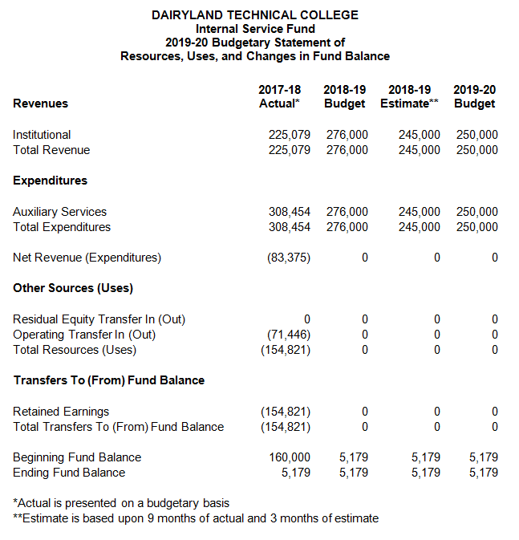

Fiduciary Fund 

### Budgetary Expenditures by Object Level

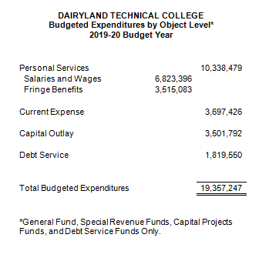



### Position Summary – FTE Basis

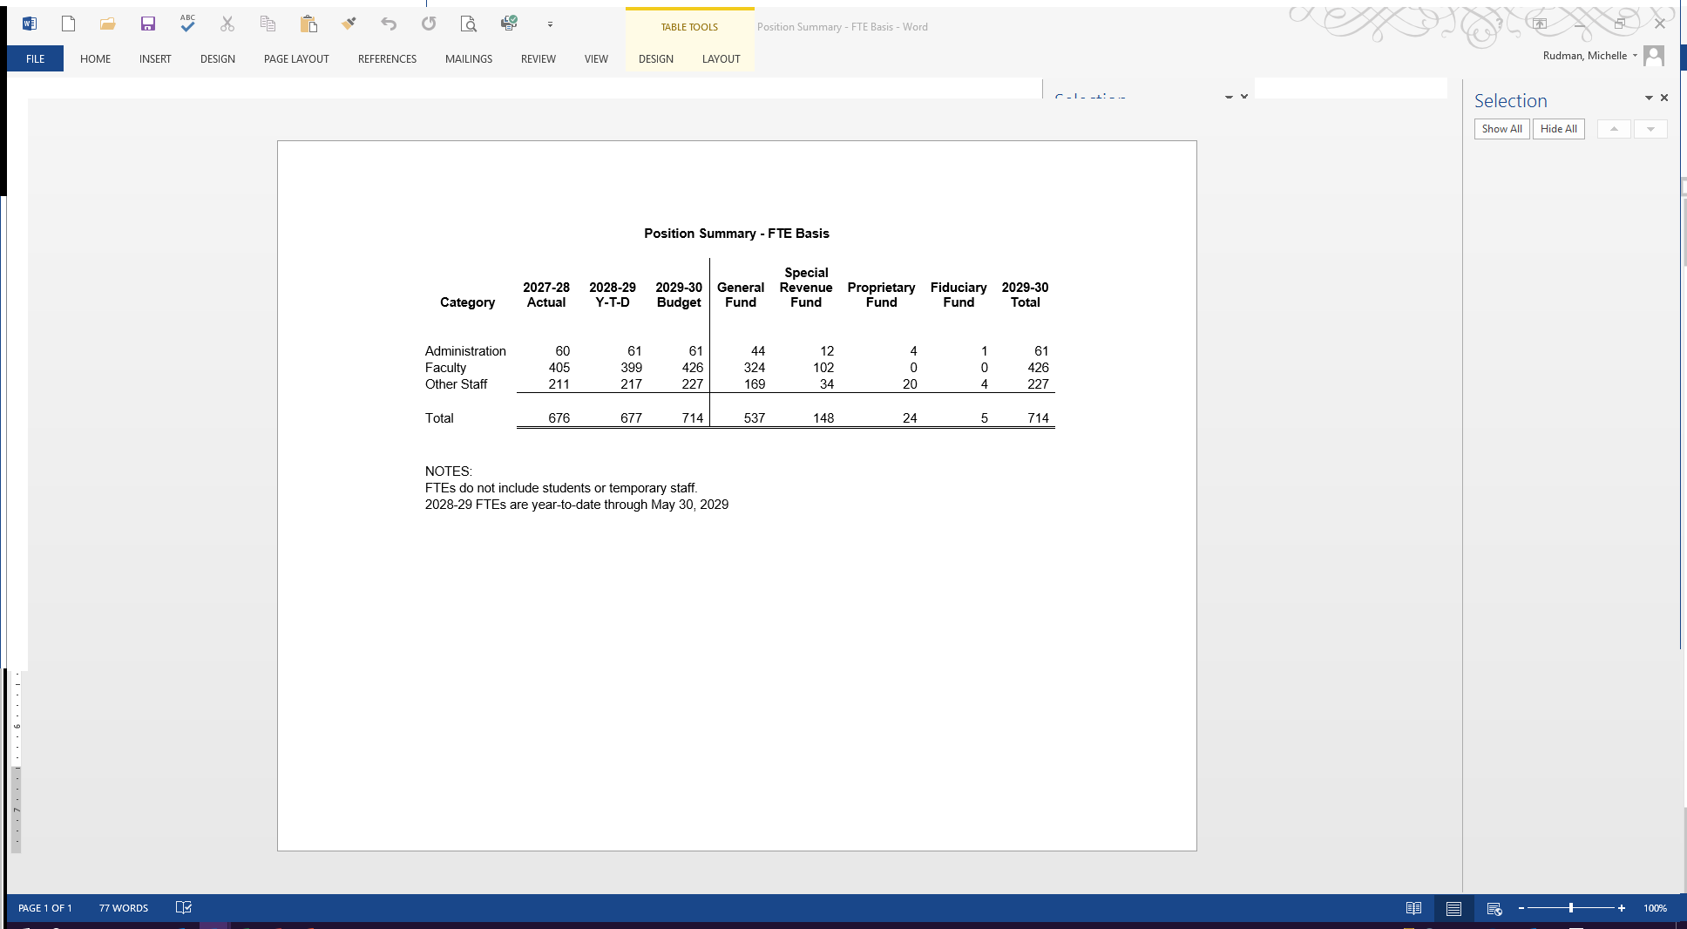

### Combined Fund Summary

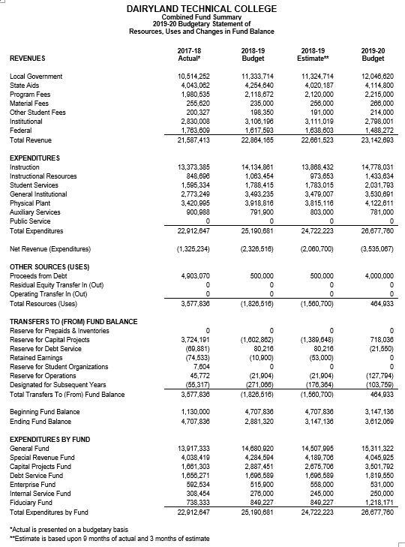

### Equalized Valuations & Mill Rates



### Legal Debt Limitations

**Dairyland Technical College**

**Legal Debt Limitations**

**2019-20 Budget Year**

State statutes impose two debt limitations on WTCS districts’ debt. The following computations are based on the aggregate debt budgeted to be outstanding as of June 30, 2020 net of resources available to fund principal and interest payments.

The aggregate indebtedness of the district may not exceed 5% of the equalized value of the taxable property located in the district per [s. 67.03(1)](http://docs.legis.wi.gov/statutes/statutes/67/03), Wis. Stats. This limitation applies to indebtedness for all purposes - bonds, promissory notes and capital leases, including taxable and nontaxable borrowings. It also applies to WRS prior service liability refinanced with the proceeds of promissory notes or bonds. The maximum aggregate indebtedness of the district budgeted for FY 2019-20 is $12,000,000. The 5% limit is $156,682,064.

The bonded indebtedness of the district may not exceed 2% of the equalized value of the property located in the district per [s. 67.03 (9)](http://docs.legis.wi.gov/statutes/statutes/67/03), Wis. Stats. This limitation applies to bonded indebtedness for the purchase of district sites, the construction and remodeling of district facilities and the equipping of district facilities. The key word is “bonded”, only include bonded indebtedness issued under s. 67.05, Wis. Stats. The maximum bonded indebtedness of the district budgeted for FY 2019-20 is $5,000,000. The 2% limit is $62,672,826.

**Budget Adoption**

**Legal Notice**

Prior to the district board's adoption of the budget, the district must hold at least one public hearing on the budget document. At least 15 days prior to each public hearing, the district shall publish a Class 1 Legal Notice (per Ch. 985 of the state statutes) which contains the budget summary, the time and place of the public hearing, and the location where the budget document is available for inspection.

The Class 1 Legal Notice provides basic financial data to the district taxpayers and indicates when the public hearing on the budget will be held. The notice shall contain the following sections:

Notice of Public Hearing

A notice of when and where a public hearing on the proposed budget will be held. It must also indicate where detailed budget information is available.

Property Tax and Expenditure History

For the budget year and each of the four preceding years, the following information shall be provided:

Mill Rate History

Column 1 Equalized valuation with TIF's excluded

Column 2 The operational mill rate. This represents the mill rate for all funds other than the debt service.

Column 3 The debt service mill rate.

Column 4 Total mill rate (operational mill rate plus debt service mill rate).

Column 5 Percentage increase / (decrease) to the total mill rate from the previous year.

Expenditure History

Column 1 Total expenditures for all funds.

Column 2 Percentage increase / (decrease) to expenditures from the previous year.

Property Tax History

Column 3 Total tax levy.

Column 4 Percentage increase / (decrease) to total tax levy from the previous year.

Column 5 Tax on property valued at $100,000 computed as the total mill rate times $100,000.

Source of Funds

The Combined Budget Summary document will be included with the legal notice. This will be page 2 of the notice.

**Budget Adoption**

Subsequent to the public hearing(s), the district board shall adopt the budget, making any modifications it deems necessary in light of the input from the public hearing(s). The budgetary process must be structured so that the board can adopt the budget and submit the approved budget to the System Office prior to July 1 as required by [s. 38.12(5m) stats](https://docs.legis.wisconsin.gov/statutes/statutes/38/12/5m).

### Notice of Public Hearing p. 1



### Notice of Public Hearing p. 2

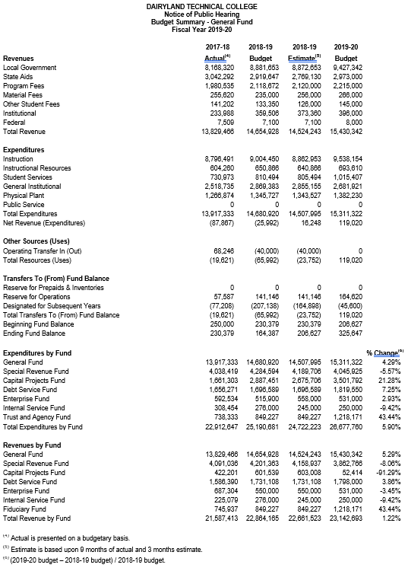

## General Requirements

### Appropriations/Expenditures

Adoption of a budget by fund type and function within a fund type shall constitute the appropriations of the district under [s. 65.90](http://nxt.legis.state.wi.us/nxt/gateway.dll?f=templates&fn=default.htm&d=stats&jd=65.90), Stats. [S. 66.0607(7)](http://docs.legis.wisconsin.gov/statutes/statutes/66/VI/0607), Stats. specifies that “No order may be issued by a …. technical college district clerk in excess of funds available or appropriated for the purposes for which the order is drawn, unless authorized by a resolution adopted by the affirmative vote of two-thirds of the entire membership of the governing body. Therefore, district expenditures by function within a fund type shall not to exceed amounts budgeted in the original adopted budget or the budget as modified per s. 65.90 (5), Stats.

### Contingencies

The district board may budget specific line item contingency sums, provided that the appropriation is transferred to the proper function and classification prior to the disbursement of such sums. However, reserves / designations for contingencies shall not be created.

### Reservations / Designations

Prior to adopting the annual budget, the district board shall adopt resolutions creating any new reserves and designations of fund balance. These resolutions shall state the specific purpose, set a maximum amount, and specify the authorized period of time. Subsequent adopting resolutions during the authorized period of time are not required unless the purpose, amount, or period is changed. Only those reserves and designations specified in the Fund Equity section of this manual may be created.

### Tax Levy

Tax levy is composed of operating levy and debt levy. The operating levy is the total levy for all funds other than Debt Service Funds. The debt levy is that portion of the total levy established to finance Debt Service Funds.

Tax levies are expressed as mill rates. A mill rate is the number of mills per thousand dollars of equalized valuation computed to five (5) decimal places. For example, a tax levy of $1,486,342 on an equalized valuation of $1,000,000,000 results in a mill rate of 1.48634 (levy ÷ equalized valuation x 1,000 rounded to five decimal places). Separate mill rates are computed for the operating levy and the debt levy.

## Budget Modification

### Budget Modification

Any modification to an adopted budget by fund type or function within a fund type is required by s. 65.90 (5), Stats., to be approved by the district board. At least two-thirds of the full district board membership must vote in favor of the modification for it to be valid. Such modification must be made prior to the disbursement of funds for goods or services not previously authorized by an appropriation of the district board. Also, this statute requires that such budget revisions be published as a Class 1 notice within 10 days of district board action to be valid.

#### System Office Reporting

[S. 38.12 (5m)](https://docs.legis.wisconsin.gov/statutes/statutes/38/12/5m) requires districts to notify the System Office within 30 days of district board approval of a budget modification. Notification to the System Office shall be in the form of Word, Excel, or Adobe Acrobat files submitted via email to the System Office budget contact.

District - Enter name of district.

Fiscal Year - Enter fiscal year of the budget being modified.

Fund - Enter the Fund Type being modified. See the Fund Type/Account Group of this manual for the seven fund types.

Current Budget - This column reports the budget prior to the modification being reported. Under "adopted" in the heading, enter the date this budget was adopted. On the appropriate resources and uses lines, enter the budget amounts prior to the current modification.

Modified Budget - This column reports the budget as modified. Under "adopted" in the heading, enter the date this modification was adopted. On the appropriate resources and uses lines, enter the budget amounts subsequent to the current modification.

Change - This column reports the difference between the current and modified columns. The amounts are computed by subtracting the current column from the modified column. The total change in the resources section must equal the total change in the uses section. Also, modifications to the Transfers from Reserves and Designated Fund Balances lines in the Resources and Uses sections are to be detailed by specific fund balance titles in footnotes as indicated on the standard report format.

#### Budget Modification (Sample)

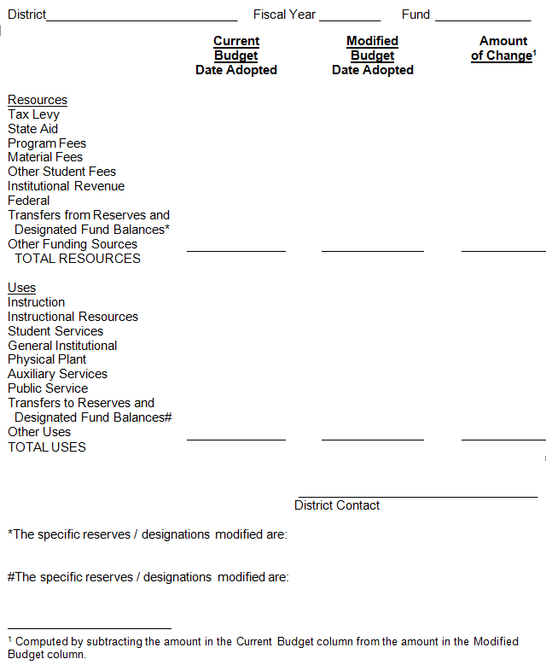

# The Financial and Single Audit

## Financial Audits

### Purpose and Description

This section establishes standards for minimum format and content for technical college districts' audited financial reports and guidelines for additional information that may be presented in audited financial reports. These reports are important sources of financial information to the district board, taxpayers, bond investors, the Wisconsin Technical College System Board (WTCSB), the System Office and other system and federal government agencies. It is important that these reports present sufficient and reliable data so that meaningful evaluations and proper financial decisions can result. What may be construed as immaterial in the audit of a non‑governmental entity may be material in a governmental unit in light of the public interest involved.

It should be noted that this section is not intended to replace the independent auditor's professional judgment, but it is intended to support and complement it. Generally Accepted Accounting Principles (GAAP) and Generally Accepted Auditing Standards (GAAS) shall apply to these audits. Standards applicable to system and local governments apply to the Wisconsin Technical College System (WTCS). These standards and regulatory guidance include federal Office of Management and Budget (OMB) Uniform Administrative Requirements, Cost Principles, and Audit Requirements for Federal Awards (Uniform Guidance). Other promulgated standards applicable to the districts include the AICPA (Audit and Accounting Guide, Audits of System and Local Governmental Units), Governmental Auditing Standards (GAS), Governmental Accounting and Financial Reporting Standards (GASB), and the system Single Audit Guidelines.

### Audit Contact

Any questions which arise during the audit concerning the requirements of this section may be referred to:

Michelle Rudman

Wisconsin Technical College System

4622 University Avenue

P.O. Box 7874

Madison, Wisconsin 53707-7874

(608) 266‑1433

[michelle.rudman@wtcsystem.edu](mailto:michelle.rudman@wtcsystem.edu)

### Major Accounting Policies

The Wisconsin Technical College System has published the Financial & Administrative Manual (FAM), which includes this section. The UFFAS section of the FAM describes the basic accounting principles, required fund types and chart of accounts. The auditor should become familiar with the entire manual.

### Procurement of Audit Services

Requests for Proposals (RFPs) of audit services shall be conducted by districts in accordance with the procurement procedures outlined in Procurement section of this manual and shall follow the procurement standards prescribed by 34 CFR, ¶ 80.36 (7-1-00 Edition). In the event of conflicting procurement standards, the more restrictive procedures will apply. The procurement of audit services is to be competitive and contracts, including any contract extensions, may not exceed five years. Extension of audit contracts beyond five years without competitive procurement is prohibited. The RFP shall identify any specific audit areas over and above those normally required by financial audits and single audits. These may include procurement, travel, staff salary allocation, personnel or other areas, as determined by the district board. The RFP for these specific audit emphasis areas shall detail the scope of the audit work to be performed. It is recommended that the RFP include minimum sample sizes for single audit program clusters, to ensure adequate audit coverage.

### The Audit

For effective fiscal controls and to comply with [s. 38.12(5)](http://docs.legis.wi.gov/statutes/statutes/38/12), Wis. Stats., and the Single Audit Act of 1984, an annual audit of the district's accounting records and financial statements must be performed. In accordance with [s. 38.12(5)](http://docs.legis.wi.gov/statutes/statutes/38/12), Wis. Stats., the district board is responsible for hiring the auditors. An independent CPA firm is to perform the annual financial and single audit. The audit must be conducted according to generally accepted auditing standards to determine if the district's financial statements present fairly the financial position of the district in accordance with generally accepted accounting principles.

The districts are required to adopt adequate record keeping procedures concerning general capital assets. This includes recording fixed asset procurements at cost or fair estimated value for donated items. Proper maintenance of acquisition and disposal records is required.

The auditor should consider the legal restrictions concerning the district's fiscal operations. This does not require the auditor to express legal opinions or otherwise practice law; it does require the auditor to determine, by suitable audit procedures, whether the district is fiscally operating in accordance with the applicable statutes, administrative rules, and system board policies and Administrative Bulletins. The auditor should obtain the Wisconsin Statutes pertaining to the WTCS from the district's chief financial officer for assistance in this regard.

Stratifying the audit sample(s) to emphasize items with high dollar values is encouraged. However, items of smaller values should not be excluded totally from the sampling process.

Independent auditors are encouraged to support the use of internal auditors by WTCS districts and to use program reviewers' and internal auditors' work to supplement or replace audit tests wherever reasonable.

### Engagement Letters

For every audit, there shall be an engagement letter created by the auditor, and formally acknowledged by the district. The engagement letter should include the following items:

The scope of the audit including a listing of statements on which an opinion is to be issued.

An approximate beginning and completion date. Where feasible, preliminary audit routines should begin before the close of the fiscal year to facilitate compliance with the statutory submission date.

The location where the audit work will take place.

The number of reports to be delivered, to whom, and the date the report is to be delivered (no later than December 31, following the end of the fiscal year). If the district is going to reproduce the audited financial report for distribution, the auditor should include a provision for review of what is reproduced.

The extent to which the auditor is responsible for detecting and disclosing illegal acts, abuse, errors, irregularities, and other similar matters, and the responsibility of the district to disclose known instances of such matters to the auditors.

Terms of compensation, including a provision for possible extended audit procedures not contemplated in the original engagement.

### Representation Letters

The auditor should obtain a letter of representation from the district. The state and local government committee (AICPA) has the following comments and suggestions concerning representation letters from clients:

"Representation letters should be tailored to governmental accounting and financial reporting. They should address the items normally covered in audits of business enterprises, should also include governmental areas, such as the inclusion of all component units, the proper classification of funds and account groups, compliance with budget ordinances, (and) compliance with grant requirements."

In addition, the auditor should review the AICPA Statement on Auditing Standards #19 regarding client representation letters.

### Attorney Letters

Auditors should obtain a copy of the district's legal representation concerning litigation, claims, and judgments. The auditor should review AICPA Statement on Auditing Standards #12 for inquiry letters to legal counsel.

### Auditor's Report

The district is responsible for the content and preparation of appropriate financial statements. The auditor's report must be addressed to the district board or its designated committee. The district board has the responsibility of receiving the findings contained in the audited financial report and management comments. The audited financial report and management comments should be personally presented to the district board or its designated committee by the audit firm so that the members may gain an understanding of their contents.

### Submission Requirements

The audited financial report must be submitted by the auditors to the district in final form prior to December 31 following the end of the fiscal year so that the district can meet the requirement of [s. 38.12(5)](http://docs.legis.wi.gov/statutes/statutes/38/12), Wis. Stats., "The district board shall submit the audited financial report to the Wisconsin Technical College System Board no later than six (6) months following the end of each fiscal year."

The district shall submit the reporting package to the Federal Clearing House as required within 30 days after receipt. State statute requires submission to the System Office by December 31. Submission to the System Office is not to be delayed for district board acceptance of the reports. The Data Collection Form must be signed by the district Chief Financial Officer and the audit firm's auditor in charge of the audit. The Data Collection Form (SF‑SAC) and instructions are located at <http://harvester.census.gov/sac/>.

The Reporting Package shall include:

Financial statements and schedules of federal and state awards.

Auditors report(s) stating an opinion on the financial statements and schedules of federal and state awards, a report on internal control related to the financial statements and major federal and state programs, a report on compliance with laws, regulations, and provisions of grant agreements, identification of each major federal and state program or program cluster, and, where applicable, a schedule of findings and questioned costs.

Corrective action plan addressing each current year audit finding and questioned cost. The plan shall provide the responsible district contact name, the corrective action planned, and the completion time frame. If applicable, a reason why corrective action is not required.

Summary schedule of prior audit findings reporting the status of all prior year findings and questioned costs and the status of all unresolved prior years findings and questioned costs relative to federal and state awards.

Data Collection Form

Auditor’s management letter and/or SAS 114 communication (if issued separately). If neither was received the transmittal is to indicate that neither was received.

### Submission List

Federal Audit Clearinghouse

Electronic submission is required. The complete single audit reporting package is to be uploaded in a single PDF file to <https://harvester.census.gov/facides/(S(ory1p3hswvp434jyswabebdu))/account/login.aspx>.

The Data Collection Form is to indicate the federal agencies that should receive copies of the single audit reporting package:

If they are affected by findings in the single audit report

When the Schedule of Findings and Questioned Costs discloses findings directly related to federal awards provided directly by the agency

* When the Summery Schedule of Prior Audit Findings reports the status of an audit finding related to federal awards provided directly by the agency

DOE eZ-Audit system (if receiving Title IV HEA financial aids)

[www.ezaudit.ed.gov](http://www.ezaudit.ed.gov)

Wisconsin Technical College System Office

Submission is to be via e‑mail to the audit contact in the form of pdf files that are text searchable, unlocked, and unencrypted.  (To ensure that pdf files are unlocked and text-searchable, do not scan a physical copy of the audit report and do not change the default security settings in your pdf creator.) Paper copies are not to be submitted to the System Office.

Other State Agencies

Contact information for other state agencies is available in the State Single Audit Guidelines section of the DOA website at:

<https://doa.wi.gov/Pages/StateFinances/State-Single-Audit-Guidelines.aspx>

Pass through entities will need to obtain the single audit reporting package from the Federal Audit Clearinghouse; however, the management letter is not a required piece of the reporting package, so you should email a copy of it to each pass through entity. Each state and federal agency will resolve questioned costs related to grants it provided to the district.

## The Audited Financial Report (AFR)

The Wisconsin Technical College System has determined that all districts are to be reported as special‑purpose governments engaged only in business-type activities, as allowed by [GASB Statement 35](http://www.gasb.org/cs/BlobServer?blobkey=id&blobnocache=true&blobwhere=1175824062976&blobheader=application%2Fpdf&blobheadername2=Content-Length&blobheadername1=Content-Disposition&blobheadervalue2=156884&blobheadervalue1=filename%3DGASBS_35.pdf&blobcol=urldata&blobtable=MungoBlobs).

#### Contents

1. Table of Contents
2. Transmittal Letter (optional)
3. Management’s Discussion and Analysis – MD&A (required supplementary information)
4. Financial Section

All revenues in this section must be detailed using the categories from section 2 of this manual. All expenditures in the financial section must be detailed by function. No other line titles will be accepted.

* 1. Auditor's Report(s) on the basic financial statements (BFS) and the schedules of federal and state awards.

The audit shall be conducted in accordance with Generally Accepted Government Auditing Standards (GAGAS). The auditors shall determine whether the financial statements of the district are presented fairly in all material respects in conformity with generally accepted accounting principles (GAAP). The auditor shall also determine whether the schedules of federal and state awards are presented fairly in all material respects in relation to the district's financial statements taken as a whole.

The auditor's report(s) may be in the form of either combined or separate reports. They shall state that the audit was conducted in accordance with OMB Uniform Guidance, an opinion (or disclaimer of opinion) as to whether the financial statements are presented fairly in all material respects in conformity with generally accepted accounting principles and an opinion (or disclaimer of opinion) as to whether the schedules of federal and state awards are presented fairly in all material respects in relation to the financial statements taken as a whole.

* 1. Basic Financial Statements
     1. Statement of Net Position
     2. Statement of Revenues, Expenses and Changes in Net Position
     3. Statement of Cash Flows
  2. Notes to the financial statements.
     1. Notes essential for fair presentation contained in Governmental Accounting Standards Board: Codification of Governmental Accounting and Financial Reporting Standards (2300.106).
     2. Computations indicating compliance with the legal debt margins (TIFs included, computers excluded) per s. 67.03(l) and (9), Wis. Stats. These computations are to be based on the aggregate debt outstanding as of June 30, net of resources available to fund principal and interest payments (the amount Restricted for Debt Service on the Statement of Net Position).
        1. The aggregate indebtedness of the district may not exceed 5% of the equalized value of the taxable property located in the district per s. 67.03(1), Wis. Stats. This limitation applies to indebtedness for all purposes - bonds, promissory notes and capital leases, including taxable and nontaxable borrowings. It also applies to WRS prior service liability refinanced with the proceeds of promissory notes or bonds. This note shall include the dollar amount of aggregate indebtedness of the district as of June 30 net of resources available to fund principal and interest payments (the amount Restricted for Debt Service on the Statement of Net Position) and the maximum allowable aggregate indebtedness computed as 5% of the district’s equalized valuation (TIFs included, computers excluded).
        2. The bonded indebtedness of the district may not exceed 2% of the equalized value of the property located in the district per s. 67.03 (9), Wis. Stats. This limitation applies to bonded indebtedness for the purchase of district sites, the construction and remodeling of district facilities and the equipping of district facilities. The key word is “bonded”, only include bonded indebtedness issued under s. 67.05, Wis. Stats. This note shall include the dollar amount of bonded indebtedness of the district as of June 30 net of resources available to fund principal and interest payments (the amount Restricted for Debt Service on the Statement of Net Position) and the maximum allowable bonded indebtedness computed as 2% of the district’s equalized valuation (TIFs included, computers excluded).

SAMPLE LANGUAGE: S. 67.03(1) Wis. Stats. limits general obligation debt of the district to 5% of the equalized value of the taxable property located in XXTC district. As of June 30, 2009, the 5% limitation was $1,395,494,387 and XXTC’s outstanding general obligation debt (net of resources available to pay principal and interest) was $22,830,986. S. 67.03(9) Wis. Stats. limits bonded indebtedness of the district to 2% of the equalized value of the taxable property located in XXTC district. As of June 30, 2009, the 2% limitation was $558,197,755 and XXTC’s outstanding bonded indebtedness (net of resources available to pay principal and interest) was $5,000,000.

* + 1. Computations indicating compliance the mill rate limit per s. 38.16, Wis. Stats.
    2. A Schedule of Long-Term Obligations.

This schedule shall be ordered by issue date with the oldest first. The required detail for each indebtedness is as follows:

* + - 1. Type of indebtedness.
      2. Original amount of indebtedness.
      3. Date of issuance (month and year).
      4. Holder of indebtedness with the exception of bond holders. If the holder has changed, the original holder must also be identified.
      5. Purpose for which the indebtedness was issued.
      6. The outstanding total principal for the issuance. Districts may also include detail by year.
    1. A Combined Schedule of Long-Term Obligations.
       1. The outstanding total principal, total interest and total indebtedness for all indebtedness, detail by year for at least the 5 subsequent years. Amounts for years beyond the 5 subsequent years may be aggregated in 5 year blocks.
  1. Required Supplementary Information
     1. Schedule of Funding Progress
     2. Schedule of Employer Contributions
  2. Supplementary Information
     1. The auditor's report on the supplemental information, including an opinion (or disclaimer of opinion) as to whether the supplemental information is presented fairly in all material respects in relation to the financial statements taken as a whole.
     2. Data required by GASB Statement 10, as amended, and Statements 25 and 27.
     3. Information required by GASB 34 regarding infrastructure assets reported using the modified approach.
     4. Budgetary comparison schedules required by GASB 34. The WTCS requires a budgetary comparison schedule for each fund type for which a budget was adopted. These schedules shall contain the following columns:
        1. The original adopted budget.
        2. The final budget, reflecting all modifications made to the original adopted budget.
        3. Actual inflows, outflows and balances stated on the budgetary basis of the fund.
        4. The variances between the final budget and actual amounts.
  3. Other Supplementary Information (Optional)

The district may elect to include supplemental information which is not required. An auditor’s opinion on this information is optional. Examples include:

* + 1. Combining Statements by fund type - where a district has more than one fund of a given fund type.
    2. Individual fund statements.
    3. Schedules
       1. A Schedule of Resources and Utilizations ‑‑ Fiduciary Funds.
       2. Schedules to present greater detail for information reported in the statements, e.g., additional revenue source detail, expenditure data by object / department, transfers, and inter-fund transactions.

1. Federal and State Assistance Section
   1. Auditor's report on the schedules of federal and state awards, if not included with the auditor's report on the BFS.
   2. Auditor's report(s) on internal control, based on the audit of the BFS and major federal and state financial assistance programs. The auditor shall obtain an understanding of the internal control over federal and state programs sufficient to plan the audit to support a low assessed level of control risk for major programs at the district.
   3. Auditor's report(s) on compliance - This report is to be based on an examination of the BFS, performed in accordance with GAS. In addition to the requirements of GAS, the auditor shall determine whether the district has complied with laws, regulations, and the provisions of contracts or grant agreements that may have a direct and material effect on each major program or program cluster.

The compliance requirements for most federal programs are included in the OMB Compliance Supplement. This Compliance Supplement also includes compliance requirements and suggested audit procedures for the student financial assistance program cluster administered by the Departments of Education and Health and Human Services. This audit guidance is in addition to the Audit Guide (Audits of Student Financial Assistance programs) issued by the Department of Education July 1997. Compliance requirements for most state programs are included in the State Single Audit Guidelines.

* 1. Schedule(s) of Federal and State Awards - Amounts recorded in non-federal and non-state classifications such as program fees, material fees, and sales are to be included. The Federal Family Education Loan Program and programs through the State of Wisconsin Higher Education Aids Board may be presented in the schedules or as footnotes to the schedules.

These schedules or the notes to these schedules are to include the following:

* + 1. A reconciliation of the schedule of federal awards to federal revenue on the Statement of Revenues, Expenses and Changes in Net Position. If federal and state are combined on one schedule, this reconciliation should immediately following the federal section.
    2. A reconciliation of the schedule of state awards to state revenue on the Statement of Revenues, Expenses and Changes in Net Position. If federal and state are combined on one schedule, this reconciliation should immediately following the state section.
    3. A list of subgrants awarded to other entities, detailing the entity, grant program and amount awarded/paid. If no subgrants were made there is to be a statement to that effect.

These reconciliations are to identify amounts by specific lines on the Statement of Revenues, Expenses and Changes in Net Position in the Operation Revenues section and the Nonoperating Revenues section.

* 1. Auditor's report on internal control pertaining to the BFS and major federal and state financial assistance programs (if not combined with the internal control report). This report shall address accounting and administrative controls used in administering major federal and state financial assistance programs.
  2. Auditor's report on compliance with laws, regulations, and the provisions of contracts or grant agreements which could have a direct and material effect on major programs (if not combined with the compliance report pertaining to the BFS).
  3. Schedule of Findings and Questioned Costs - This schedule shall include a summary of the auditor's results. The results shall include the opinion rendered on the financial statements, any disclosed reportable conditions pertaining to the audit of the financial statements and whether they were material weaknesses, non-compliance material to the financial statements, reportable conditions in internal control over major programs and whether they were material weaknesses, the auditor's opinion on compliance with major programs, identification of any major programs, the dollar threshold to identify whether a program was type A or type B, an indication of whether the district qualified as a low risk auditee, and findings reportable under GAS.

The auditor shall report the following as audit findings or questioned cost in the Schedule of Findings and Questioned Costs.

* + 1. Reportable conditions in internal control over major programs. The auditor shall consider the internal control in relationship to the compliance requirements for the major program as contained in the compliance supplement. Reportable conditions which are also individually or cumulatively material weaknesses must be reported.
    2. Material non-compliance with laws, regulations, contracts or grant requirements for major programs. The materiality determination should be made taking into consideration the type of compliance requirement and the audit objective as described in the compliance supplement.
    3. Questions costs discovered during the audit for a major program or cluster in excess of $25,000. To evaluate the materiality of a questioned cost of this amount, the auditor shall include information to provide a perspective for judging the prevalence, magnitude and consequences of the questioned cost.
    4. Known questioned costs discovered during the audit procedures in excess of $25,000 for programs not treated as major programs or clusters.
    5. Known fraud affecting federal and state financial assistance programs.
    6. Prior period findings or questioned costs where audit follow-up discloses that the summary schedule of prior year findings and questioned costs prepared by the district materially misrepresents the status of that finding or questioned cost.

Audit findings and questioned costs must be presented in such detail for the district to adequately prepare and implement a corrective action plan. Also, enough detail must be presented with the finding or questioned cost to allow the System Office, other state agencies and federal agencies as appropriate to conclude a management decision for audit resolution on the finding or questioned cost. The following detail must be provided with each finding and/or questioned cost.

* + - 1. Identification of the specific federal or state program including the Catalog of Federal or State Domestic Assistance Number (CFDA, CSDA) and title, the federal or state award number and year, the federal or state agency name, and the pass-through entity name and project identifier number.
      2. The criteria and specific compliance, internal control, statutory, or regulatory requirement upon which the audit finding or questioned cost is based.
      3. The specific condition found, including evidence to support the finding or questioned cost.
      4. The amount of a questioned cost and how that amount was determined or calculated.
      5. Information that will allow the responsible state or federal agency to make an informed management decision for the corrective action needed. This information should include whether the audit finding or questioned cost is an isolated instance or a systems problem. Additionally, it should be related to the universe and number of cases examined and be quantified for dollar amount.
      6. Recommendations to provide the district with sufficient information to ensure the finding or questioned cost will not be repeated in future fiscal year reports.
      7. A response by the responsible district contact. The response must indicate the corrective action that has been taken or will be taken to resolve the finding or questioned cost, including return of the funding associated with the questioned costs to the grantor agency. If the corrective action plan is not included in this schedule, a separate corrective action plan must be issued by the district and must accompany the financial statements. The corrective action plan must include a time-table for completion to allow the responsible federal or state grantor agency to make an informed management decision.
      8. Each finding or questioned cost shall include a reference number assigned by the auditor to allow easy referencing between fiscal years
  1. Schedule of Prior Year Findings and Questioned Costs - If findings/questioned costs were unresolved as of the issuance of the prior year’s audited financial report, they must be reported in a Schedule of Prior Year Findings and Questioned Costs. For each finding/questioned cost, the schedule is to include the district's corrective action and the auditor's resolution in which the auditor identifies whether or not the finding was resolved. For findings/questioned costs that are resolved, the schedule is to indicate if the funding associated with the questioned cost was returned to the grantor agency or resolved in another manner. If the finding/questioned cost is unresolved, the schedule is to indicate the current status of any finding/questioned cost.
  2. Other Issues Section – This section is required by Chapter 4.11 the State Single Audit Guidelines. These guidelines are available at <https://doa.wi.gov/Pages/StateFinances/State-Single-Audit-Guidelines.aspx>. The following detail is required.
     1. on-going concern - Does the auditor’s report or the notes to the financial statements include disclosure with regard to substantial doubt as to the auditee’s ability to continue as a going concern?
     2. Does the audit report show audit issues (i.e. material non- compliance, non-material noncompliance, questioned costs, material weakness, reportable condition, management letter comment, excess revenue, or excess reserve) related to grants/contracts with funding agencies that require audits to be in accordance with the *State Single Audit Guidelines:*

Department of Health and Family Services Yes/No/NA

Department of Workforce Development Yes/No/NA

Department of Corrections Yes/No/NA

Other funding agencies (list) Yes/No/NA

* + 1. Was a Management Letter/SAS 114 Communication or other document conveying audit comments issued as a result of this audit? (yes/no)
    2. name and signature of audit firm partner
    3. date of report

1. Statistical Section (Optional)

District may elect to include various types of additional information. The audit engagement may not have included an examination of this additional information. In this instance, there should be a disclaimer of opinion on these items issued by the auditors. However, the audit engagement may require the auditor to test the additional data for accuracy and state an opinion on it. Examples of this type of information follow:

* + 1. Governmental Fund Category Expenditures by Function - Last Ten Fiscal Years.
    2. Governmental Fund Category Revenues by Source - Last Ten Fiscal Years.
    3. Property Tax Levies and Collections - Last Ten Fiscal Years.
    4. Equalized Value of Taxable Property - Last Ten Fiscal Years.
    5. Ratio of Annual Debt Service for General Bonded Debt to Total General Expenditures - Last Ten Fiscal Years.
    6. Listing of investments as of June 30. The list should explain the type and location of the investment, the maturity date (if any) and interest rates (if any).

#### Internal Control

The backbone of internal control is the separation of duties so that one person does not handle a transaction in its entirety and the person who handles the record keeping does not have access to district assets. Payroll comprises a significant percentage of a district's expenditures, and internal controls should be particularly strong in this area. The auditor should be sure to examine the payroll disbursement function and the district's payroll record keeping procedures.

The auditor should determine if adequate controls are in existence and are being complied with by district employees. This test should include a review of the district board minutes and policies and WTCS Board rules and regulations (especially Wisconsin Statutes and Administrative Code pertaining to the Wisconsin Technical College System and this manual).

#### The Management Letter/SAS 114 Communication

In the course of an audit, the auditor may observe areas in the district's financial structure which, in their opinion, may need improvement. Comments on these items are to be formally communicated to the district board in a management letter or SAS 114 communication if not included in the audited financial report. The management letter/SAS 114 communication should be addressed and presented to the district board.

If a serious difference of opinion exists between the district and the auditor, the district's viewpoint should be included in the auditor's management letter/SAS 114 communication.

#### Working Papers

As part of a Quality Control review, to resolve audit findings and questioned costs, or to carry out oversight responsibilities, all working papers generated by the financial auditors shall be available upon request to the oversight agency (Department of Education), a federal or state agency providing direct or indirect funding, the General Accounting Office (GAO), the Wisconsin Technical College System, the Wisconsin Legislative Audit Bureau, and such other individuals and agencies as mutually agreed to by the district board and the financial audit firm. This access includes the unlimited right to reproduce these working papers in part or in whole. S. 38.04(11)(b) Wis. Stats.

#### Retention of Working Papers

The audit firm shall retain working papers and related reports pertaining to audits of WTCS districts for a minimum of three years after the date of the issuance of the reports. The audit firm may be required by the oversight agency or federal or state direct or indirect grantor agency to extend the retention period. When the financial audit firm is aware of notification to extend the retention period or that a particular finding or questioned cost is being contested, the auditor firm shall contact the appropriate agencies for guidance prior to destruction of the working papers and reports.

#### Sample Engagement Letter

Sample Engagement Letter

Board of Directors:

This letter is to confirm arrangements made to audit the financial statements of the Dairyland Technical College as of June 30, 20XX and for the year then ended. The purpose of our examination is to express an opinion as to whether the financial statements present fairly the financial position of the various funds and account groups, the results of operations of such funds, and cash flows of the proprietary and fiduciary funds in conformity with generally accepted accounting principles (GAAP) as contained in AICPA Audit and Accounting Guide, Audits of State and Local Governmental Units, the Governmental Accounting Standards Board pronouncements, and the Wisconsin Technical College System Board Financial & Administrative Manual. Also, our examination shall include such tests as are required by the Single Audit Act of 1984, OMB Uniform Guidance, and the State Single Audit Guidelines:

Our examination will be conducted in accordance with generally accepted auditing standards (GAAS); the provisions of Generally Accepted Government Auditing Standards (GAGAS); Standards for Audit of Governmental Organizations, Programs, Activities, and Functions, promulgated by the U.S. Comptroller General, as they pertain to financial compliance audits; the Single Audit Act of 1984 (Pub. L., No. 98‑502); the provisions of the Office of Management and Budget's (OMB) Uniform Guidance; the State Single Audit Guidelines; OMB Compliance Supplement; federal departmental compliance supplements, and will include such tests of the accounting records and such other auditing procedures as we consider necessary.

While the objective of our examination would be the expression of an unqualified opinion on the financial statements, an opinion may have to be qualified or dented as the facts and circumstances indicate. In addition, the ordinary examination leading to the expression of an opinion on the financial statements is not specifically designed and cannot be relied upon to disclose defalcations and other similar irregularities, although their discovery may result.

We direct your attention to the fact that management has the responsibility for proper recording of transactions in the books of account, for the safeguarding of assets, and for substantial accuracy of the financial statements.

As our first step in connection with our examination, we will evaluate the accounting procedures and internal controls adopted by the Dairyland Technical College for determining the scope of our work. Upon completion of this review, we will prepare our detailed audit program to be used by our professional staff in conducting the examination.

Throughout the course of our examination, we will note all areas in which we believe consideration might be given to revision of accounting procedures and internal control. These matters, in addition to any material weaknesses in the conduct of the financial operations of the district, will be the subject of a detailed management letter/SAS 114 communication which will be separate from the audit report.

The audit will be conducted on district premises. The examination shall commence on or about the              day of               and as expeditiously as possible be completed within approximately            calendar days, provided further that such estimated completion date may be modified by mutual agreement of the parties.

We will provide         copies of the audit report to the Dairyland Technical College and one copy to each of the district board members. The final report will be delivered before                     .

Assistance to be supplied by your personnel (including the preparation of schedules and analyses of accounts) has been discussed and coordinated with Mr./Ms.                         . Timely completion of this work will facilitate achieving the best audit performance with the minimum time.

Our fees are based on the time required of the individuals assigned to the engagement, plus direct expenses. Individual hourly rates may vary according to the degree of responsibility involved and the skill required. Bills for services are due when rendered, and interim billings may be submitted as work progresses and as expenses are incurred. We believe the fees for this engagement will range from $        to $        . If events occur that will cause use to significantly increase our estimates, you will be notified immediately of all details.

We look forward to our association with you and your staff and appreciate the opportunity to serve the Dairyland Technical College. Please call if you have any questions about any aspect of our engagement.

Certified Public Accounts

Accepted:

District Board Chairperson

**Please Note:** Letters engaging the services of an audit firm must be signed by the board chairperson or the chairperson of an appropriate committee, such as audit or finance.

## Single Audits

### Background

In October 1984, Congress enacted the Single Audit Act of 1984, P.L. 98‑502. This act requires that state and local governments which are recipients of federal financial assistance to comply with uniform audit requirements. The Single Audit Act Amendments of 1996, P.L. 104‑106, sets forth standards for obtaining consistency and uniformity for audit of states, local governments, and non-profit organizations expending federal awards. Selected state financial assistance programs have been included in the scope of the single audit. All state financial assistance programs administered through the Wisconsin Technical College System Board are included in the scope of a single audit. Under the Single Audit Act and 1996 amendments, all federal and state financial assistance is subject to a single audit performed in conjunction with the financial audit required by s. 38.04(11), Wis. Stats., and complying with the policies, procedures, and guidelines issued by the Director of the Office of Management and Budget to implement the Uniform Administrative Requirements, Cost Principles, and Audit Requirements for Federal Awards (Uniform Guidance) under authority of sections 503, 1111, and 7501 et seq. of title 31, United States Code, and Executive Orders 8248 and 11541.

As indicated, the State of Wisconsin expanded the federal single audit by requiring inclusion of a review of selected state financial assistance programs for compliance. In January, 1987, the Wisconsin Department of Administration issued State Single Audit Guidelines (Standards and Procedures), effective for fiscal years ending after January 1987, to meet the state single audit requirements. State funded programs at WTCS Districts are subject to audit under the state single audit requirements.

Audit firms are referred to the Financial & Administrative Manual and Administrative Code published by the Wisconsin Technical College System Board for the accounting and statutory environment of these audits.

### Overview

OMB Uniform Guidance establishes the single audit requirement for all states, local governments, and non-profit organizations expending $750,000 or more annually in federal financial assistance. Each district shall have a single audit conducted in conjunction with the annual financial audit. These audits shall comply with the provisions of the Uniform Guidance, State Single Audit Guidelines and Generally Accepted Governmental Audit Standards (GAGAS) as contained in Standards for Audit of Governmental Organizations, Programs, Activities, and Functions issued by the General Accounting Office. Also, each WTCS district shall require all community based organizations which receive subgrants or flow-through grants to meet the single audit requirements under OMB Uniform Guidance. These audits shall cover all operations of the district and shall determine and report whether:

* 1. The basic financial statements present fairly its financial position and the results of its financial operations in accordance with generally accepted accounting principles.
  2. The district has complied with all material laws and regulations.
  3. The internal control systems provide reasonable assurance that federal and state financial assistance programs are managed in compliance with applicable laws and regulations.
  4. The district has complied with laws and regulations which may have a material effect on each major federal or state assistance program. This includes testing a representative number of transactions for each major federal and state financial assistance program or program cluster. The district's financial auditors are cautioned to ensure that a representative number of transactions are sampled based on professional judgment for each major federal and state financial assistance program or program cluster. Programs audited as clusters should include testing of a sufficient number of transactions of the cluster in relation to the magnitude of the program cluster size. Transaction testing should be further expanded based on the magnitude of grant expenditure totals and number of transactions.

Federal

The district's financial auditors shall use a risk-based approach to determine which federal programs are to be audited as major programs. The risk based approach includes consideration of current and prior audit experience, oversight by federal and pass-through agencies, and the risk of the federal program under consideration.

The programs will be identified as Type A or Type B programs. Type A programs are programs where federal expenditures during the fiscal year are at least $750,000 but contingent upon the total federal awards expended by the district. All other programs not meeting this criteria by the district will be labeled as Type B programs.

Federal Stafford loans (subsidized and unsubsidized) and their cluster should be included as a Type A program. The value and size of the Federal Family Educational Loan Program (Stafford, SLS, PLUS, Consolidated) however, should not be used to exclude other programs in determining whether they are or are not Type A programs.

In addition, the district's financial auditors shall identify the Type A programs that are considered to be low risk. To be considered low risk, the program must have been audited as a major program in at least one of the last two fiscal years' audits and have had no audit findings or questioned costs required to be reported under OMB Uniform Guidance that would preclude it from being considered low risk by the financial auditors.

The district's financial auditors shall also identify Type B programs that are considered high risk. In considering whether a program that is Type B is a high risk program, the auditors professional judgment will play an important factor in the decision. To be considered are weaknesses in internal control over federal and state financial assistance programs, adherence to regulations and applicable laws that govern a program, the specific provisions of the grant agreement, experience of personnel who administer the program, prior audit findings or questioned costs, oversight by grantor or oversight agencies, and programs not recently audited as a major program.

At a minimum, the district's financial auditors shall audit as major programs, all Type A programs except those identified as low risk Type A programs and all high risk Type B programs. Low risk Type A programs may be excluded from major programs only if 50 percent of total federal awards expended are audited as major programs (percentage of coverage rule). This percentage drops to 25 percent for districts that are determined to be low risk auditees. To meet the percentage of coverage rule the auditor may audit one high risk Type B program for each low risk Type A program identified or at least one half of the high risk Type B programs but not necessarily more than the low risk Type A programs identified.

Also, refer to the OMB Compliance Supplement. For single audits, this supplement replaces agency audit guides and other audit requirement documents for individual federal programs. For student financial assistance clusters and programs, the Audit Guide - Compliance Audits (Attestation Engagements) of Federal Student Financial Assistance Programs at Participating Institutions and Institution Servicers issued by the U.S. Department of Education Office of Inspector General may be used as an additional audit resource for management assertions, compliance requirements, and suggested audit procedures.

Specific program and compliance features are contained in the Catalog of Federal Domestic Assistance (CFDA), available at <http://www.cfda.gov/>.

State

Major state financial assistance programs are any programs where expenditures of state financial assistance (not including match) exceeds $250,000 for the grant period. Additionally, the State Single Audit Guidelines identify State Financial Assistance numbers and compliance features for selected State Financial Assistance Programs.

Programs must be reviewed for a number of common compliance requirements:

1. Activities Allowed or Unallowed
2. Allowable Costs/Cost Principles
3. Cash Management
4. [reserved]
5. Eligibility
6. Equipment and Real Property Management
7. Matching, Level of Effort, Earmarking
8. Period of Performance
9. Procurement and Suspension and Debarment
10. Program Income
11. [reserved]
12. Reporting
13. Subrecipient Monitoring
14. Special Tests and Provisions

The objectives of the Common Compliance Requirements as outlined above and the agency program compliance requirements for laws and regulations applicable to each program are contained in the OMB Compliance Supplement. Also, guidance on common compliance requirements can be obtained from the OMB Uniform Guidance.

Student Financial Assistance program clusters must be reviewed for compliance with a number of common compliance requirements:

1. Activities Allowed or Unallowed

C. Cash Management

E. Eligibility

G. Matching, Level of Effort, Earmarking

H. Period of Performance

L. Reporting

N. Special Tests and Provisions

The Matrix of Common Compliance Requirements for Student Financial Assistance Program Clusters is contained in section two of the OMB Compliance Supplement. Specific compliance requirements for Student Financial Assistance programs are also contained in the compliance supplement.

Also, transactions must be tested using the following criteria:

1. Reasonable and necessary
2. Conformance to applicable grant requirements
3. Costs net of applicable credits (discounts, user charges, etc.)
4. Exclusion of costs chargeable to other federal programs
5. Properly recorded and supported by source documentation
6. Competitive procurement and advance approval, if necessary

If any non-compliance with applicable laws and regulations or material weaknesses in internal controls are observed during the audit, the district shall submit, to the System Office, comments on the findings and recommendations in the report, including a plan for corrective action to eliminate the noncompliance or weakness or a statement describing why corrective action is not necessary. In addition, a corrective action plan must be submitted for any findings or questioned costs pertaining to federal and state assistance programs. The corrective action plan must identify a time-frame for correcting the specific finding or returning questioned costs to the grantor agency within six months following the issuance of the audited financial report. This submission shall include comments on the status of corrective action taken on prior findings. Such plans shall be consistent with the Audit Resolutions Standard contained in Standards for Internal Controls in the Federal Government as issued by the General Accounting Office. The System Office shall act as oversight agency (previously Cognizant Agency) for the U.S. Department of Education. The System Office will be responsible to resolve common Internal Control and Compliance requirements that result in a finding or questioned cost at the districts. The System Office will be responsible to resolve findings and questioned costs for federal and state grant funds administered through the Wisconsin Technical College System Board and direct grant funds to districts from the U.S. Department of Education. The System Office will follow up to ensure findings or questioned costs pertaining to direct grants of other federal and state agencies and pass-through funds from other agencies are adequately resolved in a timely manner. The System Office will evaluate the plan for corrective action submitted by the district to determine its adequacy and recommend modifications as necessary. Corrective action plans must be submitted to the required federal agencies with the districts Data Collection Form and Reporting Package. The System Office audit staff will review the working papers of the financial auditors to determine that adequate tests and audit procedures were performed and that all material findings were disclosed. Also, the System Office will work directly with the districts to ensure that prompt and appropriate corrective action is taken on instances of material noncompliance weaknesses.

### Schedules

The following schedules are to be prepared in conjunction with each year’s single audit: Schedule of Expenditures of Federal and State Awards, Schedule of Findings and Questioned Costs, and Schedule of Prior Year(s) Findings and Questioned Costs.

#### Expenditures of Federal and State Awards

The district shall prepare a Schedule of Expenditures of Federal Awards and a Schedule of Expenditures of State Awards. The schedules may be combined into one schedule or may consist of separate schedules. If combined, all federal awards should be listed first, followed by all state awards. The district may choose to provide additional information as requested by a federal or state grant provider to make the information more useful to the user. When the program has multiple award years, the district should list the awards expended for each fiscal year separately. At a minimum, the schedules must:

* 1. List individual programs by federal or state agency. For programs included in a cluster, list each program within the cluster. For research and development, total federal or state awards expended must be shown either by individual award or by the federal or state agency and major division within the agency.
  2. For federal or state awards received as a subrecipient, the name of the pass-through agency and identifying number assigned by the pass-through agency must be included.
  3. Include total federal and state awards expended for each individual program and the CFDA or CSDA number or other identifying number when the catalog number is not available.
  4. Include total federal and state awards provided to subrecipients for each individual program and the CFDA or CSDA number or other identifying number when the catalog number is not available.
  5. Include notes to the schedules that describe the significant accounting policies used in preparing the schedules.
  6. The district should include in the schedules or a note to the schedules, the value of the Federal Family Education Loan Program, Wisconsin Higher Education Aids Board expenditures by program, and other program expenditures such as Job Training Partnership Act funds treated as tuition and fees. It is highly recommended that these programs be included within the Schedules of federal and state awards.

#### Findings and Questioned Costs

The Schedule of Findings and Questioned Costs must include a summary of the auditor's results. The summary must identify the opinion rendered by the auditor on the basic financial statements. If applicable, disclose reportable conditions in internal control based on an examination of the financial statements, and whether they were considered material weaknesses and, reportable conditions and material weakness over major federal and state financial assistance programs. A statement whether the audit disclosed noncompliance material to the financial statements and the opinion rendered by the auditor on compliance for major programs. The summary must also include an identification of major programs, identify the dollar threshold used to distinguish between Type A and Type B programs, and indicate whether the district qualified as a low-risk auditee.

The schedule should identify findings relating to the financial statements that are required to be reported in accordance with GAGAS.

* 1. The auditor shall report the following as audit findings or questioned cost in the Schedule of Findings and Questioned Costs.
  2. Reportable conditions in internal control over major programs. The auditor shall consider the internal control in relationship to the compliance requirements for the major program as contained in the compliance supplement. Reportable conditions which are also individually or cumulatively material weaknesses must be reported.
  3. Material noncompliance with laws, regulations, contracts or grant requirements for major programs. The determination of material should be made taking into consideration the type of compliance requirement and the audit objective as described in the compliance supplement.
  4. Questioned costs discovered during the audit for a major program or cluster in excess of $25,000. To evaluate the materiality of a questioned cost of this amount, the auditor shall include information to provide a perspective for judging the prevalence, magnitude and consequences of the questioned cost.
  5. Known questioned costs discovered during the audit procedures in excess of $25,000 for programs not treated as major programs or clusters.
  6. Known fraud affecting federal and state financial assistance programs.
  7. Prior period findings or questioned costs where audit follow-up discloses that the summary schedule of prior year findings and questioned costs prepared by the district materially misrepresents the status of that finding or questioned cost.

Audit findings and questioned costs must be presented in such detail for the district to adequately prepare a corrective action plan and implement the corrective action. Also, enough detail must be presented with the finding or questioned cost to allow the System Office, federal agencies, and state agencies, as appropriate, to conclude a management decision for audit resolution on the finding or questioned cost. The following detail must be provided with each finding and/or questioned cost.

* 1. Identification of the specific federal or state program including the Catalog of Federal or State Domestic Assistance Number (CFDA, CSDA) and title, the federal or state award number and year, the federal or state agency name, and the pass-through entity name and project identifier number.
  2. The criteria and specific compliance, internal control, statutory, or regulatory requirement upon which the audit finding or questioned cost is made.
  3. The specific condition found, including evidence to support the finding or questioned cost.
  4. The amount of a questioned cost and how that amount was determined or calculated.
  5. Information that will allow the responsible state or federal agency to make an informed management decision for the corrective action needed. This information should include whether the audit finding or questioned cost is an isolated instance or a system problem. Additionally, it should be related to the universe and number of cases examined and quantified for dollar amount.
  6. Recommendations to allow the district sufficient information to ensure the finding or questioned cost will not be repeated in future fiscal year reports.
  7. A response by the responsible district contact including recognition of the audit finding or questioned cost and the intended action to be taken by the district. The response must indicate the corrective action that has been taken or will be taken to resolve the finding or questioned cost, including return of the funding associated with the questioned costs to the grantor agency. If the corrective action plan is not included in the schedule, a separate corrective action plan must be issued by the district and must accompany the financial statements. The corrective action must include a timetable for completion to allow the responsible federal or state grantor agency to make an informed management decision.
  8. Each audit finding or questioned cost presented in the Schedule of Findings and Questioned Costs must have a reference number assigned to it by the district's auditor to allow for easy referencing and follow-up.

#### Prior Year(s) Findings and Questioned Costs

The district shall prepare a summary schedule of prior audit findings. The summary schedule shall report the current status of all audit findings and questioned costs that were included in prior audit's Schedule of Findings and Questioned Costs for federal and state awards. The audit findings and questioned costs shall continue to be included in the summary schedule each fiscal year until the finding or questioned cost has been resolved, a concluding management decision has been made, or the finding is no longer valid. Findings or questioned costs resolved prior to or during the audit of the district and reported in the Schedule of Findings and Questioned Costs must be reported in the subsequent fiscal year's Schedule of Prior Audit Findings indicating the corrective action that was taken to resolve the finding or questioned cost.

### Sample Schedules

The following pages contain samples of the Schedule of Expenditures of Federal and State Awards, Schedule of Findings and Questioned Costs, and the Schedule of Prior Year(s) Findings and Questioned Costs. Single audit literature contains a number of different formats for these schedules. We request, whenever possible, the use of the formats in the following examples to provide consistency between the WTCS districts' financial reports.

pe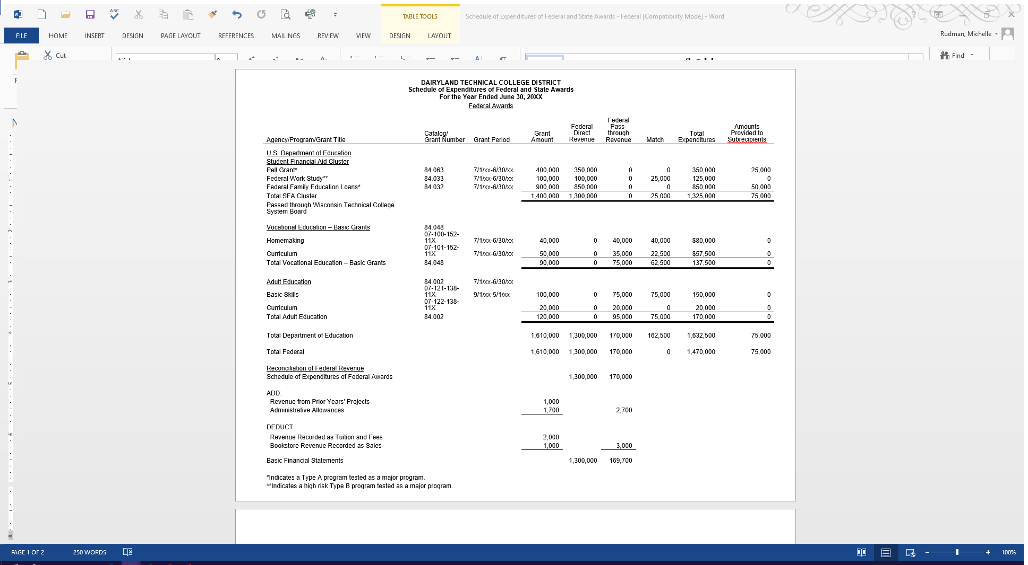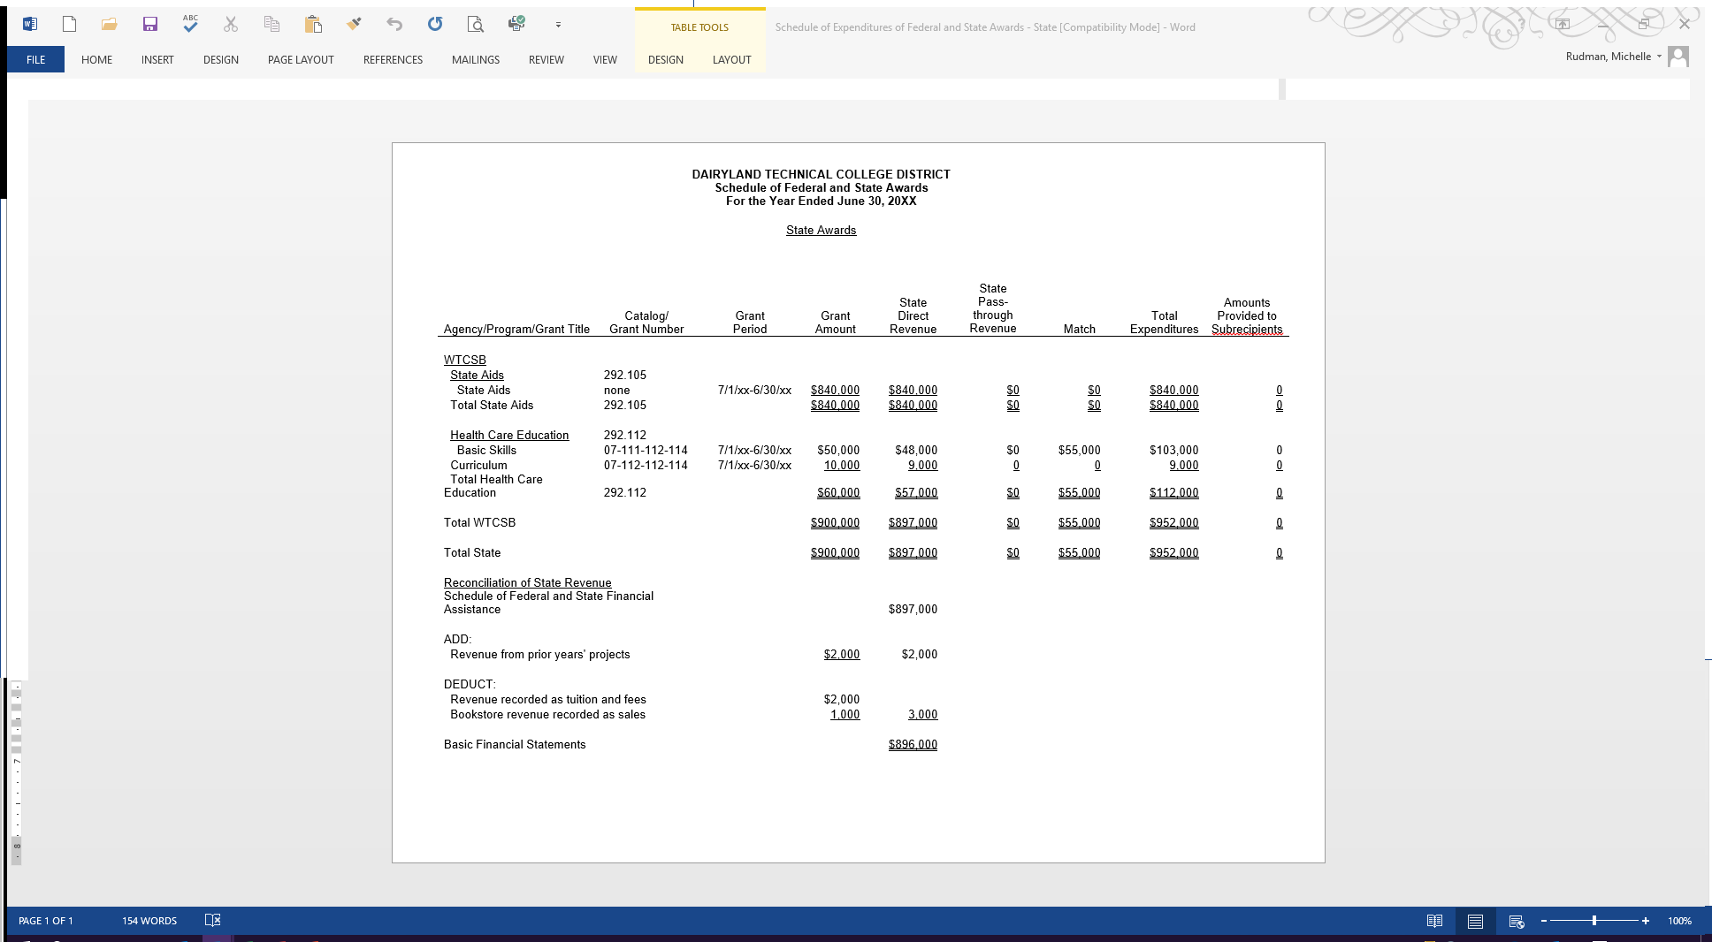n

#### Findings and Questioned Costs

Dairyland Technical College District

Schedule of Findings and Questioned Costs

For the Year Ended June 30, 20XX

The Schedule of Findings and Questioned Costs report by the auditors should be broken into three components. The first component contains a summary of the auditor's results and must include the following:

* 1. The type of report issued by the auditors on the basic financial statements (i.e., unmodified).
  2. Reportable conditions in internal control over the financial statements and if they are a material weakness.
  3. Noncompliance material to the financial statements taken as a whole.
  4. Reportable conditions in internal control over major programs and if they are material weaknesses.
  5. The type of report the auditor issued on compliance for major federal and state programs.
  6. An affirming statement if the audit disclosed any findings or questioned costs that must be presented on the Schedule of Findings and Questioned Costs.
  7. Identification of the programs that were determined to be major federal and state programs.
  8. The specific dollar threshold used to distinguish between Type A and Type B programs.
  9. A statement as to whether the district qualified as a low risk auditee.

The second component must identify findings relating to the financial statements which are required to be reported in accordance with Generally Accepted Government Auditing Standards (GAGAS).

The third component consists of specific material findings and questioned costs to each program or program cluster. The finding or questioned cost must be presented in such detail to allow the district to prepare a corrective action plan and allow the oversight or grantor agency to come to a concluding management decision. They should be organized and grouped by federal or state agency or pass through and should include the following information.

* 1. The federal or state program and specific federal or state award identification including the CFDA or CSDA number, the pass through agency name and assigned number, and any other information identifying the agency or grant number.
  2. The criteria or specific requirement upon which the finding or questioned cost is based. This should include statutory, regulatory, or other criteria pertinent to the finding or questioned cost.
  3. The specific condition found. This should include facts that support the deficiency identified.
  4. Identification of questioned costs and a description of how they were computed.
  5. The population and sample size to provide proper perspective for judging the prevalence and consequences of the finding or questioned cost. Whether it represents an isolated instance or is systemic.
  6. The possible asserted effect of the finding or questioned cost to provide sufficient information to the district, federal agency, or pass through to enable them to determine the cause and effect to facilitate a timely corrective action.
  7. Recommendations to prevent occurrence of the deficiency in future fiscal years.
  8. District response to the finding or questioned cost when there is disagreement with it.
  9. The auditor shall assign a reference number to each finding or questioned cost identified in the Schedule of Findings and Questioned Costs. This number must accompany the finding in the Schedule of Prior Year Findings and Questioned Costs to facilitate tracking and resolution of the finding or questioned cost.

#### Prior Year(s) Findings and Questioned Costs

Dairyland Technical College District

Schedule of Prior Year(s) Findings and Questioned Costs

For the Year Ended June 30, 20XX

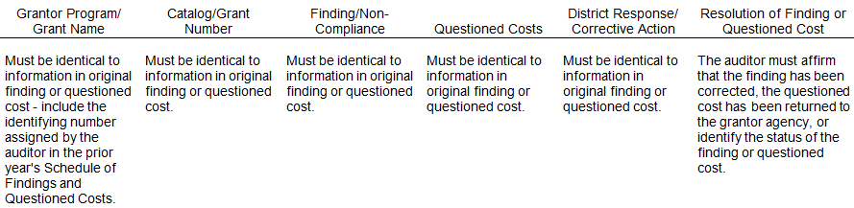

The Summary Schedule of prior years' audit findings or questioned costs shall report the status of all audit findings included in the prior audits' Schedule of Findings and Questioned Costs. The finding or questioned cost shall continue to be reported in the prior year’s schedule until one or more of the following occurs.

* 1. When findings or questioned costs are corrected, the schedule need only list the finding or questioned cost and state that corrective action was taken.
  2. When audit findings or questioned costs were not corrected, or only partially corrected, the schedule must describe the planned correction to be taken and the corrective action that has already taken place.
  3. When corrective action is significantly different from the corrective action previously reported to take place in a corrective action plan, or in the federal or state agency's or pass through entity's management decision, the summary schedule must provide an explanation.
  4. If the district believes the finding or questioned cost is no longer valid or does not warrant additional action it may be deleted from the schedule if one or more of the following occurred. Two years has lapsed since the audit report was submitted to the Federal Clearing House, the responsible federal or state agency is not following up on the finding or questioned cost, and a timely management decision was not issued.

### Management Decision

The management decision shall clearly state whether or not the finding or questioned cost is considered sustainable by the federal or state agency responsible to make the decision. It must include the reasons for the management decision and the expected district action to be taken. Also, if the corrective action has not been fully implemented, the management decision shall include a timetable for its completion and follow up to be taken. Also, the management decision should describe an appeal process that is available to the district. The following management decision responsibilities lodge with each federal or state agency.

1. Federal Agency – Direct Grants

Each Federal awarding agency is responsible for issuing a management decision for findings and questioned costs pertaining to awards the agency made directly to a district. The federal oversight agency for the WTCS districts is required to issue a management decision regarding findings and questioned costs pertaining to more than one direct federal program. The federal oversight agency for WTCS districts is the U.S. Department of Education.

1. State Agency – Direct Grants

Each state awarding agency is responsible for issuing a management decision for findings and questioned costs pertaining to awards the agency made directly to a district.

1. Pass-Through Agencies

Agencies which receive federal and/or state grant funds from other agencies and sub-grant these funds to a district shall be responsible for management decisions pertaining to those pass-through grants. Pass-through agencies shall provide subrecipients with the following information as part of the grant award:

the CFDA or CSDA title and number

the award name and number

the award year

and federal or state funding source.

* any special requirements imposed by grant agreements and other federal or state regulations or laws.

In addition, the pass- through agency must monitor the activities of the subrecipient to ensure federal and state awards are used for authorized purposes in compliance with laws and regulations pertaining to each program. They must also ensure that their subrecipients expending $750,000 or more in federal awards during the fiscal year have met the audit requirements of OMB Uniform Guidance then, the subrecipient is also required to have a single audit for any state grants meeting the single audit criteria contained in the System Single Audit Guide.

The management decision must be issued within six months after receipt of the subrecipient’ s reporting package and ensure the district takes appropriate and timely corrective action. The district must allow the System Office, other pass through agency or financial auditor access to the district records and financial statements to enable the pass‑through entity to comply with its responsibility to issue a management decision.

### District Responsibilities as a Subrecipient Grantor

The district as a subrecipient of federal or state grant funds is responsible for monitoring and management decisions for amounts the district subgrants to other agencies, community based organizations, and other entities. In such cases of subgrants, the district is considered the primary recipient and must assume the responsibilities as a primary recipient for all amounts it subgrants to other organizations. The district shall identify awards made by informing subrecipients of the CFDA or CSDA title and number the award name and number, the award year, and the federal or state funding source. The district shall also advise the subrecipient of any special requirements imposed by the funding type, grant agreement, or the federal or state regulation or law. In addition, the district must monitor the activities of the subrecipient to ensure the federal or state awards are used for authorized purposes in compliance with laws and regulations pertaining to each program. The district must also ensure that subrecipients expending more than $750,000 or more in federal funds have met the audit requirements of OMB Uniform Guidance.

The district is required to issue a management decision to the subrecipient for any findings or questioned cost pertaining to funds granted through the district. The management decision must be issued within six months after the district receives the subrecipients annual or bi-annual audit report. The district must ensure that the subrecipient takes appropriate and timely corrective action on the finding or questioned cost.

### Primary Recipient Monitoring Responsibilities

A primary recipient such as the System Office or a district may fulfill their monitoring responsibilities of federal or state grant funds sub-granted through them by one of the following methods.

1. Ensure that an audit in accordance with Office of Management and Budget Uniform Guidance or a program compliance audit was performed on the subrecipient and the federal and state grant funds passed through the primary recipient were included in this audit. The resolution and issue of the management decision where necessary for subgranted funds is a part of the monitoring responsibilities.
2. Require hard copy documentation of salary, fringe benefit, and other expenditures claimed on a federal or state grant by the subrecipient. This hard copy documentation would be submitted to the primary recipient with the requests for reimbursement. This methodology of monitoring does not replace the primary recipients responsibilities pertaining to findings and questioned costs resolution or issuance of a management decision for federal and state grant funds administered through the primary recipient.
3. On-site review of the accounting records and federal or state program expenditures pertaining to the subgrant funds of the primary recipient may be done. To ensure access to the accounting records to be reviewed, the primary recipient should require this access when issuing the original award letter. This monitoring supplement does not supplant the requirement that a primary recipient has to ensure an audit was performed where necessary in accordance with OMB Uniform Guidance and the resolution of audit findings and questioned costs and a management decision report when required.

## Cost Allocation Report Reconciliation

After completing the financial audit, the district staff shall prepare a reconciliation of the post-audit revenue and expenditure amounts to the cost allocation report. This reconciliation shall be prepared for each fund type for revenue by source (from the VE‑CA‑7) and expenditures by function (from the VE‑CA‑1). If necessary, the district staff shall obtain assistance from the financial auditors in preparing this reconciliation. This reconciliation is to be submitted as an attachment to an e-mail to the audit contact within thirty (30) days after issuance of the audited financial report but no later than December 31, following the audited year.

### Format

The reconciliation shall be structured in the following format:

1. A transmittal statement including the following statement: "I affirm that the attached reconciliation of revenues and expenditures for fiscal year                  between the cost allocation report and the district audited financial report is a true and accurate statement of the variances between these reports." If there are no variances between the cost allocation report and audited financial report, the transmittal statement should so indicate. This statement shall be included on the reconciliation or in the transmitting e-mail.
2. A reconciliation of revenues by fund and the following sources from the cost allocation report (VE‑CA‑7):
   1. Local Government -- This amount should consist of revenue from local units of government only.
   2. State Aids -- This amount should consist of revenue from regular state aids only.
   3. Other State -- All other state sources of revenue should be classified as "Other State."
   4. Statutory Fees -- Statutory fees are program fees (tuition) under s. 38.24(1), Wis. Stats., (except for material fees) from students or their sponsors.
   5. Material Fees -- This revenue represents material fees collected from students or their sponsors.
   6. Other Student Fees - All other fees from students should be classified as "Other Student Fees."
   7. Institutional -- Institutional revenue includes interest earned from investments or deposits, gifts from private sources, or sale of equipment which was non-aidable in previous years. Revenues should not be recognized from refunds, insurance recoveries or sale of items previously expensed which received state aids. Funds received for previous expenditures should be abated against the cost centers that were originally charged.
   8. Federal Government -- All federal government revenue, including Vocational or Federal Work Study, SEOG, PELL, VEA grants, ABE grants, and JTPA grants should be classified as federal.

### Revenue Reconciliation Example

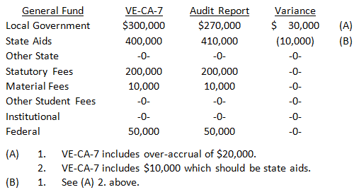

1. A reconciliation of expenditures by fund and function from the cost allocation report (VE‑CA‑1).

### Expenditure Reconciliation Example

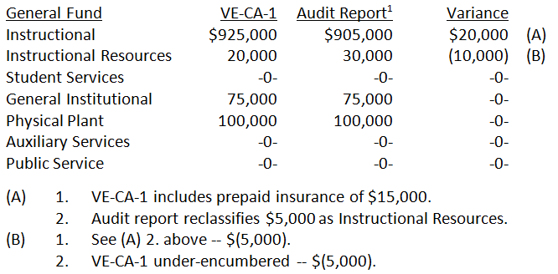

[3]

## Remuneration Standards for Federal and State Grants

### Standards for Allowable Compensation

Compensation for personal services includes all remuneration, direct or indirect, paid currently or accrued, for services rendered during the period of performance under the grant agreement. Such compensation is allowable to the extent that total compensation for individual employees: 1) is reasonable for the services rendered; 2) is consistent with district personnel and payroll policies and procedures; and 3) is accountable.

Reasonable - Compensation for employees engaged in federal and state program assisted activities will be considered reasonable to the extent that it is consistent with that paid for similar work in other activities of the district. In cases where the kinds of employees required for federal and state program assisted activities are not found in the other activities of the district, compensation will be considered reasonable to the extent that it is comparable to that paid for similar work in the labor market in which the employing district competes for the kind of employees involved.

Consistent - Self-explanatory.

Accountable - Compensation charged to grant programs must be based on documented payrolls supported by employee contracts, time-cards, time and effort records, etc. Budget estimates do not qualify as support for charges to federally funded projects unless they are documented after the fact.

### Required Support Documentation

Support documentation is required as follows:

Salaries - Budgetary documentation will consist of the contract, letter of appointment, or similar documentation. This documentation must identify the employee, fiscal period, salary, and position (e.g. instructor, counselor, etc.). This documentation or ancillary documentation must identify the federal or state projects involved and the time and effort proration to each project. Also, position descriptions must be available for all salaried employees.

Salaries must be supported by confirming documentation. This documentation may consist of time and effort reports, written confirmation by the project supervisor, or similar documentation. Salaries or wages of employees assigned to more than one grant program or other cost objective must be supported by time distribution records signed by the employee. Confirming documentation must be generated contemporaneously at least monthly for instructional and non-instructional staff. It is strongly suggested that confirming payroll documentation be prepared by staff and their supervisors on a payroll by payroll basis.

Wages - Budgetary documentation will consist of a request for time cards, letter of assignment, or similar documentation. This documentation must identify the employee, period of project employment, hours authorized, hourly rate, position, and federal project. Wages must be supported by confirming documentation consisting of time cards, time sheets, or other similar documentation identifying the project and affirmed by the supervisor.

Honorarium - Budgetary and affirming documentation may be included on the same document. This documentation may be a request for honorarium, authorization to pay, or similar documentation. It must include the individual's name, date(s) of service, service performed, amount, and federal project.

Consultant Fees - Budgetary and affirming documentation may be included on the same document. This documentation may be a letter of engagement, authorization to pay, or similar documentation. It must include the consultant's name, date(s) of consultation, preparation time if any, the subject of the consultation, amount, and federal project.

Transfers - All transfers for remuneration must be documented. The transfer authorization must include the employee's name, period involved, specific computation of amount transferred (percentage of contract, proration of time and effort, hours, etc.), the federal project and position.

Budgetary Documentation - Budgetary documentation must be signed by an authorized supervisor or administrator.

Affirming Documentation - Affirming documentation must be signed by a supervisor knowledgeable of the time and effort of the individual employee.

For additional requirements pertaining to remuneration standards for state and federal programs, see the OMB Uniform Guidance.

### Paper vs. Electronic Documentation

Paper documentation or electronic equivalents can be used to meet these documentation requirements.

# Cost Allocation Report

## Introduction

The cost allocation methodology for the Wisconsin Technical College System equitably assigns costs to various categories by divisional and aid category levels to assure consistent fiscal comparisons among and between districts, within individual districts, and on a statewide level.

Consistent use of the UFFAS section of the Financial & Administrative Manual is assumed. Budget basis data (as opposed to GAAP basis data) is required. All seven funds are to be reported unless one or more has no activity.

### List of Schedules

The Cost Allocation Report is composed of nine schedules:

VE-CA-1 BUDGET/EXPENDITURE SUMMARY

VE-CA-2 STAFF AND EXPENDITURE RE-CAP

VE-CA-3 FUNCTIONAL COST ALLOCATION

VE-CA-4 DIVISIONAL COST ALLOCATION

VE-CA-5 DIVISIONAL SUMMARY

VE-CA-6 ALLOCATION BASES

VE-CA-7 REVENUE SUMMARY

VE-CA-8 form not used

VE-CA-9 COST ALLOCATION SUMMARY

VE-CA-9s SUPPLEMENT

### Submission Requirements

For each fiscal year, the following reports are to be submitted (listed in chronological order):

November projected –November preceding the beginning of the fiscal year (VE-CA-9 and 9s)

April projected –April preceding the beginning of the fiscal year (VE-CA-9 and 9s)

Budget – July at the beginning of the fiscal year (all schedules) and OPEB spreadsheet

November re-estimate – November during the fiscal year (VE-CA-9 and 9s)

April re-estimate – April during the fiscal year (VE-CA-9 and 9s)

Actual – November following the end of the fiscal year (all schedules) and OPEB spreadsheet

The budget and actual mode reports include all nine schedules. The budget mode report is to be based on the adopted district budget. The transmittal should contain detail of any variances between the adopted budget and the budget document prepared for the pre-adoption public hearing. The actual mode report is to be completed using actual budget based data (as opposed to GAAP based data) for the most recent completed fiscal year.

In November and April, projected and re-estimate mode reports are due. The projected mode reports are to be completed using estimated data for the forthcoming fiscal year. The re‑estimate mode reports are to be completed using a combination of actual and estimated data for the current fiscal year. Both the projected and re-estimate mode reports include only the VE‑CA‑9 and VE‑CA‑9s.

In November actual mode reports are due. Districts other than Madison that have finalized their Uniform Financial Fund Accounting System (UFFAS) data may opt to have their actual mode cost allocation report generated by the System Office using UFFAS and Client Reporting System data. Madison must also have finalized their Contract Reporting System data and submit Basis B for schedule VE-CA-6. To exercise this option, please notify the Cost Allocation Report contact via email.

Submission dates for all modes of cost allocation reports are annually established by [Administrative Bulletin](https://mywtcs.wtcsystem.edu/initiatives-policies/state-law-and-policy/administrative-bulletins). – see the Report Dates Subject to Withholding of State or Federal Aids for FY 20xx-xx bulletin for the applicable period.

Also, subsequent to any month in which the district's estimated FTEs for the year and/or aidable cost for the year changes by 5% or more, a projected/re‑estimate report must be submitted. Districts may also submit a report for any other month. For these unscheduled reports, submit only the VE‑CA‑9 and VE‑CA‑9s.

The System Office will prepare a final UFFAS mode cost allocation report for any district which doesn’t have the System Office prepare that actual mode report.

Cost Allocation Reports in all modes are to be submitted to the Cost Allocation Report contact via email as attached Excel spreadsheets.

### Cost Allocation Report Contact

Questions regarding the Cost Allocation Report or this section should be directed to:

Michelle Rudman

Wisconsin Technical College System

4622 University Avenue

P.O. Box 7874

Madison, Wisconsin 53707-7874

(608) 266‑1433

[michelle.rudman@wtcsystem.edu](mailto:michelle.rudman@wtcsystem.edu)

## Schedule Instructions

### VE-CA-1 Expenditure Summary

Complete heading – FISCAL YEAR, DISTRICT, and DATE PREPARED.

FISCAL YEAR is the fiscal year being reported, not necessarily the year in which the schedules are completed.

All dollar amounts are rounded to the nearest dollar and must foot and cross-foot.

In the REDUCTIONS column enter the amount of OPEBs (classification 5157) and Wisconsin Retirement System (classification 5158) prior service payments reported in the GENERAL/SR OPER column. Regular amortization payments are to be reported by function. Pay-downs are to be reported on line f. Gen. Institutional. OPEB trust fund activity is to be recorded in the Fiduciary/SR-NA column.

In the FUNDS 1-2 SUBTOTAL column enter the net of the GENERAL/SR OPER column less the REDUCTIONS column. The GENERAL/SR OPER column is to be used in computing the amount in the total – all funds column – do not use the REDUCTIONS or FUNDS 1-2 SUBTOTAL columns to compute this amount.

Lines a-c and f-g

Enter the amounts for each Fund and Function. In the GENERAL/SR OPER column, enter the General Fund and Special Revenue - Operational Fund expenditures. Leave lines d-e blank

Line h

Total lines a-g for each column. The amount on line h in the FUNDS 1-2 SUBTOTAL column is the operational cost.

Line i

Enter the total federal revenue associated with functions 1-7. Do not include any federal revenue associated with functions 8-9. Therefore, the amount on this line may not be equal to the federal revenue reported on line i on schedule VE-CA-7.

Line j

Enter the non-federal portions of line h (line h minus line i).

Lines k and l

Enter the amounts for each Fund for Functions 8 and 9. Be careful not to include in Functions 8 and 9 costs or portions of costs which are operational in nature, which are to be included in operational costs.

Line m

Enter the total of lines h, k. and l. The amount on line m in the TOTAL - ALL FUNDS column is the total district-wide expenditures.

### VE-CA-2 Expenditure Re-Cap

Complete the heading – FISCAL YEAR, DISTRICT, and DATE PREPARED.

Column 1 lists the expenditure Object Levels which are to be reported on lines 1-f. Enter the total expenditures (all seven Funds and nine Functions) in column 2 on lines a through f. Line g TOTAL EXPENDITURES must agree with the total of lines a‑f on this schedule and the amount on line m in the TOTAL - ALL FUNDS column on schedule VE‑CA‑1.

Line a Salaries – report all expenditures in UFFAS classifications 50xx

Line b Fringe Benefits – report all expenditures in UFFAS classifications 51xx

Line c Current Expenses – report all expenditures in UFFAS classifications 52xx – 56xx

Line d Resale Merchandise – report all expenditures in UFFAS classifications 57xx

Line e Capital – report all expenditures in UFFAS classifications 58xx

Line f Debt Retirement – report all expenditures in UFFAS classifications 59xx

### VE-CA-3 Functional Cost Allocation

Complete heading – FISCAL YEAR, DISTRICT, and DATE PREPARED.

In the TOTAL column on lines c-j, enter the amounts from lines a-h on schedule VE‑CA‑1 in the FUNDS 1-2 SUBTOTAL column. Then allocate the amount entered on line c between lines a and b. On line b the expenditures for Academic Administration (Cost Center 919) and the net amount (line c - line b) on line a.

**NOTE:**  Academic Administration reported on line b is net of any amount reported on line a in the REDUCTIONS column on VE-CA-1 (OPEBS and Wisconsin Retirement System prior service amortization payments).

Next, distribute the amounts in the TOTAL column on lines a-b and d-i to the Division columns.

For line a, enter direct costs by division including technical assistance from cost centers 910-918.

For the remaining lines, use the following bases from schedule VE‑CA‑6.

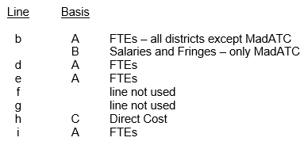

Sum the amounts on lines c-i in each column on line j.

### VE-CA-4 Divisional Cost Allocation

#### Division Schedule Instructions

A separate schedule VE‑CA‑4 is required for each instructional division. Complete the heading for each schedule – FISCAL YEAR, DISTRICT, and DATE PREPARED. Also fill in the name of the division in the far right column.

For each division’s schedule VE‑CA‑4, transfer the amounts from the appropriate column of schedule VE‑CA‑3 to the DIVISION/TOTAL column.

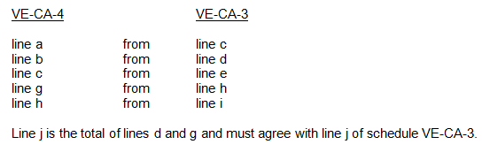

Repeating for each division’s VE-CA-4, allocate the Division/Total column amount for each function (footing and cross-footing subtotals and totals) over the columns (aid categories of collegiate transfer, associate degree, technical diploma, vocational adult, non-postsecondary and community services) according to the following groupings:

Collegiate Transfer 20

Associate Degree 10

Technical Diploma 30, 31, 32, 50

Vocational Adult 42, 44, 45, 47

Non-Postsecondary 73, 74, 75, 76, 77, 78

Community Services 60

#### Distribution Instructions

Division/Total column distributions to the functional columns are to be rounded as follows:

lines a-c, g-h dollar amounts rounded to the nearest whole dollar (no decimal places)

line k FTEs rounded the nearest hundredth FTE (two decimal places)

line l Cost/FTE rounded to the nearest whole dollar (no decimal places)

line m PHI to the nearest whole PHI (no decimal places)

line n Cost/PHI rounded to the nearest cent (two decimal places)

lines d, g and h subtotal and total lines – no rounding necessary

Line a - Madison distributes using VE‑CA‑6 Basis B Salaries and Fringe Benefits percentages. All districts, except Madison, distribute using Basis A FTEs percentages from schedule VE‑CA‑6.

NOTE: It is necessary to use VE-CA-6 A1, A2, A3, A4, A5, and A6 percentages by division as they form 100% of Basis A for each division or VE-CA-6 B1, B2, B3, B4, B5 and B6 percentages by division as they form 100% of Basis B for each division.

Lines b, c, g and h – Distribute using Basis A FTE percentages from schedule VE‑CA‑6.

NOTE: It is necessary to use A1, A2, A3, A4, A5, and A6 percentages by division as they form 100% of Basis A for each division.

#### Instructions for Other Lines

Lines d, i and j – Verify that these lines foot and cross-foot accurately.

Line k - Enter FTEs from VE-CA-6 Basis A for the appropriate division.

Line l - Calculate the cost per FTE by dividing line h by line i for each column. Round to the nearest whole dollar.

### VE-CA-5 Divisional Summary

Complete the heading – FISCAL YEAR, DISTRICT, and DATE PREPARED.

Each cell on schedule VE-CA-5 corresponds to the cell in the same column/line location on each VE-CA-4 schedule.

Lines a‑c, g-h and k - Compute the amount in each cell on lines a‑c, g-h, and k on schedule VE-CA-5 by summing the amounts in the corresponding cells on each schedule VE-CA-4. For example, the amount entered on line a in the Collegiate Transfer column of schedule VE-CA-5 is the sum of the amounts on line a in the Collegiate Transfer column on each of the divisional schedule VE-CA-4s.

Line d - Compute the amount on line d in each column by summing lines a‑c in the same column.

Line i - Compute the amount on line i in each column by summing lines g-h in the same column.

Line j - Compute the amount on line j in each column by summing lines d and i in the same column.

Line l – Compute the cost per FTE by dividing line j by line k for each column. Round to the nearest whole dollar for each column.

Verify that the amount on line j in the Total column equals the amount on schedule VE‑CA‑1 on line h in the FUNDS 1-2 SUBTOTAL column (operational cost).

DO NOT complete schedule VE‑CA‑5 by entering the functional totals from schedule VE‑CA‑3 and allocating them to the aid categories. This will not result in the same amounts as using the specified methodology.

### VE-CA-6 Allocation Bases

This schedule calculates the bases that are used to allocate costs to instructional divisions and aid categories within each division.

Complete the heading – FISCAL YEAR, DISTRICT, and DATE PREPARED.

All FTE, Salary/Fringe and Direct Cost lines add horizontally to the Total column. However, only Percent by Division and Percent of Total percentage lines add horizontally to the Total column.

Basis A: For actual mode reporting use Client Reporting System report VE215570A from the System Office to complete this basis. For all other modes use the best available estimate of FTEs (full-time equivalent students) expected for the fiscal year.

Line A - Enter total FTEs for each division (column) on line A and enter the sum of the divisional FTEs in the TOTAL column on line A. Calculate a Percent by Division for each divisional FTE number by dividing the divisional FTE number by the Total FTE number on line A. Enter each percentage on the spreadsheet row below the applicable FTE number. Be sure that these percentages add horizontally to 100%.

Lines A1- A6 - Within each division (column), enter the FTEs for each aid categories in which you expect to have (or had) enrollments. The sum of each division’s FTEs must add vertically to the number on line A (A1 + A2 + A3 + A4 + A5 + A6 = A). For each aid category, sum the FTEs horizontally and enter the total in the TOTAL column. The sum of FTEs in the TOTAL column must add vertically to the number on line A (A1 + A2 + A3 + A4 + A5 + A6 = A).

Calculate the Percent of Total for each FTE number by dividing the aid category FTE number by the Total FTE number on line A (e.g., A1 FTEs ÷ A FTEs). Enter each percentage on the spreadsheet row below the applicable FTE number. Be sure that these percentages add vertically to 100%.

NOTE: Each cell must have two figures ‑‑ number of FTEs and the appropriate percentage. In each case, use two decimal places.

Basis B: All districts, except Madison, are to enter the same amounts and %s entered for Basis A.

**Madison** is to enter the total course related personal services cost (including fringe benefits) for instructors on line B. All amounts are to be rounded to the nearest dollar. In actual mode, Madison must enter the dollar amounts for each cell and use them to compute the allocation %s.

On line B, calculate the Percent by Division to two decimal places for each column. These percentages must add horizontally to 100%.

Within each division (column), calculate the Percent of Total number by dividing the aid category number (B1, B2, B3 etc.) by the Total number on line B (e.g., B1 ÷ A). Enter each percentage on the spreadsheet row below the applicable dollar amount. Be sure that these percentages add vertically to 100%. Calculate these percentages to two decimal places.

Basis C: Fill in the Direct Cost figure for each division by copying line a from schedule VE‑CA‑3. Calculate Percent of Total to two decimal places for each division. These percentages must add horizontally to 100%.

### VE-CA-7 Revenue Summary

This schedule identifies the various sources of revenue by fund. All columns are to be completed.

Complete heading – FISCAL YEAR, DISTRICT, and DATE PREPARED.

Enter revenue amounts by fund as follows:

Line a: Local Government - Revenue from local units of government. classifications 4100-4199

Line b: State Aids - Revenue from regular state aids only. classifications 4210‑4213, 4215 and 4219

Line c: Other State Sources - Revenue from all other state sources, including other state agencies. Federal programs such as JTPA, however, are federal even though they may be administered through another level. classifications 4214, 4216, 4217, 4218 and 4220‑4261

Line d: Stat Fees 38.24(a) - Statutory program fees (tuition) collected under s. 38.24(1) stats. Statutory program fees are collegiate transfer, postsecondary, and vocational adult program fees. These fees do not include community service fees, non-resident tuition or out-of-state tuition which are to be reported on line f. classifications 4300-4399

Line e: Materials Fees – Statutory material fees collected under s. 38.24(1)(c) stats. classifications 4400-4499

Line f: Other Student Fees - All other fees collected from or for students for whatever purpose. Classifications 4500-4599

Line g: Institutional Revenue - Other revenues such as interest earned from investments or deposits and gifts from private sources. Classifications 4600-4899

Line h: Subtotal of lines a through g.

Line i: Federal - All revenue from federal assistance programs. Classifications 4900-4999

Line j: Total of lines h and i.

Line k: Other Sources - Net other sources not included in revenues. Classifications 6010-6040 minus 7010-7030

Line l: Fund Balance - Net change in fund balance. Classifications 6100-6499 minus 7100-7499

Line m: GRAND TOTALS - Total of lines j, k and l for each column. With the exception of the General and Spec. Rev. Aidable columns, line m on schedule VE‑CA‑7 must agree with the corresponding column total on line m of schedule VE‑CA‑1. The sum of amounts on line m in the General and Spec. Rev. Aidable columns on schedule VE‑CA‑7 must agree with the Funds 1-2 Subtotal column total on line m of schedule VE‑CA‑1.

### VE-CA-8 Non-Resident Tuition (Deleted)

THIS SCHEDULE HAS BEEN DELETED. INTERDISTRICT TUITION IS NO LONGER PAID BY DISTRICTS.

### VE-CA-9 Cost Allocation Summary

Complete heading – DISTRICT, FISCAL YEAR, and DATE PREPARED.

All dollar amounts are rounded to the nearest dollar and must foot and cross-foot.

Line A Total Operations – Enter the amounts from line j of schedule VE‑CA‑5 in the appropriate columns on line A.

Line B Federal - Enter federal revenue from schedule VE‑CA‑1, line i, FUNDS 1-2 SUBTOTAL column in the Total Aidable and Total columns of line B.

Distribute this amount to the Associate Degree, Technical Diploma, Vocational Adult aid and Non-Postsecondary columns based on the amounts on line A in these columns as follows:

sum the line A amounts in the Associate Degree, Technical Diploma, Vocational Adult and Non‑Postsecondary columns

divide the amount on line B in the Associate Degree column by the total from step one

multiply the resulting percentage time the amount in the TOTAL column on line B

enter the resulting amount in the Associate Degree column on line B

* repeat steps 2-4 for the Technical Diploma, Vocational Adult and Non‑Postsecondary columns

Line C Total Non-Federal - Compute line C in each column by subtracting the amount on line B from the amount on line A.

Line D.1 Material Fees - Enter material fees by aid category based on classifications. The amount in the Total column must equal the total of the Funds 1 and 2 amounts on line e, schedule VE‑CA‑7.

Line D.2 Student Fees - Enter Other Student Fees (General Fund and Special Revenue – Operational Fund only) from line f, schedule VE‑CA‑7 net of out-of-state fees on line D.2 in the TOTAL column. Detail of these fees is to be entered on schedule VE‑CA‑9s. Out-of-state fees are entered on line E.2.

Directly assign Motorcycle Training, Group Dynamics and Multiple Offender fees to the Vocational Adult column and Community Services fees to the Community Services column.

Distribute the net remaining amount to the aid categories based on line A aid category amounts as percentages of the amount on line A in the TOTAL column. For each aid category column divide the associated line A amount by the amount on line A in the TOTAL column, multiply the resulting percentage times the net remaining student fees and enter the resulting amount on line D.2 in the same column.

Line D.3 Other Exclusions - Enter Total Other Exclusions from line l on schedule VE‑CA‑9s and distribute to the aid categories using the methodology from line D.2.

Line D.4 GPR Categorical Aids - Enter GPR funded categorical aids received through the System Office -classifications 4220‑254 and 4260. Distribute to the aid categories using the allocation methodology from line B Federal.

Line D Total Exclusions – Sum lines D.1-4.

Line E.1 Net Program Fees - Sum the amounts in the Funds 1 and 2 columns on line d of schedule VE‑CA‑7 and enter in the TOTAL AIDABLE and TOTAL columns on line E.1 of schedule VE-CA-9. Distribute this sum to the aid category columns based on classifications.

NOTE: For state aid computations the higher of actual or computed will be used. The computed amount is based on the statutory percentage recovery requirement.

Line E.2 Net Out-of-State Fees - Enter total out-of-state fees in the TOTAL AIDABLE and TOTAL columns on line E.2. Distribute this sum to the aid category columns based on classifications.

Line E Total Fees Revenue - Sum lines E.1-2.

Line F Net Aidable Operations – Subtract lines D and E from line C.

Line G.1 Debt Service – On line G.1 enter total debt service from line h in the Debt Service column on schedule VE‑CA‑1.

Line G.2 Exclusions – Sum the following amounts and enter the total on line G.2 in the TOTAL AIDABLE and TOTAL columns:

Debt Service Fund federal revenue from schedule VE‑CA‑1, Debt Service column, line i

expenditures resulting from debt refinancing

* other exclusions from aidable debt service. This includes but is not limited to debt service specifically for non-aidable activities such as WRS and OPEBs prior service costs, varsity, and intramural athletics, public service, and operational borrowing.

Line G Net Debt Service – Subtract line G.2 from line G.1.

Line H Aidable Capital Projects - Enter the net Capital Projects Fund tax levy. Annually, the System Office sends a Mill Rate and Tax Levy survey to the district chief financial officers. This survey includes a request for the district’s estimated amount of Capital Projects Fund tax levy. The amount reported in this survey establishes the maximum Capital Projects Fund tax levy that will be included in aidable cost. If a higher amount is reported in a subsequent cost allocation report the lesser survey amount will be used in state aid calculations.

Line I Net Aidable Costs – Sum lines F, G and H.

Line J FTEs - Enter FTEs from schedule VE‑CA‑5, line i.

### VE-CA-9s Cost Allocation Summary Supplement

This form details the exclusions from operational cost reported on lines D.2 and D.3 of schedule VE‑CA‑9.

Complete heading – FISCAL YEAR, DISTRICT, and DATE PREPARED.

**All amounts on this schedule are Funds 1 and 2 only.**

Line a - Line not used - leave blank.

Line b Outside Authority Fees – Sum of classifications 4540-4541. Do not allocate this amount on schedule VE‑CA‑9, assign it directly to the Vocational Adult column on line D.2, schedule VE‑CA‑9.

Line c Community Service Fees –Sum of classifications 4550-4559. Do not allocate this amount on schedule VE‑CA‑9, assign it directly to the Community Services column on line D.2, schedule VE‑CA‑9.

Line d Other Student Fees –Sum of classifications 4522 and 4570-4599. This amount gets allocated to the aid categories on line D.2, schedule VE‑CA‑9.

Line e – Line not used - leave blank.

Line f Total Other Student Fees – Sum lines a-f. This total must agree with line D.2 in the Total column of schedule VE‑CA‑9.

Line g Net Interest Income – Sum of classifications 4660-4669 minus Classification 5431. (do not include functions 8 or 9). If less than zero, enter zero.

Line h Teacher Certification – Classification 5290.

Line i Institutional Revenue - Sum of classifications 4600-4899 minus classifications 4660-4669 (do not include functions 8 or 9).

Line j State Grants - Other Sources – Sum of classifications 4255-4259 and 4261 (do not include functions 8 or 9)

NOTE: classification 4260 is deducted on line D.4 of schedule VE-CA-9.

Line k Other Exclusions – Sum of classification 5432 plus classification 6019.

Line l Total Other Exclusions – Sum lines g‑k. Also enter this total in the Total column of schedule VE‑CA‑9 on line D.3.

## Schedule Examples

Examples of the Cost Allocation Report schedules are presented on the following pages. Also, the System Office annually produces a UFFAS mode cost allocation report which contains computational formulas and comments defining the UFFAS classifications reported in various cells that can be useful in preparing reports in other modes. Contact the cost allocation report contact if your district does not have a copy of the latest UFFAS mode cost allocation report on file.

### VE-CA-1

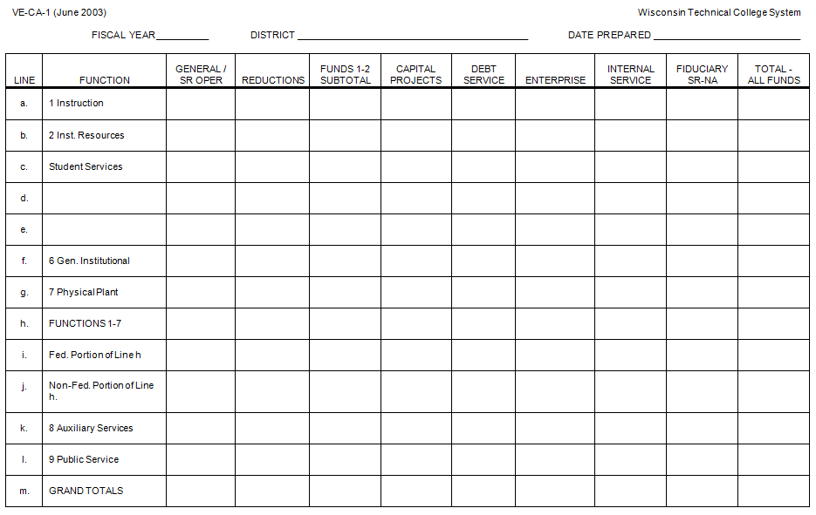

### VE-CA-2

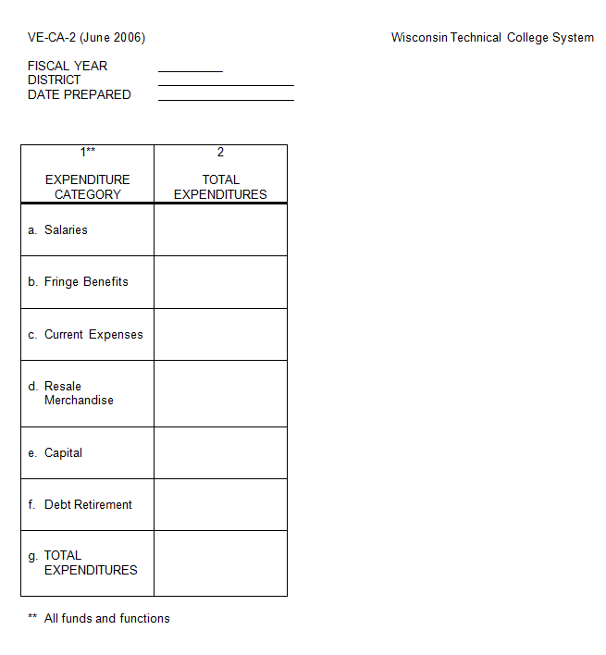

### VE-CA-3

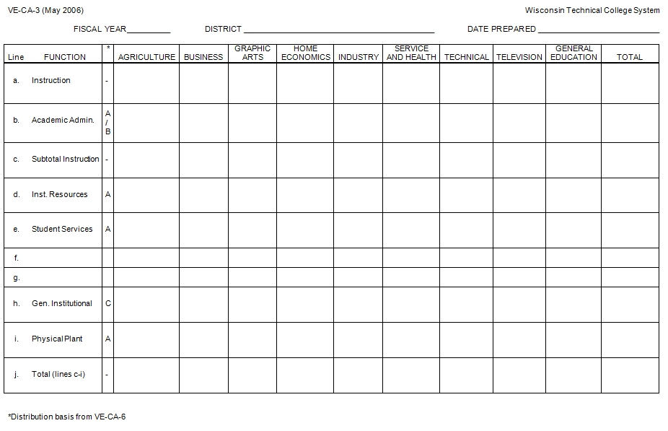

### VE-CA-4

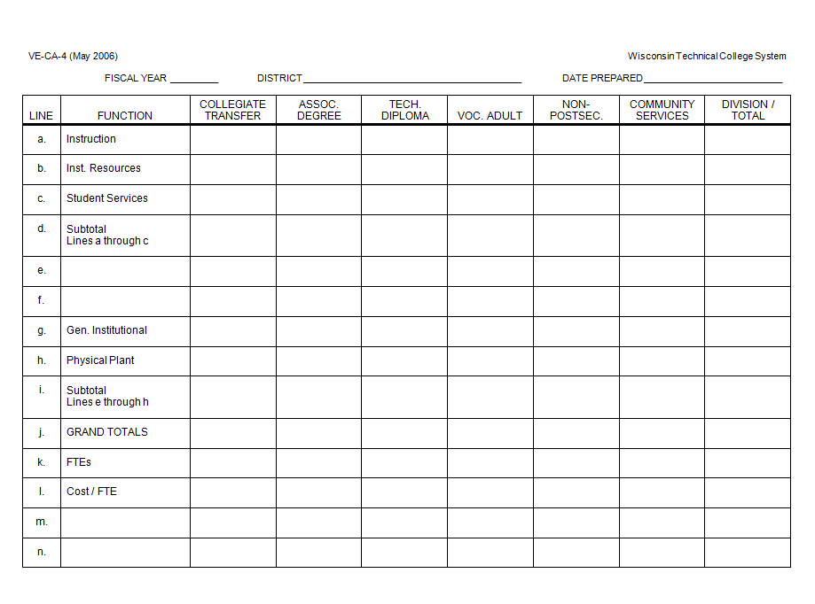

### VE-CA-5

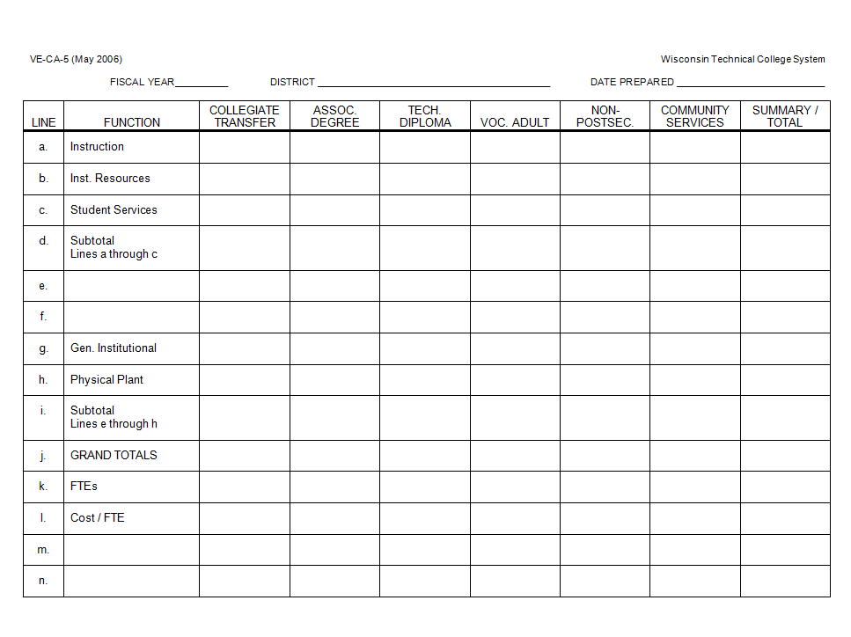

### VE-CA-6A

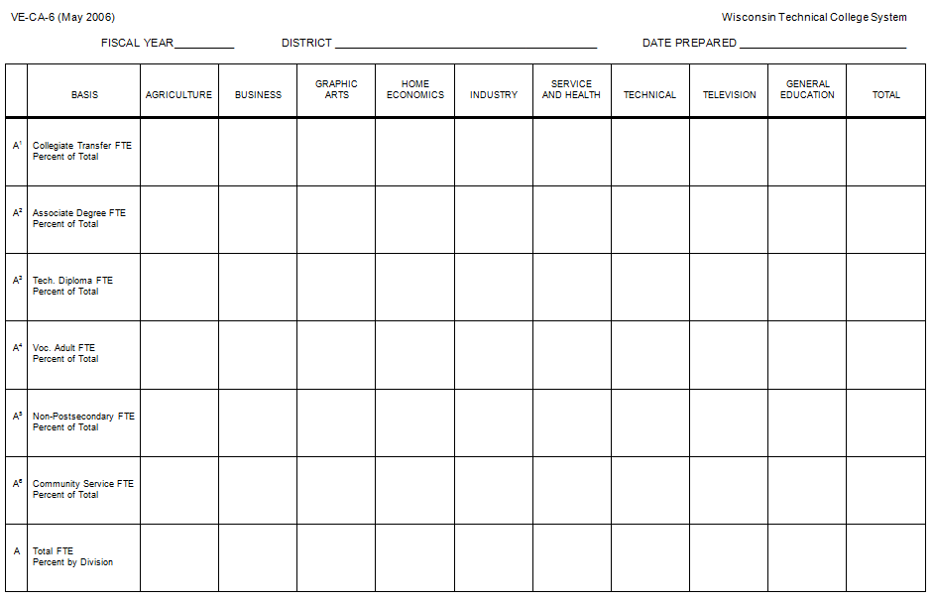

### VE-CA-6B/C

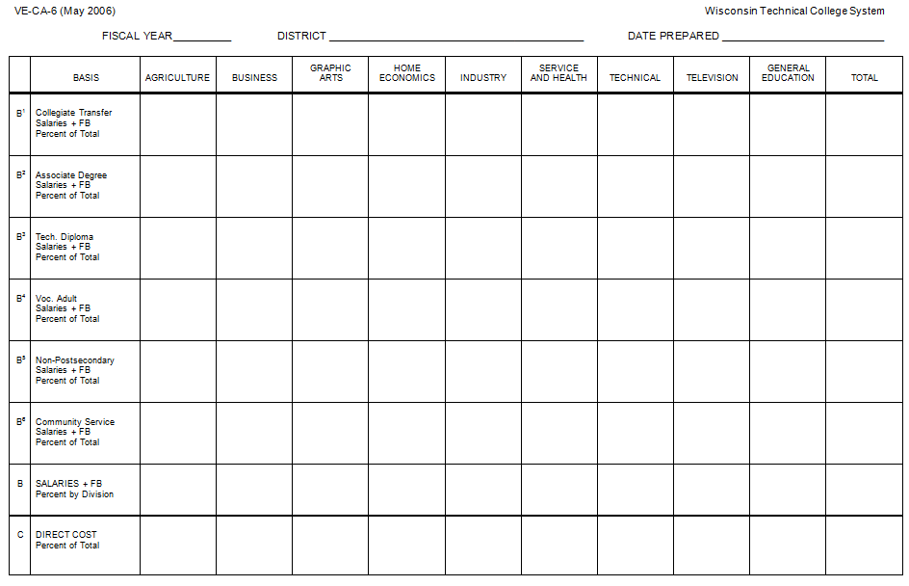

### VE-CA-7

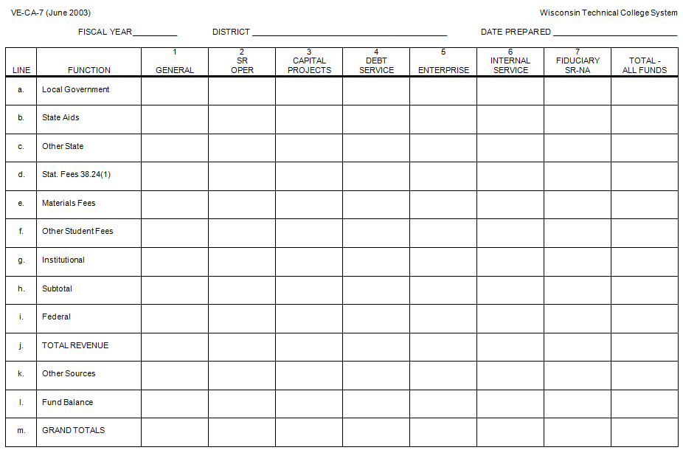

### VE-CA-8

NO SCHEDULE VE-CA-8

THIS SCHEDULE HAS BEEN DELETED. INTERDISTRICT TUITION IS NO LONGER PAID BY DISTRICTS.

### VE-CA-9

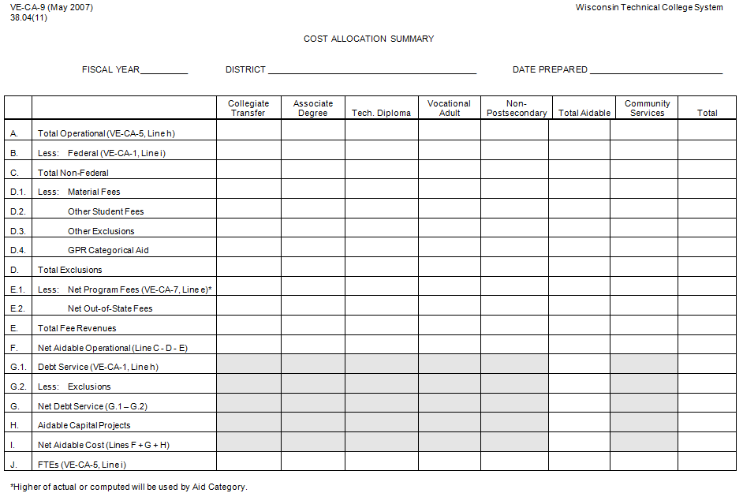

### V-CA-9s

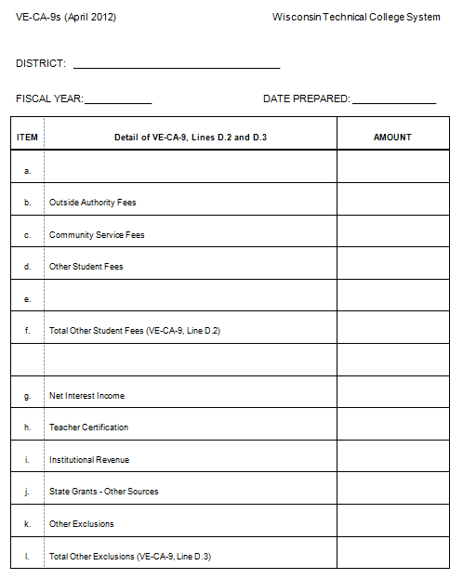

## IPED’s Financial Reporting

Contact your district’s research staff for the link and log-in information needed for access to the forms used to submit data. The IPEDs data system is at:

<https://surveys.nces.ed.gov/ipeds/>

The following information interprets the reporting instructions specifically for WTCS districts. It is intended to supplement the on-line reporting instructions, not replace them.

Be sure to select the forms and instructions for public institutions using the GASB 34/35 reporting standards. Report all financial data on GASB 34/35 basis, not the budgetary basis. The values of some lines are automatically computed based on the amounts entered on other lines. These lines are identified on the form and instructions with “CV” (calculated value).

**General Information**

1. Fiscal Year Calendar – Report the beginning and ending month and year of the fiscal year being reported. This period should be the same as the period covered by the audited financial statements used to complete the IPEDs report.

2. Audit Opinion – Report Yes if your district received an unmodified opinion on the General Purpose Financial Statements. Otherwise, report No. If you don’t know, contact your district’s chief financial officer.

3. GASB Statement 34 Reporting Model – report Business Type Activities.

4. Endowment Assets – Report Yes if your district or an affiliated organization owns endowment assets. Otherwise, report No. Generally, the only affiliated organization that a district might have is a foundation and these are only included for IPEDs reporting if they are reported as a component unit in a separate column on the General Purpose Financial Statements. Contact your district’s chief financial officer if you don’t know if your district has a reportable affiliated organization.

5. Component Units – If your district has not early implemented GASB Statement 39 (required to be implemented effective with FY 2004-05), report 0 in both the FASB and GASB boxes. If your district has early implemented GASB Statement 39, enter the number of columns included on your General Purpose Financial Statements for component units that report under FASB standards in the FASB standards box and enter the number of columns included on your General Purpose Financial Statements for component units that report under GASB standards in the GASB standards box. The numbers entered in these boxes determines how many sets of Part F and Part G forms must be submitted.

System or Governing Board – Select the first option – “This Finance Survey form is for an institution that is NOT part of a system.” While your district is part of the Wisconsin Technical College System, it has a separate governing board.

### Part A – Statement of Net Position

All amounts in part A are to be obtained from the Statement of Net Position (SNP) in the GPFS unless otherwise indicated.

Current Assets

01 Total Current Assets - Enter the amount from the Total Current Assets line.

Noncurrent Assets

02 Capital Assets - Enter the non-depreciated total capital assets. If the amount on the SNP is net of depreciation, obtain the amount of non-depreciated capital assets from the Capital Assets note in the Notes to the Financial Statements section of the audited financial report.

03 Accumulated Depreciation - Enter the accumulated depreciation on capital assets as a positive amount. If the capital assets reported on the SNP are net of depreciation, obtain the accumulated depreciation from the Capital Assets note in the Notes to the Financial Statements section of the audited financial report.

04 Other Noncurrent Assets – CV Automatically calculated after line 5 is completed.

05 Total Noncurrent Assets – Enter the amount from the Total Non-Current Assets line of the SNP.

Total Assets

06 Total Assets – CV Automatically calculated after line 5 is completed. The automatically calculated amount should equal the Total Assets amount on the SNP.

Current Liabilities

The terms liabilities and obligations are used interchangeably on financial statements. To simplify these instructions all references are to liabilities but your district’s financial statements may use the term obligations.

07 Long-Term Debt, Current Portion – Enter the amount from the Current Portion of Long-Term Liabilities line of the SNP. This is the amount due within one year of the end of the period covered by the financial statements. If this amount is not on a separate line on the SNP, it can be obtained from the Due Within One Year column in the Long-Term Liabilities note in the Notes to the Financial Statements section of the audited financial report.

08 Other Current Liabilities – CV Automatically calculated after line 9 is completed.

09 Total Current Liabilities – Enter the amount from the Total Current Liabilities line of the SNP.

Noncurrent Liabilities

10 Long-Term Debt – Enter the total promissory notes, bonds and capital leases reported in the Long-Term Liabilities section of the SNP. If these amounts are not on separate lines on the SNP, they can be obtained from the Long-Term Liabilities note in the Notes to the Financial Statements section of the audited financial report, excluding the amounts due within one year.

11 Other Noncurrent Liabilities - CV Automatically calculated after line 12 is completed.

12 Total Noncurrent Liabilities - Enter the amount from the Total Long-Term Liabilities line of the SNP.

Total Liabilities

13 Total Liabilities – CV Automatically calculated after line 12 is completed. The automatically calculated amount should equal the Total Liabilities amount on the SNP.

Net Assets

14 Invested in Capital Assets, Net of Related Debt – Enter the amount from the Invested in Capital Assets, Net of Related Debt line of the SNP.

15 Restricted – Expendable – Enter the amount from line(s) identified as “restricted” in the Net Assets section of the SNP that the district is not required to retain in perpetuity.

16 Restricted – Nonexpendable – Enter the amount from line(s) identified as “restricted” in the Net Assets section of the SNP that the district is required to retain in perpetuity.

17 Unrestricted – CV Automatically calculated after line 18 is completed. The automatically calculated amount should equal the amount on the Unrestricted line in the Net Assets section of the SNP.

18 Total Net Assets – CV Automatically calculated after line 13 is completed. The automatically calculated amount should equal the amount on the Total Net Assets line in the Net Assets section of the SNP.

19 Line not used.

20 Line not used.

Plant, Property and Equipment

The amounts in this section are obtained from the Capital Assets note in the Notes to the Financial Statements section of the audited financial report. Use the pre-depreciation amounts from the upper section of this note for reporting lines 21 – 27 in IPEDs. Use amounts from the depreciation section of the note for reporting line 28 in IPEDs. If you reported “Yes” to number 4 in the General Information section (related to Endowment Assets), exclude any values that are part of the endowment funds. For each line, there are four columns:

Beginning Balance – this is generally the left column of the table in the note, identified as the balance as of the June 30 before the beginning of the fiscal period covered by the audited financial statements.

Additions - this is generally the column just to the right of the one used to report Beginning Balances and represents assets purchased or acquired during the fiscal year.

Retirements – CV Automatically calculated after the amount in the Ending Balance column is entered. This should equal the amount in the Deletions/Disposals column in the note. If the note also includes an Adjustments column, the amount from that column would also be included.

Ending Balance - this is generally the rightmost column of the table in the note, identified as the balance as of the June 30 at the end of the fiscal period covered by the audited financial statements.

21 Land and Land Improvement – Report the amounts on the Land and Land (Site) Improvement lines in the note. These amounts are from Uniform Financial Fund Accounting System classifications 1810 – 1829. If your district included infrastructure items (roads, bridges, water and sewer systems, etc.) with land (site) improvements, these items should be subtracted from the note amounts and reported on line 22.

22 Infrastructure – generally, this line will be reported as $0 in all columns.

23 Buildings - Report the amounts on the Buildings and Improvement line(s) in the note. These amounts are from Uniform Financial Fund Accounting System classifications 1830 – 1849.

24 Equipment - Report the amounts on the Equipment line in the note. These amounts are from Uniform Financial Fund Accounting System classifications 1850 – 1859.

25 Art and Library Collections - generally, this line will be reported as $0 in all columns. This does not include books, films, tapes and other library materials intended for use by patrons.

26 Property Obtained Under Capital Leases – Report the amounts on the Leasehold Improvements line in the note. These amounts are from Uniform Financial Fund Accounting System classifications 1860 – 1869. Exclude any property obtained under capital leases if it was reported on another line.

27 Construction in Progress - Report the amounts on the Construction in Progress line in the note. These amounts are from Uniform Financial Fund Accounting System classifications 1870 – 1879.

28 Accumulated Depreciation - Report the amounts on the Total Accumulated Depreciation line in the note.

### Part B – Revenue and Other Additions

All amounts in part B are to be obtained from the Statement of Revenues, Expenses and Changes in Net Position (REC) unless otherwise indicated. If Stafford Loans and/or Federal Work Study were reported on the REC, they must be deducted for reporting in Part B.

Elimination of Federal Stafford Loan funds from operating revenues will cause the scholarship allowances and discounts total to decline, thereby increasing the amount reported as tuition and fees. In addition, the amount reported as student aid expense, either as a separate line in the REC or as part of Student Services expenses, will be decreased by the same amount.

The Increase in Net Assets total will NOT change. Contact your CFO or audit firm for these calculations.Operating Revenues

01 Tuition & Fees, After Deducting Discounts & Allowances – Report amount from student fee line(s) in the Operating Revenues section of the REC, net of scholarship allowances. If your district reported Stafford Loans as federal grant revenue in the Operating Revenues section of the REC, you must adjust the scholarship allowance deducted from student fees by recalculating the scholarship allowance based on federal revenue net of Stafford Loans.

02 Federal Operating Grants and Contracts - Report amount from federal grants line in the Operating Revenues section of the REC. If Stafford Loans and/or Federal Work Study were reported on this line in the REC they must be deducted from the amount reported for IPEDs and the scholarship allowances on line 01 must be adjusted based on the reduction in federal revenue for Stafford Loans.

03 State Operating Grants and Contracts - Report amount from state grants line in the Operating Revenues section of the REC.

04 Local/Private Operating Grants and Contracts - Report amount from (business and industry) contract revenue line and any other amounts received from local governments and nongovernmental agencies and organizations reported in the Operating Revenues section of the REC.

05 Sales and Services of Auxiliary Enterprises, After Deducting Discounts & Allowances - Report amount from auxiliary enterprise line in the Operating Revenues section of the REC. This amount should be net of scholarship allowance. If your district reported Stafford Loans as revenue in the Operating Revenues section of the REC, you must adjust the scholarship allowance deducted from auxiliary enterprise revenue by recalculating the scholarship allowance based on auxiliary enterprise revenue net of Stafford Loans.

06 Sales and Services of Hospitals – Report $0.

07 Independent Operations – Report $0. This line is defined as “operations independent of the primary missions of the institution” and “generally includes only …major federally funded research and development centers.”

08 Other Sources – CV Automatically calculated after line 09 is completed.

09 Total Operating Revenue - Report amount from total operating revenues line in the Operating Revenues section of the REC, net of any Federal Stafford Loan or Work Study revenue reductions.

Nonoperating Revenues

10 Federal Appropriations – Generally, this will be $0. Do not report federal grants or contracts on this line.

11 State Appropriations – Include amounts identified as state aid and/or appropriations in the Non-Operating Revenues section of the REC. These amounts are from Uniform Financial Fund Accounting System classifications 4210 – 4239 and 4260.

12 Local Appropriations, Education District Taxes & Similar Support – Include amounts identified as property and/or local taxes in the Non-Operating Revenues section of the REC. These amounts are from Uniform Financial Fund Accounting System classifications 4100 – 4199.

13 Federal Nonoperating Grants – Include federal grants (including PELL) provided on a non‑exchange basis and reported in the Non-Operating Revenues section of the REC. Do not include capital grants, which are reported on line 21.

14 State Nonoperating Grants - Include state grants provided on a non‑exchange basis and reported in the Non-Operating Revenues section of the REC. Do not include capital grants, which are reported on line 21.

15 Local Nonoperating Grants - Include local amounts provided on a non‑exchange basis and reported in the Non-Operating Revenues section of the REC. Do not include capital grants, which are reported on line 21.

16 Gifts, Including Contributions From Affiliated Organizations - Include gifts (for which you gave nothing of value in return) reported in the Non-Operating Revenues section of the REC. These amounts are from Uniform Financial Fund Accounting System classifications 4690 – 4699. Do not include capital gifts, which are reported on line 21. If gifts are not material and included in the Miscellaneous operating revenues on the REC report $0 on this line.

17 Investment Income - Include amounts identified as investment income in the Non-Operating Revenues section of the REC. Do not reduce investment income reported in the REC by the interest expense reported in the Non-Operating Revenues section of the REC. These amounts are from Uniform Financial Fund Accounting System classifications 4660 – 4669.

18 Other Nonoperating Revenue – CV Automatically calculated after line 19 is completed.

19 Total Nonoperating Revenue - Report amount from total operating revenues line in the Non‑Operating Revenues section of the REC, net of interest expense and any other expenses reported in the Non-Operating Revenues section of the REC.

Other Revenues and Additions

20 Capital Appropriations – Generally, this will be $0.

21 Capital Grants & Gifts – Report gifts and grants with capital asset acquisition or construction as their primary purpose, regardless of source. Generally, this will be $0, but may include capital dollars received for State and Federal projects and grants.

22 Additions to Permanent Endowments – Generally, this will be $0, unless the district includes a foundation in a column on the General Purpose Financial Statements.

23 Other Revenues & Additions - CV Automatically calculated after line 24 is completed.

24 Total Other Revenues and Additions - This will be $0 unless the district has extraordinary revenue not included in the Operating Revenues or Non‑Operating Revenues sections of the REC. If the district has this type of revenue and/or additions, it would be reported on the REC under a line titled Income Before Other Revenues, Expenses, Gains, and Losses.

25 Total All Revenues and Other Additions - CV Automatically calculated after line 24 is completed.

### Part C – Expenses and Other Deductions

All amounts in part C are to be obtained from the Statement of Revenues, Expenses and Changes in Net Position (REC) unless otherwise indicated. If Stafford Loans and/or Federal Work Study were reported on the REC, they must be deducted for reporting in Part B.

Part C is used to report operating and non-operating expenses and deductions but not the cost of capitalized assets such as equipment. There are five columns for entering data but not all columns are used for every line:

Current Year Total – Report the total amount for the line

Salaries & Wages – Report all salary and wage amounts (accounts 5000 – 5099) for the line. Do not include fringes.

Employee Fringe Benefits – Report all fringes for the line (accounts 5100 – 5199).

Depreciation – Report the current year’s depreciation on capital assets. If depreciation is allocated to the functional expense lines, it is reported in this column by functional expense. If depreciation is a separate expense line, report the total on Line 09.

All Other – CV This amount is automatically calculated based on the other four columns.

Operating Expenses

01 Instruction – Report function 1 Instruction expenses including technical assistance (cost centers 910 – 918) and academic administration (cost center 919).

02 Research – Report $0. The WTCS does not use the research function (which used to be function 4).

03 Public Service – Report function 9 Public Service (cost centers 990 – 999)

04 Not used on form.

05 Academic Support – Report function 2 Instructional Resources (cost centers 920 – 929).

06 Student Services – Report function 3 Student Services. Deduct Federal Stafford Loan and Student Work Study expenses if they were recorded in function 3 (cost centers 930 – 939).

07 Institutional Support – Report function 6 General Institutional Expense (cost centers 950 – 969).

08 Operation & Maintenance of Plant – Report function 7 Physical Plant (cost centers 970 – 979).

09 Depreciation – Report depreciation which is not reported in the depreciation column on any other line in this section. If depreciation is allocated to the functional expense lines, it would be reported in column 4 of each functional expense. If depreciation is a separate expense line, report the total on Line 09.

10 Scholarships and Fellowships Expenses, Excluding Discounts and Allowances – Report scholarship expense resulting from outright grants awarded by the district to students selected by the district. Report the amount by which the grants exceed the fees and charges assessed to the students and that would not have been recorded as discounts and allowances, including PELL grants. Funds for which the district has custody but doesn’t have authority to select the recipients are not to be included (these do not result in expenses – they are reported on the Balance Sheet).

11 Auxiliary Enterprises – Report function 8 Auxiliary Services, fund 5 Enterprise Fund Type only.

12 Hospital Services - Report $0. The WTCS districts do not operate hospitals.

13 Independent Operations - Report $0. This line is defined as “operations independent of the primary missions of the institution” and “generally includes only …major federally funded research and development centers.”

14 Other Expenses & Deductions – CV Automatically calculated after line 15 is completed.

15 Total Operating Expenses – Enter the amount from the Total Operating Expenses line of the REC, adjusted for Stafford Loans and/or Federal Work Study if they were deducted on line 06 and any adjustments made to line 10.

Nonoperating Expenses and Deductions

16 Interest – Report the amount on the Interest Expense line in the Non-operating Revenues (Expenses) section of the REC.

17 Other Nonoperating Expenses & Deductions - CV Automatically calculated after line 19 is completed.

18 Total Nonoperating Expenses & Deductions - CV Automatically calculated after line 19 is completed.

### 19 Total Expenses & Deductions – Enter the sum of line 15 and all expense amounts reported in the Non-operating Revenues (Expenses) section of the REC.Part D – Summary of Changes in Net Assets

All amounts with the exception of line 04 are automatically generated from previously entered data.

01 Total Revenues & Other Additions - Automatically copied from Part B, line 25.

02 Total Expenses & Deductions - Automatically copied from Part C, line 19.

03 Increase in Net Assets During Year – CV Automatically calculated as line 01 minus line 02.

04 Net Assets Beginning of Year – Enter the Net Assets – Beginning of Year from the REC.

05 Adjustments to Beginning Net Assets - CV Automatically calculated after line 06 is completed.

06 Net Assets End of Year - Automatically copied from Part A, line 18. This will agree to the Net Assets – end of the year total on the REC.

### Part E – Scholarships and Fellowships

Scholarships include grants-in-aid, trainee stipends, tuition and fee waivers and prizes to students. Since fellowships by definition apply to graduate students they are not applicable to WTCS districts. Do not include funds for which the student must render services to the district (e.g., Federal Work Study) or loan programs where the student or parents are obligated to repay the loan (e.g., Stafford Loans).

Gross Scholarships and Fellowships

Report amounts recorded by the district as either scholarship expense or discounts and allowances. Report the gross amount on each line without differentiating between expenses and discounts and allowances.

01 Pell Grants (federal) – Report the gross amount of Pell grants.

02 Other Federal Funds – Report other federally funded scholarships, including SEOG and BIA. District matching funds should be reported under institutional grants from unrestricted resources.

03 Grants by State Government - Report Wisconsin funded scholarships, including student financial assistance from the Higher Education Aids Board.

04 Grants by Local Government – Report scholarships funded by local governments.

05 Institutional Grants from Restricted Sources - Report the amount expended from restricted expendable net assets of the district. The sources of these net assets can include businesses, foundations, individuals and foreign governments.

06 Institutional Grants from Unrestricted Resources - CV Automatically calculated after line 07 is completed.

07 Total Gross Scholarships and Fellowships – Report the total district scholarships (including discounts and allowances) and matching funds. Do not include Federal Stafford Loans or Federal Work Study.

Discounts and Allowances

08 Discounts & Allowances Applied to Tuition & Fees – Report the scholarship allowances amount from the student fee line(s) in the Operating Revenues section of the REC. If your district reported Stafford Loans as federal grant revenue in the Operating Revenues section of the REC, you must recalculate the scholarship allowance amount based on federal revenue net of Stafford Loans.

09 Discounts & Allowances Applied to Sales & Services of Auxiliary Enterprises – CV Automatically calculated after line 11 is completed. Generally, this line will be $0.

10 Total Discounts & Allowances - CV Automatically calculated after line 11 is completed.

11 Net Scholarships and Fellowships Expenses After Deducting Discounts & Allowances - Automatically copied from Part C, line 10.

### Part F – Component Units – FASB Standards

This section only applies to entities which early implemented GASB Statement 39 (required to be implemented effective with FY 2004-05) and had one or more reportable component units which were reported under the FASB standards. Refer to the number reported in the FASB standards box of question 5 of the General Information section to determine the number of sets of Part F forms which must be submitted. Generally, WTCS districts do not have component units which report under FASB standards.

### Part G – Component Units – GASB Standards

This section only applies to entities which early implemented GASB Statement 39 (required to be implemented effective with FY 2004-05) and had one or more reportable component units which were reported under the GASB standards. Refer to the number reported in the GASB standards box of question 5 of the General Information section to determine the number of sets of Part G forms which must be submitted.

Entities Included – In this space, identify the entity(s) reported in the column included on your General Purpose Financial Statements being reported with this set of Part G forms. Include the number of units if more than one unit was reported in the column on the General Purpose Financial Statements and abbreviate as needed.

Primary Nature of Unit(s) – Identify the general nature of the unit(s) being reported on this set of Part G forms (e.g., fund raising).Statement of Net Position

All amounts in this section are to be obtained from the Statement of Net Position (SNP).

01 Total Current Assets - Enter the amount from the Total Current Assets line.

02 Total Non-Current Assets - CV Automatically calculated after line 03 is completed.

03 Total Assets – Enter the amount from the Total Assets line.

04 Total Current Liabilities – Enter the amount from the Total Current Liabilities line.

05 Total Non-Current Liabilities - CV Automatically calculated after line 11 is completed.

06 Total Liabilities - CV Automatically calculated after line 11 is completed.

07 Invested in Capital Assets, Net of Related Debt - Enter the amount from the Invested in Capital Assets, Net of Related Debt line of the SNP.

08 Restricted - Expendable – Enter the amount from line(s) identified as “restricted” in the Net Assets section of the SNP that the district is not required to retain in perpetuity.

09 Restricted – Nonexpendable – Enter the amount from line(s) identified as “restricted” in the Net Assets section of the SNP that the district is required to retain in perpetuity.

10 Unrestricted – CV Automatically calculated after line 11 is completed. The automatically calculated amount should equal the amount on the Unrestricted line in the Net Assets section of the SNP.

11 Total Net Assets – Enter the amount from the Total Net Assets line in the Net Assets section of the SNP.

Statement of Revenues, Expenses and Changes in Net Position (REC)

All amount in this section are to be obtained from the Statement of Revenues, Expenses and Changes in Net Position (REC).

12 Total Operating Revenues - Report amount from total operating revenues line in the Operating Revenues section of the REC.

13 Total Operating Expenses – Report amount from the total operating expenses line in the Operating Expenses section of the REC.

13a Expenses Paid to Institution – Enter the amount included in the amount reported on line 13 that was expenses as the result of a payment made from the component unit to the district.

14 Net Operating Revenues (Expenses) - CV Automatically calculated after line 13 is completed.

15 Total Nonoperating Revenue - Report non-operating revenues from the Non-Operating Revenues (Expenses) section of the REC.

16 Total Nonoperating Expenses - CV Automatically calculated after line 17 is completed.

17 Net Income Before Other Revenues, Expenses, Gains, or Loses – Enter the amount from the line with the same title below the Non-Operating Revenues (Expenses) section of the REC.

18 Total Other Additions & Deductions - CV Automatically calculated after line 19 is completed.

19 Change in Net Assets – Enter the amount from the Increase in Net Assets line on the REC.

20 Net Assets - Beginning of Year – Enter the Net Assets – Beginning of Year from the Increase in Net Assets section of the REC.

21 Adjustments to Beginning Net Assets - CV Automatically calculated after line 22 is completed.

22 Net Assets - End of Year - Automatically copied from Part G, line 11.

### Part H – Details of Endowment Assets

This form is only completed by districts which answered YES to question 4 in the General Information section.

01 Value of Endowment Assets at the Beginning of the Fiscal Year – Enter the market value of endowment assets at the beginning of the fiscal year. If market value is not available, use the value from the General Purpose Financial Statements.

02 Value of Endowment Assets at the End of the Fiscal Year – Enter the market value of endowment assets at the end of the fiscal year. If market value is not available, use the value from the General Purpose Financial Statements.

### Part I – Not Used

Section I is not used.

### Part J – Revenue Data for Bureau of Census

In this section, exclude component units reported in Parts F or G. Report data only in the unshaded blocks. Information for the shaded blocks has been obtained from other parts of the report or is not applicable to your district.

This form has five columns:

1) Total for All Funds and Operations – all reported operations including endowment funds but exclude component units reported on forms F and G.

2) Education and General/Independent Operations – generally, everything other than Auxiliary Enterprises.

3) Auxiliary Enterprises – Report function 8 Auxiliary services, fund 5 Enterprise Fund type only.

4) Hospitals - Report $0. The WTCS districts do not operate hospitals.

5) Agriculture Extension/Experiment Services – Report $0. The WTCS districts do not have agriculture extension/experiment services.

01 Tuition and Fees – CV All amounts will be automatically entered from Parts B and E. Note: amounts will include discounts and allowances applied to tuition and fees.

02 Sales and Services – There is no cell in column 1 to enter data. In column 2 report sales revenue not reported in Part B on lines 5 and 6. The amount in column 3 will be automatically entered from Parts B and E or will be automatically calculated. Include revenue from 38.14 contracts except for contracts with local governmental units which are reported on line 7.

03 Federal Grants/Contracts – There is no cell in column 1 to enter data. Report in columns 2 and 3 all direct federal grants except PELL and federal loans received on behalf of students.

04 State Appropriations – Report all state operating, non-operating, current and capital appropriations. There is no cell in column 1 to enter data.

05 State Grants and Contracts - Report revenue from all state grants and contracts. There is no cell in column 1 to enter data.

06 Local Appropriations - Report all local current and capital appropriations. There is no cell in column 1 to enter data. Do not include property and/or local taxes – they are reported on line 08. There is no cell in column 1 to enter data.

07 Local Government Grants/Contracts – Report revenue from all local government grants and contracts. Include revenue from 118.15 contracts and 38.14 contracts with local governmental units.

08 Receipts from Property and Non-Property Taxes - Include property and/or local taxes levied by the district but not revenue from taxes levied by another unit of government and transferred to the district. Report in column 1.

09 Gifts and Private Grants – Report all gifts and private grants (including capital grants) in column 1. Exclude gifts received by component units.

10 Interest Earnings – Report interest income in column 1. Exclude interest income of component units. Dividends and realized capital gains should be reported here if they are intermingled with interest income and cannot be separately reported on lines 11 and 12.

11 Dividend Earnings – Report dividend earnings in column 1 if available. If not separately available, they should be reported on line 10 with interest.

12 Realized Capital Gains – Report realized capital gains in column 1. Do not include unrealized capital gains. If not separately available, they should be reported on line 10 with interest.

### Part K – Expenditure Data for Bureau of Census

In this section, exclude component units reported in Parts F or G. Report data only in the unshaded blocks. Information for the shaded blocks has been obtained from other parts of the report or is not applicable to your district.

This form has Five columns:

1) Total for All Funds and Operations – all reported operations including endowment funds but exclude component units reported on forms F and G.

2) Education and General/Independent Operations – generally, everything other than Auxiliary Enterprises.

3) Auxiliary Enterprises - Report function 8 Auxiliary services, fund 5 Enterprise Fund type only.

4) Hospitals - Report $0. The WTCS districts do not operate hospitals.

5) Agriculture Extension/Experiment Services – Report $0. The WTCS districts do not have agriculture extension/experiment services.

01 Salaries and Wages – Cells for data entry are only available for columns 2 and 5. Column 1 will be automatically filled with data from Part C (line 15, column 2 less line 11, column 2). Enter total from Part C, line 11, column 2 into column 3 on this line. Column 2 is the difference between column 1 and column 3, but must be entered. Report $0 in column 5.

02 Employee Benefits - Cells for data entry are only available for columns 2 and 5. Column 1 will be automatically filled with data from Part C (line 15, column 3 less line 11, column 3). Enter total from Part C, line 11, column 3 into column 3 on this line. Column 2 is the difference between column 1 and column 3, but must be entered. Report $0 in column 5.

03 Payment to State Retirement Funds – There is no cell for data entry in column 1. Report $0 in columns 2 – 5. This line only applies to state institutions – WTCS districts are local units of government.

04 Current Expenditures Other Than Salaries – Report current expenditures. Exclude employer and employee contributions to retirement, scholarships and fellowships and capital outlay. There is no cell for data entry in column 1. In column 2 enter the sum of the amounts from Part C line 15 columns 4 and 5 less the amounts in Part C line 11 columns 4 and 5. In column 3 enter the sum of the amounts from Part C line 11 columns 4 and 5. In columns 4 and 5 enter $0.

05 Construction - There is no cell for data entry in column 1. In column 2 enter the sum of the amounts from the Additions column of Part A lines 23 and 27. Enter $0 in columns 3 -5 unless your district has recorded construction expenditures in Enterprise Funds. If your district recorded construction expenditures in Enterprise Funds those expenditures should be deducted from the sum of the amounts from the Additions column of Part A lines 23 and 27 and reported in columns 3 with the net amount from the Additions column of Part A lines 23 and 27 reported in column 2.

06 Equipment Purchases - There is no cell for data entry in column 1. Enter the amount from the Additions column of Part A line 24 in columns 2 and 3 as appropriate. Enter $0 in columns 4 and 5.

07 Land Purchases - There is no cell for data entry in column 1. In column 2 enter the amount from the Additions column of Part A line 21.

08 Interest on Debt – The only cell for data entry is in column 1. Enter the amount from the Current Year Total column of Part C line 16.

09 Scholarships/Fellowships – Do not report anything on this line. It will be automatically obtained from Part E.

### Part L – Debt and Assets

Debt

The section of Part L reports long-term and short-term general obligation debt of the district, including promissory notes, bonds and capital leases. Short-term obligations are debt issued with a due date of less than one year and the portion of long-term debt due within the next year. The amounts on lines 01 -04 can all be obtained from the Long-Term Obligations notes in the Notes to the Financial Statements section of the audited financial report. These amounts are total long-term obligations, including the amounts due within one year. The amounts on lines 05 -06 can all be obtained from the Short-Term Debt and Long-Term Obligations notes in the Notes to the Financial Statements section of the audited financial report.

01 Long-Term Debt Outstanding at Beginning of Fiscal Year – Report the amount(s) from the general obligation and lease lines in the left column of the note. This column is usually titled “Balance June 30, 20xx” where xx is the calendar year in which the fiscal year began.

02 Long-Term Debt Issued During Fiscal Year - Report the amount(s) from the general obligation and lease lines in the Additions column of the note.

03 Long-Term Debt Retired During Fiscal Year - Report the amount(s) from the general obligation and lease lines in the Deletions/Reductions or Payments column of the note.

04 Long-Term Debt Outstanding at End of Fiscal Year – Report the amount(s) from the general obligation and lease lines in the column just to the left of the Due Within One Year column of the note. This column is usually titled “Balance June 30, 20xx” where xx is the calendar year in which the fiscal year ended.

05 Short-Term Debt Outstanding at Beginning of Fiscal Year – Report the amount(s) from the left column of the Short-Term Debt note (this column is usually titled “Balance June 30, 20xx” where xx is the calendar year in which the fiscal year began) in the audited financial report for the fiscal year being reported and the Due Within One Year column of the Long-Term Obligations note in the audited financial report for the fiscal year prior to the fiscal year being reported.

06 Short-Term Debt Outstanding at End of Fiscal Year – Report the amount(s) from the right column of the Short-Term Debt note (this column is usually titled “Balance June 30, 20xx” where xx is the calendar year in which the fiscal year ended) in the audited financial report for the fiscal year being reported and the Due Within One Year column of the Long-Term Obligations note in the audited financial report for the fiscal year being reported.

Assets

07 Total Cash and Security Assets Held at End of Fiscal Year in Sinking or Debt Service Funds – Report the total amount from Uniform Financial Fund Accounting System classifications 1100 – 1299 in fund 4 Debt Service Fund. If a portion of these assets are restricted to pay bond obligations, that portion should be reported on line 08.

08 Total Cash and Security Assets Held at End of Fiscal Year in Bond Funds – See line 07.

09 Total Cash and Security Assets Held at End of Fiscal Year in All Other Funds - Report the total amount from Uniform Financial Fund Accounting System classifications 1100 – 1299 in all funds other than fund 4.

## Higher Learning Commission Reporting

**Annual Institutional Data Update**

**Data Collection Worksheet**

Annually, the Higher Education Commission (HLC) requires member institutions to complete a data worksheet. According to the HLC website at <http://www.ncahigherlearningcommission.org/> this is a commission of the North Central Association of Colleges and Schools (NCA).

The business office may be asked to complete some sections of the data worksheet. The following guidance interprets the reporting instructions specifically for WTCS districts. It is intended to supplement the on-line reporting instructions, not replace them. Contact your research staff for the link and log-in information needed to submit data.

### IV EDUCATIONAL PROGRAMS

Only the last question in this section may require information from the business office.

INSTRUCTIONAL SPENDING & PERCENTAGE OF REVENUES

The form and instructions specify data for the preceding Fall term. However, it is difficult to match expenditures to a particular semester. Therefore, the response to this question should be completed based on financial data for the entire year from the most current audited financial report and FTEs from IPEDs for the same fiscal year.

1. Fall 20xx Instructional spending per student FTE:

Compute this number by dividing the sum of the Instructional and Instructional Resources expenses from the Operating Expenses section of the Statement of Revenues, Expenses & Changes in Net Assets by the fiscal year’s total FTEs (aidable and non-aidable). Round to the nearest whole dollar.

2. Fall 20xx Percentage of unrestricted revenues used for instruction (including expenditures on both direct instruction and learning resources):

Compute this percentage by dividing the sum of the Instructional and Instructional Resources expenses from the Operating Expenses section of the Statement of Revenues, Expenses & Changes in Net Assets by the sum of the Operating Revenues and the revenue items from the Non-Operating Revenues (Expenses) section of the Statement of Revenues, Expenses & Changes in Net Assets.

Compute to two (2) decimal places, e.g. 67.32%.

### V FINANCIAL STRENGTH

NET OPERATION INCOME & FINANCIAL RATIOS

1. Change in Net Assets:

Report the amount from the Increase in Net Assets line of the Statement of Revenues, Expenses & Changes in Net Assets.

The ratios computed in items 2 – 5 are to be computed as decimals. Compute to four (4) decimal places.

2. Viability ratio: Expendable Net Assets/Long-Term Debt

Amounts for the numerator (Expendable Net Assets) are from the Net Assets section of the Statement of Net Position. Sum the expendable restricted net assets and the unrestricted net assets. The expendable restricted net assets include the amount restricted for debt service and other restricted amounts that you consider expendable. Do not include invested in capital assets.

Amounts for the denominator (Long-Term Debt) are from the Long-Term Liabilities/Obligations section of the Statement of Net Position. Sum the current and long-term portion of general obligation debt (promissory notes and bonds) and capital leases. Do not include employee benefit obligations or debt whose related assets are cash or assets convertible to cash in the normal course of business, such as unexpended bond proceeds for capital purposes.

3. Primary reserve ratio: Expendable Net Assets/Total Expenses

For the numerator (Expendable Net Assets), use the same amount used in the numerator of the previous ratio (Viability).

Amounts for the denominator (Total Expenses) are from the Statement of Revenues, Expenses & Changes in Net Assets. Sum the Total Operating Expenses and the expense items from the Non-Operating Revenues (Expenses) section of the statement.

4. Net Operating Revenues ratio: Net Reserves/Total Revenue

For the numerator (Adjusted Net Operating Revenues), use the Net Operating income (loss) and the Net Non-Operating Revenues (Expenses) amounts from the Statement of Revenues, Expenses & Changes in Net Assets.

Amounts for the denominator (Adjusted Total Income) are also from the Statement of Revenues, Expenses & Changes in Net Assets. Sum the Total Operating Revenues and the revenue items from the Non-Operating Revenues (Expenses) section of the statement.

5. Debt burden ratio: Debt Service (interest + principal payments)/Total Expenditures

The amount for the numerator (Debt Service) is from the Debt Service Fund schedule of Revenues, Expenditures, and Changes in Fund Balance (Non-GAAP Budgetary Basis) and Actual and is the total principal and interest payments on general obligation debt. Do not include payments on capital leases.

Amounts for the denominator (Total Expenses) are from the Statement of Revenues, Expenses & Changes in Net Assets. Sum the Total Operating Expenses and the expense items from the Non-Operating Revenues (Expenses) section of the statement, less the Depreciation expense and add the total principal payments.

BOND RATINGS (if applicable):

1. Current Bond Rating(s):

Report your district’s most current available bond rating(s).

2. Last Year’s Bond Rating(s):

Report your district’s bond rating(s) for the fiscal year prior to the year reported in question 1.

# Procurement

### Scope

Procurement includes purchases, rentals, lease/purchases, rental/purchases, and contracts for services including personal and professional services. The following procurement policies and procedures are based on Administrative Rule [TCS 6](http://docs.legis.wi.gov/code/admin_code/tcs/6/Title) and [34 CFR, ¶ 80.36](https://www.gpo.gov/fdsys/pkg/CFR-2011-title34-vol1/pdf/CFR-2011-title34-vol1-sec80-36.pdf) (7-1-11 Edition), but are not limited to them. All federal regulations apply unless State Board Policy, State Statutes or Administrative Rules are more restrictive. These procedures apply to all district expenditures.

### Procurement Contact

Questions regarding procurement should be directed to:

Michelle Rudman  
Wisconsin Technical College System   
4622 University Avenue  
P.O. Box 7874  
Madison, WI 53707-7874  
608‑266‑1433  
[michelle.rudman@wtcsystem.edu](mailto:michelle.rudman@wtcsystem.edu)

### Procurement Review

Procurement means buying, purchasing, renting, leasing, or otherwise acquiring any supplies, services, equipment or construction, and includes any other activity pertaining to obtaining supplies, services, equipment or construction.

Annually, as required in Administrative Rule [TCS 6.05(2)(h)](http://docs.legis.wi.gov/code/admin_code/tcs/6/05/2/h), district staff shall prepare a review of all procurements of $50,000 or less of similar goods, supplies, or services that total $50,000 or more in aggregate to determine if a more competitive process should be used in succeeding years. This review is to be based on a report containing transaction detail grouped by similar goods, supplies and services and a total for each grouping. Since similar items of a common nature are generally purchased from a common vendor, a report of procurements with transaction detail by vendor is sufficient to comply with this requirement. This report should then be totaled to determine if the aggregate by vendor for the transactions is greater than $50,000. Those that total to more than $50,000 by vendor should be included in the review to determine if a more competitive process should be used in the future.

Annually, the district board shall take formal action by October 31 on the procurement review and report related to the prior fiscal year. Such action is to be reflected in the board minutes.

### General Requirements

1. Districts shall maintain a written code or standards of conduct which shall govern the performance of the officers, employees or agents engaged in the award and administration of procurement.
2. Districts shall establish procedures to avoid the procurement of unnecessary or duplicative items.
3. Where appropriate, an analysis shall be made of lease versus purchase alternatives.
4. Districts are encouraged to patronize Wisconsin businesses, small and minority businesses, women's business enterprises, and businesses in labor surplus areas.
5. All procurement transactions shall be conducted in a manner that provides maximum open and free competition.
6. Where allowed by district policy, districts may accept bids/RFPs via fax, or e-mail, and phone bids. To maintain security and integrity of bids/RFPs it is highly recommended that districts allowing faxed bids maintain a separate fax machine in the purchasing department or dedicated secure area for the purposes of accepting bids/RFPs and districts allowing e-mail bids/RFPs maintain a separate secure e-mail address be used for accepting e-mail bids/RFPs. For phone bids, it is recommended that specific procedures be established by the district and a specific phone number designated for the purpose of receiving phone bids.
7. Awards shall be made only to responsible contractors that possess the ability to perform successfully under the terms and conditions of the proposed procurement.
8. Annually, it is recommended that districts review vendor lists to ensure they are current.
9. Districts should exercise caution when using vendors to assist in the development of specifications for bids or RFPs. Districts are prohibited from considering a bid or RFP response from a vendor that developed salient features of the bid/RFP which would provide the vendor with an unfair advantage due to designing the specifications in a non-generic manner, advanced notice of specifications for contracted services, or would in any way provide such a vendor with an unfair competitive advantage. Per the requirements of Title 2, Part 200.319 (a), for procurements using federal funds, contractors that develop or draft specifications, requirements, statements of work, or invitations for bids or requests for proposals must be excluded from competing for such procurements.
10. Districts are required to maintain documentation identifying sole source and emergency procurements, including the specific rationale used to meet the aforementioned criteria.
11. Procurement contracts may be awarded for a period of no longer than five years with districts having an option of additional consecutive one year extensions up to a maximum total contract length (including extensions) of seven years. This maximum contract length restriction shall apply regardless of the procurement method used or cost of the contract. For bids or RFPs, the proposed contract period along with any provisions for extensions must be incorporated into the original bid or RFP specifications. For written quotes, the length of the contract must be documented in the quote file. Contracts may not be renewed beyond the original contract length including any allowable extensions. Products or services needed beyond the length of the contract and extensions must follow appropriate procurement processes.

Exceptions to the seven year total contract length rule are:

1. Contracts for audit services, which are restricted to five years total (including extensions) per the Financial and Single Audit section of this manual.
2. Maintenance agreements for ERP systems, which are limited to no longer than ten years (including extensions), per approval of the extended contract length by the System Office due to the nature of the pricing structure of the agreements.
3. Procurement of outside legal counsel, which may be obtained either by use of the RFP process on a regular basis or through an annual letter of engagement, per Item #26 below.
4. Changes or modifications to the scope of the original RFP and resulting contracts shall be considered separate procurements and are required to follow appropriate procurement processes.
5. A cost/benefit analysis of contracting for professional services vs. employing staff is recommended when a district contracts for professional services on an ongoing basis.
6. Real estate leases are subject to the following requirements:
   * 1. Real estate leases for 15,000 sq. ft. or less, cover a period of 5 years or less, and do not require the construction of a new building are exempt from the competitive purchasing processes.
     2. Real estate leases for greater than 15,000 sq. ft., cover a period of greater than 5 years, or require the building of a custom built facility must comply with all applicable WTCS procurement requirements.
     3. Exceptions to the competitive process for real estate leases are:
        1. Real estate leases from district foundations,
        2. Renewals of current real estate leases,
        3. Real estate leases for buildings within one quarter mile of the perimeter of a current district owned facility.

Note: All real estate leases, regardless of cost, square footage, duration or procurement process are subject to State Board review and approval, per [s. 38.04 (10)](http://docs.legis.wi.gov/statutes/statutes/38/04/10) Wis. Stats. The only exception to the State Board approval requirement are rentals of $50,000 or less and where the term of the lease is 3 years or less. These are considered to be minor rentals and are exempt from approval under s. 38.04 (10) Wis.Stats., per Administrative Rule [TCS 5.09 (2).](http://docs.legis.wi.gov/code/admin_code/tcs/5/09/2)

1. Purchases of land or existing buildings must be procured by means of an RFP, unless it can be demonstrated that a sole source situation exists for buildings in the immediate proximity of existing district owned building facilities, in which case noncompetitive negotiation is permitted. Immediate proximity would be defined as an area within one quarter mile of the perimeter of a current district owned facility.
2. Lease/purchase of equipment is subject to the procurement requirements.
3. Resale items are not subject to competitive requirements since these items may need to be procured in an expedient manner to restock supplies, or to acquire goods via unique one time sales. However, whenever possible, bulk food supplies should be bid.
4. Purchases may be made from another governmental unit without intervention of bids per [s. 66.0131 (2)](http://docs.legis.wi.gov/statutes/statutes/66/I/0131/2), Wis. Stats., including purchases made from a current contract awarded by UW System or its campuses, the state Department of Administration - Purchasing, other state agencies, or other WTCS districts.
5. Purchases from a state/governmental contract are subject to the requirement that the local district board approve disbursements exceeding $2,500.
6. Districts may use the sole source procurement process where cooperative purchasing under [s. 16.73](http://docs.legis.wi.gov/statutes/statutes/16/IV/73), Wis. Stats., is utilized or a cooperative purchasing association is recognized by the system president provided the vendor was selected through at least a comparable competitive process to that required of WTCS districts, per [TCS 6.05 (2)(d)](http://docs.legis.wisconsin.gov/code/admin_code/tcs/6). Requests for recognition of cooperative purchasing associations are to be submitted to the System Office contact indicated at the beginning of this section.
7. A district acting as a fiscal agent for district consortium efforts is required to follow the procurement requirements contained in this manual and the policies and procedures of the fiscal agent district.
8. Bid bonds are required for public works contracts under [s. 62.15](http://docs.legis.wi.gov/statutes/statutes/62/I/15), Wis. Stats.
9. Purchases of materials or equipment by a district on behalf of a general contractor are subject to the procurement requirements of the WTCS, including those under s. [38.18](http://docs.legis.wi.gov/statutes/statutes/38/18), Wis. Stats.
10. Purchases of used equipment from a vendor who offers it for immediate sale may be purchased through noncompetitive negotiation.
11. Districts are to obtain outside legal counsel either by use of the RFP process on a regular basis or through an annual letter of engagement.
12. Districts are required to establish written procedures to clarify the circumstances in which they will engage outside legal counsel.
13. Districts procuring outside legal counsel by means of a retainer agreement are to annually provide their local district board a cost analysis of the services rendered and the resulting costs. The cost analysis must provide sufficient detail to allow the district board to make a determination whether a retainer agreement continues to be the most cost effective manner of obtaining outside legal counsel.
14. Districts are prohibited from including payment of fringe benefits in any professional services contracts.

### Procurement Procedures

#### Less than $25,000

Districts may use their own procurement policy for any procurement of less than $25,000. However, price quotations must be obtained from an adequate number of sources. For federal procurements of $10,000 or less, districts are allowed to procure supplies or services using the ‘micro-purchase’ process under Title 2, Part 200.320 (a). This process allows purchases of $10,000 or less to be awarded without soliciting competitive quotations if the Non-federal entity considers the price to be reasonable. Note: The micro-purchase process for federal procurements may only be used if allowed under district procurement policies. Districts may request a higher micro-purchase threshold, not to exceed $25,000, from their federal cognizant agency.

#### $25,000 to $50,000

Except as provided in the Exceptions section, procurements where the total cost is at least $25,000 and does not exceed $50,000 shall be based on written quotations from a minimum of 3 vendors. Solicitation of quotations shall be done in a manner to maximize competition.

#### Greater than $50,000

###### Sealed Bids

Except as provided by item 24 in the General Requirements section and the Exceptions subsection, procurements where the total cost is greater than $50,000 shall be based on written, competitive bids. Refer the Competitive Sealed Bids subsection for specific requirements.

For the purpose of procurement, the district board shall possess the powers conferred by s[. 62.15](http://docs.legis.wi.gov/statutes/statutes/62/I/15) Wis. Stats., on the Board of Public Works and the Common Council. All contracts for projects requiring bids under this section shall be made in the name of the district and shall be executed by the district board chairperson and district secretary.

###### Competitive Selection (RFP)

Where conditions are not appropriate for the use of sealed bids, competitive selection will be used. Generally, competitive selection is used if a firm-fixed price contract is not appropriate or when factors other than price are of primary consideration in awarding the procurement, e.g., professional services where qualifications are of primary consideration. Refer to the [Competitive Selection (RFP)](#_Competitive_Selection_(RFP)) subsection for specific requirements.

#### Public Construction

Except as provided in the Exceptions subsection, procurements of public construction under ss. [38.18](http://docs.legis.wi.gov/statutes/statutes/38/18) and [62.15](http://docs.legis.wi.gov/statutes/statutes/62/I/15/1) (1), (11) and (14), Wis. Stats., where the total cost is greater than $25,000 shall be based on written, competitive bids. Refer the Competitive Sealed Bids subsection for specific requirements.

For public construction greater than $5,000 but not exceeding $25,000, [s. 62.15(1)](http://docs.legis.wi.gov/statutes/statutes/62/I/15/1), Wis. Stats., requires the publication of a [class 1 notice](http://docs.legis.wi.gov/statutes/statutes/985#/statutes/statutes/985/_11) of the proposed construction prior to execution of the contract.

#### Formal Consortium Method of Procurement Thresholds

Formal consortiums granted the authority by the individual colleges to make purchases on behalf of the colleges ([s. 66.0301(2)](https://docs.legis.wisconsin.gov/statutes/statutes/66/III/0301/2), Wis. Stats.) are permitted to follow the consortium purchasing thresholds. The WTC Purchasing Consortium was created to jointly exercise individual college authority to purchase goods and services by combining individual college purchases into a single solicitation. The WTC Marketing Consortium also has the authority to purchase on behalf of the colleges. The threshold for determining the method of procurement used by the Consortium is calculated by dividing the total anticipated procurement amount by the number of colleges participating in the procurement. For example, if the Purchasing Consortium is asked to facilitate a procurement of specific pieces of equipment totaling $300,000 for 10 WTCS districts, the procurement methodology used would be solicitation of 3 written quotes since the WTCS procurement rules require the solicitation of 3 written quotes for procurements of at least $25K up to $50K and each district’s share computes to $30K ($300K/10 = $30K/district).

#### Exceptions

Certain circumstances justify the use of less stringent procurement procedures. These situations are:

###### Sole Source

Districts may purchase directly from a vendor in the following situations. The district board may delegate the authority to authorize sole source procurements to the district director or other district staff.

* + - 1. The item or service is only available from a single source.
      2. After solicitation in a competitive procurement, competition is determined to be inadequate.
      3. The purchase is from another governmental body.
      4. Cooperative purchasing under [s. 16.73](http://docs.legis.wi.gov/statutes/statutes/16/IV/73), Wis. Stats., is utilized.
      5. The purchase is made through a cooperative purchasing association which has a competitive purchasing process that is substantially the same as the competitive procurement requirements applicable to the WTCS and which has been recognized by the system president.
      6. The federal or other grantor agency authorizes noncompetitive negotiation.
      7. Used equipment from a vendor who offers it for immediate sale may be purchased through noncompetitive negotiation.
      8. Resale items are not subject to competitive requirements since these items may need to be procured in an expedient manner to restock supplies, or to acquire goods via unique one time sales.

###### Emergency Procurements

When public exigency or emergency will not permit a delay incident to competitive procurement, districts may determine the procurement methodology most appropriate to the situation. Emergency procurements are limited to procurements necessitated by a threat to the continued operation of the district or to the health, safety or welfare of students, staff, or the immediately affected general public. Written documentation of the basis of the emergency and the vendor selection methodology and selection must be maintained.

###### Outside Legal Counsel

Districts are to obtain outside legal counsel either by use of the RFP process on a regular basis or through an annual letter of engagement.

### Competitive Procurement Procedures (>$50,000)

Procurements where the total cost exceeds $50,000 shall comply with the requirements and guidelines outlined in this section. Public construction greater than $25,000 is limited to the competitive sealed bid procedures.

Solicitations of offers shall include a clear and accurate description of the item or service being procured. This description shall not contain features which unduly restrict competition. Detailed product specifications should be avoided if at all possible. When a clear and accurate description is impractical or uneconomical, a "brand name or equal" description may be used. The specific features of the named brand which must be met by offerors shall be clearly stated. Solicitations of offers shall include all requirements which offerors must fulfill and all other factors to be used in evaluating bids or proposals.

#### Competitive Sealed Bids

Procurements greater than $50,000 shall be made based on competitive sealed bids when a complete, adequate and realistic purchase description is available, two or more responsible suppliers are willing and able to compete, the procurement lends itself to a firm-fixed price contract, and selection of the supplier can be made principally on the basis of price. Districts may waive minor irregularities in bids. However, any irregularity which could substantially change the bids of other vendors may not be waived. Contracts may be awarded for a period of no longer than five years with districts having an option of additional consecutive one year extensions up to a maximum total contract length (including extensions) of seven years. The proposed contract period along with any provisions for extensions must be incorporated into the bid specifications. Contracts may not be renewed beyond the original contract length including any allowable extensions.

Public construction procurements must be bid pursuant to s. [62.15(1)](http://docs.legis.wi.gov/statutes/statutes/62/I/15/1), Wis. Stats., and comply with all requirements of this section. S. [62.15(3)](http://docs.legis.wi.gov/statutes/statutes/62/I/15/3) Wis. Stats. requires publication of a [class 2 notice](http://docs.legis.wi.gov/statutes/statutes/985#/statutes/statutes/985/_11) to inform potential bidders of the proposed construction.

###### Formal Advertising –

In addition to soliciting bids from an adequate number of known suppliers, an invitation to bid will be published as a [class 1 notice](http://docs.legis.wi.gov/statutes/statutes/985#/statutes/statutes/985/_11) in a district board designated newspaper or posted on a district designated public website. For procurement of construction, publishing a [class 2 notice](http://docs.legis.wi.gov/statutes/statutes/985#/statutes/statutes/985/_11) in the board designated newspaper is required regardless of the solicitation method used for other bids. This bid solicitation shall contain:

* + - 1. A bid identification - Each procurement being bid shall be assigned a unique title or code for identification purposes.
      2. The place the sealed bid should be returned to and the deadline for accepting bids (time and date). This deadline shall be at least seven (7) days after the publication of the invitation to bid. The district shall record the time and date of receipt.
      3. Adequate purchase description – The bid specifications shall include a clear and concise description of the service and/or item(s) being purchased. If the purchase description is not published, the invitation to bid must clearly state how it may be obtained.
      4. The length of the proposed contract, along with any extensions, must be included in the specifications.
      5. A statement identifying the method by which bids will be accepted and that the bid identification number must be stated on the face of the bid envelope, in the subject line for districts that accept e-mail bids, on the fax cover sheet for districts that accept fax bids, or communicated to the district staff person taking the phone bid for districts that accept phone bids.
      6. The time, date, and place of the public opening. The phrase "public opening" must be used.
      7. A statement that bids must be guaranteed for a period of thirty (or more) days following the date of the bid opening. This period allows for district board review and approval of bids consistent with district policy.

###### Public Opening

All bids must be opened at a public opening. At least two district employees shall be present. The bid opening may be held at the bid submission deadline. The bids will be presented for public inspection. The award may be made at the opening.

A Bid Opening Spreadsheet will be completed at the time the bids are opened. This document will include the bid identification, the publication date of invitation to bid, date and time of the public opening, each bid received, and the individuals present unless documented elsewhere. When the procurement is awarded, the successful bid shall be identified on the spreadsheet. If any bid is rejected, the specific reason(s) shall be recorded on the spreadsheet or attached to it.

###### Bid Award

The award shall be made to the lowest acceptable bidder. Factors such as discounts, transportation costs, and life-cycle costs may be taken into consideration. Payment discounts may be considered only if the district has generally taken them in the past.

* + - 1. Any or all bids may be rejected when there are sound, documented business reasons.
      2. Except as otherwise provided by statute, bid bonds, performance bonds, sureties, etc., are not required but may be used if they are required by district policy.

#### Competitive Selection (RFP)

For procurement of greater than $50,000 where conditions are not appropriate for the use of sealed bids, competitive selection will be used. Generally, competitive selection is used if a firm-fixed price contract is not appropriate or when factors other than price are of primary consideration in awarding the procurement, e.g., professional services where qualifications are of primary consideration. In the case of professional services contracts, service is defined by Administrative Rule [TCS 6.05 (1)(i)](http://docs.legis.wi.gov/code/admin_code/tcs/6/05/1/i), as "the furnishing of labor, time, or effort by a contractor, not involving the delivery of a specific end product other than reports that are merely incidental to the required performance." Contracts may be awarded for a period of no longer than five years with districts having an option of additional consecutive one year extensions up to a maximum total contract length (including extensions) of seven years. The proposed contract period along with any provisions for extensions must be incorporated into the RFP specifications. Contracts may not be renewed beyond the original contract length including any allowable extensions.

* + 1. Proposals shall be solicited from an adequate number of qualified sources and the request for proposals (RFP) shall be publicized. Publicize, at a minimum, means publication in the official district newspaper as a Class 1 Notice or posted on a district designated public website. Additional notification may also be provided by other means to targeted vendors (i.e., direct mailings to known vendors, use of specific industry publications, trade journals, etc.).
    2. The place the RFP should be returned to and the deadline for accepting bids (time and date). This deadline shall be at least seven (7) days after the publication of the RFP. The district shall record the time and date of receipt.
    3. The scope of the RFP must be written in clear, concise and measurable terms.
    4. The request for proposals shall identify all significant evaluation factors and their relative importance.
    5. The length of the proposed contract, along with any extensions, must be included in the specifications.
    6. Districts shall provide mechanisms for the technical evaluation of the proposals received, determination of responsible offerors for the purpose of written or oral discussions, and selection for contract award.
    7. The award will be made to the qualified offeror whose proposal is most advantageous ‑ price and other evaluation factors considered.
    8. A statement identifying the method by which RFPs will be accepted and that the RFP identification must be stated on the face of the RFP envelope, in the subject line for districts that accept e-mail RFPs, or on the fax cover sheet for districts that accept fax RFPs.

**Best and Final Offer**

The best and final offer (BAFO) process represents an optional step in the selection process in the request for proposal (RFP) process and is not part of the contract negotiation process.

1. The BAFO process may be used when:
   1. No single response addresses all the specifications.
   2. The cost submitted by all proposers is too high.
   3. The scores of two or more proposers are very close after the evaluation process.
   4. All proposers submitted responses that are unclear or deficient in one or more areas.
2. Procedures for the use of the BAFO process:
   1. The original RFP document must contain language that indicates that the BAFO process may be used.
   2. The evaluation committee determines if the BAFO process will be conducted and who will receive the solicitation.
   3. The evaluation committee may restrict the number of proposers invited to submit a BAFO, or may offer the option to all proposers.
   4. BAFOs may be conducted with only those proposer(s) most likely to be awarded a contract. Any proposer(s) deemed not likely to be awarded may be dropped at this point and noted in the documentation. These proposal(s) will not figure into the scoring thereafter.
   5. In order to develop content of the best and final solicitation, the purchasing lead may collect questions about the proposals from the evaluation committee.
   6. The content of the best and final solicitation may also be developed as a result of negotiations with the proposer(s) most likely to be awarded a contract.
   7. The evaluation committee may request that the proposer(s) readdress important aspects of the proposal such as the implementation schedule, level of support, type or amount of resources proposed, contract terms and conditions and/or cost.
   8. The purchasing lead will send out the request for BAFOs in a letter stating the areas to be covered and the date and time in which the BAFO must be returned.
   9. All communication to and from proposers regarding the best and final solicitation will be coordinated by the purchasing lead.
   10. All responses to a BAFO must be returned to the purchasing lead.
   11. BAFOs submitted after the deadline may not be accepted. Only the original and that proposer’s most recently submitted response may be used.
3. Content and structure of best and final solicitations:
   1. Best and final solicitations must contain specific information on what is being requested. Enhanced core components of the RFP may be solicited; however, the integrity of the scope of the original RFP must be maintained. Proposers may be asked to provide additional clarification to specific sections of their response, and to rework their proposal content or cost proposal.
   2. Best and final solicitations must include submission requirements with time lines.
   3. Best and final solicitations must contain information on how the offers will be evaluated and the process that will be used to determine the successful proposer(s). The evaluation committee will evaluate the submissions of BAFOs and rescore the original response based entirely on the content of the BAFO submission.
   4. Proposers are not required to submit a BAFO and may submit a written response stating that their response remains as originally submitted.
   5. The best and final solicitation must not identify either the current rank of any of the proposers or the lowest costs currently proposed.
   6. Proposer(s) may be requested to make an oral presentation regarding their BAFO. The evaluation committee will have full discretion to accept or reject any information submitted in a BAFO.
   7. The purchasing lead may elect to issue a best and final solicitation for cost only to the proposer(s) selected for award by the evaluation committee.
4. Scoring of BAFOs:
   1. Evaluation committee members score or rescore the technical portion of the BAFO.
   2. Evaluation score sheets for the BAFOs will be developed and provided to the evaluation committee members by the purchasing lead. All scoring worksheets (original evaluation scores, oral presentation scores, best and final scores) must be retained for inclusion in the procurement file. Scores for the BAFOs are entered into a new score sheet/summary worksheet by the purchasing lead.
   3. Cost proposals (if requested) are rescored by the purchasing lead or designee. Only the revised cost proposals from the proposer(s) asked to participate in the BAFO process will be used to calculate the cost proposal score.

### Specific Brand Name

For instructional equipment, when key employers in the district require that potential employees be trained on a specific brand of equipment, the district is authorized to procure that brand.

To procure a specific brand name of equipment, the district must have letters from key employers which state that individuals need to be trained on one particular brand. The district must obtain these letters prior to awarding the procurement. As an alternative to obtaining letters, district may use the minutes of Advisory Committee meetings supporting a specific brand name purchase as evidence of “letters from key employers” if it is documented in the motion that the members of the Advisory Committee are the key employers in the area and they need their employees trained on a specific brand of equipment.

For non-instructional equipment procurements, specific brand name is authorized when:

* the procured equipment interfaces with existing district equipment and the function of the existing equipment will be impaired if a different brand is procured, or
* the procured equipment is incorporated into a piece of existing district equipment that will not function using another brand, or
* existing district equipment includes a warranty that will be voided if component units are combined/replaced with another brand,
* the federal or other grantor agency authorizes or requires the use of a specific brand.

If the specified brand is only available from one vendor, the procurement may be made as a sole source procurement. If the specified brand is available from more than one vendor, the procurement shall be made using the appropriate competitive process. The purchase description may contain the brand name without the use of the term "or equal."

#### Documentation

Districts shall maintain documentation and records sufficient to detail the significant history of a procurement including:

###### Sealed bid documentation

* + - 1. Publicized invitation to bid (a copy of the Class 1 notice or proof of internet posting on a district designated website)
      2. Bid Document, including specifications, any amendments, and proposed contract length along with any possible extensions
      3. Vendor lists of solicited bids
      4. Bids from vendors, including date and time received
      5. Completed bid spreadsheets
      6. Vendor selection, including rationale if not awarded to lowest bidder
      7. All other significant correspondence or documentation

###### Requests for proposals documentation

* + - 1. Publicized requests for proposals (a copy of the Class 1 notice or proof of internet posting on a district designated website)
      2. RFP Document, including specifications, any amendments, evaluation factors and relative weight, and proposed contract length along with any possible extensions
      3. Vendor lists of solicited proposals
      4. Proposals from vendors, including date and time received
      5. Completed evaluation summary sheets
      6. Vendor selection, including rationale if not awarded to vendor with highest score
      7. All other significant correspondence or documentation

#### Contract Provisions

All contracts in excess of $50,000 shall contain:

1. Provisions for termination by the district
2. Conditions under which the contract may be terminated for default
3. Conditions where the contract may be terminated due to circumstances beyond the control of the contractor
4. Provisions for administrative, contractual or legal remedies when contractors violate or breach contract terms.
5. A provision requiring compliance with Executive Order 11246, entitled "Equal Employment Opportunity" as amended by Executive Order 11375, and as supplemented in Department of Labor regulations (41 CFR Part 60). For construction contracts, the threshold for compliance with this provision is $10,000.

#### Miscellaneous

###### Copyrighted Materials

Copyrighted materials shall be procured through noncompetitive negotiation unless they are available from more than one vendor.

###### Scrap Metal

Procurement of scrap metal and similar items from a vendor who offers it for immediate sale may be through noncompetitive negotiation.

###### Subgrantees and Delegate Agencies

These institutions are subject to this procurement policy insofar as project expenditures are involved. It is the district's responsibility to inform them of all applicable regulations and to monitor their fiscal activities to ensure compliance.

#### Disposal of Property

S. 38.14(2)(bm) Wis. Stats., allows district boards to request approval from the state director to sell any property which it finds to be no longer needed by the district. Real property sales typically involve high cost items that require state board approval; therefore, a specific process has been developed for that purpose. For personal property sales (equipment, furniture, etc.) districts are required to develop disposal policies that include language that requires the following component. Those policies that include these components will be considered as satisfying the requirement to requesting approval of the state director for items less than $25,000. Items with a fair market value of $25,000 or more will require approval of the state director.

1. Identification of the items to be disposed of.
2. Evidence of district approval.
3. Determine the fair market value of the items being disposed of.
4. For each item valued at $25,000 or more, submit the list to the WTCS Office for approval.
5. Determine if any federal funds were involved in the original purchase and comply with any requirements.
6. Determine the disposal process to be used (open sale, auction, bids, etc.)

Note: The language in s. 38.14(2)(bm) Wis. Stats., only allows districts to sell property it no longer needs which, by definition, does not include donations.

### Bid Notice/Opening Spreadsheet Samples

#### Bid Notice Sample

**Notice No. 197**

**Notice to Office Furniture Suppliers**

Notice is hereby given that sealed bids will be received by the Area Technical College System District X in the Purchasing Office, Room 237, 652 - 7th Street, Anywhere, Wisconsin 53796 until 3:30 p.m., on Monday, June 6, 2020 or the purchase of Office Furniture. Descriptions and specifications of the items to be purchased can be obtained from the Purchasing Office.

All bids must be submitted in a sealed envelope which has the Notice Number clearly stated on its face. A public opening will be held in Room 117 at 10:00 a.m., on June 8, 2020.

The district reserves the right to reject any bid for due cause or to waive minor irregularities in any bid.

All bids must be guaranteed for 30 days after the date of opening.

#### Bid Opening Spreadsheet Sample

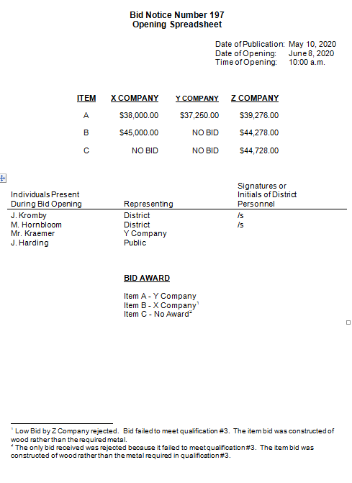

# Facilities

### Scope

Wisconsin State statutes require that the Wisconsin Technical College System Board approve proposals by Technical College Districts for land acquisition, additional or new facilities, rentals and remodeling of existing facilities. The Wisconsin Administrative Code, Chapter [TCS 5](http://docs.legis.wisconsin.gov/code/admin_code/tcs/5) includes the criteria to be used in the review of these proposals.

This chapter outlines the process to request that approval.

### Facilities Contact

Questions regarding facilities should be directed to:

Dan Scanlon  
Wisconsin Technical College System   
4622 University Avenue  
P.O. Box 7874  
Madison, WI 53707-7874  
608‑266‑1809  
[dan.scanlon@wtcsystem.edu](mailto:dan.scanlon@wtcsystem.edu)

## General Requirements

Acquisitions, new or additional facilities, or remodeling in excess of $1,500,000 (excluding movable equipment) and rentals with total lease payments over the term of the lease in excess of $3,000,000 shall be reviewed under a two-phased process consisting of Project Concept Review and Project Approval.

Acquisitions of real estate without improvements that would be used for instruction, located within one quarter mile of district-owned property, may be reviewed in a single-phased process. New or additional facilities, or remodeling related to the acquired real estate, will follow the appropriate facilities approval process.

Acquisitions, new or additional facilities, or remodeling of $1,500,000 or less (excluding movable equipment) or rentals with total lease payments over the term of the lease of $3,000,000 or less shall be reviewed in a single-phase process/Project Approval.

For all projects where donations are part of the funding, including donations made through a district’s foundation, documentation must be provided indicating the donor(s) name and amount(s) provided. In addition, for donations greater than $50,000, a letter from the donor, or donor’s representative, indicating the amount and date of the donation must be provided. If a donation is made by a district’s foundation where the foundation borrowed the funds, then documentation of the loan must be provided. If a donation is made by a district’s foundation from investment earnings, then documentation of those earnings must be provided. The first $5 million of donations for a project must be received by the district prior to WTCS Board approval. For all donations after the first $5 million, a minimum of 50 percent must be received by the district prior to WTCS Board approval. The remaining donations for the project shall be committed and placed in escrow (or similar binding arrangement) that sets out a schedule for disbursement of funds towards the project without qualifications or contingencies.

### Project Concept Review

Submission of Request. The submission must be made not less than 45 days prior to the State Board meeting at which the proposal will be reviewed. Depending on the complexity of the project and the completeness of the supporting material, WTCS Board action may not occur when requested.

### Project Approval

1. Submission of Request. The submission must be made not less than 45 days prior to the State Board meeting at which the request will be considered. Depending on the complexity of the project and the completeness of the supporting material, WTCS Board action may not occur when requested. Certain projects may require an Environmental Impact Statement (EIS). In those cases, the EIS must be prepared and public hearings conducted prior to submittal of the request for approval.
2. Approval Limits. Approvals are granted for a specific cost. If actual costs exceed the approved amount by more than 15%, additional review and approval by the WTCS Board is required. This additional approval shall be obtained prior to awarding of contracts.

## Requests

### Project Concept Review Request

In support of the request, the following information shall be submitted relative to the proposal for evaluation by the Wisconsin Technical College System Board.

1. A description of the project including approximate areas of new construction and/or remodeling, preliminary site plan and floor plan, preliminary budget, and project schedule.

2. A report relating programmatic and student requirements per TCS 5.04(2)(d). This report shall clearly document the need for the project.

3. Preliminary educational specifications or space program.

### Land Acquisition

In support of the request and as outlined in [TCS 5.04](http://docs.legis.wisconsin.gov/code/admin_code/tcs/5#/code/admin_code/tcs/5/_7), the following information relative to the proposal shall be submitted for evaluation by the Wisconsin Technical College System Board.

TCS 5.04(1)(a) "A resolution of the district board approving the land acquisition contingent upon board approval."

Provide a copy of the resolution approving the land acquisition. The property to be acquired shall be clearly identified in the resolution.

TCS 5.04(1)(c) "Evidence of compliance with s.1.11, Stats."

The appropriate environmental review Environmental Assessment (EA) or Environmental Impact Statement (EIS) pursuant to Chapter TCS 12, Wis. Adm. Code, must be completed. During project planning and well before the submittal of a Request for Approval, district staff shall consult with the WTCS Director of Facilities Development for a determination pursuant to Ch. TCS 12.03, Wis. Admin. Code, of the type of environmental review required. It should be noted that the EIS process can require 4 to 6 months to accommodate the required public comment periods. The environmental review must be completed prior to Wisconsin Technical College System Board action on the request.

TCS 5.04(1)(d) "A copy of a certified land survey indicating the boundaries and legal description of the land to be acquired."

In addition to the survey, provide a Phase I Environmental Site Assessment of the land and improvements to be acquired identifying any potential for environmental contamination.

TCS 5.04(1)(e) "A report relating programmatic and student station requirements, and the needs of business and industry, to the need for land acquisition. The report shall include data indicating the need for land acquisition based upon:

(1) An analysis of needs of business and industry for persons with new skills and persons with updated skills.

(2) An analysis of available student stations, and the need for additional student stations, including consideration of the needs of persons with handicaps.

(3) Relevant program trend data for the district, including enrollment and placement data as available.

TCS 5.04(1)(f) "A statement of the costs to be incurred for the land acquisition, including survey and legal fees."

In addition to the statement of costs, provide an appraisal of the market value for the property to be acquired and the offer to purchase.

TCS 5.04(1)(g) "A statement indicating the availability and specific source of funds for the land acquisition."

### Additional or New Facilities

In support of the request and as outlined in [TCS 5.04](http://docs.legis.wisconsin.gov/code/admin_code/tcs/5#/code/admin_code/tcs/5/_7), the following information relative to the proposal shall be submitted for evaluation by the Wisconsin Technical College System Board.

Pursuant to WTCS Board [Policy #706](http://www.wtcsystem.edu/board/pdf/policy_manual.pdf), all new construction in excess of 5,000 square feet shall be designed and constructed to meet the U.S. Green Building Council’s LEED Silver Certification Standards. To demonstrate compliance with the policy, the Request for Approval shall include:

The Technical College’s Sustainability Goals and the LEED Sustainable Design Worksheet for the project indicating the points to be achieved.

Documentation from the project architect that the project will be designed and specified to meet the LEED points identified on the Sustainable Design Worksheet.

It is noted that some building additions or remodeling projects, due to the scope, configuration, or other circumstances, may not be able to accumulate the points necessary for Silver Certification. Accordingly, an exception to meeting the LEED Silver Certification standards may be granted by the System Office, provided the inability to achieve the points is documented and the project is designed and constructed to the highest sustainable level possible.

1. TCS 5.04(2)(a) "A resolution of the district board approving the additional or new facilities."

Provide a copy of the resolution approving the additional or new facilities. The proposal shall be clearly identified in the resolution.

1. TCS 5.04(2)(c) "Evidence of compliance with [s. 1.11](http://docs.legis.wisconsin.gov/statutes/statutes/1/11), Stats."

The appropriate environmental review Environmental Assessment (EA) or Environmental Impact Statement (EIS) pursuant to Chapter [TCS 12](http://docs.legis.wisconsin.gov/code/admin_code/tcs/12), Wis. Adm. Code, must be completed. During project planning and well before the submittal of a Request for Approval, district staff shall consult with the WTCS Director of Facilities Development for a determination pursuant to Ch. TCS 12.03, Wis. Admin. Code, of the type of environmental review required. It should be noted that the EIS process can require 4 to 6 months to accommodate the required public comment periods. The environmental review must be completed prior to Wisconsin Technical College System Board action on the Request.

4. TCS 5.04(2)(d) "A report relating programmatic and student station requirements, and the needs of business and industry, to the need for additional or new facilities. The report shall include data indicating the need for additional or new facilities based upon:

(1) An analysis that considers the joint use of facilities as required under [s. 20.901(4)](https://docs.legis.wisconsin.gov/statutes/statutes/20/X/901), Stats.

(2) An analysis of needs of business and industry for persons with new skills and persons with updated skills.

(3) An analysis of available student stations, and the need for additional student stations, including consideration of the needs of persons with handicaps.

(4) Relevant program trend data for the district, including enrollment and placement data as available.

Please note that the reference to s. 20.901(4) Stats., relates to cooperation between the University of Wisconsin System and Wisconsin Technical College System. The response shall include current and projected utilization (hours per week and students per class) for classrooms and laboratories. The need for additional space shall be clearly documented. Typically, enrollments for the past three years as well as three year projections of the affected programs should be provided.

5. TCS 5.04(2)(e) "Educational specifications relating specific space requirements for approved programs to the need for additional or new facilities."

Provide a copy of the proposed space program identifying both net and gross square feet. For all proposed classrooms, laboratories or other instructional space, the number of student stations shall be identified.

6. TCS 5.04(2)(f) "An analysis of the fiscal impact of additional or new facilities on the district's operating budget, including availability and specific source of funds as required under s. TCS 5.05," which states:

TCS 5.05 "Fiscal impact. The analysis of the fiscal impact of additional or new facilities, rentals and remodeling of existing facilities submitted to the board under s. TCS 5.04(2)(f), (3)(e) and (f) shall include:

(1) Data relative to increased instructional costs, increased administrative, maintenance and energy costs and costs for new or replacement equipment resulting from the additional or new facilities, rentals or remodeling of existing facilities.

(2) A list of the source of funds in substantially the following form:

(a) Tax levy - FY

(b) Fund transfer or reserve fund

(c) Proposed sale of bonds or notes

(d) Other funds:

1. Federal funds

2. Gifts or grants

(e) Total funds

The specific response to TCS 5.05(1) should compare the operating costs of the current fiscal year with those projected for the first year following project completion. All significant changes in those costs must be discussed. The "total funds" noted in TCS 5.05(2) should equal the project cost.

7. TCS 5.04(2)(g) "A conceptual sketch of the proposed additional or new facilities."

Provide a copy of existing and proposed site plan and floor plan. Plans must be drawn to scale with the scale identified.

8. TCS 5.04(2)(h) "The estimated project cost by the following categories:

1. General construction

2. Heating, ventilating and air conditioning

3. Electrical

4. Plumbing

5. Other contracts (specify)

6. Equipment, both fixed and movable

7. Miscellaneous costs (specify)

8. Fees

9. TCS 5.04(2)(I) "A copy of the district energy study analysis indicating compliance with [s. 1.12](http://docs.legis.wisconsin.gov/code/admin_code/tcs/12/01/1), Stats."

This study shall consist of energy modeling to meet the U.S. Green Building Council’s LEED minimum energy performance and include all calculations and assumptions used.

### Leasing & Rentals

In support of the request and as outlined in TCS 5.04, the following information shall be submitted relative to the proposal for evaluation by the Wisconsin Technical College System Board.

Note: Districts are limited to $1.5 million in District borrowing, to improve the site, for the lifetime of the Districts occupation of a leased site and facility.

As outlined in TCS 5.09, “Exclusion of minor remodeling and minor rentals”, rentals of $50,000 or less and where the term of the lease is three years or less are considered minor rentals and are exempt from approval under s. 38.04 (10) (a), Stats.

1. TCS 5.04(3)(a) "A resolution of the district board approving the lease contingent upon board approval."

Provide a copy of the resolution approving the lease. The lease shall be clearly identified in the resolution.

2. TCS 5.04(3)(c) "A copy of the proposed lease reviewed by the district's legal counsel."

Include documentation from legal counsel that the lease has been reviewed.

3. TCS 5.04(3)(d) "A report relating programmatic and student station requirements, and the needs of business and industry, to the need for the rental. The report shall include data indicating the need for rental based upon:

(1) An analysis of needs of business and industry for persons with new skills and persons with updated skills.

(2) An analysis of available student stations, and the need for additional student stations, including consideration of the needs of persons with handicaps.

(3) Relevant program trend data for the district, including enrollment and placement data as available.

The response shall include current and projected utilization (hours per week and students per class) for classrooms and laboratories. The need for additional space shall be clearly documented.

4. TCS 5.04(3)(e) "An analysis of the fiscal impact of additional or new facilities on the district's operating budget, including availability and specific source of funds as required under s. [TCS 5.05](http://docs.legis.wisconsin.gov/code/admin_code/tcs/5/05)," which states:

TCS 5.05 "Fiscal impact. The analysis of the fiscal impact of additional or new facilities, rentals and remodeling of existing facilities submitted to the board under s. TCS 5.04(2)(f), (3)(e) and (4)(f) shall include:

(1) Data relative to increased instructional costs, increased administrative, maintenance and energy costs and costs for new or replacement equipment resulting from the additional or new facilities, rentals or remodeling of existing facilities.

(2) A list of the source of funds in substantially the following form:

(a) Tax levy - FY

(b) Fund transfer or reserve fund

(c) Proposed sale of bonds or notes

(d) Other funds:

1. Federal funds

2. Gifts or grants

(e) Total funds

The specific response to TCS 5.05(l) should compare the operating costs of the current fiscal year with those projected for the first year following project completion. All significant changes in those costs must be discussed. The "total funds" noted in TCS 5.05(2) should equal the project cost.

### Remodeling

In support of the request and as outlined in TCS 5.04, the following information relative to the proposal shall be submitted for evaluation by the Wisconsin Technical College System Board.

As outlined in TCS 5.09, “Exclusion of minor remodeling and minor rentals”, remodeling of existing facilities where project costs for a fiscal year do not exceed $100,000 per single campus site, as determined by the board under s. TCS 7.07(6), are considered minor remodeling and are exempt from board review and approval under s. 38.04 (10) (a), Stats.

Pursuant to WTCS Board Policy #706, all major renovation in excess of 5,000 square feet, where major renovation involves elements of major HVAC renovation, significant envelope modifications and major interior rehabilitation, shall be designed and constructed to meet the U.S. Green Building Council’s LEED Silver Certification standards. To demonstrate compliance with the policy, the Request for Approval shall include:

The Technical College’s Sustainability Goals and the LEED Sustainable Design Worksheet for the project indicating the points to be achieved.

Documentation from the project architect that the project will be designed and specified to meet the LEED points identified on the Sustainable Design Worksheet.

It is noted that some building additions or remodeling projects, due to the scope, configuration, or other circumstances, may not be able to accumulate the points necessary for Silver Certification. Accordingly, an exception to meeting the LEED Silver Certification standards may be granted by the System Office, provided the inability to achieve the points is documented and the project is designed and constructed to the highest sustainable level possible.

1. TCS 5.04(4)(a) "A resolution of the district board approving the remodeling of existing facilities."

Provide a copy of the resolution approving the remodeling of existing facilities. The proposal shall be clearly identified in the resolution.

2. TCS 5.04(4)(c) "Evidence of compliance with s. 1.11, Stats."

The appropriate environmental review Environmental Assessment (EA) or Environmental Impact Statement (EIS) pursuant to Chapter TCS 12, Wis. Adm. Code, must be completed. During project planning and well before the submittal of a Request for Approval, district staff shall consult with the WTCS Director of Facilities Development for a determination pursuant to Ch. TCS 12.03, Wis. Admin. Code, of the type of environmental review required. It should be noted that the EIS process can require 4 to 6 months to accommodate the required public comment periods. The environmental review must be completed prior to WTCSB action on the Request.

3. TCS 5.04(4)(d) "A report relating programmatic and student station requirements, and the needs of business and industry, to the need for additional or new facilities. The report shall include data indicating the need for additional or new facilities based upon:

(1) An analysis of needs of business and industry for persons with new skills and persons with updated skills.

(2) An analysis of available student stations, and the need for additional student stations, including consideration of the needs of persons with handicaps.

(3) Relevant program trend data for the district, including enrollment and placement data as available.

The response shall include current and projected utilization (hours per week and students per class) for classrooms and laboratories. The need for additional space shall be clearly documented. Typically, enrollments for the past three years as well as three year projections for the affected programs should be provided.

5. TCS 5.04(4)(e) "Educational specifications relating specific space requirements for approved programs to the need for remodeling of existing facilities."

Provide a copy of proposed space program including net and gross square feet. For all proposed classrooms, laboratories or other instructional space, the number of student stations shall be identified.

6. TCS 5.04(4)(f) "An analysis of the fiscal impact of additional or new facilities on the district's operating budget, including availability and specific source of funds as required under s. TCS 5.05," which states:

TCS 5.05 "Fiscal impact. The analysis of the fiscal impact of additional or new facilities, rentals and remodeling of existing facilities submitted to the board under s. TCS 5.04(2)(f), (3)(e) and (4)(f) shall include:

(1) Data relative to increased instructional costs, increased administrative, maintenance and energy costs and costs for new of replacement equipment resulting from the additional or new facilities, rentals or remodeling of existing facilities.

(2) A list of the source of funds in substantially the following form:

(a) Tax levy - FY

(b) Fund transfer or reserve fund

(c) Proposed sale of bonds or notes

(d) Other funds:

1. Federal funds

2. Gifts or grants

(e) Total funds

The specific response to TCS 5.05(l) should compare the operating costs of the current fiscal year with those projected for the first year following project completion. All significant changes in those costs must be discussed. The "total funds" noted in TCS 5.05(2) should equal the project cost.

7. TCS 5.04(4)(g) "A conceptual sketch of the proposed remodeling of existing facilities."

Provide a copy of existing and proposed site plan and floor plan. Plans must be drawn to scale with the scale identified.

8. TCS 5.04(4)(h) "The estimated project cost by the following categories:

1. General construction

2. Heating, ventilating and air conditioning

3. Electrical

4. Plumbing

5. Other contracts (specify)

6. Equipment, both fixed and movable

7. Miscellaneous costs (specify)

8. Fees

9. TCS 5.04(4)(I) A copy of the district energy study analysis indicating compliance with s.1.12, Stats.

Major remodeling projects designed to U.S. Green Building Counsel’s LEED Silver Certification require energy modeling to verify compliance with minimum energy performance. For those projects, attach the modeling calculations. The criteria is not applicable to other remodeling projects.

## Three Year Facilities Plan

Annually, each Wisconsin Technical College District is required to prepare and submit a Three‑Year Facilities Plan to the Wisconsin Technical College System Board (WTCSB). The Plan must be approved by the District Board and submitted no later than August 1st of each year. The reporting shall be on a fiscal year basis and include information for the current and next two fiscal years. The Plan will be accepted and reviewed by the WTCSB but no action will be taken, as each project continues to be subject to review and approval on an individual basis pursuant to s. 38.04(10), Stats.

Facility development projects, acquisitions, construction of new or addition facilities, and remodeling that have not been included in a Plan will not be considered for WTCSB review and approval. However, recognizing the need for districts to be responsive, an exception may be granted to this policy provided a Technical College can demonstrate extenuating circumstances. The WTCSB will act on granting an exception prior to taking any action on the project.

The Plan shall be arranged as follows:

**Section 1 – Executive Summary**

Provide a summary of projects under consideration during the planning period (a total dollar amount for each category in Section 3) and a brief description of the Technical College’s facilities planning process. Include, by reference or summary, any comprehensive long-range facilities planning studies that have been undertaken.

**Section 2 – Existing Facilities**

Provide a listing of properties owned or leased by the district. (Leased space defined as “minor rental” per TCS 5.09 Wis. Adm. Code shall be excluded.) For each campus, provide a summary matrix/table with the floor area as detailed in Attachment A.

List the value of owned existing properties. This data should be consistent with the data included in the Comprehensive Annual Financial Report and list land/improvements and buildings separately.

**Section 3 – Three-Year Project Summary**

Provide a summary of capital projects and rentals under consideration for each of the next three years as follows:

* Acquisition / Building Construction
* Remodeling
* Capital Improvements
* Rentals

For the acquisition / building construction and remodeling projects, provide a brief description of project scope including approximate area, rationale for project, budget, source of funds, and year of implementation.

For the capital improvement projects, provide only the total anticipated budget for each year. Such projects generally represent the renewal or replacement of existing building components or systems, independent of remodeling that reallocates or reconfigures space, and is further defined in TCS 7.06(4) Wis. Admin. Code.

**WTCS Facility Inventory System Detailed Report of Space**

The WTCS Facility Inventory System is a physical inventory of buildings and rooms for all district-owned facilities. The Inventory provides a breakdown by campus, building, and individual rooms. Those rooms are classified by function, area, and number of student stations where applicable.

Technical Colleges shall maintain the WTCS Facility Inventory System. A revision to the Inventory submitted in July 2003, as a part of the 2003-08 Facilities Plans, must be submitted only when the building area of a campus has been increased or decreased.

The Three-Year Facilities Plan shall include a summary matrix / table showing the total floor area for these four general categories at each campus:

* Instruction 100 & 200 Series
* Office 300 Series
* General/ Support 400, 500, 600 & 700 Series
* Non-Assignable WWW, XXX & YYY

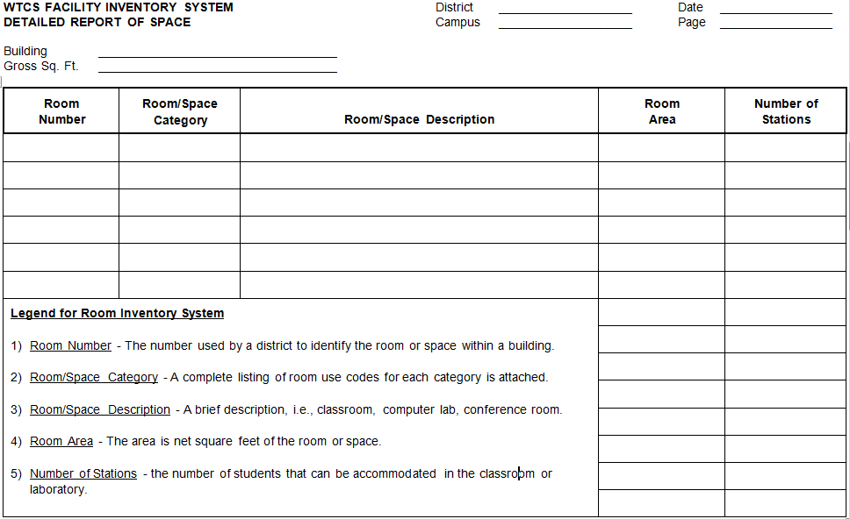

**Room Use Codes WTCS Facility Inventory System** (Based upon Postsecondary Education Facilities Inventory and Classification Manual, U.S. Dept. Of Ed., Nov. 1992)

**100 Classroom Facilities**

**General** This category aggregates classroom facilities as an institution-wide resource, even though these areas may fall under different levels of organizational control. The term “classroom” includes not only general purpose classrooms, but also lecture halls, recitation rooms, seminar rooms, and other rooms used primarily for scheduled non-laboratory instruction.

**110 Classroom** Definition: A room used for classes and that is also not tied to a specific subject or discipline by equipment in the room or the configuration of the room.

**115 Classroom Service** Definition: A room that directly serves one or more classroom s as an extension of the activities in that room.

**200 Laboratory Facilities**

**General** A laboratory is a facility characterized by special purpose equipment or a specific room configuration which ties instructional or research activities to a particular discipline or a closely related group of disciplines.

**210 Class Laboratory** Definition: A room used primarily for formally or regularly scheduled classes that require special purpose equipment or a specific room configuration for student participation, experimentation, observation, or practice.

**215 Class Laboratory Service** Definition: A room that directly serves one or more class laboratories as an extension of the activities in those rooms.

**220 Open Laboratory** Definition: A laboratory used primarily for individual or group instruction that is informally scheduled, unscheduled, or open.

**225 Open Laboratory Service** Definition: A room that directly serves one or more open laboratories as an extension of the activities in those rooms.

**300 Office Facilities**

**General** Office facilities are individual, multi-person, or workstation space specifically assigned to academic, administrative, and service functions of a college or university.

**310 Office** Definition: A room housing faculty, staff, or students working at one or more desks, tables, or workstations.

**315 Office Service** Definition: A room that directly serves an office or group of offices as an extension of the activities in those rooms.

**350 Conference Room** Definition: A room serving an office complex and used primarily for staff meetings and departmental activities.

**400 Study Facilities**

**General** Study space is classified into three categories: study room, stack and open-stack study.

**410 Study Room** Definition: A room or area used by individuals to study at their convenience, which is not restricted to a particular subject or discipline by contained equipment.

**420 Stack** Definition: A room used to house arranged collections of educational materials for use as a study resource.

**430 Open-Stack Study Room** Definition: A combination study room and stack, generally without physical boundaries between the stack and study areas.

**500 Special use Facilities**

**General** This category includes several room use categories that are sufficiently specialized in their primary activity or function to merit a unique room code.

**520 Athletic or Physical Education** Definition: A room or area used by students, staff, or the public for athletic or physical education activities.

**530 Media Production** Definition: A room used for the production or distribution of multimedia materials or signals.

**540 Clinic** Definition: A room used for providing diagnosis, consultation, treatment or other services to patients.

**600 General Use Facilities**

**General** General use facilities are characterized by a broader availability to faculty, students, staff, or the public than are Special Use Facilities (500 series), which are typically limited to a small group or special population.

**610 Assembly** Definition: A room designed and equipped for the assembly of many persons for such events as dramatic, musical, devotional, livestock judging, or commencement activities.

**620 Exhibition** Definition: A room or area used for exhibition of materials, works of art, artifacts, etc., and intended for general use by faculty, students, staff, and the public.

**630 Food Facility** Definition: A room used for eating.

**635 Food Facility Service** Definition: A room that directly serves a food facility as an extension of the activities in that facility.

**640 Day Care** Definition: A room used to provide day or night, child or elderly adult care as a nonmedical service to members of the institutional community.

**650 Lounge Definition:** A room used for rest and relaxation that is not restricted to a specific group of people, unit or area.

**660 Merchandising** Definition: A room used to sell products or services.

**670 Recreation** Definition: A room used by students, staff or the public for recreational purposes.

**680 Meeting Room** Definition: A room that is used by the institution or the public for a variety of non-classroom meetings.

**700 - Support Facilities**

**710 Central Computer Or Telecommunications** Definition: A room used as a computer based data processing or telecommunications center with applications that are broad enough to serve the overall administrative or academic primary equipment needs of a central group of users.

**720 Shop** Definition: A room used for the manufacture, repair, or maintenance of products or equipment.

**730 Central Storage** Definition: A room or building that is used to store equipment or materials and that serves multiple room use categories, organizational units, or buildings.

**750 Central Service** Definition: A room or area that is used for the processing, preparation, testing, or delivery of a complex-central or campus-wide support service.

**Nonassignable Area**

The following categories are included to complete the list of room use categories for institutions that choose to include nonassignable space in the facilities room inventory.

* WWW Circulation Area
* XXX Building Service Area
* YYY Mechanical Area

## Single Campus Site Designation

The designation of Single Campus Sites by Wisconsin Technical College System Board is based in Statute and Administrative Rule. In establishing capital expenditure limits [s. 38.15](https://docs.legis.wisconsin.gov/statutes/statutes/38/15) Stats. states in part:

….all projects located on a single campus site within one district which are bid concurrently or which are approved by the board under [s.38.04(10)](https://docs.legis.wisconsin.gov/statutes/statutes/38/04) within a two-year period shall be considered as one capital expenditure project.

The Wisconsin Technical College System Board’s definition for designating an additional single campus site provides that:

The facilities are owned by the District, have a value in excess of the referendum limit (currently $1,500,000); and

The facilities are not located within a reasonable commuting distance (30 miles) of another designated campus.

**Single Campus Site Designations**

**(For Purposes of** [**s. 38.15**](https://docs.legis.wisconsin.gov/statutes/statutes/38/15)**)**

**Blackhawk Technical College District**

Site #1 Janesville

- Aviation Center

- Transportation Center

Site #2 Monroe

**Chippewa Valley Technical College District**

Site #1 Eau Claire

- West/Gateway Campus

Site #2 Chippewa Falls

Site #3 Menomonie

Site #4 River Falls

**Fox Valley Technical College District**

Site #1 Appleton

Site #2 Oshkosh

- Aviation Center

Site #3 Chilton

Site #4 Wautoma

**Gateway Technical College District**

Site #1 Kenosha

- Transportation Center

Site #2 Racine

Site #3 Elkhorn

**Lakeshore Technical College District**

Site #1 Cleveland

**Madison Area Technical College District**

Site #1 Madison - Truax

- Commercial Avenue Center

- Downtown Education Ctr.

Site #2 Watertown

Site #3 Fort Atkinson

Site #4 Portage

Site #5 Reedsburg

**Mid-State Technical College District**

Site #1 Wisconsin Rapids

Site #2 Marshfield

Site #3 Stevens Point

**Milwaukee Area Tech. College District**

Site #1 Milwaukee

Site #2 Oak Creek

- Aviation Center

Site #3 Mequon

Site #4 West Allis

**Moraine Park Technical College District**

Site #1 Fond du Lac

Site #2 West Bend

Site #3 Beaver Dam

**Nicolet Area Technical College District**

Site #1 Rhinelander

**Northcentral Technical College District**

Site #1 Wausau

Site #2 Antigo

Site#3 Phillips

**Northeast WI Technical College District**

Site #1 Green Bay

Site #2 Sturgeon Bay

Site #3 Marinette

Site #4 Shawano

**Southwest WI Technical College District**

Site #1 Fennimore

**Waukesha County Area Technical College** **District**

Site #1 Pewaukee

Site #2 Waukesha

**Western WI Technical College District**

Site #1 LaCrosse

- Industrial Park Center

Site #2 Mauston

Site #3 Independence

- Black River Falls

Site #4 Tomah

Site #5 Viroqua

Site #6 Sparta

**WI Indianhead Technical College District**

Site #1 Rice Lake

Site #2 New Richmond

Site #3 Ashland

Site #4 Superior

Site #5 Shell Lake

# SUMMARY OF CHANGES

## Overall

Cleaned up formatting throughout the entire manual.

Removed ASC date references throughout the manual.

Added hyperlinks to authoritative guidance (primarily Wis. Statutes) referenced.

## UFFAS

Clarified capitalization threshold of $5,000 throughout this section.

Updated Fund Balance Designations and associated UFFAS edits for new personal property tax aid classification 4214.

Removed Staff Accounting references throughout section.

Updated Fiduciary Fund language to reflect changes made with GASB 84: removed expendable trust fund, non-expendable trust fund and agency fund; added pension trust fund, investment trust fund, private-purpose trust fund and custodial fund; updated Fiduciary Activities; and added a flowchart to assess reporting of Fiduciary Activities. Changed UFFAS edits to allow student fees (classification 4571) in Fund 2.

Updated OPEB guidelines to reflect changes made with GASB 74 & 75.

Updated examples of Enterprise Operations in the Non-Governmental Fund Accounting guidance.

## Annual Budget

Removed Staff Accounting references throughout section.

Updated budgetary statement examples.

Updated Fiduciary Fund language to reflect changes made with GASB 84.

## The Financial and Single Audit

Updated Fiduciary Fund language to reflect changes made with GASB 84.

## Cost Allocation Report

Removed Staff Accounting references throughout section.

## Procurement

The federal micro-purchase procurement threshold has increased to $10,000, or $25,000 for those districts approved by the Federal government.

## Facilities

Single campus site designation list has been updated.

The Wisconsin Technical College System (WTCS) is in full compliance with state and federal equal opportunity and affirmative action laws and regulations including Title VII of the 1964 Civil Rights Act, Age Discrimination in Employment Act, Title VI of the 1964 Civil Rights Act, Equal Pay Act, Title IX of the 1972 Education Amendments, and Section 504 of the 1973 Rehabilitation Act, Wisconsin Fair Employment Law, Wisconsin Civil Service Law and Executive Orders, the Carl Perkins Career and Technical Education Act, Adult Basic Education Act, Job Training Partnership Act, the Office of Civil Rights Guidelines for the Elimination of Discrimination in Technical Education, the Americans with Disabilities Act, and/or other applicable state or federal legislation. It is the policy of the WTCS not to discriminate on the basis of race, color, creed, national origin, religion, sex, age, disability, arrest record, conviction record, political affiliation, marital status, sexual orientation, and membership in the National Guard, state defense force or any other reserve component of the military forces of the United States, or this state. Inquiries regarding equal opportunity may be directed to the Wisconsin Technical College System, P.O. Box 7874, Madison, Wisconsin 53707-7874; telephone (608) 266-1766 or Telecommunications Device for the Deaf (TDD) (608) 267-2483. Internet: [www.wtcsystem.edu](http://www.wtcsystem.edu/)

1. P. 13, Governmental Accounting and Financial Reporting Standards as of November 1, 1984, GASB.
2. P. 13, Governmental Accounting and Financial Reporting Standards as of November 1, 1984, GASB.
3. From statement prepared on the budgetary basis (including encumbrances).