Program Enrollment Cube Examples
Data to Support Program Development Efforts
- We believe that clients living within our district are enrolling in an academic program in a surrounding district that we do not currently offer. How do I find data to validate this assumption?
Connect to the WTCS server through the Cisco VPN. Open Excel and connect to the Program Enrollment Cube. Reference the OLAP Cube Connection Requirements and Instructions for District Users document for full instructions on connecting to the Cubes. Once connected, replicate the below Cube combination. In the filters, limit the District field to the districts you believe clients from your district are enrolling; this ensures you are filtering for all districts data but your own. Additionally, filter the District of Residence field to include your district; this ensures you are filtering for clients who live within your district. The resulting combination will provide you with the number of clients within your district who are enrolling in the academic program outside of your district.
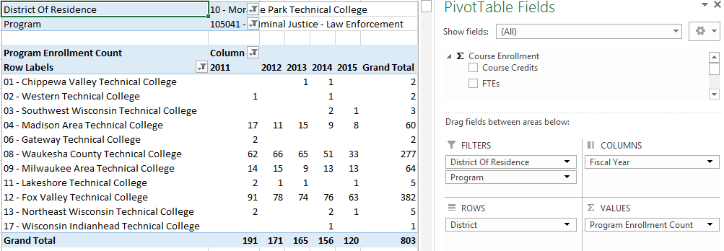

Data to Identify Academic Program High School Direct Enrollment
- How do I identify my districts high school enrollment patterns into academic programs? Am I able to see if my districts high school graduates are enrolling in an academic program at a surrounding district?
Connect to the WTCS server through the Cisco VPN. Open Excel and connect to the Program Enrollment Cube. Reference the OLAP Cube Connection Requirements and Instructions for District Users document for full instructions on connecting to the Cubes. Once connected, replicate the below Cube combination. In the filters, limit the Effort District field to your district number; this ensures you are filtering for your district high schools. Additionally, filter the Fiscal Year field to the fiscal year of direct enrollment you are interested in analyzing. Finally, filter the High School Graduation Year field to (Fiscal Year – 1); this ensures you are filtering for direct enrollments. The resulting combination will provide you with the number of direct enrollments into an academic program among high schools within your district. Add a filter for Program to limit the results by academic program or certificate of enrollment.
