WTCS QRP Cube User’s Guide
QRP – Indicator #1 Successful Course Completion
Contents
Overview: 1
Cube Measure Group & Dimension Groups: 1
How to Use the Data: 8
Cube Combination Examples: 9
Drill-Through Capabilities: 12
Commonly Asked Questions: 13

Overview:
The QRP – Indicator #1 Successful Course Completion Cube includes a Curriculum Course Completion Metrics measure group and ten dimension groups. Dimensions can be used to uncover the who, what, when, and where in an effort to answer why high or low successful course completion rates exist. In essence, the Cube is meant to drive continuous improvement efforts by uncovering anomalies, and by providing actionable pieces of data.

Cube Measure Group & Dimension Groups:

Measure Group:
Curriculum Course Completion Metrics – data is sourced to the WTCS Client Reporting System and the WTCS Course and Curriculum System; courses within a programs curriculum are identified through district submissions in the Course and Curriculum System; program enrollees are identified through district submissions in the Client Reporting System with program enrollments on the S9 record; course enrollments are identified through district submissions in the Client Reporting System with course enrollments on the S3 record
Measures:
Courses - Enrolled – the duplicated count of curriculum course enrollments for a specific program among students enrolled in the program
Courses - Successfully Completed – the duplicated count of curriculum course enrollments with a grade of C or better or a PP grade for a specific program among students enrolled in the program
Courses - % Successfully Completed – the quotient of “Courses - Successfully Completed” and “Courses - Enrolled”
Credits - Enrolled – the sum of curriculum course credits enrolled for a specific program among students enrolled in the program
Credits - Successfully Completed – the sum of curriculum course credits enrolled with a grade of C or better or a PP grade for a specific program among students enrolled in the program
Courses - % Successfully Completed – the quotient of “Credits - Successfully Completed” and “Credits - Enrolled”
FTEs - Enrolled – the sum of curriculum course FTEs enrolled for a specific program among students enrolled in the program
FTEs - Successfully Completed – the sum of curriculum course FTEs enrolled with a grade of C or better or a PP grade for a specific program among students enrolled in the program
FTEs - % Successfully Completed – the quotient of “FTEs - Successfully Completed” and “FTEs - Enrolled”
Measure Group:
Curriculum Course Student Count – data is sourced to the same data systems as the “Curriculum Course Completion Metrics”
Measures:
Student Count – the unduplicated count of students enrolled in the program and the programs curriculum

Dimension Group:
Client Demographic – data is sourced to the WTCS Client Reporting System
Dimensions:
Academically Disadvantaged – reference definitions in the Client Reporting System Manual; based on Academically Disadvantaged field
Age Group – calculated age as of June 1st of the fiscal year in question; age is based on Birth Date field in Client Reporting; age is grouped into the following categories; <18, 18-24, 25-29, 30-34, 35-44, 45-54, 55-61, 62 and Older, and Unknown when Client date of birth is not reported
Client Number – WTCS assigned number for each Client reported in Client Reporting
County of Residence – reference definitions in the Client Reporting System Manual; based on County Code field
Disability – reference definitions in the Client Reporting System Manual; based on Person with Disability field
Displaced Homemaker – reference definitions in the Client Reporting System Manual; based on Displaced Homemaker field
District of Residence – reference definitions in the Client Reporting System Manual; based on WTCS District of Residence field
District Student Id – reference definitions in the Client Reporting System Manual; based on District Student ID field
Economically Disadvantaged – reference definitions in the Client Reporting System Manual; based on Economically Disadvantaged field
Effort District – the WTCS district a high school is located in, per the district boundaries defined in WTCS State Board policy; this code is not reported, but is added to the high school tables to allow Technical Colleges and the System Office to see where high school attendees/graduates from the various Technical College districts enroll

Full-time 24 Or More Credits – calculation of the sum of credits enrolled in during the said academic year; includes credits across all aid codes from Client Reporting
Gender – reference definitions in the Client Reporting System Manual; based on Sex Code field
High School Graduation Year – reference definitions in the Client Reporting System Manual; based on Year of High School Graduation field
High School Last Attended - reference definitions in the Client Reporting System Manual; based on High School Attended field
Highest Credential Received - reference definitions in the Client Reporting System Manual; based on Highest Credential Received at Enrollment field
Highest Grade Completed - reference definitions in the Client Reporting System Manual; based on Highest Grade Completed at Enrollment field
Incarcerated - reference definitions in the Client Reporting System Manual; based on Incarcerated field
Limited English Proficiency - reference definitions in the Client Reporting System Manual; based on Limited English Proficiency field
Minority - reference definitions in the Client Reporting System Manual; based on Ethnic Code/Race field; minority status of “Yes” includes American Indian/Alaskan Native, Asian, Black, Hispanic, Multiple, Pacific Islander; minority status of “No” includes White and Unknown
Municipality of Residence - reference definitions in the Client Reporting System Manual; based on Municipality Code field
Program Enrollee – Student has an S9 record in Client Reporting in the said academic year
Program Graduate – Student has an S9 graduate record in Client Reporting in the said academic year
Race Ethnicity - reference definitions in the Client Reporting System Manual; based on Ethnic Code/Race field
Single Parent - reference definitions in the Client Reporting System Manual; based on Single Parent field
Work Status - reference definitions in the Client Reporting System Manual; based on Work Status at Enrollment field
Dimension Group:
Course Completion Status – data is sourced to the WTCS Client Reporting System
Dimensions:
Completion Status – reference definitions in the Client Reporting System Manual; based on Course Completion Status field
Dimension Group:
Course Details – data is sourced to the WTCS Client Reporting System; limited to courses within a programs curriculum as reported in the Course and Curriculum System
Dimensions:
Academic Or Technical Course – based on the first digit of the Instructional Area Number field; Instructional Area Number that begins with 8 are Academic Courses; Instructional Area Number that begins with anything but 8 are Technical Courses
Aid – reference definitions in the Client Reporting System Manual; based on Aid Code field
Course – a combination of the Course Number field reported in Client Reporting and the Course Title field reported in the Course and Curriculum System
Course Number – reference definitions in the Client Reporting System Manual; based on Course Number field
Course Title – reference definitions in the Course and Curriculum System; based on Course Title field
Instructional Area Code - reference definitions in the Client Reporting System Manual; based on Instructional Area Number field
Dimension Group:
Course Grades – data is sourced to the WTCS Client Reporting System
Dimensions:
Course Grade – reference definitions in the Client Reporting System Manual; based on Course Grade field
Dimension Group:
Course Section – data is sourced to the WTCS Client Reporting System
Dimensions:
Course Section – reference definitions in the Client Reporting System Manual; based on Section Number field
Dimension Group:
Courses Delivery – data is sourced to the WTCS Client Reporting System
Dimensions:
Course Delivery Method – reference definitions in the Client Reporting System Manual; based on Nonstandard Delivery Code field
Dimension Group:
Districts – data is sourced to the WTCS Client Reporting System
Dimensions:
District – reference definitions in the Client Reporting System Manual; combined field including the District Number field reported in the Client Reporting System and the associated district name
District Code – reference definitions in the Client Reporting System Manual; based on District Number field
District Initials – initials of district based on the District Number field in the Client Reporting System
District Name – district name based on the District Number field in the Client Reporting System
District Short Name – district name excluding “Technical College” verbiage; based on the District Number field in the Client Reporting System
Dimension Group:
Fiscal Year – data is sourced to the WTCS Client Reporting System
Dimensions:
Fiscal Year – reference definitions in the Client Reporting System Manual; based on Fiscal Year field
Dimension Group:
Location of Instruction – data is sourced to the WTCS Client Reporting System
Dimensions:
Location – reference definitions in the Client Reporting System Manual; based on Location Code field
Dimension Group:
Program Type – data is sourced to the WTCS Program Approval System
Dimensions:
Program Type – Programs can be assigned a program type that can be unique to the district; this is the field that the WTCS uses to flag Embedded Technical Diplomas, shared programs, etc.
Dimension Group:
Programs – data is sourced to the WTCS Client Reporting System
Dimensions:
Career Cluster – Each program is assigned a Career Cluster; more information can be found on MyWTCS
CIP Code – Classification of Instructional Programs (CIP) assigned to an academic program during the program approval process
Division – Each program is assigned a Division; division is assigned based on the first digit of the programs instructional area
Instructional Area – the description associated with the three digit instructional area code within the program number
Instructional Area Code – the three digit instructional area code associated with a program number ex. program number = 10-101-1 and instructional area code = 101
NTO Bias – identifies if a “Male Gender Bias”, “Female Gender Bias”, or “No Bias” exists for a program
Program – combination of the program number and the program title associated with the program number
Program Aid Code – the first two digits of the program number
Program Number – reference definitions in the Client Reporting System Manual; based on Program Number field
Dimension Group:
Recognized Credit – data is sourced to the WTCS Client Reporting System
Dimensions:
Recognized Credit Code – reference definitions in the Client Reporting System Manual; based on the first two digits of the Recognized Credit Code field
Recognized Credit Code Descriptor – reference definitions in the Client Reporting System Manual; based on Recognized Credit Code field
FTE Generating – reference definitions in the Client Reporting System Manual; any course with a Recognized Credit Code with a type of credit of 1 thru 8 are non-FTE-generating course records

How to Use the Data:
The purpose of the QRP Cubes is to provide Colleges with business intelligence resources to drive continuous improvement efforts. Below are some example uses of the various dimension groups to assist in continuous improvement.
Dimension Group | Example Uses
Client Demographic | Identify which demographic groups are positively or negatively impacting QRP indicators.
Course Completion Status | Identify withdrawals or incompletes; compare completion status codes with course grades for reporting consistency.
Course Details | Identify which courses within a program curriculum are positively or negatively impacting QRP indicators.
Course Grades | Identify the grade distribution within a course or a demographic group.
Course Section | Identify specific course sections that are positively or negatively impacting QRP indicators.
Courses Delivery | Identify program or individual course completion rates by course delivery method; identify the delivery methods that appear to be positively or negatively impacting QRP indicators.
Districts | Benchmark successes or areas for improvement with other districts. Data can be used to prompt an in-depth conversation with other districts for best-practice sharing.
Fiscal Year | Identify trends for QRP indicators.
Location of Instruction | Identify which course locations are positively or negatively impacting QRP indicators.
Program Type | Identify the Embedded Technical Diplomas within your district to better understand Career Pathway student outcomes
Programs | Identify which programs have high or low success rates and identify QRP indicator benchmarks by career cluster or division.
Recognized Credit | Limit the types of credit in the analysis; example, include only FTE-generating courses.

Cube Combination Examples:
- Identify QRP Successful Course Completion indicators for a program.
Connect to the WTCS server through the Cisco VPN. Open Excel and connect to the QRP – Indicator #1 Successful Course Completion Cube. Reference the OLAP Cube Connection Requirements and Instructions for District Users document for full instructions on connecting to the Cubes. Once connected, replicate the below Cube combination. In the filters, limit the FTE Generating field to “Y” and “Yes – No Recognized Credit Code”; this ensures you are not including any compulsorily education courses not taken at your institution. Additionally, filter the Completion Status field to include statuses of “01 Pass”, “02 Fail”, and “04 Withdraw”; this ensures you are not including course records in your denominator that were never assigned letter grade or a completion status not applicable to QRP Successful Course Completion. The resulting combination will provide you with successful course completion indicators for academic and technical courses. The Grand Total row will identify overall course completion; academic and technical courses together. The Grand Total column will identify course completion for all of the years included in the analysis for each row.
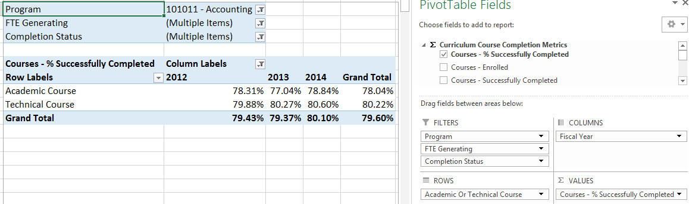
- Identify QRP Successful Course Completion indicators for a program for your district and other districts.
Connect to the WTCS server through the Cisco VPN. Open Excel and connect to the QRP – Indicator #1 Successful Course Completion Cube. Reference the OLAP Cube Connection Requirements and Instructions for District Users document for full instructions on connecting to the Cubes. Once connected, replicate the below Cube combination. In the filters, limit the FTE Generating field to “Y” and “Yes – No Recognized Credit Code”; this ensures you are not including any compulsorily education courses not taken at your institution. Additionally, filter the Completion Status field to include statuses of “01 Pass”, “02 Fail”, and “04 Withdraw”; this ensures you are not including course records in your denominator that were never assigned letter grade or a completion status not applicable to QRP Successful Course Completion. The resulting combination will provide you with successful course completion indicators for academic and technical courses by district. This combination can be used for benchmarking purposes. The individual district row will identify overall course completion for the district; academic and technical courses together. The Grand Total column will identify course completion for all of the years included in the analysis for each row.
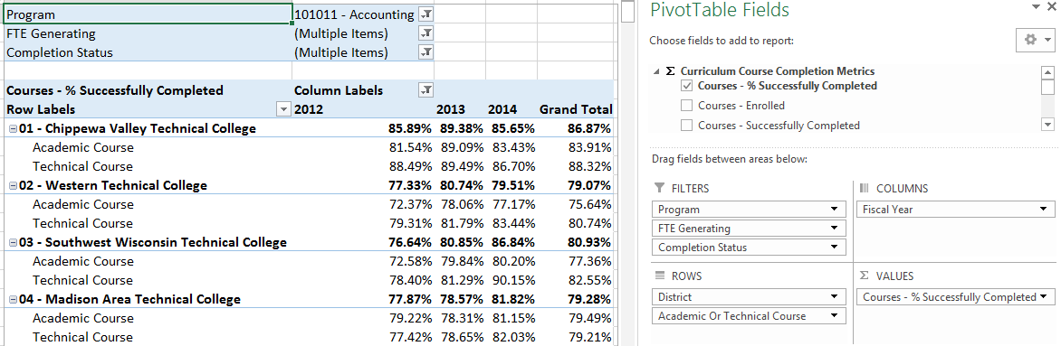
- Identify the courses within a programs curriculum that are positively or negatively impacting QRP Successful Course Completion indicators for a program.
Connect to the WTCS server through the Cisco VPN. Open Excel and connect to the QRP – Indicator #1 Successful Course Completion Cube. Reference the OLAP Cube Connection Requirements and Instructions for District Users document for full instructions on connecting to the Cubes. Once connected, replicate the below Cube combination. In the filters, limit the FTE Generating field to “Y” and “Yes – No Recognized Credit Code”; this ensures you are not including any compulsorily education courses not taken at your institution. Additionally, filter the Completion Status field to include statuses of “01 Pass”, “02 Fail”, and “04 Withdraw”; this ensures you are not including course records in your denominator that were never assigned letter grade or a completion status not applicable to QRP Successful Course Completion. The resulting combination will provide you with successful course completion indicators for all academic and technical courses within a program as well as successful course completion for each course within the programs curriculum. This combination can be used for root cause analysis. The academic course and technical course rows will identify overall course completion for all of the courses within each set of academic and technical courses. The Grand Total column will identify course completion for all of the years included in the analysis for each row.
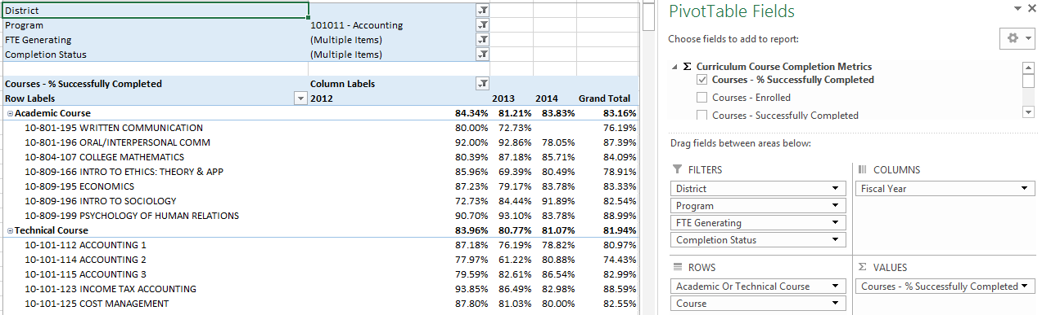

- Identify the course characteristics or student demographics for a program curriculum course that are positively or negatively impacting QRP Successful Course Completion indicators for a program.
Connect to the WTCS server through the Cisco VPN. Open Excel and connect to the QRP – Indicator #1 Successful Course Completion Cube. Reference the OLAP Cube Connection Requirements and Instructions for District Users document for full instructions on connecting to the Cubes. Once connected, replicate the below Cube combination. In the filters, limit the FTE Generating field to “Y” and “Yes – No Recognized Credit Code”; this ensures you are not including any compulsorily education courses not taken at your institution. Additionally, filter the Completion Status field to include statuses of “01 Pass”, “02 Fail”, and “04 Withdraw”; this ensures you are not including course records in your denominator that were never assigned letter grade or a completion status not applicable to QRP Successful Course Completion. The resulting combination will provide you with successful course completion indicators for a program course broken out by course characteristics or student demographics. This combination can be used for root cause analysis. The Grand Total column will identify course completion for all of the years included in the analysis for each row.
Student Demographics:
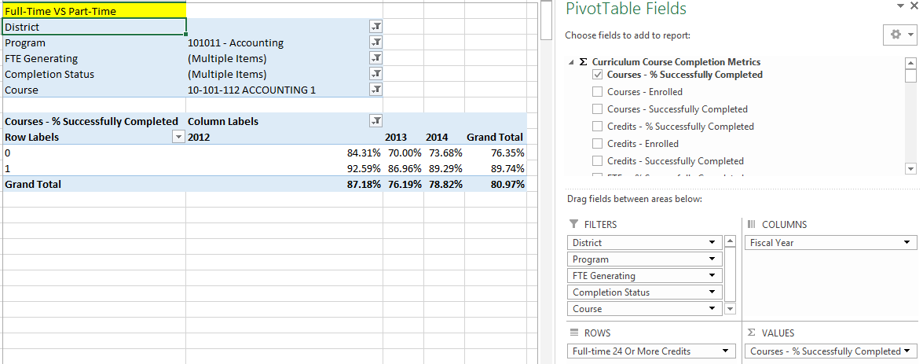
Course Characteristics:
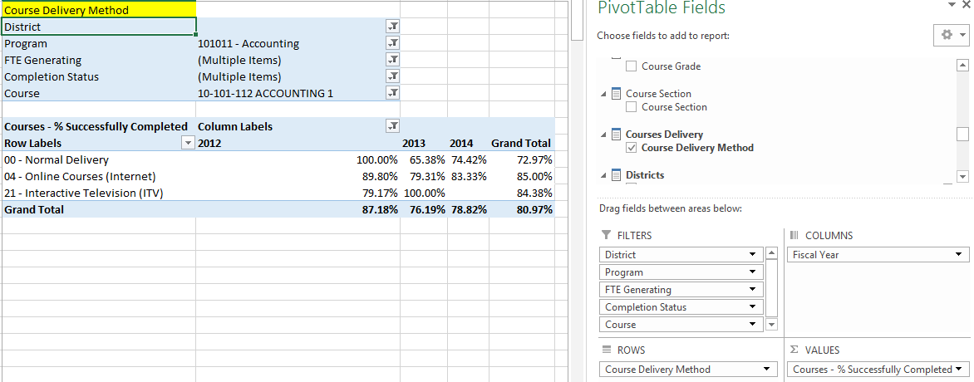

Drill-Through Capabilities:
Excel 2013 or more recent versions allow end-users to drill-through QRP Indicator measures within the Cubes. Follow these steps to drill-through:
- Select the measure cell you want to drill-through.
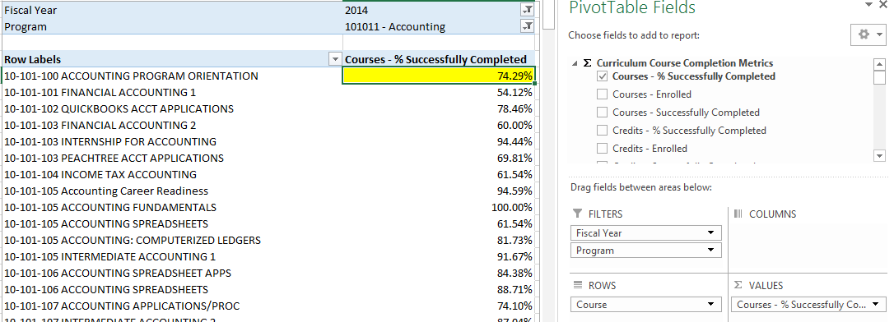
- Right-click in the field and select “Quick Explore”.
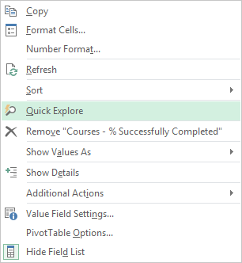
- An “Explore” menu will populate – select a field within the available dimensions that you would like to drill-through to get more details and double-click. In this example, “Academically Disadvantaged” is selected. The resulting output shows the measure for the field selected in step one, and is broken out by the field selected in step three
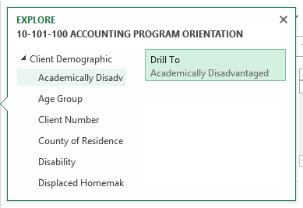

Commonly Asked Questions:
- Where does the data come from that the Cubes draw from?
Data within the Cubes is sourced to the data the districts supply in Client Reporting and Course and Curriculum submissions.
- Are alternate courses included when assessing course completion within a programs curriculum?
The Cubes are built to include alternate courses within a programs curriculum. If the district supplies the courses within their Course and Curriculum files for the fiscal year assessed, then they will be included within the Cubes.
- I am noticing that the courses within a program are not matching the courses within the program curriculum posted on our website; why is that?
The courses tied to the programs curriculum are driven by what is supplied in the Course and Curriculum files that the districts supply to the WTCS. If the district does not supply an up-to-date Course and Curriculum file each fiscal year, then the courses will not be included in the QRP indicator.
- I am noticing that a lot of course records have Unknown grades. Why is that?
The 04 – Withdrew course completion status code will result in an Unknown course grade; reference the valid Course Grades and Course Completion Status matrix for the S3 record in the Client Reporting Manual. Course grades within the Cubes are driven by what is supplied in the Client Reporting files that the districts supply to the WTCS. If the district does not supply grades, then grades will not be available within the cubes and presented as Unknown.
- I am noticing Course Grade and Completion Status combinations that don’t seem to align. Why is that?
Course Grade and Completion Status fields within the Cubes are driven by what is supplied in the Client Reporting files that the districts supply to the WTCS. The Course Grade and Completion Status are two separate fields on the S3 record of Client Reporting. Some Client edits exist to stop mismatch combinations between Course Grade and Completion Status; reference the valid Course Grades and Course Completion Status matrix for the S3 record in the Client Reporting Manual. The Cubes can be used to identify these “odd” combinations, and updates to the current years Client files can be submitted by districts before Client closes.

