WTCS QRP Cube User’s Guide
QRP – Indicator #3 Graduation
Contents
Overview: 1
Cube Measure Group & Dimension Groups: 1
How to Use the Data: 7
Cube Combination Examples: 8
Drill-Through Capabilities: 10
Commonly Asked Questions: 11

Overview:
The QRP – Indicator #3 Graduation Cube includes a Graduation Metrics measure group and four dimension groups. Dimensions can be used to uncover the who, what, when, and where in an effort to answer why high or low successful graduation rates exist. In essence, the Cube is meant to drive continuous improvement efforts by uncovering anomalies, and by providing actionable pieces of data.

Cube Measure Group & Dimension Groups:

Measure Group:
Graduation Metrics – program enrollees and graduations are identified through district submissions in the Client Reporting System with program enrollments and graduations on the S9 record; graduation metrics follow a cohort methodology where the cohort is generated in the cohort year based on the following requirements
- Includes only first time program students who have not been enrolled in the program assessed during the four years previous to the year the cohort is generated, however, program enrollees in the cohort may have been enrolled in another program at any time
- program enrollees in the cohort must be enrolled in at least one FTE generating course with a course completion status of 01-Pass, 02-Fail, 03-Incomplete, or 04-Withdrew in the year the cohort is generated
  - Associate Degree (10) and Liberal Arts (20) program enrollees must be enrolled in at least one FTE generating Associate Degree (10) or Liberal Arts (20) aid code course
  - Short-Term Tech Diploma (30), One-Year Tech Diploma (31), and Two-Year Tech Diploma (32) program enrollees must be enrolled in at least one FTE generating Associate Degree (10), Liberal Arts (20), Short-Term Tech Diploma (30), One-Year Tech Diploma (31), or Two-Year Tech Diploma (32) aid code course
  - Apprenticeship (50) program enrollees must be enrolled in at least one FTE generating Apprenticeship (50) aid code course
Measures:
1st Year Graduation – Cohort Count – the unduplicated count of program enrollees for a specific program who meet the above cohort requirements
1st Year Graduation – Achieved Count – the unduplicated count of program enrollees from the cohort who graduated from the program assessed in the same year the cohort was generated
1st Year Graduation – % Graduated – the quotient of “1st Year Graduation – Achieved Count” and “1st Year Graduation – Cohort Count”
2nd Year Graduation – Cohort Count – the unduplicated count of program enrollees for a specific program who meet the above cohort requirements
2nd Year Graduation – Achieved Count – the unduplicated count of program enrollees from the cohort who graduated from the program assessed in the same year the cohort was generated or in the year following
2nd Year Graduation – % Graduated – the quotient of “2nd Year Graduation – Achieved Count” and “2nd Year Graduation – Cohort Count”
****3rd, 4th, 5th, and 6th Year Graduation metrics follow the same methodology, but extend the length for assessing graduations
Nursing Assoc – 3rd Year Graduation – Cohort Count – the unduplicated count of 10-543-1 Nursing Associate Degree program enrollees who meet the above requirements and are reported in course 10-543-102 Nursing Skills
Nursing Assoc – 3rd Year Graduation – Achieved Count – the unduplicated count of 10-543-1 Nursing Associate Degree program enrollees from the cohort who graduated from the program assessed in the same year the cohort was generated or in the following two years
Nursing Assoc – 3rd Year Graduation – % Graduated – the quotient of “Nursing Assoc – 3rd Year Graduation – Achieved Count” and “Nursing Assoc – 3rd Year Graduation – Cohort Count”
****Nursing Assoc – 4th Year Graduation metrics follow the same methodology, but extend the length for assessing graduations
Nursing Tech – 2nd Year Graduation – Cohort Count – the unduplicated count of 31-543-1 Nursing Associate Degree program enrollees who meet the above requirements and are reported in either course 10-543-102/31-543-102/31-543-302 Nursing Skills
Nursing Tech – 2nd Year Graduation – Achieved Count – the unduplicated count of 10-543-1 Nursing Associate Degree program enrollees from the cohort who graduated from the program assessed in the same year the cohort was generated or in the following two years
Nursing Tech – 2nd Year Graduation – % Graduated – the quotient of “Nursing Assoc – 3rd Year Graduation – Achieved Count” and “Nursing Assoc – 3rd Year Graduation – Cohort Count”
****Nursing Tech – 4th Year Graduation metrics follow the same methodology, but extend the length for assessing graduations

Dimension Group:
Client Demographic – data is sourced to the WTCS Client Reporting System
Dimensions:
Academically Disadvantaged – reference definitions in the Client Reporting System Manual; based on Academically Disadvantaged field
Age Group – calculated age as of June 1st of the fiscal year in question; age is based on Birth Date field in Client Reporting; age is grouped into the following categories; <18, 18-24, 25-29, 30-34, 35-44, 45-54, 55-61, 62 and Older, and Unknown when Client date of birth is not reported
Client Number – WTCS assigned number for each Client reported in Client Reporting
County of Residence – reference definitions in the Client Reporting System Manual; based on County Code field
Disability – reference definitions in the Client Reporting System Manual; based on Person with Disability field
Displaced Homemaker – reference definitions in the Client Reporting System Manual; based on Displaced Homemaker field
District of Residence – reference definitions in the Client Reporting System Manual; based on WTCS District of Residence field
District Student Id – reference definitions in the Client Reporting System Manual; based on District Student ID field
Economically Disadvantaged – reference definitions in the Client Reporting System Manual; based on Economically Disadvantaged field
Effort District – the WTCS district a high school is located in, per the district boundaries defined in WTCS State Board policy; this code is not reported, but is added to the high school tables to allow Technical Colleges and the System Office to see where high school attendees/graduates from the various Technical College districts enroll

Full-time 24 Or More Credits – calculation of the sum of credits enrolled in during the said academic year; includes credits across all aid codes from Client Reporting
Gender – reference definitions in the Client Reporting System Manual; based on Sex Code field
High School Graduation Year – reference definitions in the Client Reporting System Manual; based on Year of High School Graduation field
High School Last Attended - reference definitions in the Client Reporting System Manual; based on High School Attended field
Highest Credential Received - reference definitions in the Client Reporting System Manual; based on Highest Credential Received at Enrollment field
Highest Grade Completed - reference definitions in the Client Reporting System Manual; based on Highest Grade Completed at Enrollment field
Incarcerated - reference definitions in the Client Reporting System Manual; based on Incarcerated field
Limited English Proficiency - reference definitions in the Client Reporting System Manual; based on Limited English Proficiency field
Minority - reference definitions in the Client Reporting System Manual; based on Ethnic Code/Race field; minority status of “Yes” includes American Indian/Alaskan Native, Asian, Black, Hispanic, Multiple, Pacific Islander; minority status of “No” includes White and Unknown
Municipality of Residence - reference definitions in the Client Reporting System Manual; based on Municipality Code field
Program Enrollee – Student has an S9 record in Client Reporting in the said academic year
Program Graduate – Student has an S9 graduate record in Client Reporting in the said academic year
Race Ethnicity - reference definitions in the Client Reporting System Manual; based on Ethnic Code/Race field
Single Parent - reference definitions in the Client Reporting System Manual; based on Single Parent field
Work Status - reference definitions in the Client Reporting System Manual; based on Work Status at Enrollment field
Dimension Group:
Cohort Year – data is sourced to the WTCS Client Reporting System; the year the cohort is generated
Dimensions:
Cohort Year – reference definitions in the Client Reporting System Manual; based on Fiscal Year field
Dimension Group:
Districts – data is sourced to the WTCS Client Reporting System
Dimensions:
District – reference definitions in the Client Reporting System Manual; combined field including the District Number field reported in the Client Reporting System and the associated district name
District Code – reference definitions in the Client Reporting System Manual; based on District Number field
District Initials – initials of district based on the District Number field in the Client Reporting System
District Name – district name based on the District Number field in the Client Reporting System
District Short Name – district name excluding “Technical College” verbiage; based on the District Number field in the Client Reporting System
Dimension Group:
Program – data is sourced to the WTCS Client Reporting System
Dimensions:
Career Cluster – Each program is assigned a Career Cluster; more information can be found on MyWTCS
CIP Code – Classification of Instructional Programs (CIP) assigned to an academic program during the program approval process
Division – Each program is assigned a Division; division is assigned based on the first digit of the programs instructional area
Instructional Area – the description associated with the three digit instructional area code within the program number
Instructional Area Code – the three digit instructional area code associated with a program number ex. program number = 10-101-1 and instructional area code = 101
NTO Bias – identifies if a “Male Gender Bias”, “Female Gender Bias”, or “No Bias” exists for a program
Program – combination of the program number and the program title associated with the program number
Program Aid Code – the first two digits of the program number
Program Number – reference definitions in the Client Reporting System Manual; based on Program Number field
Dimension Group:
Program Type – data is sourced to the WTCS Program Approval System
Dimensions:
Program Type – Programs can be assigned a program type that can be unique to the district; this is the field that the WTCS uses to flag Embedded Technical Diplomas, shared programs, etc.
Dimension Group:
Report Year – data is sourced to the WTCS Client Reporting System; the last year the cohort is assessed
Dimensions:
Report Year – reference definitions in the Client Reporting System Manual; based on Fiscal Year field

How to Use the Data:
The purpose of the QRP Cubes is to provide Colleges with business intelligence resources to drive continuous improvement efforts. Below are some example uses of the various dimension groups to assist in continuous improvement.
Dimension Group | Example Uses
Client Demographic | Identify which demographic groups are positively or negatively impacting QRP indicators.
Cohort Year | Track a cohort for up to six years to identify tipping points in graduation.
Districts | Benchmark successes or areas for improvement with other districts. Data can be used to prompt an in-depth conversation with other districts for best-practice sharing.
Programs | Identify which programs have high or low success rates and identify QRP indicator benchmarks by career cluster or division.
Report Year | Identify trends for QRP indicators.

Cube Combination Examples:
- Identify QRP Graduation indicators for a program.
Connect to the WTCS server through the Cisco VPN. Open Excel and connect to the QRP – Indicator #3 Graduation Cube. Reference the OLAP Cube Connection Requirements and Instructions for District Users document for full instructions on connecting to the Cubes. Once connected, replicate the below Cube combination. The resulting combination will provide you with graduation rates for a specific program. The Grand Total row will identify overall graduation rates and student cohort counts for all years assessed.
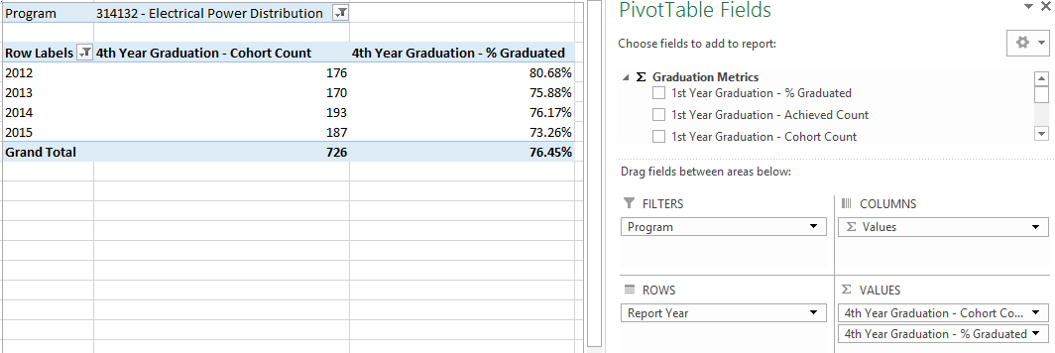
- Identify QRP Graduation indicators for a program for your district and other districts.
Connect to the WTCS server through the Cisco VPN. Open Excel and connect to the QRP – Indicator #3 Graduation Cube. Reference the OLAP Cube Connection Requirements and Instructions for District Users document for full instructions on connecting to the Cubes. Once connected, replicate the below Cube combination. The resulting combination will provide you with graduation rates for a specific program by district. This combination can be used for benchmarking purposes. The individual district row will identify graduation rates for the district. The Grand Total column will identify graduation rates for all of the years included in the analysis for each row. The Grand Total row will identify overall graduation rates for all districts assessed by year.
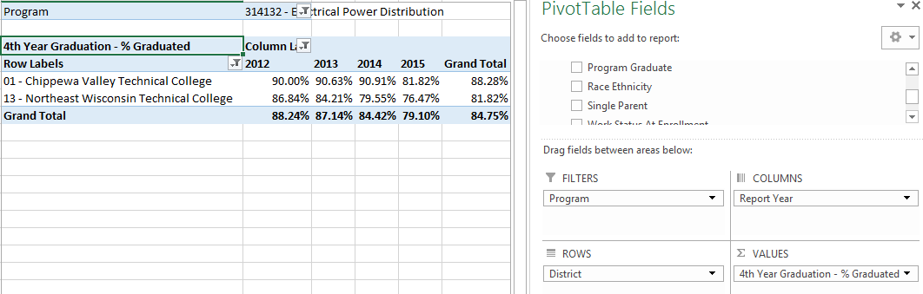

- Identify graduation rates by demographic groups for a program.
Connect to the WTCS server through the Cisco VPN. Open Excel and connect to the QRP – Indicator #3 Graduation Cube. Reference the OLAP Cube Connection Requirements and Instructions for District Users document for full instructions on connecting to the Cubes. Once connected, replicate the below Cube combination. The resulting combination will provide you with graduation rates for a specific program broken out by student demographics. The Grand Total column will identify graduation rates for all of the years included in the analysis for each row. The Grand Total row will identify overall graduation rates for all demographic variables assessed by year.
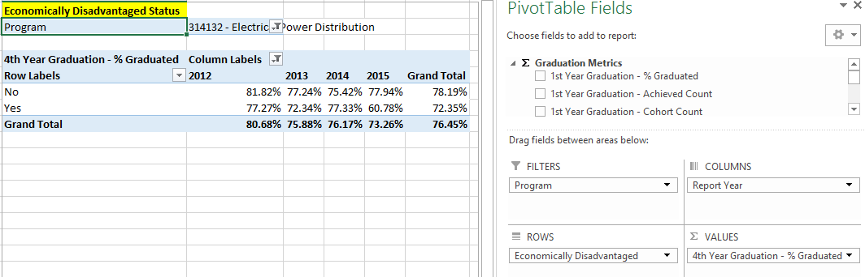
- Track graduation rates six years out for the same cohort by program.
Connect to the WTCS server through the Cisco VPN. Open Excel and connect to the QRP – Indicator #3 Graduation Cube. Reference the OLAP Cube Connection Requirements and Instructions for District Users document for full instructions on connecting to the Cubes. Once connected, replicate the below Cube combination. The resulting combination will demonstrate how you can track the same cohort for multiple years to identify graduation rates from 1st year to 6th year; note the cohort counts are the same based on the metric and report year combination.
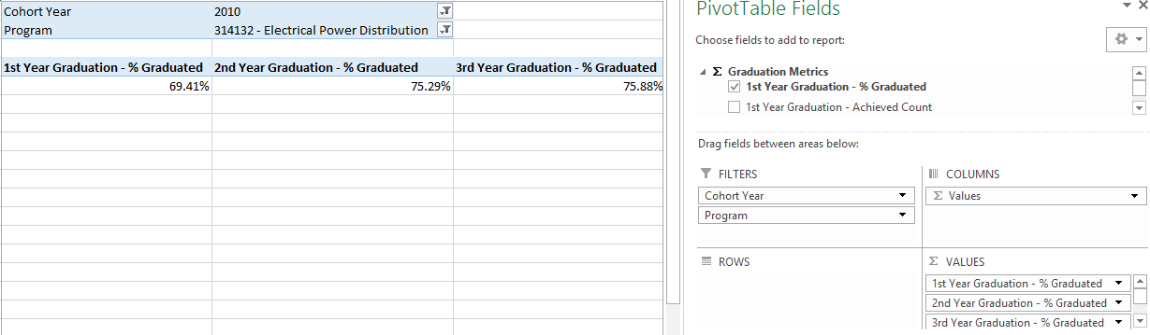

Drill-Through Capabilities:
Excel 2013 or more recent versions allow end-users to drill-through QRP Indicator measures within the Cubes. Follow these steps to drill-through:
- Select the measure cell you want to drill-through.
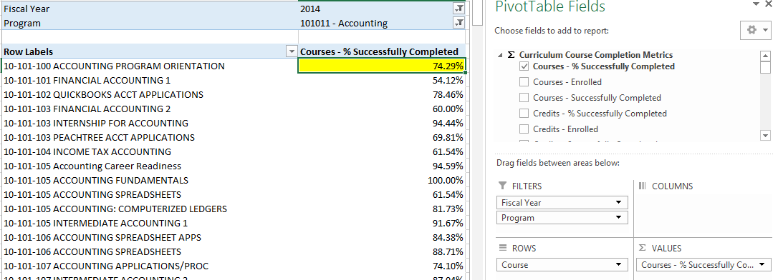
- Right-click in the field and select “Quick Explore”.
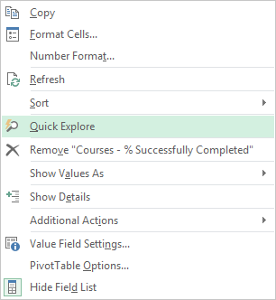
- An “Explore” menu will populate – select a field within the available dimensions that you would like to drill-through to get more details and double-click. In this example, “Academically Disadvantaged” is selected. The resulting output shows the measure for the field selected in step one, and is broken out by the field selected in step three
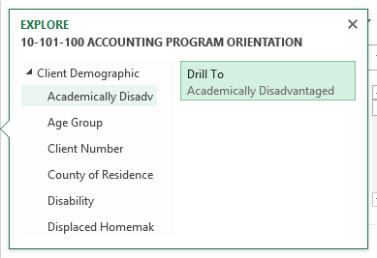

Commonly Asked Questions:
- Where does the data come from within the Cubes?
Data within the Cubes is sourced to the data the districts supply in Client Reporting submissions.
- Can I track a cohort of students longitudinally to identify in what year graduation rates plateau?
Yes, the cubes allow you to track graduation rates from 1st year to 6th year graduation. Cube combination example four demonstrates this capability.

