WTCS QRP Cube User’s Guide
QRP – Indicator #4 Transfer
Contents
Overview: 1
Cube Measure Group & Dimension Groups: 1
Cube Combination Examples: 6
Drill-Through Capabilities: 8

Overview:
The QRP – Indicator #4 Transfer Cube includes a Program Record/Transfer Record measure group and seven dimension groups. Dimensions can be used to uncover the who, what, when, and where in an effort to answer why high or low transfer rates exist. In essence, the Cube is meant to drive continuous improvement efforts by uncovering anomalies, and by providing actionable pieces of data.

Cube Measure Group & Dimension Groups:

Measure Group:
Program Record – The program record information is sourced to the Client Reporting System with program enrollments reported on the S9 record.
Transfer Record Measures - Transfer is identified through record matching in the National Student Clearinghouse System.
It is important to consider that transfer is longitudinal in nature. The National Student Clearinghouse data is not final until the fall of the next calendar year after the fiscal year Client has closed.
Example: I want to assess the fiscal year 2014 program graduates. To assess if the completers transferred to a non-WTCS institution, I will need to wait until fall of the 2015 calendar year when National Student Clearinghouse data is available.
Measures:
Program Student Count – the unduplicated count of program students
Transfer Student Count – the unduplicated count of program students who transfer to a non-WTCS 2-year or 4-year institution the year after reported program enrollment if the program enrollee did not graduate OR the year after reported graduation/completion; example – 2014 fiscal year completers who have a transfer record from January 1, 2014 to December 31, 2014 or January 1, 2015 to June 30, 2015
% Transfer – the quotient of “Transfer Student Count” and “Program Student Count”
Dimension Group:
Client Demographic – data is sourced to the WTCS Client Reporting System
Dimensions:
Academically Disadvantaged – reference definitions in the Client Reporting System Manual; based on Academically Disadvantaged field
Age Group – calculated age as of June 1st of the fiscal year in question; age is based on Birth Date field in Client Reporting; age is grouped into the following categories; <18, 18-24, 25-29, 30-34, 35-44, 45-54, 55-61, 62 and Older, and Unknown when Client date of birth is not reported
Client Number – WTCS assigned number for each Client reported in Client Reporting
County of Residence – reference definitions in the Client Reporting System Manual; based on County Code field
Disability – reference definitions in the Client Reporting System Manual; based on Person with Disability field
Displaced Homemaker – reference definitions in the Client Reporting System Manual; based on Displaced Homemaker field
District of Residence – reference definitions in the Client Reporting System Manual; based on WTCS District of Residence field
District Student Id – reference definitions in the Client Reporting System Manual; based on District Student ID field
Economically Disadvantaged – reference definitions in the Client Reporting System Manual; based on Economically Disadvantaged field
Effort District – the WTCS district a high school is located in, per the district boundaries defined in WTCS State Board policy; this code is not reported, but is added to the high school tables to allow Technical Colleges and the System Office to see where high school attendees/graduates from the various Technical College districts enroll

Full-time 24 Or More Credits – calculation of the sum of credits enrolled in during the said academic year; includes credits across all aid codes from Client Reporting
Gender – reference definitions in the Client Reporting System Manual; based on Sex Code field
High School Graduation Year – reference definitions in the Client Reporting System Manual; based on Year of High School Graduation field
High School Last Attended - reference definitions in the Client Reporting System Manual; based on High School Attended field
Highest Credential Received - reference definitions in the Client Reporting System Manual; based on Highest Credential Received at Enrollment field
Highest Grade Completed - reference definitions in the Client Reporting System Manual; based on Highest Grade Completed at Enrollment field
Incarcerated - reference definitions in the Client Reporting System Manual; based on Incarcerated field
Limited English Proficiency - reference definitions in the Client Reporting System Manual; based on Limited English Proficiency field
Minority - reference definitions in the Client Reporting System Manual; based on Ethnic Code/Race field; minority status of “Yes” includes American Indian/Alaskan Native, Asian, Black, Hispanic, Multiple, Pacific Islander; minority status of “No” includes White and Unknown
Municipality of Residence - reference definitions in the Client Reporting System Manual; based on Municipality Code field
Program Enrollee – Student has an S9 record in Client Reporting in the said academic year
Program Graduate – Student has an S9 graduate record in Client Reporting in the said academic year
Race Ethnicity - reference definitions in the Client Reporting System Manual; based on Ethnic Code/Race field
Single Parent - reference definitions in the Client Reporting System Manual; based on Single Parent field
Work Status - reference definitions in the Client Reporting System Manual; based on Work Status at Enrollment field
Dimension Group:
Districts – data is sourced to the WTCS Client Reporting System
Dimensions:
District – reference definitions in the Client Reporting System Manual; combined field including the District Number field reported in the Client Reporting System and the associated district name
District Code – reference definitions in the Client Reporting System Manual; based on District Number field
District Initials – initials of district based on the District Number field in the Client Reporting System
District Name – district name based on the District Number field in the Client Reporting System
District Short Name – district name excluding “Technical College” verbiage; based on the District Number field in the Client Reporting System
Dimension Group:
Fiscal Year – data is sourced to the WTCS Client Reporting System
Dimensions:
Fiscal Year – reference definitions in the Client Reporting System Manual; based on Fiscal Year field
Dimension Group:
Program – data is sourced to the WTCS Client Reporting System; identifies the parent program in a pathway linked to an Embedded Technical Diploma or a Pathway Certificate
Dimensions:
Career Cluster – Each program is assigned a Career Cluster; more information can be found on MyWTCS
CIP Code – Classification of Instructional Programs (CIP) assigned to an academic program during the program approval process
Division – Each program is assigned a Division; division is assigned based on the first digit of the programs instructional area
Instructional Area – the description associated with the three digit instructional area code within the program number
Instructional Area Code – the three digit instructional area code associated with a program number ex. program number = 10-101-1 and instructional area code = 101
NTO Bias – identifies if a “Male Gender Bias”, “Female Gender Bias”, or “No Bias” exists for a program
Program – combination of the program number and the program title associated with the program number
Program Aid Code – the first two digits of the program number
Program Number – reference definitions in the Client Reporting System Manual; based on Program Number field
Dimension Group:
Program Enrollee or Graduate – data is sourced to the WTCS Client Reporting System
Dimensions:
Graduate Status – reference definitions in the Client Reporting System Manual; based on Program Graduate field; identifies if a program enrollee graduated from a specific program; if a program enrollee was reported in two programs and graduated from only one, they will be counted separately (once as a graduate and once as a program enrollee)
Dimension Group:
Transfer Institution – data is sourced to the National Student Clearinghouse and refers to the institution of transfer
Dimensions:
College Name – the college name a student is enrolled in and reported on in the National Student Clearinghouse
College State – the geographic state of the college a student is enrolled in and reported on in the National Student Clearinghouse
Public or Private College – the public or private classification of the college a student is enrolled in and reported on in the National Student Clearinghouse
Two or Four Year College – the two or four year classification of the college a student is enrolled in and reported on in the National Student Clearinghouse
Dimension Group:
Transfer Program – data is sourced to the National Student Clearinghouse and refers to the program a student is reported in as an enrollee
Dimensions:
Transfer Program CIP – the CIP tied to the program reported by the transfer institution to the National Student Clearinghouse
Transfer Program Major – the major tied to the program reported by the transfer institution to the National Student Clearinghouse

Cube Combination Examples:
- Identify QRP transfer rates for a specific program, comparing graduates of the program to program enrollees who have not graduated.
Connect to the WTCS server through the Cisco VPN. Open Excel and connect to the QRP – Indicator #4 Transfer Cube. Reference the OLAP Cube Connection Requirements and Instructions for District Users document for full instructions on connecting to the Cubes. Once connected, replicate the below Cube combination. The resulting combination will provide you with the QRP transfer rate metrics for a program in a given fiscal year; pull in the district field for benchmarking across the System.
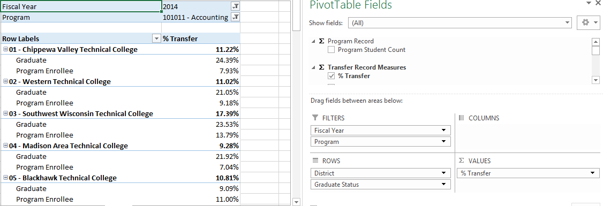
- Identify the institution program graduates are transferring to.
Connect to the WTCS server through the Cisco VPN. Open Excel and connect to the QRP – Indicator #4 Transfer Cube. Reference the OLAP Cube Connection Requirements and Instructions for District Users document for full instructions on connecting to the Cubes. Once connected, replicate the below Cube combination. The resulting combination will provide you with information on the institutions program graduates are transferring to.
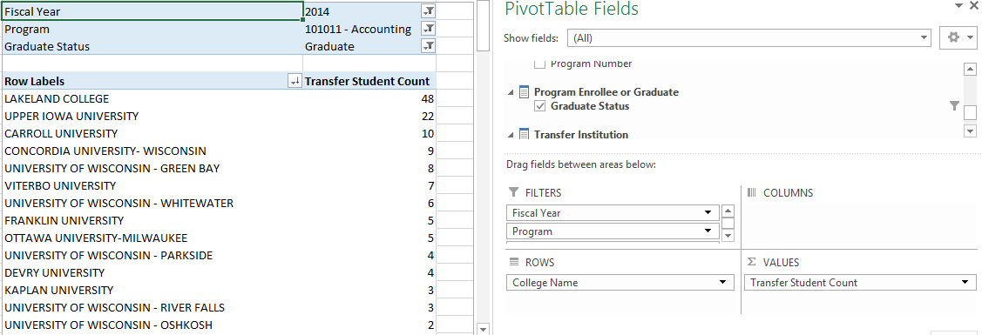

- Identify the major of transfer among graduates of a specific program.
Connect to the WTCS server through the Cisco VPN Open Excel and connect to the QRP – Indicator #4 Transfer Cube. Reference the OLAP Cube Connection Requirements and Instructions for District Users document for full instructions on connecting to the Cubes. Once connected, replicate the below Cube combination. The resulting combination will provide you with information on the major program graduates are transferring into. It is important to note that the major field is not reported by all institutions to the National Student Clearinghouse; in the below example, there are 34 graduate transfer records with a major not supplied.
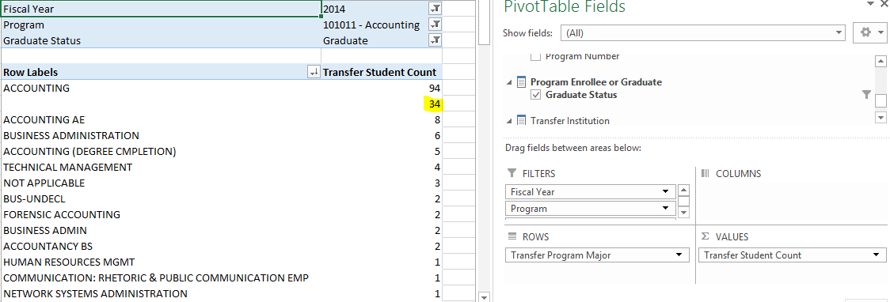

Drill-Through Capabilities:
Excel 2013 or more recent versions allow end-users to drill-through QRP Indicator measures within the Cubes. Follow these steps to drill-through:
- Select the measure cell you want to drill-through.
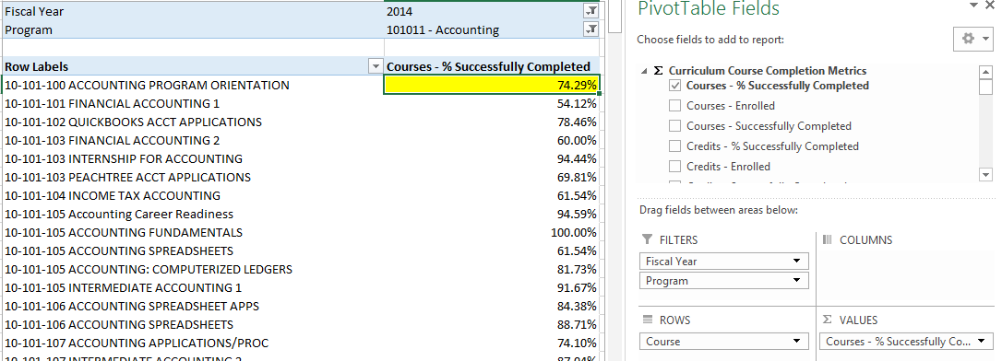
- Right-click in the field and select “Quick Explore”.
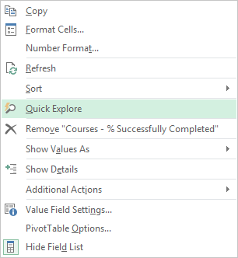
- An “Explore” menu will populate – select a field within the available dimensions that you would like to drill-through to get more details and double-click. In this example, “Academically Disadvantaged” is selected. The resulting output shows the measure for the field selected in step one, and is broken out by the field selected in step three
