WTCS QRP Cube User’s Guide
QRP – Indicator #5 Job Placement
Contents
Overview: 1
Cube Measure Group & Dimension Groups: 1
How to Use the Data: 8
Cube Combination Examples: 9
Drill-Through Capabilities: 12
Commonly Asked Questions: 13

Overview:
The QRP – Indicator #5 Job Placement Cube includes a Job Placement Metrics measure group and ten dimension groups. Dimensions can be used to uncover the who, what, when, and where in an effort to provide insight into why high or low job placement rates exist. In essence, the Cube is meant to drive continuous improvement efforts by uncovering anomalies, and by providing actionable pieces of data.

Cube Measure Group & Dimension Groups:

Measure Group:
Job Placement Metrics – data is sourced to the WTCS Graduate Follow-Up Reporting System and based on a graduates best program if more than one credential is attained in a given year; QRP identified job placement indicators include the percent of graduates in the labor force who reported employment and the percent of employed graduates who reported related employment
Measures:
% Employed – the quotient of “Employed” and “In Labor Force”
% Employed in District – the quotient of “Employed in District” and “Employed Location Known”
% Employed in Wisconsin – the quotient of “Employed in Wisconsin” and “Employed Location Known”
% Employed Related – the quotient of “Related Employed” and “Employed”
% Responding – the quotient of “Graduates Responding” and “Graduates Surveyed”
Employed – the count of responding graduates surveyed who reported “Employed (including active military services)” as their present status (Q3)
Employed in District – the count of responding graduates surveyed who reported “Employed (including active military services)” as their present status (Q3) and location of employment is reported in district
Employed in Wisconsin – the count of responding graduates surveyed who reported “Employed (including active military services)” as their present status (Q3) and location of employment is reported in Wisconsin
Employed Location Known – the count of responding graduates surveyed who reported “Employed (including active military services)” as their present status (Q3) and reported a known employment location
Graduates Responding – the count of graduates surveyed who responded
Graduates Surveyed – the count of graduates surveyed; based on the graduates best program if more than one credential is attained in a given year
In Labor Force – the count of responding graduates surveyed who reported “Employed (including active military services)” or “Not employed, but seeking” as their present status (Q3)
Employed Related – the count of responding graduates surveyed who reported “Employed (including active military services)” as their present status (Q3) and who reported “Yes” or “Yes, I work as an EMT or Firefighter, but it is NOT my primary occupation” as their job related status (Q5)
Seeking Employment – the count of responding graduates surveyed who reported “Not employed, but seeking” as their present status (Q3)

Dimension Group:
Client Demographic – data is sourced to the WTCS Client Reporting System
Dimensions:
Academically Disadvantaged – reference definitions in the Client Reporting System Manual; based on Academically Disadvantaged field
Age Group – calculated age as of June 1 of the fiscal year in question; age is based on Birth Date field in Client Reporting; age is grouped into the following categories; <18, 18-24, 25-29, 30-34, 35-44, 45-54, 55-61, 62 and Older, and Unknown when Client date of birth is not reported
Client Number – WTCS assigned number for each Client reported in Client Reporting
County of Residence – reference definitions in the Client Reporting System Manual; based on County Code field
Disability – reference definitions in the Client Reporting System Manual; based on Person with Disability field
Displaced Homemaker – reference definitions in the Client Reporting System Manual; based on Displaced Homemaker field
District of Residence – reference definitions in the Client Reporting System Manual; based on WTCS District of Residence field
District Student Id – reference definitions in the Client Reporting System Manual; based on District Student ID field
Economically Disadvantaged – reference definitions in the Client Reporting System Manual; based on Economically Disadvantaged field
Effort District – the WTCS district a high school is located in, per the district boundaries defined in WTCS State Board policy; this code is not reported, but is added to the high school tables to allow Technical Colleges and the System Office to see where high school attendees/graduates from the various Technical College districts enroll

Full-time 24 Or More Credits – calculation of the sum of credits enrolled in during the said academic year; includes credits across all aid codes from Client Reporting
Gender – reference definitions in the Client Reporting System Manual; based on Sex Code field
High School Graduation Year – reference definitions in the Client Reporting System Manual; based on Year of High School Graduation field
High School Last Attended - reference definitions in the Client Reporting System Manual; based on High School Attended field
Highest Credential Received - reference definitions in the Client Reporting System Manual; based on Highest Credential Received at Enrollment field
Highest Grade Completed - reference definitions in the Client Reporting System Manual; based on Highest Grade Completed at Enrollment field
Incarcerated - reference definitions in the Client Reporting System Manual; based on Incarcerated field
Limited English Proficiency - reference definitions in the Client Reporting System Manual; based on Limited English Proficiency field
Minority - reference definitions in the Client Reporting System Manual; based on Ethnic Code/Race field; minority status of “Yes” includes American Indian/Alaskan Native, Asian, Black, Hispanic, Multiple, Pacific Islander; minority status of “No” includes White and Unknown
Municipality of Residence - reference definitions in the Client Reporting System Manual; based on Municipality Code field
Program Enrollee – Student has an S9 record in Client Reporting in the said academic year
Program Graduate – Student has an S9 graduate record in Client Reporting in the said academic year
Race Ethnicity - reference definitions in the Client Reporting System Manual; based on Ethnic Code/Race field
Single Parent - reference definitions in the Client Reporting System Manual; based on Single Parent field
Work Status - reference definitions in the Client Reporting System Manual; based on Work Status at Enrollment field
Dimension Group:
Districts – data is sourced to the WTCS Client Reporting System
Dimensions:
District – reference definitions in the Client Reporting System Manual; combined field including the District Number field reported in the Client Reporting System and the associated district name
District Code – reference definitions in the Client Reporting System Manual; based on District Number field
District Initials – initials of district based on the District Number field in the Client Reporting System
District Name – district name based on the District Number field in the Client Reporting System
District Short Name – district name excluding “Technical College” verbiage; based on the District Number field in the Client Reporting System

Dimension Group:
Employer Location – data is sourced to the WTCS Graduate Follow-Up System
Dimensions:
Employer Location – reference definitions in the Graduate Follow-Up System Manual; based on Employer Location field; districts identify employer location based on the employer address respondents provide (Q6)
Dimension Group:
Fiscal Year – data is sourced to the WTCS Client Reporting System
Dimensions:
Fiscal Year – reference definitions in the Client Reporting System Manual; based on Fiscal Year field
Dimension Group:
Job Related to Training – data is sourced to the WTCS Graduate Follow-Up System
Dimensions:
Job Related Status – reference definitions in the Graduate Follow-Up System Manual; based on Job Related to Training field (Q5)
Dimension Group:
Occupation Title – data is sourced to the WTCS Graduate Follow-Up System
Dimensions:
Occupational Title – reference definitions in the Graduate Follow-Up System Manual; based on Job Title field (Q6A)
Dimension Group:
Present Status – data is sourced to the WTCS Graduate Follow-Up System
Dimensions:
Present Status – reference definitions in the Graduate Follow-Up System Manual; based on Present Status field (Q3)
Dimension Group:
Programs – data is sourced to the WTCS Client Reporting System; program information is the graduate’s best program if more than one credential is attained in a given year
Dimensions:
Career Cluster – Each program is assigned a Career Cluster; more information can be found on MyWTCS
CIP Code – Classification of Instructional Programs (CIP) assigned to an academic program during the program approval process
Division – Each program is assigned a Division; division is assigned based on the first digit of the programs instructional area
Instructional Area – the description associated with the three digit instructional area code within the program number
Instructional Area Code – the three digit instructional area code associated with a program number ex. program number = 10-101-1 and instructional area code = 101
NTO Bias – identifies if a “Male Gender Bias”, “Female Gender Bias”, or “No Bias” exists for a program
Program – combination of the program number and the program title associated with the program number
Program Aid Code – the first two digits of the program number
Program Number – reference definitions in the Client Reporting System Manual; based on Program Number field
Dimension Group:
Program Type – data is sourced to the WTCS Program Approval System
Dimensions:
Program Type – Programs can be assigned a program type that can be unique to the district; this is the field that the WTCS uses to flag Embedded Technical Diplomas, shared programs, etc.
Dimension Group:
Reason for Attending – data is sourced to the WTCS Graduate Follow-Up System
Dimensions:
Reason for Attending – reference definitions in the Graduate Follow-Up System Manual; based on Reason for Attending field (Q2)
Dimension Group:
Training Satisfaction – data is sourced to the WTCS Graduate Follow-Up System
Dimensions:
Training Satisfaction – reference definitions in the Graduate Follow-Up System Manual; based on Satisfaction with Training field (Q1)

Dimension Group:
When Work Started – data is sourced to the WTCS Graduate Follow-Up System
Dimensions:
When Work Started – reference definitions in the Graduate Follow-Up System Manual; based on When Work Started field (Q4)

How to Use the Data:
The purpose of the QRP Cubes is to provide Colleges with business intelligence resources to drive continuous improvement efforts. Below are some example uses of the various dimension groups to assist in continuous improvement.
Dimension Group | Example Uses
Client Demographic | Identify which demographic groups are positively or negatively impacting QRP indicators.
Districts | Benchmark successes or areas for improvement with other districts. Data can be used to prompt an in-depth conversation with other districts for best-practice sharing.
Employer Location | Identify where graduates are finding employment by program.
Fiscal Year | Identify trends for QRP indicators.
Job Related to Training | Validate QRP indicators; breakout response of “Yes” and “Yes, I work as an EMT or Firefighter, but it is NOT my primary occupation.”
Present Status | Validate QRP indicators; identify multiple not available for employment reasons by program.
Program | Identify which programs have high or low success rates and identify QRP indicator benchmarks by career cluster or division.
Reason for Attending | Identify reasons for attending by program; filter for those employed vs those not employed to see if they met their reason for attending.
Training Satisfaction | Identify training satisfaction by program; conduct analysis to see how employed vs not employed impacts training satisfaction.
When Work Started | Identify when employed graduates starting working in their present job by program.

Cube Combination Examples:
- Identify QRP Job Placement indicators for programs.
Connect to the WTCS server through the Cisco VPN. Open Excel and connect to the QRP – Indicator #5 Job Placement Cube. Reference the OLAP Cube Connection Requirements and Instructions for District Users document for full instructions on connecting to the Cubes. Once connected, replicate the below Cube combination. The resulting combination will provide you with job placement indicators based on your filter combination. Interchange the % Employed and the % Employed Related measures to identify each QRP indicator separately. The Grand Total row will identify overall job placement indicators across all programs present. The Grand Total column will identify job placement indicators for all of the years included in the analysis for each row.
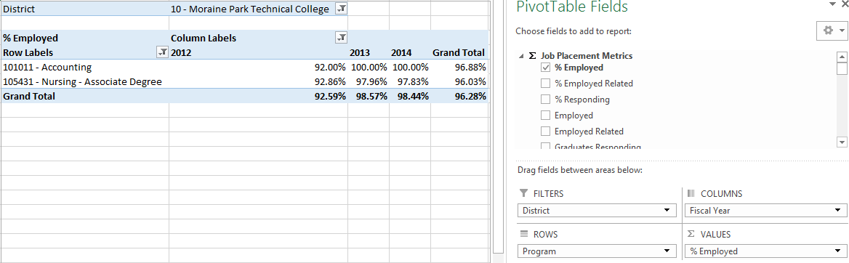
- Identify QRP Job Placement indicators for a program for your district and other districts.
Connect to the WTCS server through the Cisco VPN. Open Excel and connect to the QRP – Indicator #5 Job Placement Cube. Reference the OLAP Cube Connection Requirements and Instructions for District Users document for full instructions on connecting to the Cubes. Once connected, replicate the below Cube combination. The resulting combination will provide you with job placement indicators based on your filter combination for all districts. Interchange the % Employed and the % Employed Related measures to identify each QRP indicator separately. The individual district row will identify job placement indicators for the district. The Grand Total column will identify an overall job placement indicator for all of the years included in the analysis for each row.
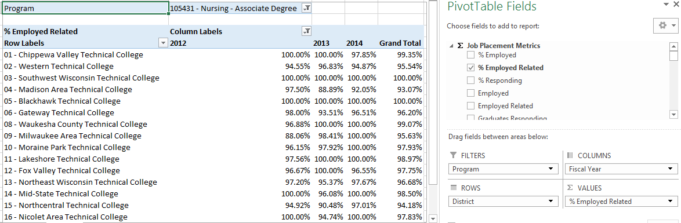
- Identify employer location information among employed related graduates responding to the survey.
Connect to the WTCS server through the Cisco VPN. Open Excel and connect to the QRP – Indicator #5 Job Placement Cube. Reference the OLAP Cube Connection Requirements and Instructions for District Users document for full instructions on connecting to the Cubes. Once connected, replicate the below Cube combination. The resulting combination will provide you with respondent counts who are employed in a related field for each employer location option.
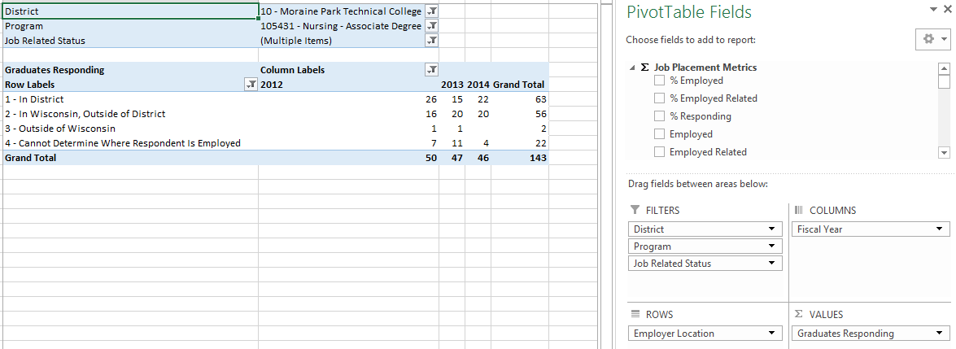
- Identify when employed related graduates responding found their current job.
Connect to the WTCS server through the Cisco VPN. Open Excel and connect to the QRP – Indicator #5 Job Placement Cube. Reference the OLAP Cube Connection Requirements and Instructions for District Users document for full instructions on connecting to the Cubes. Once connected, replicate the below Cube combination. The resulting combination will provide you with respondent counts who are employed in a related field for each when work started status.
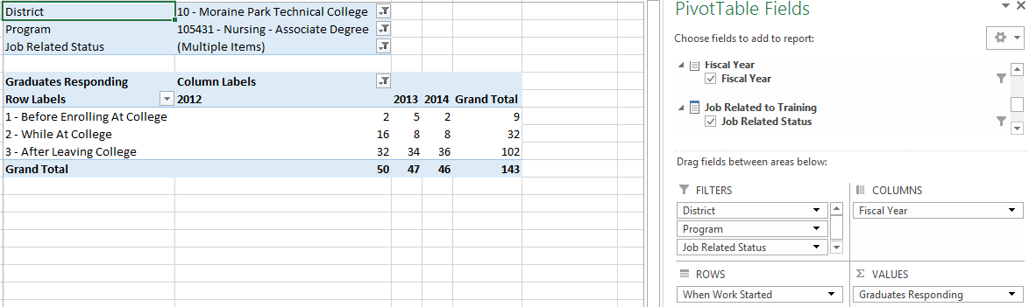

- Identify student demographics that are positively or negatively impacting QRP Job Placement indicators for a program.
Connect to the WTCS server through the Cisco VPN. Open Excel and connect to the QRP – Indicator #5 Job Placement Cube. Reference the OLAP Cube Connection Requirements and Instructions for District Users document for full instructions on connecting to the Cubes. Once connected, replicate the below Cube combination. The resulting combination will provide you with job placement indicators by student demographics.
Student Demographics:
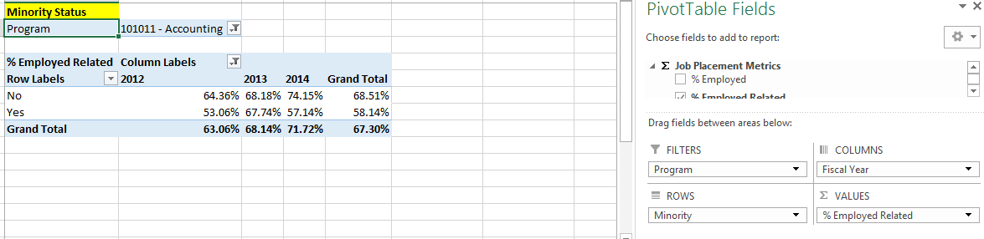
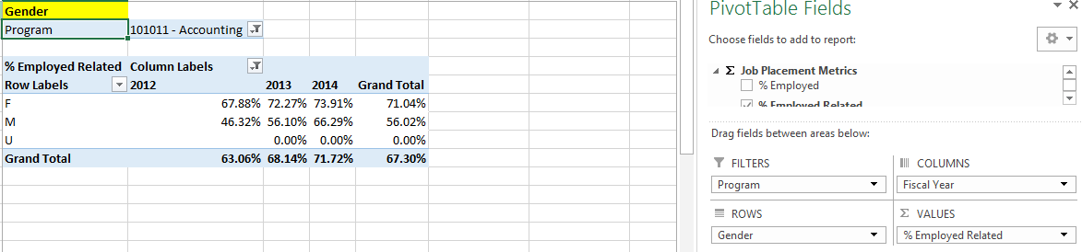
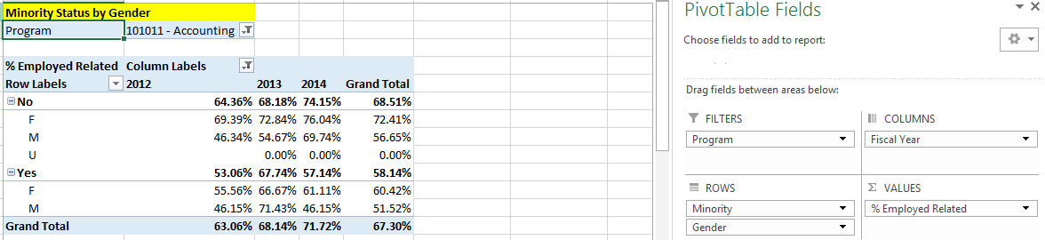

Drill-Through Capabilities:
Excel 2013 or more recent versions allow end-users to drill-through QRP Indicator measures within the Cubes. Follow these steps to drill-through:
- Select the measure cell you want to drill-through.
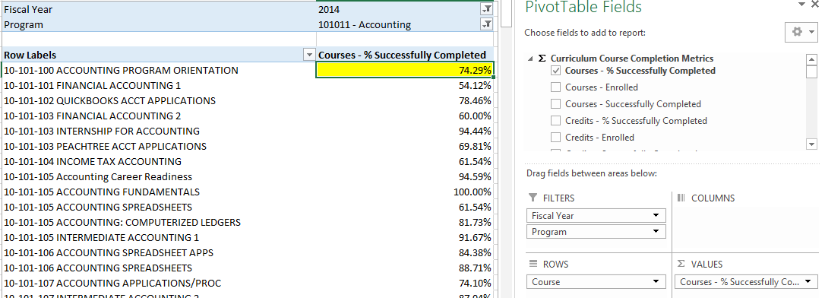
- Right-click in the field and select “Quick Explore”.
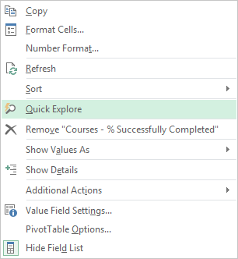
- An “Explore” menu will populate – select a field within the available dimensions that you would like to drill-through to get more details and double-click. In this example, “Academically Disadvantaged” is selected. The resulting output shows the measure for the field selected in step one, and is broken out by the field selected in step three
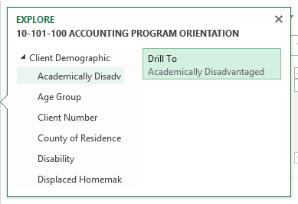

Commonly Asked Questions:
- Where does the data come from that the Cubes draw from?
Data within the Cubes is sourced to the data the districts supply in Client Reporting and Graduate Follow-Up submissions.
- Client demographics change every fiscal year a student is enrolled; what fiscal year is used for the client demographics available?
The Cubes are built to include the client demographics as of the year the client graduated based on the data districts provide in their final Client Reporting submission. If a client reported an Unknown gender in fiscal year 2013, a Female gender in 2014, and graduated in 2014, then the student’s gender will be Female based on the program and fiscal year combination assessed.
- If a client graduates from two programs in a fiscal year, which program is used for the QRP job placement indicators?
QRP job placement indicators are based on a graduate’s best program if more than one credential is attained in a fiscal year. If Student graduated from multiple programs, use the following tiebreakers (in the order listed):
  - Highest program rigor by aid code (10, 20, 32, 31, 30); if equal,
  - Total course credits for the graduate reported in Client Reporting that are attributable to the program using the approved program curriculum; if equal,
  - Total number of courses for the graduate reported in Client Reporting that are attributable to the program using the approved program curriculum; if equal,
  - Total credits in the Program Curriculum file for the approved program curriculum; if equal,
  - Total number of courses in the Program Curriculum file for the approved program curriculum; if equal,
  - Lowest Instructional Area number in the programs reported in Client Reporting.

