WTCS QRP Cube User’s Guide
QRP – Indicator #6 Pathway Progression
Contents
Overview: 1
Cube Measure Group & Dimension Groups: 1
Cube Combination Examples: 9
Drill-Through Capabilities: 10

Overview:
The QRP – Indicator #6 Pathway Progression Cube includes a Pathway Progression measure group and five dimension groups. Dimensions can be used to uncover the who, what, when, and where in an effort to answer why high or low pathway progression rates exist. In essence, the Cube is meant to drive continuous improvement efforts by uncovering anomalies, and by providing actionable pieces of data.

Cube Measure Group & Dimension Groups:

Measure Group:
Pathway Progression – Embedded credentials (either Embedded Technical Diplomas or Pathway Certificates with an approved parent program curriculum) are district and fiscal year specific, and identified through the program approval process. The program approval process also defines the relationship between and embedded credential and the credential’s parent program.
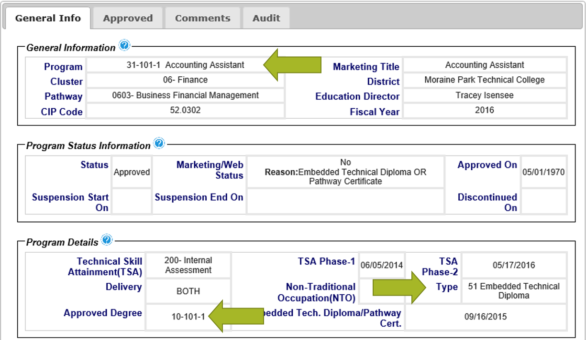
The Pathway Progression Cube identifies three successful progression points after completion of an embedded credential. These include:
- Embedded credential completer continues to the parent program in the pathway
- Embedded credential completer attains related employment after completion
- Embedded credential completer transfers to continue their education

Completions of embedded credentials and subsequent enrollment in the credentials parent program are identified through district submissions in the Client Reporting System with program enrollments and completions reported on the S9 record. Related employment after completion is identified through the Graduate Follow-Up System. Transfer is identified through record matching in the National Student Clearinghouse System. The below image defines the three progression success points.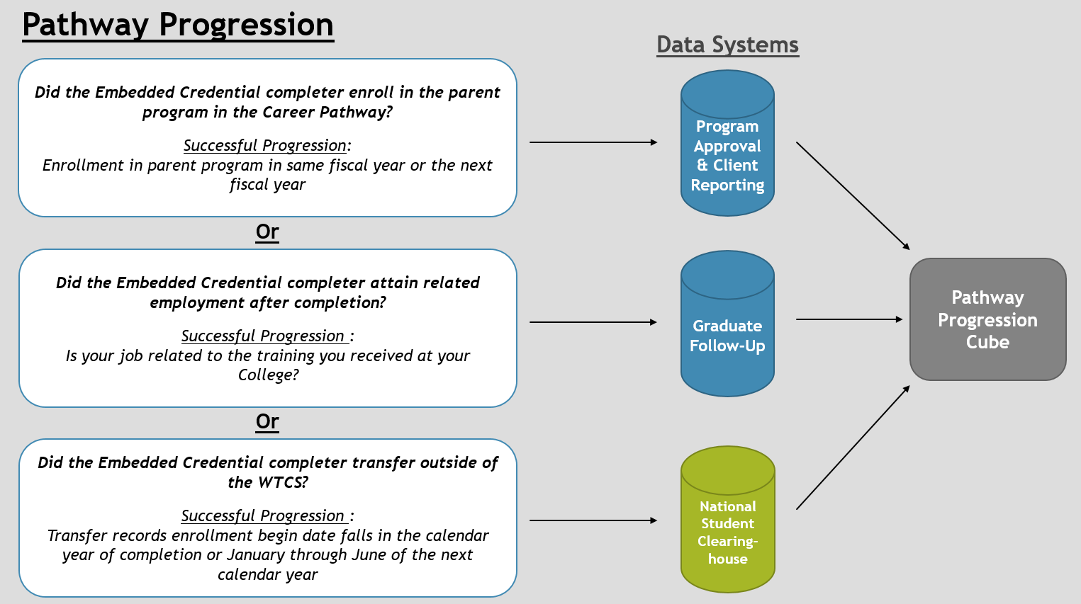
It is important to consider that pathway progression is longitudinal in nature. Enrollment in the parent program is not final until the closing of the subsequent Client Reporting System year; Graduate Follow-Up data is not final until the spring of the calendar year after completion; and the National Student Clearinghouse data is not final until the fall of the next calendar year after completion.
Example: I want to assess the 2014 embedded credential completers. To assess if the completers enrolled in the parent program, I will need to wait until fiscal year 2015 Client Reporting is closed; this would be available September of the 2015 calendar year. To assess if the completers find related employment, I will need to wait until the Graduate Follow-Up Survey for the 2014 completers is final; this would be available spring of the 2015 calendar year. To assess if the completers transferred to a non-WTCS institution, I will need to wait until fall of the 2015 calendar year when National Student Clearinghouse data is available.
It is important to consider limitations to the existing data. Related employment is captured via the Graduate Follow-Up System. Pathway Certificate completers are not surveyed in the Graduate Follow-Up System. Additionally, related employment data is by best program; example – if I complete an Associate Degree and a One-Year Technical Diploma in the same fiscal year, any Graduate Follow-Up results will be tied to my Associate Degree record. Reference the Graduate Follow-Up System Manual on myWTCS for more information on the best program definition and the sample surveyed in the Graduate Follow-Up System.
Measures:
Embedded Credential Enrollee – the duplicated count of embedded credential enrollees (Embedded Technical Diploma or Pathway Certificate enrollees)
Embedded Credential Completions – the duplicated count of embedded credential enrollees who completed their credential (Embedded Technical Diploma graduates or Pathway Certificate completers)
Enroll in Next Credential – the duplicated count of embedded credential completers who enroll in the parent program of the pathway as defined in the program approval process
Related Employed – the unduplicated count of embedded technical diploma graduates surveyed who reported “Employed (including active military services)” as their present status (Q3) and who reported “Yes” or “Yes, I work as an EMT or Firefighter, but it is NOT my primary occupation” as their job related status (Q5) *****Note that Pathway Certificate completers are not surveyed in the Graduate Follow-Up Survey and collected data is by best program if one student completes multiple credentials in a given fiscal year
Transfer – the duplicated count of embedded credential completers who transfer to a non-WTCS 2-year or 4-year institution the year after completion; example – 2014 fiscal year completers who have a transfer record from January 1, 2014 to December 31, 2014 or January 1, 2015 to June 30, 2015
Enroll in Next Credential or Related Employment – the unduplicated count of embedded credential completers who were counted in the “Enroll in Next Credential” measure or the “Related Employed” measure
Enroll in Next Credential or Related Employment or Transfer – the unduplicated count of embedded credential completers who were counted in the “Enroll in Next Credential” measure or the “Related Employed” measure or the “Transfer” measure
% Next Credential – the quotient of “Enroll in Next Credential” and “Embedded Credential Completions”
% Next Credential or Related Employment – the quotient of “Enroll in Next Credential or Related Employment” and “Embedded Credential Completions”
% Next Credential or Related Employment or Transfer – the quotient of “Enroll in Next Credential or Related Employment or Transfer” and “Embedded Credential Completions”

Dimension Group:
Client Demographic – data is sourced to the WTCS Client Reporting System
Dimensions:
Academically Disadvantaged – reference definitions in the Client Reporting System Manual; based on Academically Disadvantaged field
Age Group – calculated age as of June 1st of the fiscal year in question; age is based on Birth Date field in Client Reporting; age is grouped into the following categories; <18, 18-24, 25-29, 30-34, 35-44, 45-54, 55-61, 62 and Older, and Unknown when Client date of birth is not reported
Client Number – WTCS assigned number for each Client reported in Client Reporting
County of Residence – reference definitions in the Client Reporting System Manual; based on County Code field
Disability – reference definitions in the Client Reporting System Manual; based on Person with Disability field
Displaced Homemaker – reference definitions in the Client Reporting System Manual; based on Displaced Homemaker field
District of Residence – reference definitions in the Client Reporting System Manual; based on WTCS District of Residence field
District Student Id – reference definitions in the Client Reporting System Manual; based on District Student ID field
Economically Disadvantaged – reference definitions in the Client Reporting System Manual; based on Economically Disadvantaged field
Effort District – the WTCS district a high school is located in, per the district boundaries defined in WTCS State Board policy; this code is not reported, but is added to the high school tables to allow Technical Colleges and the System Office to see where high school attendees/graduates from the various Technical College districts enroll

Full-time 24 Or More Credits – calculation of the sum of credits enrolled in during the said academic year; includes credits across all aid codes from Client Reporting
Gender – reference definitions in the Client Reporting System Manual; based on Sex Code field
High School Graduation Year – reference definitions in the Client Reporting System Manual; based on Year of High School Graduation field
High School Last Attended - reference definitions in the Client Reporting System Manual; based on High School Attended field
Highest Credential Received - reference definitions in the Client Reporting System Manual; based on Highest Credential Received at Enrollment field
Highest Grade Completed - reference definitions in the Client Reporting System Manual; based on Highest Grade Completed at Enrollment field
Incarcerated - reference definitions in the Client Reporting System Manual; based on Incarcerated field
Limited English Proficiency - reference definitions in the Client Reporting System Manual; based on Limited English Proficiency field
Minority - reference definitions in the Client Reporting System Manual; based on Ethnic Code/Race field; minority status of “Yes” includes American Indian/Alaskan Native, Asian, Black, Hispanic, Multiple, Pacific Islander; minority status of “No” includes White and Unknown
Municipality of Residence - reference definitions in the Client Reporting System Manual; based on Municipality Code field
Program Enrollee – Student has an S9 record in Client Reporting in the said academic year
Program Graduate – Student has an S9 graduate record in Client Reporting in the said academic year
Race Ethnicity - reference definitions in the Client Reporting System Manual; based on Ethnic Code/Race field
Single Parent - reference definitions in the Client Reporting System Manual; based on Single Parent field
Work Status - reference definitions in the Client Reporting System Manual; based on Work Status at Enrollment field
Dimension Group:
Districts – data is sourced to the WTCS Client Reporting System
Dimensions:
District – reference definitions in the Client Reporting System Manual; combined field including the District Number field reported in the Client Reporting System and the associated district name
District Code – reference definitions in the Client Reporting System Manual; based on District Number field
District Initials – initials of district based on the District Number field in the Client Reporting System
District Name – district name based on the District Number field in the Client Reporting System
District Short Name – district name excluding “Technical College” verbiage; based on the District Number field in the Client Reporting System

Dimension Group:
Embedded Credential – data is sourced to the WTCS Client Reporting System; identifies the programs that are classified as either Embedded Technical Diplomas or Pathway Certificates
Dimensions:
Embedded Credential.Career Cluster – Each program is assigned a Career Cluster; more information can be found on MyWTCS
Embedded Credential.CIP Code – Classification of Instructional Programs (CIP) assigned to an academic program during the program approval process
Embedded Credential.Division – Each program is assigned a Division; division is assigned based on the first digit of the programs instructional area
Embedded Credential.Instructional Area – the description associated with the three digit instructional area code within the program number
Embedded Credential.Instructional Area Code – the three digit instructional area code associated with a program number ex. program number = 10-101-1 and instructional area code = 101
Embedded Credential.NTO Bias – identifies if a “Male Gender Bias”, “Female Gender Bias”, or “No Bias” exists for a program
Embedded Credential.Program – combination of the program number and the program title associated with the program number
Embedded Credential.Program Aid Code – the first two digits of the program number
Embedded Credential.Program Number – reference definitions in the Client Reporting System Manual; based on Program Number field
Dimension Group:
Fiscal Year – data is sourced to the WTCS Client Reporting System
Dimensions:
Fiscal Year – reference definitions in the Client Reporting System Manual; based on Fiscal Year field
Dimension Group:
Parent Program – data is sourced to the WTCS Client Reporting System; identifies the parent program in a pathway linked to an Embedded Technical Diploma or a Pathway Certificate
Dimensions:
Parent Program.Career Cluster – Each program is assigned a Career Cluster; more information can be found on MyWTCS
Parent Program.CIP Code – Classification of Instructional Programs (CIP) assigned to an academic program during the program approval process
Parent Program.Division – Each program is assigned a Division; division is assigned based on the first digit of the programs instructional area
Parent Program.Instructional Area – the description associated with the three digit instructional area code within the program number
Parent Program.Instructional Area Code – the three digit instructional area code associated with a program number ex. program number = 10-101-1 and instructional area code = 101
Parent Program.NTO Bias – identifies if a “Male Gender Bias”, “Female Gender Bias”, or “No Bias” exists for a program
Parent Program.Program – combination of the program number and the program title associated with the program number
Parent Program.Program Aid Code – the first two digits of the program number
Parent Program.Program Number – reference definitions in the Client Reporting System Manual; based on Program Number field

Cube Combination Examples:
- Identify embedded credential programs and there parent program.
Connect to the WTCS server through the Cisco VPN. Open Excel and connect to the QRP – Pathway Progression Cube. Reference the OLAP Cube Connection Requirements and Instructions for District Users document for full instructions on connecting to the Cubes. Once connected, replicate the below Cube combination. The resulting combination will provide you with an understanding of the embedded credential and parent program relationship for your district.
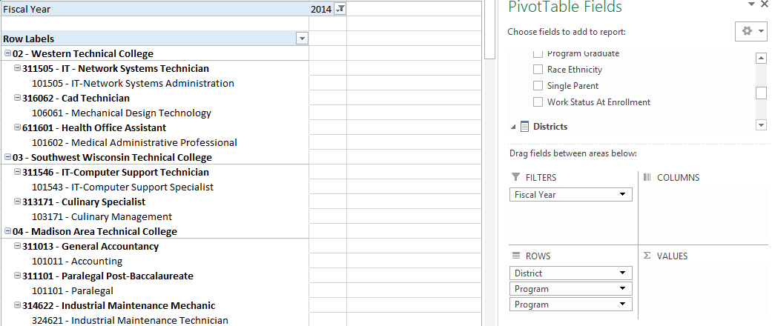
- Identify progression rates for a specific program.
Connect to the WTCS server through the Cisco VPN. Open Excel and connect to the QRP – Pathway Progression Cube. Reference the OLAP Cube Connection Requirements and Instructions for District Users document for full instructions on connecting to the Cubes. Once connected, replicate the below Cube combination. The resulting combination will provide you with the number of embedded credential completions and progression rates for a given program and fiscal year.
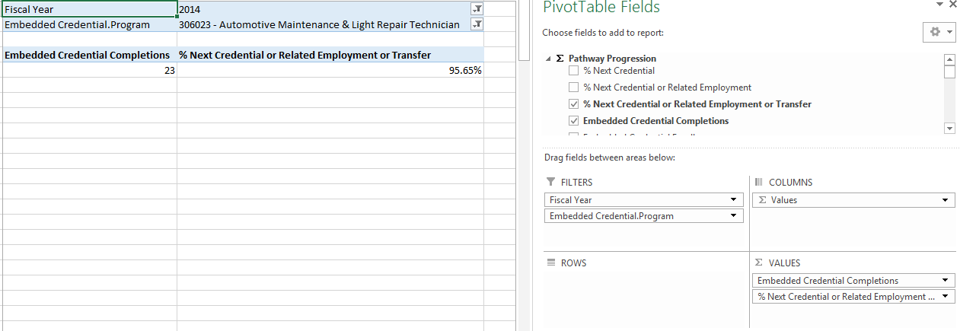

Drill-Through Capabilities:
Excel 2013 or more recent versions allow end-users to drill-through QRP Indicator measures within the Cubes. Follow these steps to drill-through:
- Select the measure cell you want to drill-through.
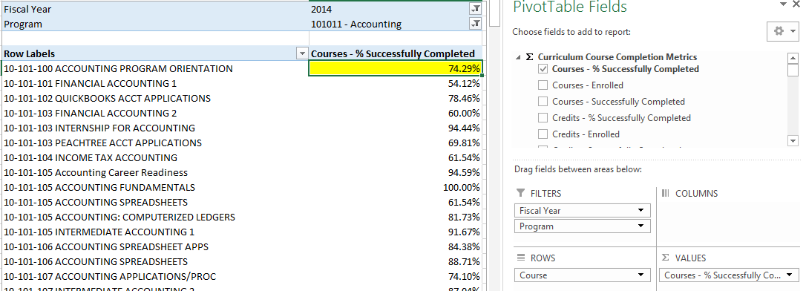
- Right-click in the field and select “Quick Explore”.
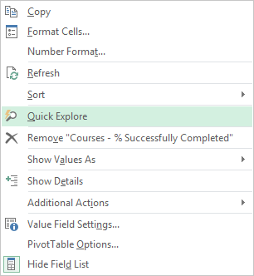
- An “Explore” menu will populate – select a field within the available dimensions that you would like to drill-through to get more details and double-click. In this example, “Academically Disadvantaged” is selected. The resulting output shows the measure for the field selected in step one, and is broken out by the field selected in step three
