Cost Allocation Report

Introduction
The cost allocation methodology for the Wisconsin Technical College System equitably assigns costs to various categories by instructional and aid category levels to assure consistent fiscal comparisons among and between districts, within individual districts, and on a statewide level.
Consistent use of the UFFAS section of the Financial & Administrative Manual is assumed. Budget basis data (as opposed to GAAP basis data) is required. All seven funds are to be reported unless one or more has no activity.

List of Schedules
The Cost Allocation Report is composed of nine schedules:
VE-CA-1 BUDGET/EXPENDITURE SUMMARY
VE-CA-2 STAFF AND EXPENDITURE RE-CAP
VE-CA-3 FUNCTIONAL COST ALLOCATION
VE-CA-4 CLUSTER COST ALLOCATION
VE-CA-5 CLUSTER SUMMARY
VE-CA-6 ALLOCATION BASES
VE-CA-7 REVENUE SUMMARY
VE-CA-8 form not used
VE-CA-9 COST ALLOCATION SUMMARY
VE-CA-9s SUPPLEMENT

Submission Requirements
For each fiscal year, the following reports are to be submitted (listed in chronological order):
November projected –November preceding the beginning of the fiscal year (VE-CA-9 and 9s)
April projected –April preceding the beginning of the fiscal year (VE-CA-9 and 9s)
Budget – July at the beginning of the fiscal year (all schedules) and OPEB spreadsheet
November re-estimate – November during the fiscal year (VE-CA-9 and 9s)
April re-estimate – April during the fiscal year (VE-CA-9 and 9s)
Actual – November following the end of the fiscal year (all schedules) and OPEB spreadsheet
The budget and actual mode reports include all nine schedules. The budget mode report is to be based on the adopted district budget. The transmittal should contain detail of any variances between the adopted budget and the budget document prepared for the pre-adoption public hearing. The actual mode report is to be completed using actual budget based data (as opposed to GAAP based data) for the most recent completed fiscal year.
In November and April, projected and re-estimate mode reports are due. The projected mode reports are to be completed using estimated data for the forthcoming fiscal year. The re-estimate mode reports are to be completed using a combination of actual and estimated data for the current fiscal year. Both the projected and re-estimate mode reports include only the VE-CA-9 and VE-CA-9s.
In November actual mode reports are due. Districts other than Madison that have finalized their Uniform Financial Fund Accounting System (UFFAS) data may opt to have their actual mode cost allocation report generated by the System Office using UFFAS and Client Reporting System data. Madison must also have finalized their Contract Reporting System data and submit Basis B for schedule VE-CA-6. To exercise this option, please notify the Cost Allocation Report contact via email.
Submission dates for all modes of cost allocation reports are annually established by the System Office. – see the Report Dates Subject to Withholding of State or Federal Aids for FY 20xx-xx reporting requirements for the applicable period.

Also, subsequent to any month in which the district's estimated FTEs for the year and/or aidable cost for the year changes by 5% or more, a projected/re-estimate report must be submitted. Districts may also submit a report for any other month. For these unscheduled reports, submit only the VE-CA-9 and VE-CA-9s.
The System Office will prepare a final UFFAS mode cost allocation report for any district which doesn’t have the System Office prepare that actual mode report.
Cost Allocation Reports in all modes are to be submitted to the Cost Allocation Report contact via email as attached Excel spreadsheets.

Cost Allocation Report Contact
Questions regarding the Cost Allocation Report or this section should be directed to:
Michelle Rudman
Wisconsin Technical College System
4622 University Avenue
P.O. Box 7874
Madison, Wisconsin 53707-7874
(608) 266-1433
michelle.rudman@wtcsystem.edu

Schedule Instructions

VE-CA-1 Expenditure Summary
Complete heading – FISCAL YEAR, DISTRICT, and DATE PREPARED.
FISCAL YEAR is the fiscal year being reported, not necessarily the year in which the schedules are completed.
All dollar amounts are rounded to the nearest dollar and must foot and cross-foot.
In the REDUCTIONS column enter the amount of OPEBs (classification 5157) and Wisconsin Retirement System (classification 5158) prior service payments reported in the GENERAL/SR OPER column. Regular amortization payments are to be reported by function. Pay-downs are to be reported on line f. Gen. Institutional. OPEB trust fund activity is to be recorded in the Fiduciary/SR-NA column.
In the FUNDS 1-2 SUBTOTAL column enter the net of the GENERAL/SR OPER column less the REDUCTIONS column. The GENERAL/SR OPER column is to be used in computing the amount in the total – all funds column – do not use the REDUCTIONS or FUNDS 1-2 SUBTOTAL columns to compute this amount.
Lines a-e
Enter the amounts for each Fund and Function. In the GENERAL/SR OPER column, enter the General Fund and Special Revenue - Operational Fund expenditures.
Line f
Total lines a-f for each column. The amount on line f in the FUNDS 1-2 SUBTOTAL column is the operational cost.
Line g
Enter the total federal revenue associated with functions 1-7. Do not include any federal revenue associated with functions 8-9. Therefore, the amount on this line may not be equal to the federal revenue reported on line i on schedule VE-CA-7.
Line h
Enter the non-federal portions of line f (line f minus line g).
Lines i and j
Enter the amounts for each Fund for Functions 8 and 9. Be careful not to include in Functions 8 and 9 costs or portions of costs which are operational in nature, which are to be included in operational costs.
Line k
Enter the total of lines f, i and j. The amount on line k in the TOTAL - ALL FUNDS column is the total district-wide expenditures.

VE-CA-2 Expenditure Re-Cap
Complete the heading – FISCAL YEAR, DISTRICT, and DATE PREPARED.
Column 1 lists the expenditure categories which are to be reported on lines a-f. Enter the total expenditures (all seven Funds and nine Functions) in column 2 on lines a through f. Line g TOTAL EXPENDITURES must agree with the total of lines a-f on this schedule and the amount on line k in the TOTAL - ALL FUNDS column on schedule VE-CA-1.
Line a Salaries – report all expenditures in UFFAS classifications 50xx
Line b Fringe Benefits – report all expenditures in UFFAS classifications 51xx
Line c Current Expenses – report all expenditures in UFFAS classifications 52xx – 56xx
Line d Resale Merchandise – report all expenditures in UFFAS classifications 57xx
Line e Capital – report all expenditures in UFFAS classifications 58xx
Line f Debt Retirement – report all expenditures in UFFAS classifications 59xx
Line g Total Expenditures – total lines a-f.

VE-CA-3 Functional Cost Allocation
Complete heading – FISCAL YEAR, DISTRICT, and DATE PREPARED.
In the TOTAL column on lines c-g, enter the amounts from lines a-e on schedule VE-CA-1 in the FUNDS 1-2 SUBTOTAL column. Then allocate the amount entered on line c between lines a and b. On line b the expenditures for Academic Administration (Cost Center 919) and the net amount (line c - line b) on line a.
NOTE: Academic Administration reported on line b is net of any amount reported on line a in the REDUCTIONS column on VE-CA-1 (OPEBS and Wisconsin Retirement System prior service amortization payments).
Next, distribute the amounts in the TOTAL column on lines a-b and d-g to the Cluster columns.
For line a, enter direct costs by cluster including:
- Instruction costs from cost centers included in the cluster. Use the Cluster Crosswalk to map cost centers to the appropriate cluster; and
- Division administration from cost centers 000, 100, 200, 300, 400, 500, 600, 700, 800, and 900, and technical assistance from cost centers 910-918 are totaled by instructional division and allocated proportionately to each cost center. (e.g. total costs from 000 and 910 are allocated proportionately to cost centers 001 through 099, then added to the instruction costs of the cluster the cost center is included in).
For the remaining lines, use the following bases from schedule VE-CA-6.
Line | Basis
b | A  B | FTEs – all districts except MadATC  Salaries and Fringes – only MadATC
d | A | FTEs
e | A | FTEs
f | C | Direct Cost
g | A | FTEs

Sum the amounts on lines c-g in each column on line h.

VE-CA-4 Cluster Cost Allocation

Cluster Schedule Instructions
A separate schedule VE-CA-4 is required for each instructional cluster. Complete the heading for each schedule – FISCAL YEAR, DISTRICT, and DATE PREPARED. Also fill in the name of the cluster in the far right column.
For each cluster’s schedule VE-CA-4, transfer the amounts from the appropriate column of schedule VE-CA-3 to the CLUSTER/TOTAL column.
VE-CA-4 |  | VE-CA-3
line a | from | line c
line b | from | line d
line c | from | line e
line e | from | line f
line f | from | line g
line h is the total of lines d and g and must agree with line h of schedule VE-CA-3
Repeating for each cluster’s VE-CA-4, allocate the Cluster/Total column amount for each function (footing and cross-footing subtotals and totals) over the columns (aid categories of collegiate transfer, associate degree, technical diploma, vocational adult, non-postsecondary and community services) according to the following groupings:
Collegiate Transfer 20
Associate Degree 10
Technical Diploma 30, 31, 32, 50
Vocational Adult 42, 44, 45, 47
Non-Postsecondary 73, 74, 75, 76, 77, 78
Community Services 60

Distribution Instructions
Cluster/Total column distributions to the aid category columns are to be rounded as follows:
lines a-c, e-f dollar amounts rounded to the nearest whole dollar (no decimal places)
line i FTEs rounded the nearest hundredth FTE (two decimal places)
line j Cost/FTE rounded to the nearest whole dollar (no decimal places)
lines d, g and h subtotal and total lines – no rounding necessary

Line a - Madison distributes using VE-CA-6 Basis B Salaries and Fringe Benefits percentages. All districts, except Madison, distribute using Basis A FTEs percentages from schedule VE-CA-6.
NOTE: It is necessary to use VE-CA-6 A¹, A², A³, A⁴, A⁵, and A⁶ percentages by cluster as they form 100% of Basis A for each cluster or VE-CA-6 B¹, B², B³, B⁴, B⁵ and B⁶ percentages by cluster as they form 100% of Basis B for each cluster.
Lines b, c, e and f – Distribute using Basis A FTE percentages from schedule VE-CA-6.
NOTE: It is necessary to use A¹, A², A³, A⁴, A⁵, and A⁶ percentages by cluster as they form 100% of Basis A for each cluster.

Instructions for Other Lines
Lines d, g and h – Verify that these lines foot and cross-foot accurately.
Line i - Enter FTEs from VE-CA-6 Basis A for the appropriate cluster and aid category.
Line j - Calculate the cost per FTE by dividing line h by line i for each column. Round to the nearest whole dollar.

VE-CA-5 Cluster Summary
Complete the heading – FISCAL YEAR, DISTRICT, and DATE PREPARED.
Each cell on schedule VE-CA-5 corresponds to the cell in the same column/line location on each VE-CA-4 schedule.
Lines a-c and e-f - Compute the amount in each cell on lines a-c and e-f on schedule VE-CA-5 by summing the amounts in the corresponding cells on each schedule VE-CA-4. For example, the amount entered on line a in the Collegiate Transfer column of schedule VE-CA-5 is the sum of the amounts on line a in the Collegiate Transfer column on each of the cluster schedule VE-CA-4s.
Line d - Compute the amount on line d in each column by summing lines a-c in the same column.
Line g - Compute the amount on line g in each column by summing lines e-f in the same column.
Line h - Compute the amount on line h in each column by summing lines d and g in the same column.
Line i - Enter Total FTEs from VE-CA-6 Basis A for the appropriate aid categories.
Line j – Compute the cost per FTE by dividing line h by line i for each column. Round to the nearest whole dollar for each column.
Verify that the amount on line h in the Total column equals the amount on schedule VE-CA-1 on line h in the FUNDS 1-2 SUBTOTAL column (operational cost).
DO NOT complete schedule VE-CA-5 by entering the functional totals from schedule VE-CA-3 and allocating them to the aid categories. This will not result in the same amounts as using the specified methodology.

VE-CA-6 Allocation Bases
This schedule calculates the bases that are used to allocate costs to instructional clusters and aid categories within each cluster.
Complete the heading – FISCAL YEAR, DISTRICT, and DATE PREPARED.
All FTE, Salary/Fringe and Direct Cost lines add horizontally to the Total column. However, only Percent by Cluster and Percent of Total percentage lines add horizontally to the Total column.
Basis A: For actual mode reporting use Client Reporting System report CLI570A from the System Office to complete this basis. For all other modes use the best available estimate of FTEs (full-time equivalent students) expected for the fiscal year. Please note: the Cost Allocation Summary Report prepared by the System Office uses Client Reporting System report CLI570C, which includes transcripted credit and advanced standing FTEs, to complete this basis.
Line A - Enter total FTEs for each cluster (column) on line A and enter the sum of the cluster FTEs in the TOTAL column on line A. Calculate a Percent by Cluster for each cluster FTE number by dividing the cluster FTE number by the Total FTE number on line A. Enter each percentage on the spreadsheet row below the applicable FTE number. Be sure that these percentages add horizontally to 100%.
Lines A¹- A⁶ - Within each cluster (column), enter the FTEs for each aid categories in which you expect to have (or had) enrollments. The sum of each cluster’s FTEs must add vertically to the number on line A (A¹ + A² + A³ + A⁴ + A⁵ + A⁶ = A). For each aid category, sum the FTEs horizontally and enter the total in the TOTAL column. The sum of FTEs in the TOTAL column must add vertically to the number on line A (A¹ + A² + A³ + A⁴ + A⁵ + A⁶ = A).
Calculate the Percent of Total for each FTE number by dividing the aid category FTE number by the Total FTE number on line A (e.g., A1 FTEs ÷ A FTEs). Enter each percentage on the spreadsheet row below the applicable FTE number. Be sure that these percentages add vertically to 100%.
NOTE: Each cell must have two figures -- number of FTEs and the appropriate percentage. In each case, use two decimal places.
Basis B: All districts, except Madison, are to enter the same amounts and %s entered for Basis A.
Madison is to enter the total course related personal services cost (including fringe benefits) for instructors on line B. All amounts are to be rounded to the nearest dollar. In actual mode, Madison must enter the dollar amounts for each cell and use them to compute the allocation %s.
On line B, calculate the Percent by Division to two decimal places for each column. These percentages must add horizontally to 100%.
Within each cluster (column), calculate the Percent of Total number by dividing the aid category number (B¹, B², B³ etc.) by the Total number on line B (e.g., B¹ ÷ A). Enter each percentage on the spreadsheet row below the applicable dollar amount. Be sure that these percentages add vertically to 100%. Calculate these percentages to two decimal places.
Basis C: Fill in the Direct Cost figure for each cluster by copying line a from schedule VE-CA-3. Calculate Percent of Total to two decimal places for each division. These percentages must add horizontally to 100%.

VE-CA-7 Revenue Summary
This schedule identifies the various sources of revenue by fund. All columns are to be completed.
Complete heading – FISCAL YEAR, DISTRICT, and DATE PREPARED.
Enter revenue amounts by fund as follows:
Line a: Local Government - Revenue from local units of government. classifications 4100-4199
Line b: State Aids - Revenue from regular state aids only. classifications 4210-4213, 4215 and 4219
Line c: Other State Sources - Revenue from all other state sources, including other state agencies. Federal programs such as JTPA, however, are federal even though they may be administered through another level. classifications 4214, 4216, 4217, 4218 and 4220-4261
Line d: Stat Fees 38.24(a) - Statutory program fees (tuition) collected under s. 38.24(1) stats. Statutory program fees are collegiate transfer, postsecondary, and vocational adult program fees. These fees do not include community service fees, non-resident tuition or out-of-state tuition which are to be reported on line f. classifications 4300-4399
Line e: Materials Fees – Statutory material fees collected under s. 38.24(1)(c) stats. classifications 4400-4499
Line f: Other Student Fees - All other fees collected from or for students for whatever purpose. Classifications 4500-4599
Line g: Institutional Revenue - Other revenues such as interest earned from investments or deposits and gifts from private sources. Classifications 4600-4899
Line h: Subtotal of lines a through g.
Line i: Federal - All revenue from federal assistance programs. Classifications 4900-4999
Line j: Total of lines h and i.
Line k: Other Sources - Net other sources not included in revenues. Classifications 6010-6040 minus 7010-7030
Line l: Fund Balance - Net change in fund balance. Classifications 6100-6499 minus 7100-7499
Line m: GRAND TOTALS - Total of lines j, k and l for each column. With the exception of the General and Spec. Rev. Aidable columns, line m on schedule VE-CA-7 must agree with the corresponding column total on line k of schedule VE-CA-1. The sum of amounts on line m in the General and Spec. Rev. Aidable columns on schedule VE-CA-7 must agree with the Funds 1-2 Subtotal column total on line k of schedule VE-CA-1.

VE-CA-8 Non-Resident Tuition (Deleted)
THIS SCHEDULE HAS BEEN DELETED. INTERDISTRICT TUITION IS NO LONGER PAID BY DISTRICTS.

VE-CA-9 Cost Allocation Summary
Complete heading – DISTRICT, FISCAL YEAR, and DATE PREPARED.
All dollar amounts are rounded to the nearest dollar and must foot and cross-foot.
Line A Total Operations – Enter the amounts from line h of schedule VE-CA-5 in the appropriate columns on line A.
Line B Federal - Enter federal revenue from schedule VE-CA-1, line g, FUNDS 1-2 SUBTOTAL column in the Total Aidable and Total columns of line B.
Distribute this amount to the Associate Degree, Technical Diploma, Vocational Adult aid and Non-Postsecondary columns based on the amounts on line A in these columns as follows:
sum the line A amounts in the Associate Degree, Technical Diploma, Vocational Adult and Non-Postsecondary columns
divide the amount on line A in the Associate Degree column by the total from step one
multiply the resulting percentage time the amount in the TOTAL column on line B
enter the resulting amount in the Associate Degree column on line B
- repeat steps 2-4 for the Technical Diploma, Vocational Adult and Non-Postsecondary columns
Line C Total Non-Federal - Compute line C in each column by subtracting the amount on line B from the amount on line A.
Line D.1 Material Fees - Enter material fees by aid category based on classifications. The amount in the Total column must equal the total of the Funds 1 and 2 amounts on line e, schedule VE-CA-7.
Line D.2 Student Fees - Enter Other Student Fees (General Fund and Special Revenue – Operational Fund only) from line f, schedule VE-CA-7 net of out-of-state fees on line D.2 in the TOTAL column. Detail of these fees is to be entered on schedule VE-CA-9s. Out-of-state fees are entered on line E.2.
Directly assign Motorcycle Training, Group Dynamics and Multiple Offender fees to the Vocational Adult column and Community Services fees to the Community Services column.
Distribute the net remaining amount to the aid categories based on line A aid category amounts as percentages of the amount on line A in the TOTAL column. For each aid category column divide the associated line A amount by the amount on line A in the TOTAL column, multiply the resulting percentage times the net remaining student fees and enter the resulting amount on line D.2 in the same column.
Line D.3 Other Exclusions - Enter Total Other Exclusions from line i on schedule VE-CA-9s and distribute to the aid categories using the methodology from line D.2.
Line D.4 GPR Categorical Aids - Enter GPR funded categorical aids received through the System Office -classifications 4220-4254 and 4260. Distribute to the aid categories using the allocation methodology from line B Federal.
Line D Total Exclusions – Sum lines D.1-4.
Line E.1 Net Program Fees - Sum the amounts in the Funds 1 and 2 columns on line d of schedule VE-CA-7 and enter in the TOTAL AIDABLE and TOTAL columns on line E.1 of schedule VE-CA-9. Distribute this sum to the aid category columns based on classifications.
NOTE: For state aid computations the higher of actual or computed will be used. The computed amount is based on the statutory percentage recovery requirement.
Line E.2 Net Out-of-State Fees - Enter total out-of-state fees in the TOTAL AIDABLE and TOTAL columns on line E.2. Distribute this sum to the aid category columns based on classifications.
Line E Total Fees Revenue - Sum lines E.1-2.
Line F Net Aidable Operations – Subtract lines D and E from line C.
Line G.1 Debt Service – On line G.1 enter total debt service from line f in the Debt Service column on schedule VE-CA-1.
Line G.2 Exclusions – Sum the following amounts and enter the total on line G.2 in the TOTAL AIDABLE and TOTAL columns:
Debt Service Fund federal revenue from schedule VE-CA-1, Debt Service column, line g
expenditures resulting from debt refinancing
- other exclusions from aidable debt service. This includes but is not limited to debt service specifically for non-aidable activities such as WRS and OPEBs prior service costs, varsity, and intramural athletics, public service, and operational borrowing.
Line G Net Debt Service – Subtract line G.2 from line G.1.
Line H Aidable Capital Projects - Enter the net Capital Projects Fund tax levy. Annually, the System Office sends a Mill Rate and Tax Levy survey to the district chief financial officers. This survey includes a request for the district’s estimated amount of Capital Projects Fund tax levy. The amount reported in this survey establishes the maximum Capital Projects Fund tax levy that will be included in aidable cost. If a higher amount is reported in a subsequent cost allocation report the lesser survey amount will be used in state aid calculations.
Line I Net Aidable Costs – Sum lines F, G and H.
Line J FTEs - Enter FTEs from schedule VE-CA-5, line i.

VE-CA-9s Cost Allocation Summary Supplement
This form details the exclusions from operational cost reported on lines D.2 and D.3 of schedule VE-CA-9.
Complete heading – FISCAL YEAR, DISTRICT, and DATE PREPARED.
All amounts on this schedule are Funds 1 and 2 only.
Line a Outside Authority Fees – Sum of classifications 4540-4541. Do not allocate this amount on schedule VE-CA-9, assign it directly to the Vocational Adult column on line D.2, schedule VE-CA-9.
Line b Community Service Fees –Sum of classifications 4550-4559. Do not allocate this amount on schedule VE-CA-9, assign it directly to the Community Services column on line D.2, schedule VE-CA-9.
Line c Other Student Fees –Sum of classifications 4522 and 4570-4599. This amount gets allocated to the aid categories on line D.2, schedule VE-CA-9.
Line d Total Other Student Fees – Sum lines a-c. This total must agree with line D.2 in the Total column of schedule VE-CA-9.
Line e Net Interest Income – Sum of classifications 4660-4669 minus Classification 5431. (do not include functions 8 or 9). If less than zero, enter zero.
Line f Teacher Certification – Classification 5290.
Line g Institutional Revenue - Sum of classifications 4600-4899 minus classifications 4660-4669 (do not include functions 8 or 9).
Line h State Grants - Other Sources – Sum of classifications 4255-4259 and 4261 (do not include functions 8 or 9)
NOTE: classification 4260 is deducted on line D.4 of schedule VE-CA-9.
Line i Other Exclusions – Sum of classifications 5432-5433 plus classification 6019.
Line j Total Other Exclusions – Sum lines e-i. Also enter this total in the Total column of schedule VE-CA-9 on line D.3.

Schedule Examples

Examples of the Cost Allocation Report schedules are presented on the following pages. Also, the System Office annually produces a UFFAS mode cost allocation report which contains computational formulas and comments defining the UFFAS classifications reported in various cells that can be useful in preparing reports in other modes. Contact the cost allocation report contact if your district does not have a copy of the latest UFFAS mode cost allocation report on file.

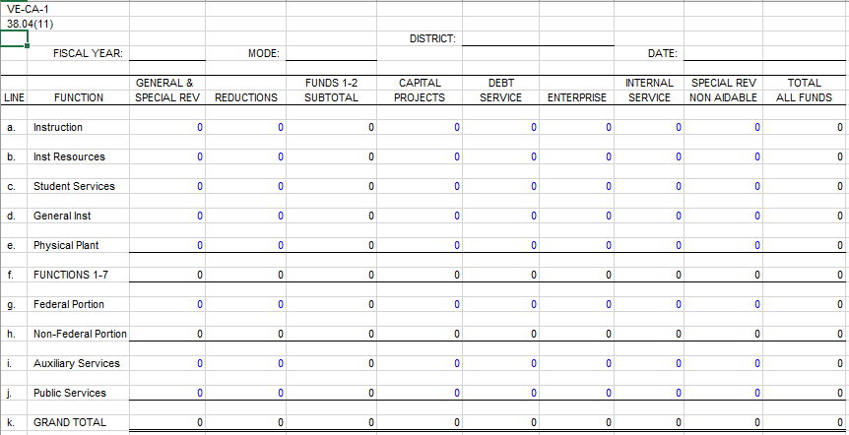

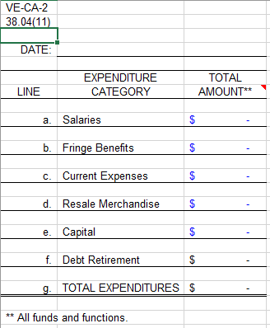

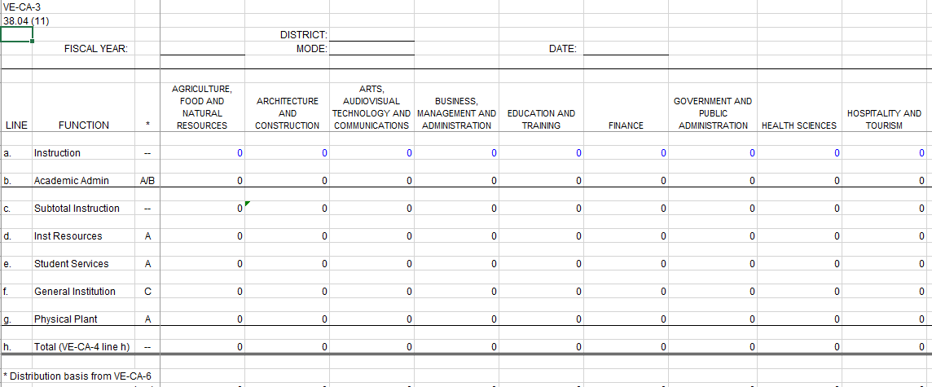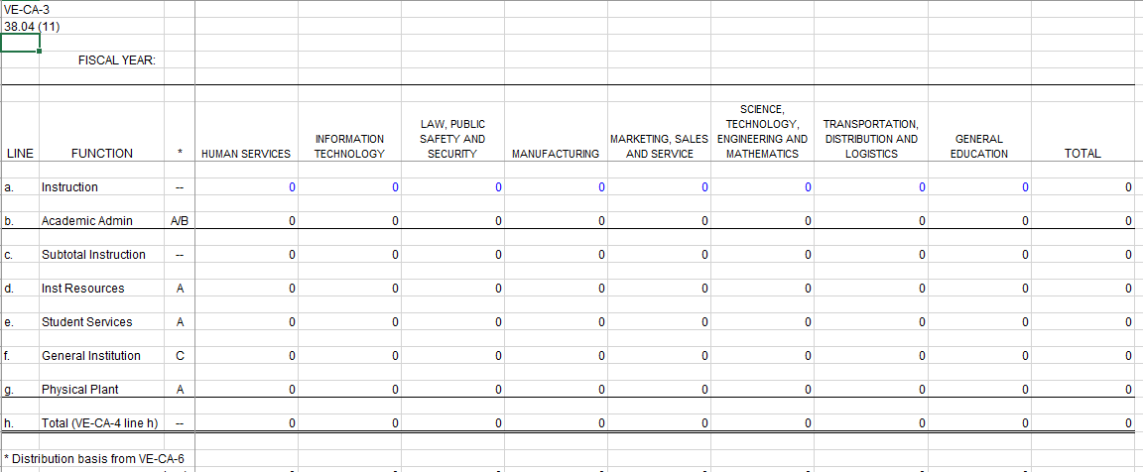
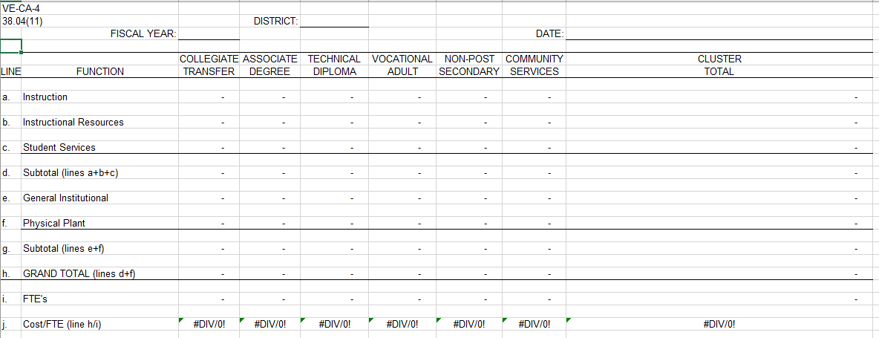

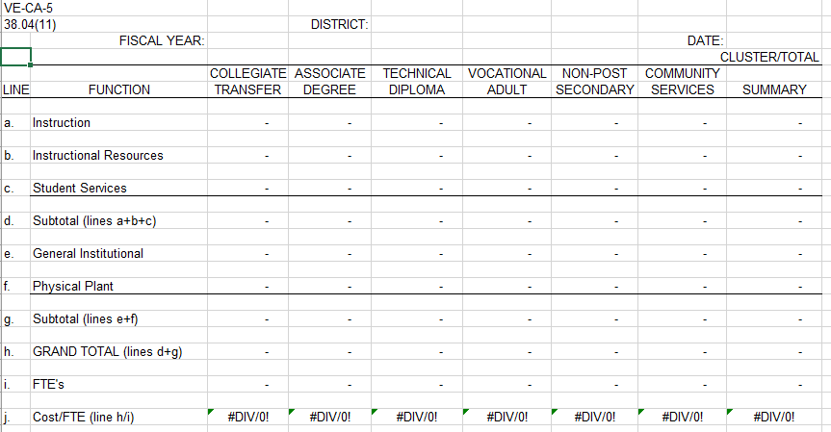

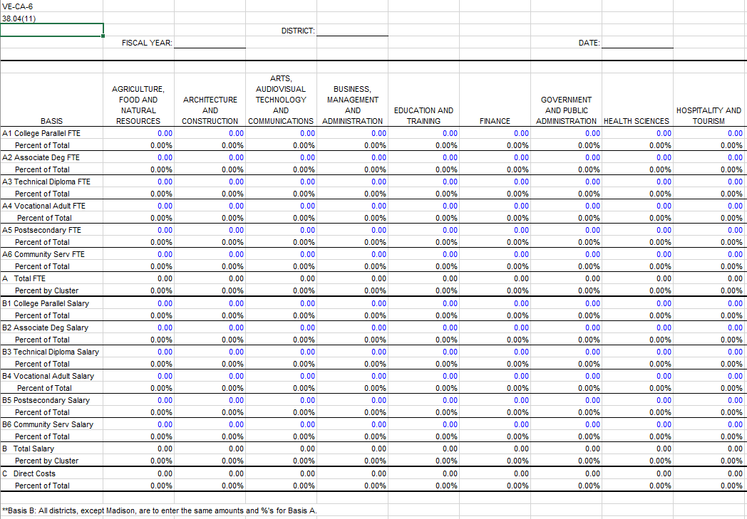
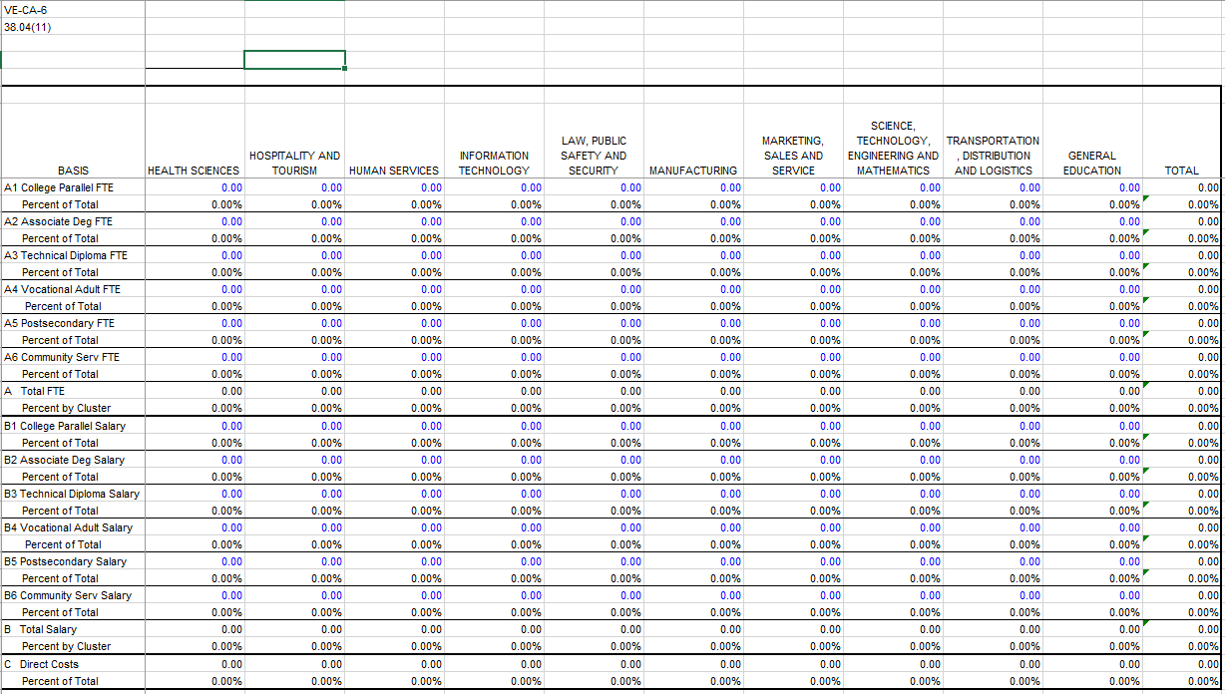

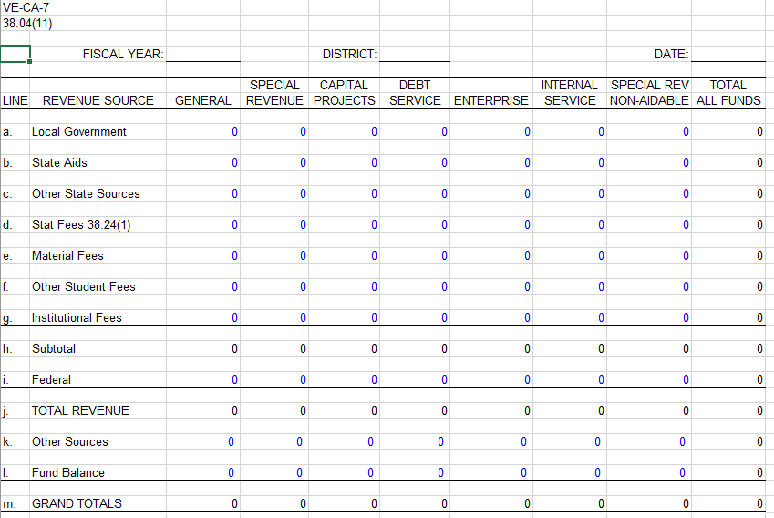

NO SCHEDULE VE-CA-8
THIS SCHEDULE HAS BEEN DELETED. INTERDISTRICT TUITION IS NO LONGER PAID BY DISTRICTS.

