WTCS Employees of Color Mentoring Program

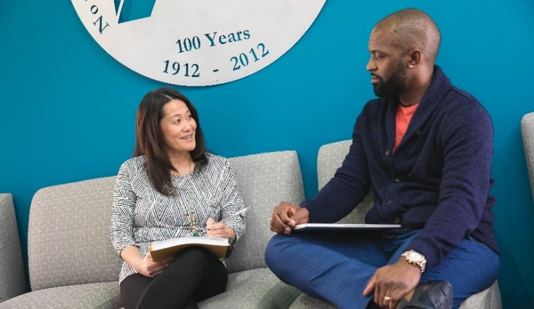

Overview
The WTCS Employees of Color Mentoring Program was created to connect professionals of color working at WTCS institutions across the state to each other. The program encourages a type of mentorship that is self-sustained by mentors and guided by the goals of mentees.
Fostering these mentoring relationships aims to support the retention of WTCS employees of color by:
- Providing employees with resources to advance their professional goals
- Creating a system-wide network and sense of community
- Offering support and techniques for navigating situations where power dynamics and/or marginalization may be at play

Matching Process
The program does not automatically match mentors with mentees. Instead follow the steps below to participate as a mentor or mentee.

If you are looking to mentor someone else
- Add your name to the next available line on the EOC mentoring program sign-up sheet.
- Wait for an interested mentee to contact you.
- Update the mentor sign-up sheet with your current availability and mentee information.

If you are looking to find a mentor
- Review the EOC mentoring program sign-up sheet for mentor contact information and availability.
- Contact the mentor you would like to work with.
- If you would like help finding or connecting with a mentor sign up on the mentee interest form.
Visit the WTCS EOC Mentoring Program webpage for additional resources. Contact colleen.larsen@wtcsystem.edu with questions.

In the words of program participants

As a recent college graduate starting out their professional career, this program was a meaningful and supportive experience for me. My mentor and I share similar identities so it was easy to connect and build rapport since we could relate to one another. She's a great resource and always encourages me to go out of my comfort zone to grow personally and professionally.

As a mentor, I got as much out of this program as my mentee did. I looked forward to our monthly meetings, and we both benefitted from having a safe environment to discuss best practices. I found it particularly rewarding to connect with someone from a different college. It was a good opportunity to reflect on common issues within the WTCS as well as to get perspective on the unique challenges of our individual roles at different institutions.
This was a great opportunity. I am so glad that I took advantage of it. It was great to have someone to ask questions and gain insight from outside of my organization. I'd highly recommend to anyone interested in continued growth and building connections.
I loved being a mentor within the program. I was fortunate to have a great mentor relationship in my past and am thrilled to be able to pay-it-forward. The experience was so rewarding and I learned as much from my mentee as she learned from me. Not only did we form a great bond, but we also created additional connections between our colleges. It gave us another opportunity to learn from each other and be more effective in serving our students. It was a great experience, and I highly recommend it!
My mentor provided me with knowledge to navigate through college as well as the work force. The care and thoughtfulness she shared with me of her pitfalls and achievements will definitely stick with me as compass leading me through my career and educational odyssey.

