# WTCS Apply Portal Guide

Contents

WTCS Apply Portal Guide 1

Log in and/or Create an Account 1

Apply Portal Home Screen 2

Grant Applications within the Apply Portal 3

Revision Process 5

## Log in and/or Create an Account

Navigate to <https://wtcs.smapply.io/>

Returning users can use the ‘Log In’ link.

First time users will need to click on the green ‘Register’ link to create an account.

To create an account, you may be able to use the Google account registration if your work email is synced with Google. Otherwise, most users will have to create an account by filling out the registration form (name, email, password).

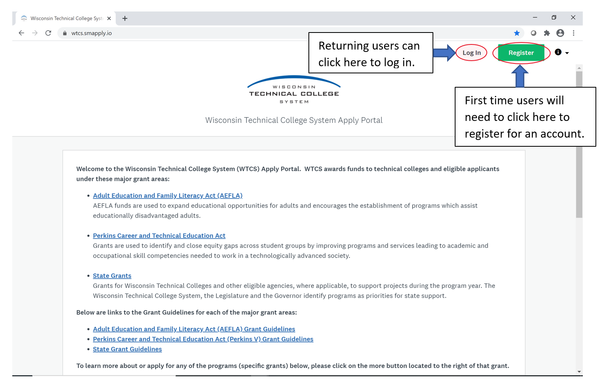

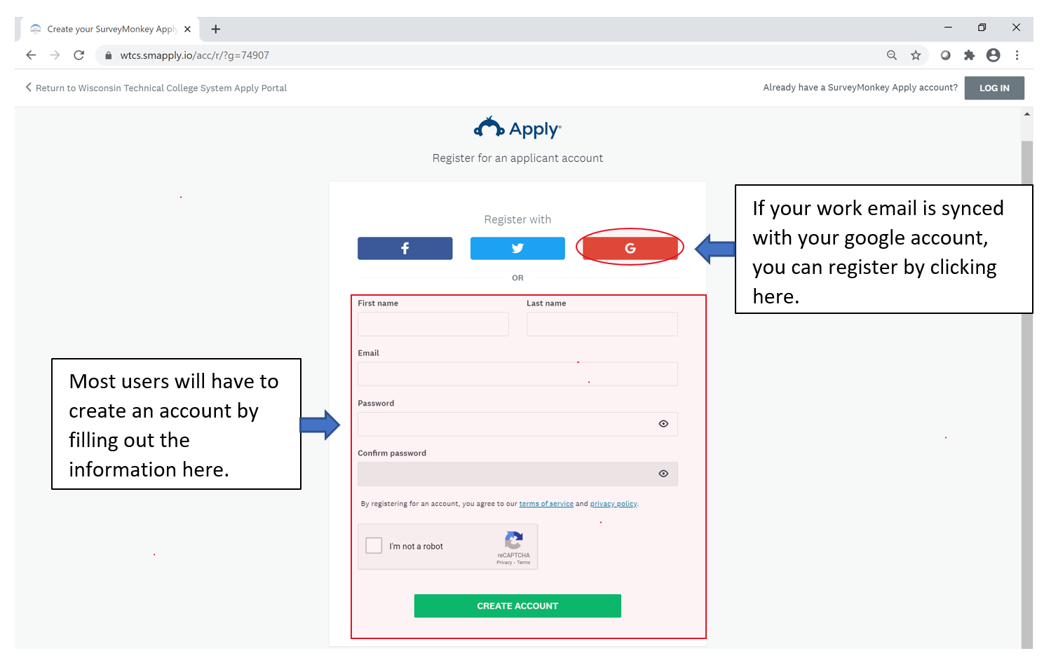

## Apply Portal Home Screen

On the home screen, you can:

* Access all programs (i.e., grant categories) through the ‘[Programs](https://wtcs.smapply.io/prog/lst/)’ link that are available and corresponding grant guidelines for eligibility.
* See all the grant applications that they have started through the ‘[My Applications](https://wtcs.smapply.io/prog/)’ link.
* Select the alert circle icon to get a dropdown menu to:
  + Email the [WTCS grants office](mailto:grants@wtcsystem.edu)
  + View the [Apply Portal frequently asked questions](https://help.smapply.io/hc/en-us/sections/115000366434-Applicant-Recommender-and-Reviewer-FAQ) page
  + Contact the [Apply Portal help desk](https://wtcs.smapply.io/helpdesk/)
* View your [account settings and information](https://wtcs.smapply.io/acc/app/)
* Within the programs (i.e., grant categories) table, you can find the grant application deadline and information about each grant category by clicking on the green ‘MORE’ link. You can also access your grant application if one has already been started within the program/grant category by selecting the ‘See my application’ link.

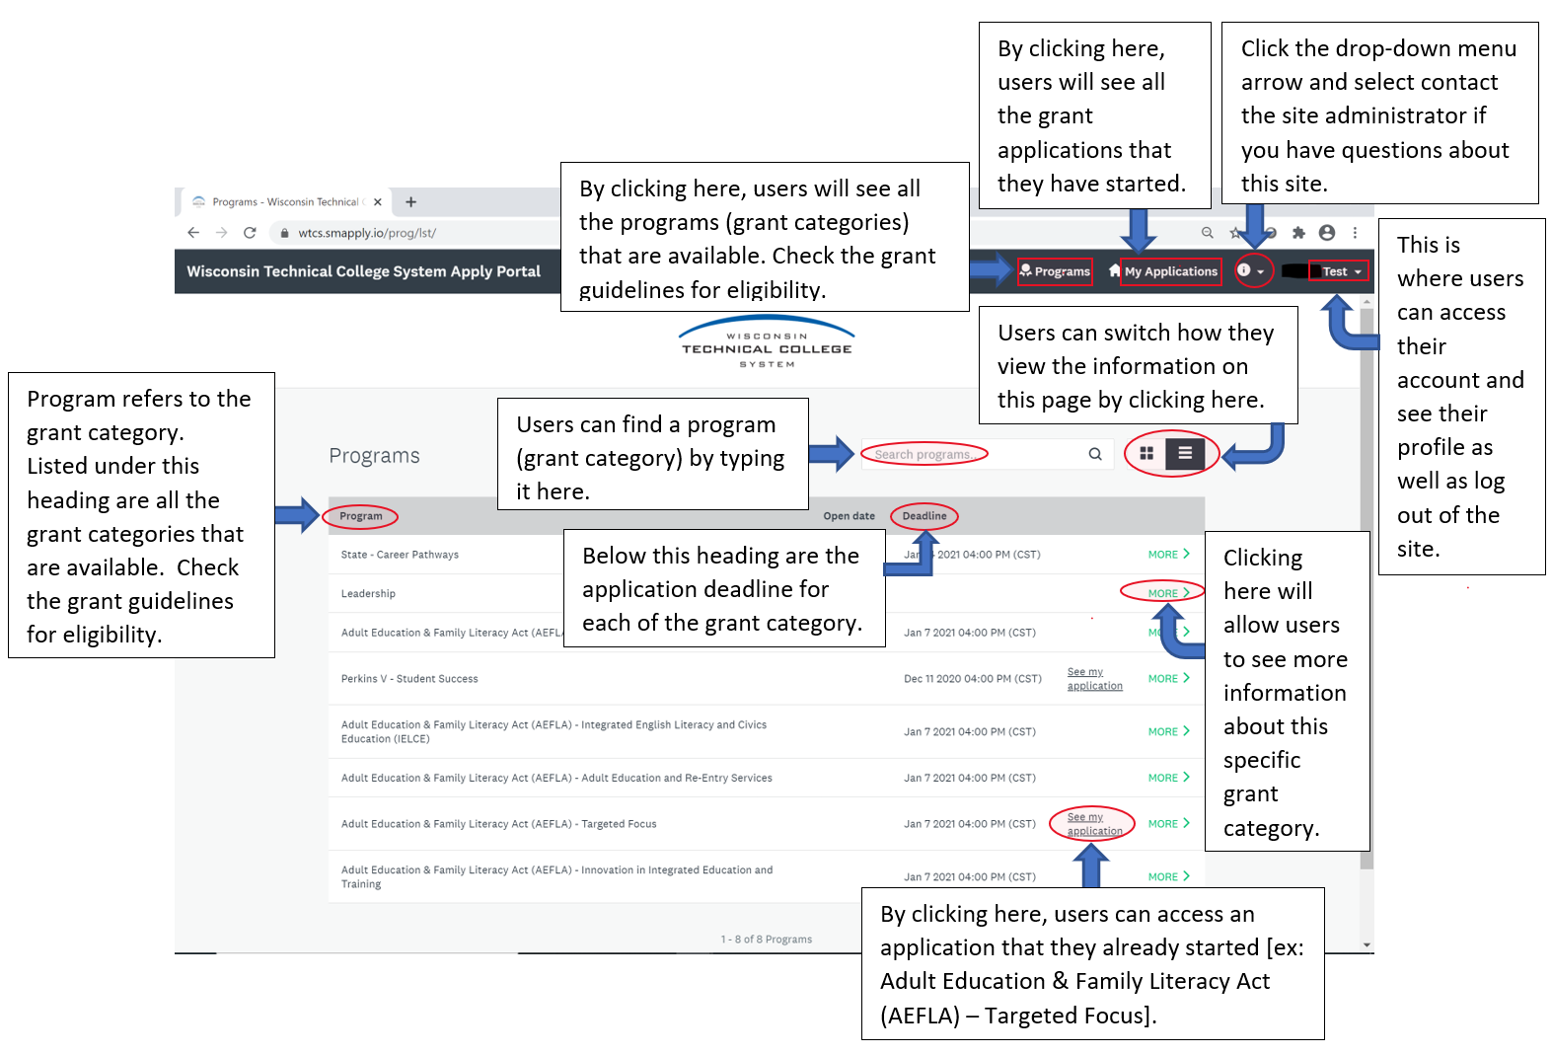

## Grant Applications within the Apply Portal

Within a grant application page, you can:

* See the progress bar with the number of tasks that are complete.
* See when the grant application was last updated.
* See the submission deadline for the grant application.
* View the owner of the grant application (name and email address).
* Add a collaborator.
* Submit the grant application for review, once all the required tasks are complete.

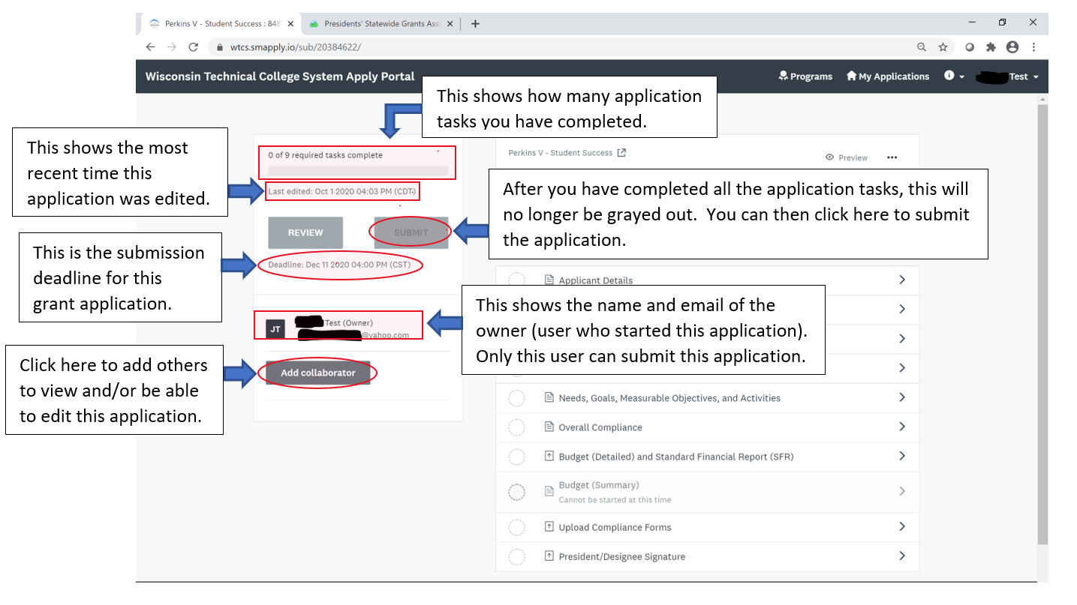

Continued list of actions that you can take and information you can find within the Apply Portal grant application page:

* View the program/grant category name for the grant application.
* View the autogenerated number for the grant application. If your college/organization is submitting multiple grant applications within one category, this number can be used to identify each grant application.
* Preview the grant application.
* Download the grant application with the three dots (‘…’) more options menu link.
* View a record of updates/changes to the grant by selecting the ‘ACTIVITY’ link.
* View the specific grant application tasks that need to be completed. Some tasks are connected to others. For example, the ‘Budget (detailed) and standard finance report (SFR)’ needs to be completed before the ‘Budget (summary)’.

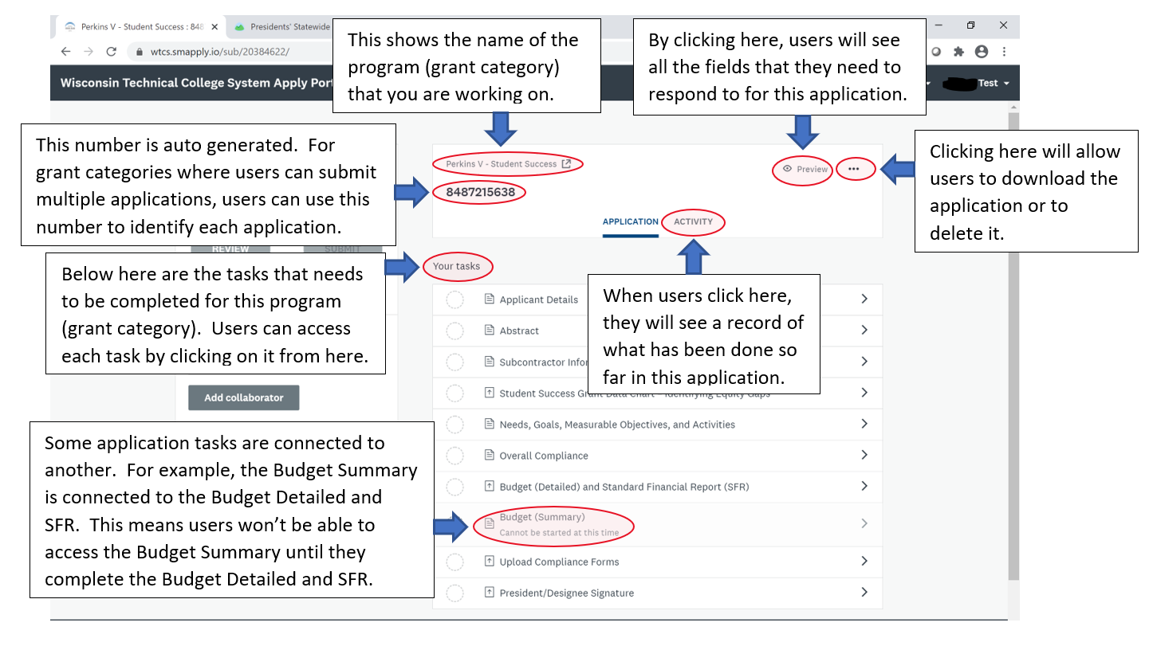

## Revision Process

1. Contact the WTCS Education Director with revision plans to ensure that these are allowable. Formal revisions are needed if **more** than 20% of any budget line item is changing/moving.
2. If a formal revision is needed, email the marked-up version of the grant application to show what is changing with the proposed revision. A screenshot of a computer

   Description automatically generated**24 .**
   1. **If this is the first revision, please do the following**:
      1. Navigate to the grant application within the Apply Portal and download the attached/currently uploaded grant document (containing the Abstract, Statement of Need/Focused Need, Overview and Activities, Overall Monitoring and Evaluation Process)
      2. To convey what is changing, show what is being removed with strikethrough and what is being added with underlined text formatting.
   2. **For subsequent revisions, please do the following:**
      1. Navigate to the grant application within the Apply Portal and download the attached/currently uploaded grant document (containing the Abstract, Statement of Need/Focused Need, Overview and Activities, Overall Monitoring and Evaluation Process)
      2. Delete the current strikethrough verbiage and remove the underlines. This will show the current grant you are working with.
      3. Now use strikethrough and underline to show the new revision.

* 1. Next, go to the budget (detailed) and standard financial report task and download the attached/currently uploaded detailed budget.
  2. Use red font as needed to show all budget item(s) that are being changed (decreased, increased, deleted or added). If a budget item is being totally removed, please update the amount to show $0 and keep it in the budget. Do not underline or strike through anything in the budget detailed and SFR spreadsheet.
  3. If this is the second or subsequent time you are submitting a budget revision for this grant, delete any budget line item(s) that are in red font and have $0. For other budget line item(s) that are in red font containing a grant amount, change the red font back into black. This is now the current budget (detailed) and standard financial report that you are working with. You would then make the changes in red font to show the new revisions.

1. Send the marked-up version of the grant document and the detailed budget sheet to the WTCS Education Director. When they have confirmed that the proposed changes are allowable, they will re-open the grant application within the Apply Portal. You should receive an automated email that the application has been re-opened.
2. In the Apply Portal, view your grant applications by selecting the ‘My Applications” link and then click the green “Continue” link for the specific application that you will be revising.

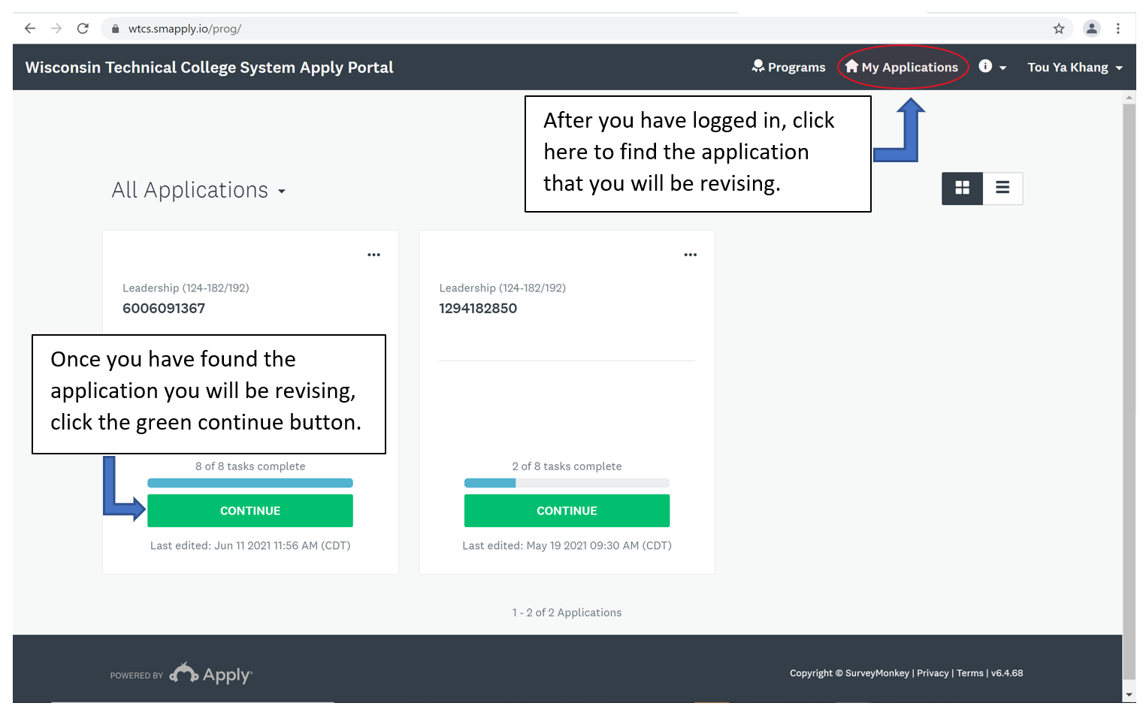

1. Within this application, select the ‘Applicant Details’ link.

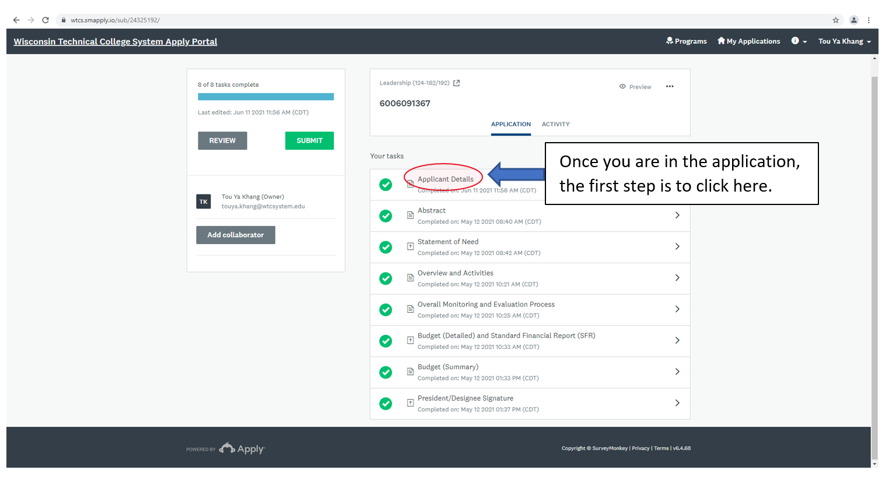

1. Then, select the three dots (‘…’) to see more options and select ‘Edit’.

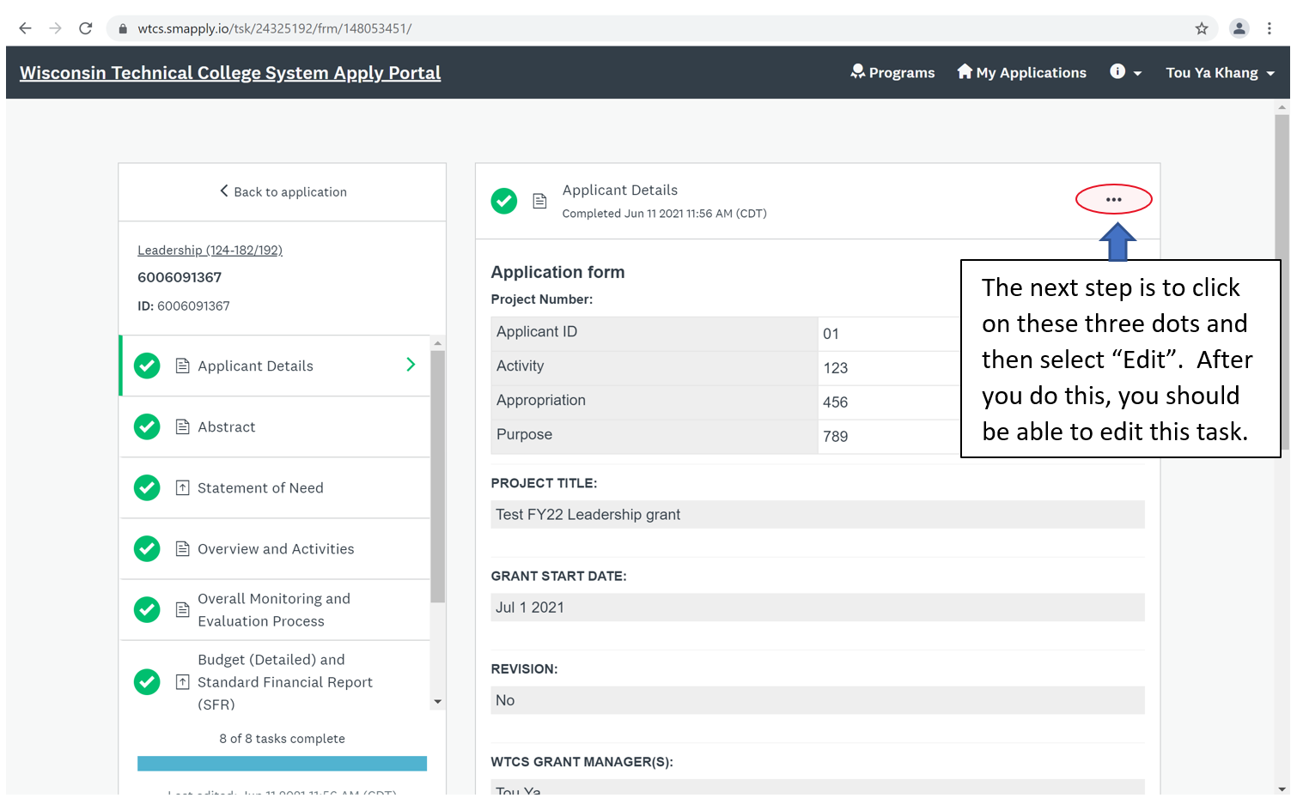

1. Scroll to the ‘REVISION’ prompt. Select ‘Yes’ and provide a summary of the changes to the grant application within the corresponding textbox. If there has already been a previous revision to this grant application, then the ‘Yes’ for the ‘REVISION’ field will already be selected and the revision summary from the last revision will be in the textbox. In this case, delete the old revision summary and provide a new summary of the current revisions in the grant application within the textbox.

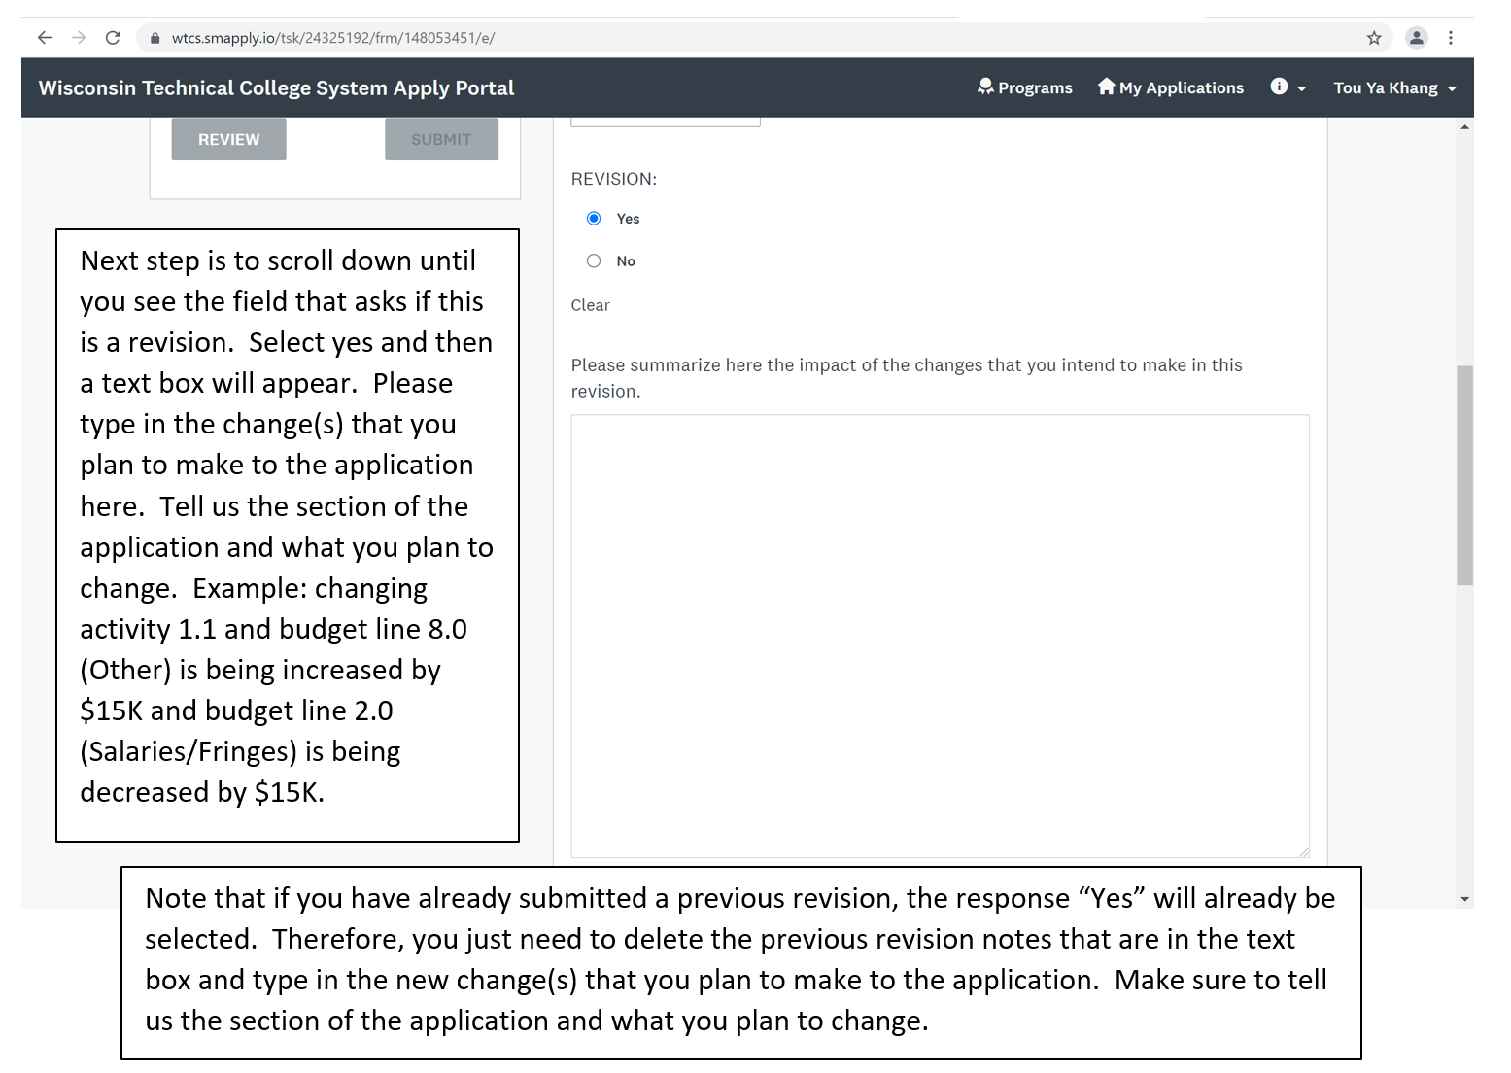

1. Scroll to the bottom of the ‘Applicant Details’ section and select the green ‘Mark as Complete’ link.

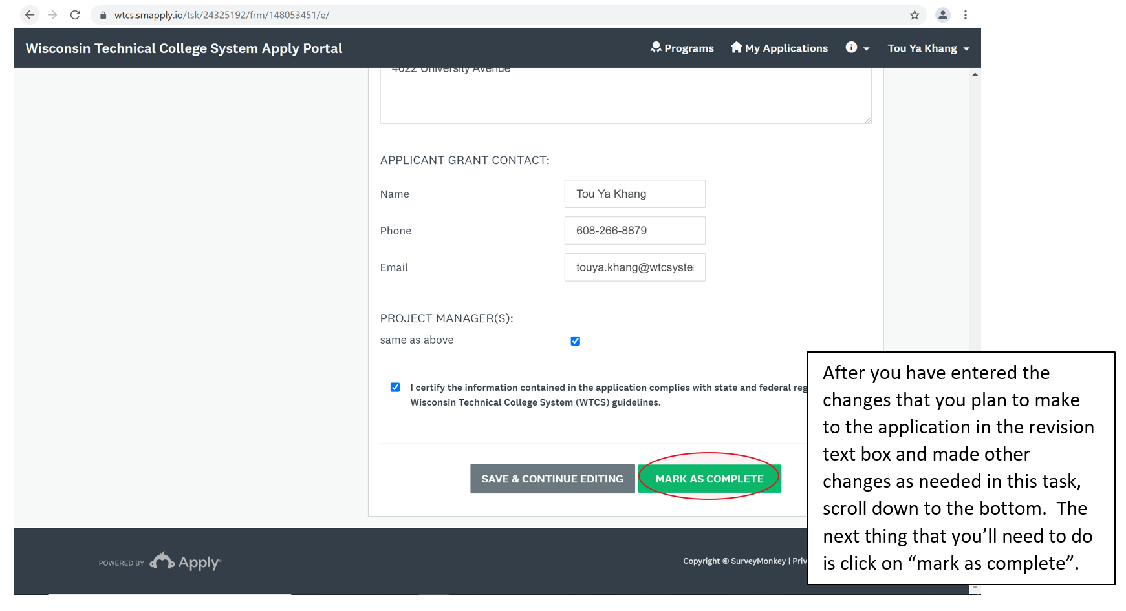

1. Go back to the ‘Current Grant’ section and upload the revised grant document (containing strikethrough and underline) by selecting the ‘Attach File Button’. When the document is uploaded, select the ‘Mark as Complete’ link.

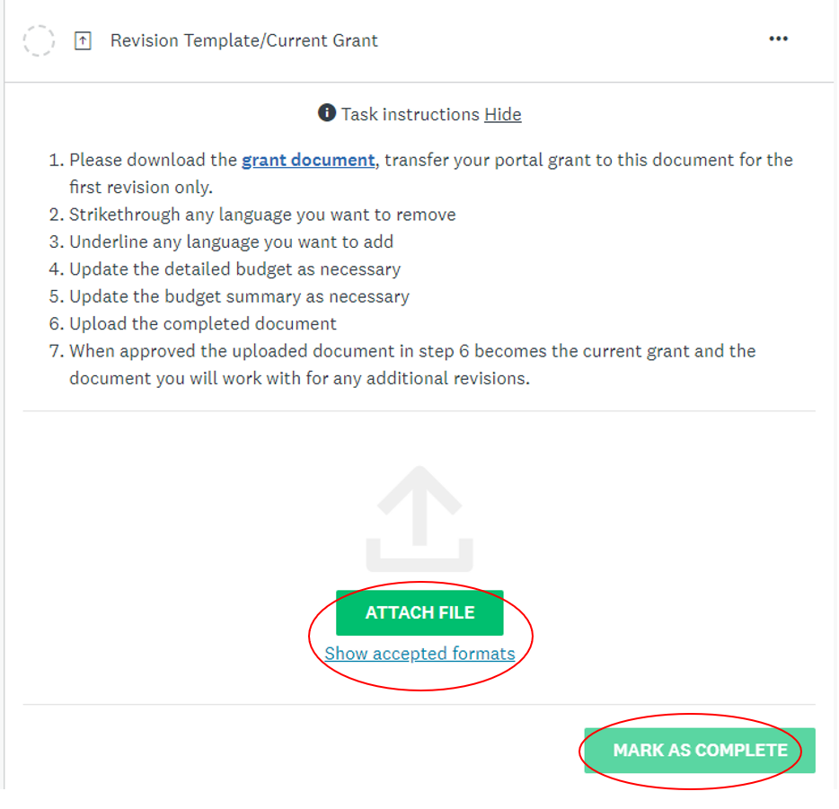

1. If you are making changes to the budget, first update the budget (detailed) and standard financial report (SFR) task. Then, you can update the budget (summary) part of the grant application.

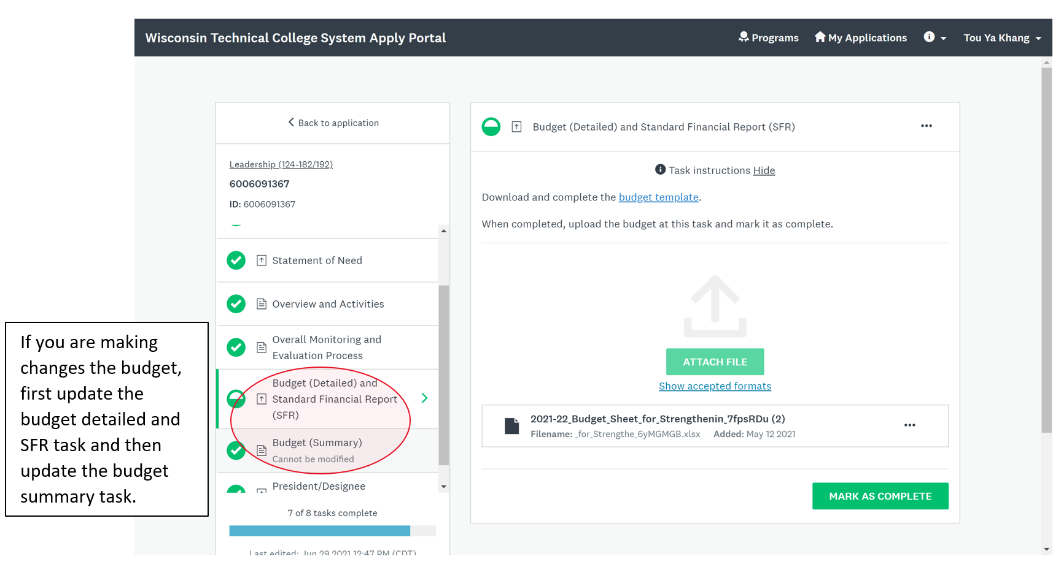

1. To make changes to the grant application budget spreadsheet, follow these steps:
   1. Select the ‘Budget (Detailed) and Standard Financial Report (SFR)’ grant application task/section.
   2. Click on the three dots (‘…’) in the upper right corner of the task and then select ‘Edit’.

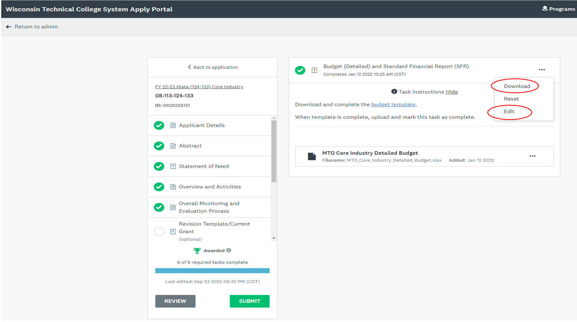

* 1. This will reopen the task so that you can remove the current budget sheet and upload the revised budget sheet (containing red text to show budget item(s) that have been decreased, increased, deleted or added). To remove the previous current budget sheet, click on the three dots (‘…’) for that file and select ‘Remove’.

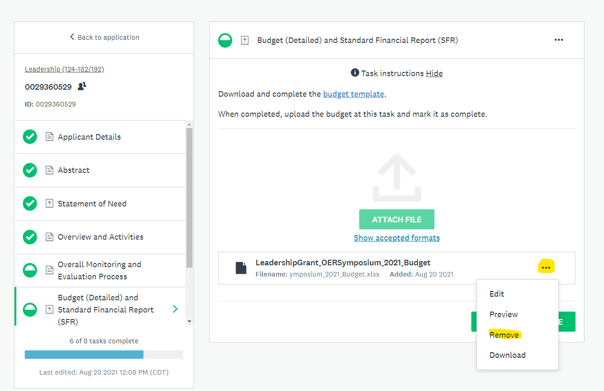

* 1. You can then use the green ‘attach file’ button to re-upload the updated budget sheet.
  2. Mark the task as complete once the new budget sheet is uploaded.

1. As shared, if you revised the budget (detailed) and standard financial report (SFR), please make sure to update the budget (summary) part of the grant application as well.
2. After you have made all revision changes, the blue task bar will indicate that all tasks have been marked as complete (e.g., 8 of 8 tasks complete). The green ‘Submit’ button will be enabled and you can select this ‘Submit’ link to submit the revision. This action will notify the WTCS Education Director to review the revised grant application.

