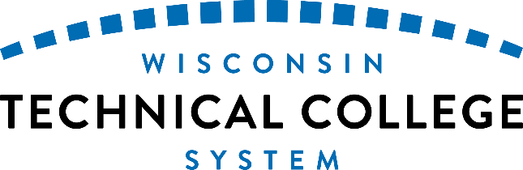

Wisconsin Technical College System Resources

The Wisconsin Technical College System (WTCS) offers all populations in Wisconsin a variety of support services and opportunities to meet their education and career goals. Whether someone is looking for information about English language classes, high-school equivalencies, earning college credit for prior learning, starting a new path to further education or the workforce, or continuing a path they have already started, one of the 16 technical colleges in Wisconsin can help all learners meet their goals.
This guide is intended to be used by service providers to help students access English language classes, enroll in adult education classes, or college classes and technical diplomas. Use this guide to find a college close to home, explore what the college offers, and contact someone designated to help.
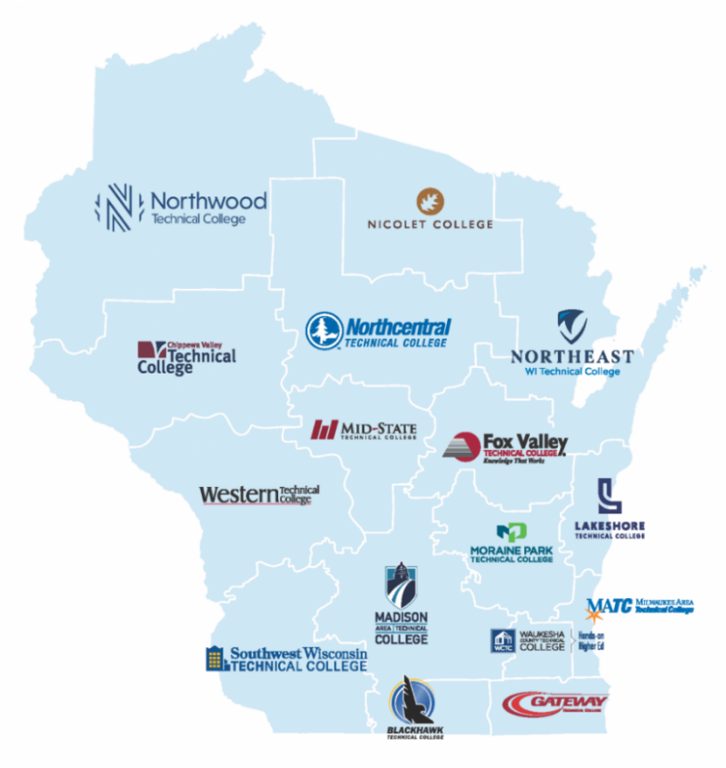
Detailed WTCS map

Contents

Wisconsin Technical College System Resources 1
Adult Education and English Language Learning 2
Explore a Career Pathway 4
Integrated Education and Training (IET) 4
Earn College Credit for Previous Learning 5
Connect with Academic and Personal Support 5
Career and Employment Services 6
Academic Advising 6
Mental Health Counseling 6
Disability Services 6
Multicultural Student Support 6
Student Life 6
Basic Needs Supports 6
Borrow/rent laptops 7
Childcare Services 7
Veteran Services 7
Mentoring Programs 7
TRIO Programs 7
Promise Programs 7
Financial Assistance 7
Financial Aid & Scholarships 8
Emergency Assistance 8
Ability to Benefit 8
Earn College Credit while in High School (for children in K-12) 8
Dual Enrollment 8
Wisconsin Technical College System Office Contact Information 9

Adult Education and English Language Learning
Adult Education programs support adult students who are building academic skills, working to earn a high school credential, working to improve their employment situation, and/or who are learning English.
A major support for WTCS Adult Education programming is federal Adult Education and Family Literacy (AEFL) Title II funding, which prepares adult learners to:
- Successfully enter and succeed in postsecondary certificate, technical degree or diploma programs, apprenticeship training, associates degree, transfer and/or other postsecondary education
- Attain and retain meaningful and sustainable employment
- Effectively support literacy development and academic success within the family
- Become informed and productive participants in community and civic life
- Become self-directed and lifelong learners

Adult Education includes several categories of adult learning, including:
Adult Basic Education which spans grades K – 8.9 instruction with grade levels equivalent to academic courses offered by an accredited school district in the state and that build toward the equivalent of high school enrollment.
Adult Secondary Education which includes 9.0 – 12.9 instruction with grade levels equivalent to academic courses and acceptable for credit toward high school completion approved by the Wisconsin Department of Public Instruction (DPI). ASE includes courses that are designed to prepare learners in pursuit of a GED or high school equivalency diploma (HSED) as well as preparing students for transition and success in postsecondary education.

GED/HSED
Having a GED or HSED also qualifies eligible students to apply for and receive financial aid.
Options may include;
- The General Education Degree (GED) and High School Equivalency Diploma (HSED).
- GED/HSED 5.08 which allows persons who completed the equivalent of high school or post-secondary study in another country to be granted a high school equivalency diploma from the state of Wisconsin.
- 5.09 HSED which is a competency-based program that is designed to prepare students with the knowledge and skills necessary to earn a High School Equivalency Diploma.
- Spanish language GED program
- HEP program which is targeted to help migrant and seasonal farm workers and their family members earn a GED/HSED.
For a more comprehensive list of GED and HSED options please contact the technical college in your district.
- For more information, contact Dr. Christina Lorge, Associate Vice President of Student Success, christina.lorge@wtcsystem.edu

English Language Learning (ELL) refers to instructional programs designed to assist eligible adults who are English language learners achieve competence in reading , writing, speaking, and comprehension of the English language learners. All 16 colleges in the Wisconsin Technical College System (WTCS) offer beginning to advanced English language classes at no /low cost to students. English language learning prepares students for success as community members, parents, and employees The course(s) provide skills leading to high school completion, entry into post-secondary education, career-related education, or job placement. The program also helps all students interested in becoming a U.S. citizen prepare to do so through integrated courses which include civics.
- For more information, contact Cristina Parente, Education Director of ELL Programming, cristina.parente@wtcsystem.edu.
Justice-Involved Education can include components of Adult Education, ELL and/or occupational skills education and training, and is often delivered in partnership between colleges, state and local correctional institutions, and other community partners. The goal of this programming is to reduce recidivism and increase employment for justice-involved individuals.
- For more information, contact Lenard Simpson, Education Director, lenard.simpson@wtcsystem.edu.

Explore a Career Pathway
Whether students are looking to launch their first career, jump into a new career, or just explore their options, technical colleges are here to help. Wisconsin technical colleges offer a variety of connected education and training strategies and support services to enable individuals to secure stackable industry relevant credentials and obtain employment within an occupational area as well as advance to higher levels of education and employment in that area.
The technical colleges offer single classes, short-term certificates, degree programs, and connections to apprenticeships where students are paid by their employer while they learn.
- Prospective students can meet with college staff to explore career pathways and find the right place to start.
- Visit the WTCS Programs page for more information on degrees and short-term certificates at the 16 technical colleges.

Integrated Education and Training (IET)
IET has emerged as a service approach to help individuals acquire basic skills while pursuing occupational or industry-specific training. Through an IET model, participants receive simultaneous instruction in basic skills, such as math, reading, or spoken English, as well as workforce training and workforce preparation.

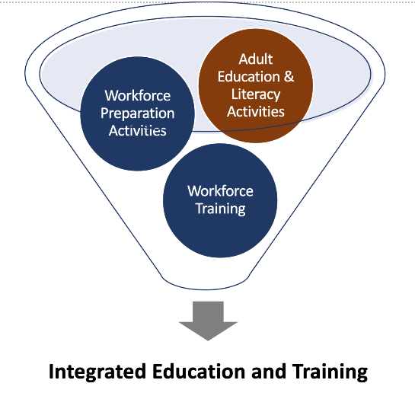
Collectively, IET programming has the potential to:
- Accelerate economic mobility. Learners participating in IET build their skills while progressing towards industry validated credentials with labor market value.
- Save time for learners. Structured IET pathways with concurrent and contextualized learning integrate the three components of IET, mitigating a need to complete each separately.
- Enhance learner outcomes and beliefs. Learners participating in IET have more favorable views of instruction, an increased sense of confidence in the classroom, and stronger literacy outcomes (Konruff, 2020; Shore, 2004; Wang, 2017).
- Act as a pipeline to industry-validated credentials. Learners participating in IET access a career pathways on-ramp to WTCS credentials and/or industry certifications.
- Serve as a lever to supporting educational and workforce equity while addressing workforce needs. Industry validated IET pathways provide the unemployed and underemployed with a roadmap to upward social mobility, positively impacting their lives, the community, and the workforce.
- Make career pathways accessible to underserved communities which may include but is not limited to justice-involved individuals, English language learners, refugees, communities of color, and internationally trained professionals.
- Check with the technical college in your district for more information on their IET programs.
Earn College Credit for Previous Learning
Have you or a client you’re working with already earned a degree at another institution? Learned skills through experience working or volunteering? Technical colleges can assess prior learning through assessments, portfolios, and skills demonstrations to determine if credit can be awarded toward a program credential.
- College staff can also help connect you to credential evaluation services. Most colleges will accept evaluations by any National Association of Credit Evaluation Services (NACES) agencies such as, One Earth International Credential Evaluations or Educational Credentials Evaluators (ECE)
- Download a list of additional recommended credential evaluation services.
- Ask a college representative about how to connect with the college’s Credit for Prior Learning program.

Connect with Academic and Personal Support
Each college provides a variety of services to support a student’s overall development and growth. These services are free to access for enrolled students and can be critical to a student’s persistence and success. Services and eligibility may vary from college to college. The best strategy for identifying student services at a particular college is to visit the college website and use the search bar. A list of some common services colleges offer include the following:

Career and Employment Services
- Help determining which program to go into, finding employment and internship opportunities, writing resumes and cover letters, and interviewing.

Academic Advising
- Help searching for and enrolling in courses in line with a student’s skills and program requirements. Academic advisors can also help students navigate college resources and make referrals to other service providers on campus or in the community.

Mental Health Counseling
- One-on-one or group mental health counseling services are offered at WTCS colleges or in collaboration with community partners. Some colleges may have eligibility requirements including a minimum number of enrolled credits or have a cap on the number of sessions a student may access. Some colleges partner with a third-party telehealth provider to reach more populations.

Disability Services
- Each college provides support and services including accommodations, assistive technology, sign language interpreting etc. to students with disabilities based on the Americans with Disabilities Act of 1990 (ADA) and Section 504 of the Rehabilitation Act of 1973. Students must self-identify as having a disability and bring documentation of their disability to an accommodations specialist. Reasonable accommodations for classes and testing are determined on a case-by-case basis. For specific assistance or accommodation requests, contact the Accommodation Service Office at your college.

Multicultural Student Support
- Multicultural services or diversity, equity, and inclusion offices advocate for students with a diverse set of racial and ethnic backgrounds and gender identities. Students may be able to connect with programs, services, and student organizations where they can meet other students in multi-cultural spaces.

Student Life
- Student life offices organize events and organizations to help students connect with each other outside of class. They may also be the place where students can learn about and access resources like a campus ID, bus pass, parking pass etc.

Basic Needs Supports
- Many colleges offer support for students in need of housing, transportation, childcare, food, health care, and connection to public resources.

Borrow/rent laptops
- Many college programs and services are offered online or in a hybrid format but not all students have access to devices and stable internet. Some colleges loan laptops, tablets, and mobile hotspots to students through the college library or student services.

Childcare Services
- Some colleges offer childcare services on campus or have relationships with community partnerships.

Veteran Services
- Veteran Services staff provide case management, benefits support, and referrals to military service members and their families.

Mentoring Programs
- Many colleges across the WTCS have mentoring programs available for different populations of students. Search for mentoring on your college’s website for additional information about mentoring opportunities available at your institution.

TRIO Programs
- Some WTCS colleges offer federally funded TRIO programs which offer specialized support for students with disabilities, first generation students, and those coming from low-income backgrounds.
  - LTC TRIO Program
  - GTC TRIO Program
  - Madison College TRIO Program

Promise Programs
- Many colleges in the system offer Promise Programs which allow students to attend college tuition-free. Eligibility requirements for these programs vary by college. You can learn more by visiting the Scholarships and Promise Programs page of the WTCS website.

- Contact Colleen Larsen (colleen.larsen@wtcsystem.edu) or Stephanie Glynn (stephanie.glynn@wtcsystem.edu) with questions about student services.

Financial Assistance

Financial Aid & Scholarships
Financial aid offices help students connect to federal and state financial aid grants and loans.

- Many of the programs offered by the 16 colleges are eligible for financial aid, and many factors determine the level and types of aid students receive. Learn more about the Free Application for Federal Student Aid and other available programs.
- There may also be college-specific scholarships for students so contact your financial aid office to learn more.
- Financial aid staff may also be able to help students find additional funding or fill in gaps between terms.

Emergency Assistance
WTCS colleges make funds available to support students dealing with emergency situations that may impact their ability to stay in college.
- This assistance can help offset costs related to transportation, housing, dependent care, medical care, and more.
- Eligibility to receive emergency assistance funding may differ by college. Some assistance funds may require enrollment in a certain amount of credits, documentation of emergency, etc.

Ability to Benefit
Ability to Benefit is a provision in the Higher Education Act that allows a student who has not received a high school diploma to be eligible for Federal student aid. Students enrolled in IETs (INTEGRATED EDUCATION AND TRAINING), for example, may become eligible for Ability to Benefit.
- Check with your college representative to learn more.

Earn College Credit while in High School (for children in K-12)

Dual Enrollment
All 16 WTCS Colleges have a dual enrollment program where students can take college courses while in high school.
- Many colleges offer multiple dual enrollment or dual credit options.
- Some high school students not only receive credit from a technical college but earn technical college certificates and associate degrees before high school graduation at no cost to the student or family.
- Every college has a Career Prep Coordinator that works with partners at their local K-12 schools.

Wisconsin Technical College System Office Contact Information
- If you need assistance finding contacts at any of the WTCS colleges related to the areas above please contact the appropriate system office education director at https://mywtcs.wtcsystem.edu/about-wtcs/staff-directory/

